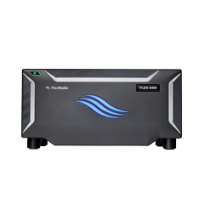
Marty Boroff WD9GYM
Martin.boroff@gmail.com
North Shore Radio Club
Flex-Cadre Radio Access

Table of Contents
Mission Statement 2
File Repository 2
VPN Architecture and Access 3
Radio Scheduling 4
Administering the System 15

Mission Statement
Thanks to the generosity of Burt Krain, our group has deployed a network of Flex Radios and Maestro units for the benefit of the amateur radio community. Our mission is to bring together a dedicated cadre of hams to collaborate on learning and mastering Flex Radio technology and its related software suites.
We are committed to fostering a welcoming, collaborative environment where members can learn from one another, share knowledge, and enjoy the experience of operating state-of-the-art software-defined radios remotely. Above all, we are committed to ensuring that every member has a great experience.
Our growing network currently includes five Flex Radio transceivers across four locations: two in Mundelein (EN52xg), and one each in Northfield (EN62cc), Northbrook (EN62cd), and Skokie (EN62db). As we work to expand access and participation, we are actively seeking additional hosts with versatile antenna systems and strong internet service to join our network.

File Repository
The files for this project are stored in two Guthub repositories:
WEB Site code - https://github.com/mboroff/nsrc-flex-scheduler
Node-red Flows - https://github.com/mboroff/src-flx-scheduler-node-red-project
VPN Creation Files - https://github.com/mboroff/VPN-Creation-Files
A copy of this document is stored in the VPN Creation Files repository.

VPN Architecture and Access

Each of the Flex radio locations has a Raspberry Pi used to monitor for lightening strikes and control the power on/off and in some locations disconnect the antennas. Thess Pis also run a VPN. Marty Boroff - WD9GYM manages these Pis and user access to the VPN. The Pis are named:
MundeleinVPN
NorthbrookVPN
NorthfieldVPN
SkokieVPN
This system is located in Mundelein. Once connected to the VPN users set their browser to:
http://10.0.0.127:8080
This will take the user to the login page.
To add a user to the VPN, Marty uses the VPN server admin tool to create a user id. This is usually the user’s call sign. He assigns a password and saves the information. Then on a windows computer, the Create-VPN-Package-and-letter-prompt-HTML.bat is run. This .bat file prompts for the name of the VPN connection, call sign and password. The .bat file is uploaded to Dropbox and the link is copy and pasted into the prompt. Then it generates a .bat file and three html files for use with creating an email to send to the user.

Radio Scheduling

To access the Flex radios users must login to the scheduling system after connecting to our VPN server. Once connected to the server open a browser to http://10.0.0.209. You will be presented with a login screen. If you do not have an account utilize the Create Account button and provide the requested information.

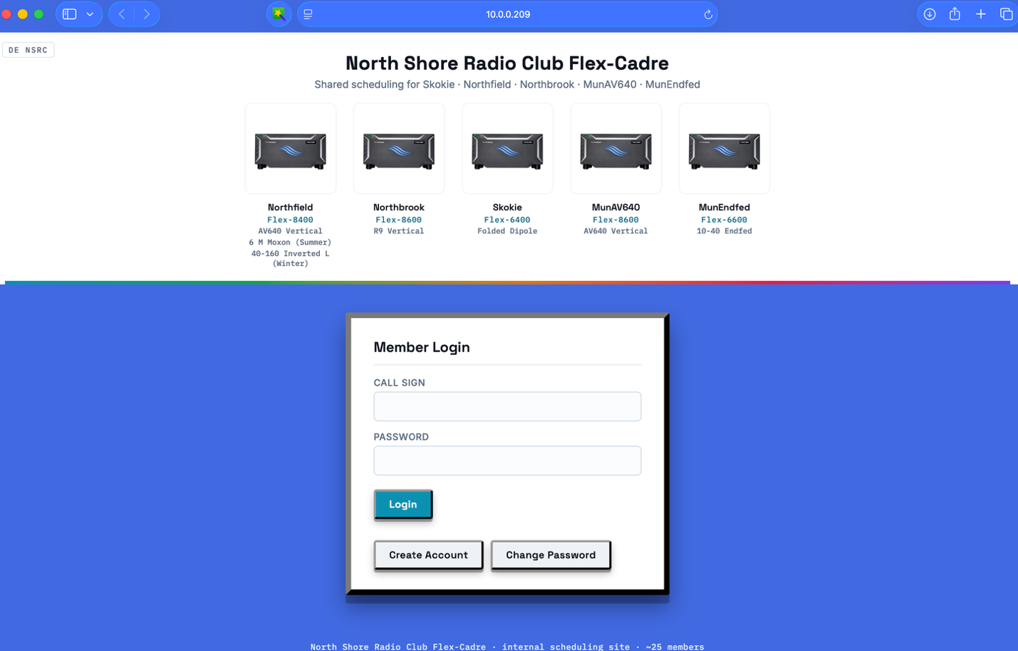

Once logged in, you will be presented with a calendar used to reserve time for your usage. This is not required. If you click on a date, you will be taken to the scheduling sheet for that date. If you wish to just activate a radio for connecting with SmartLink click on the Radio Activation button. Buttons are also provided to display your account information, your reservations, all reservations, and logging out.

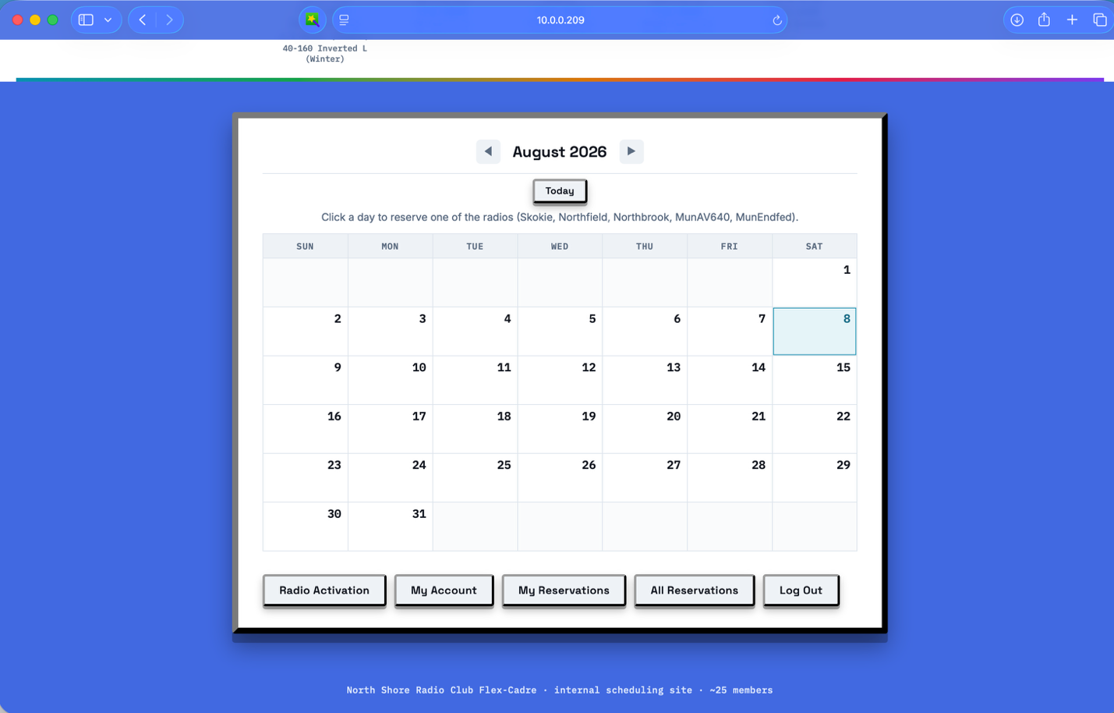

Click on a time for a radio to reserve it. Clicking on the time again will remove the reservation.
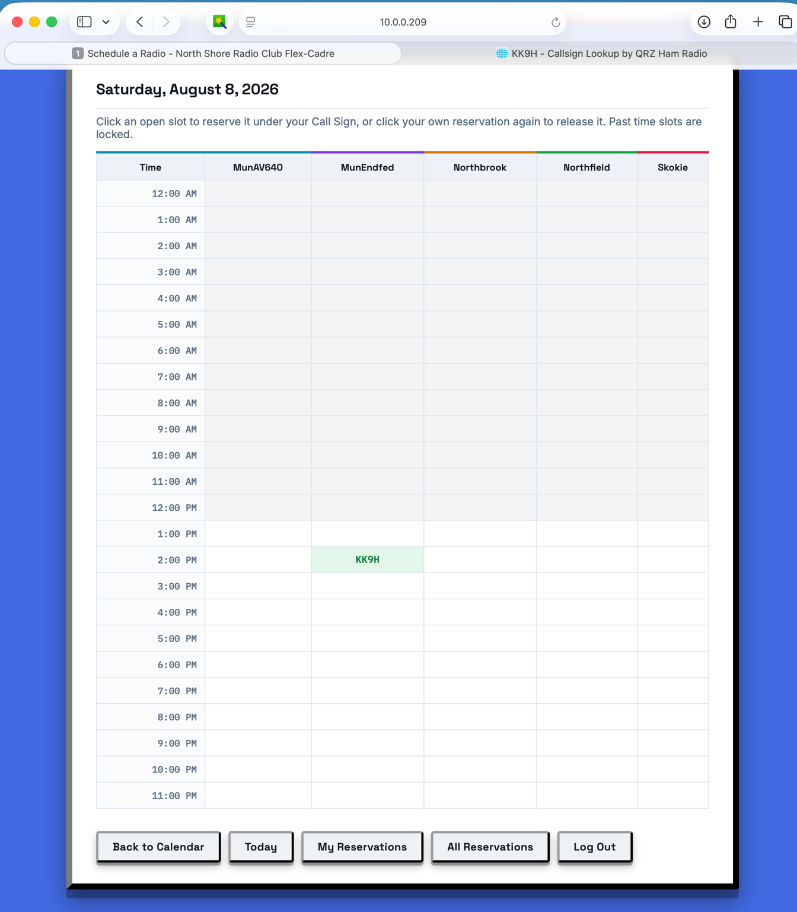

Clicking on My Account on the Calendar page presents this display. The user can modify any field and save it.
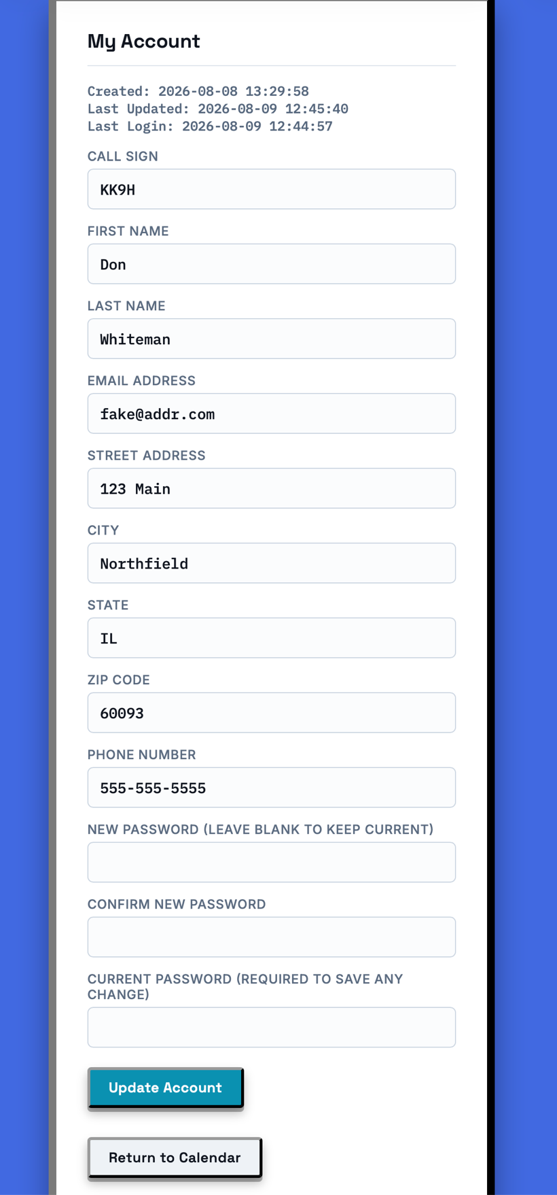

Clicking on My Reservations displays this page.
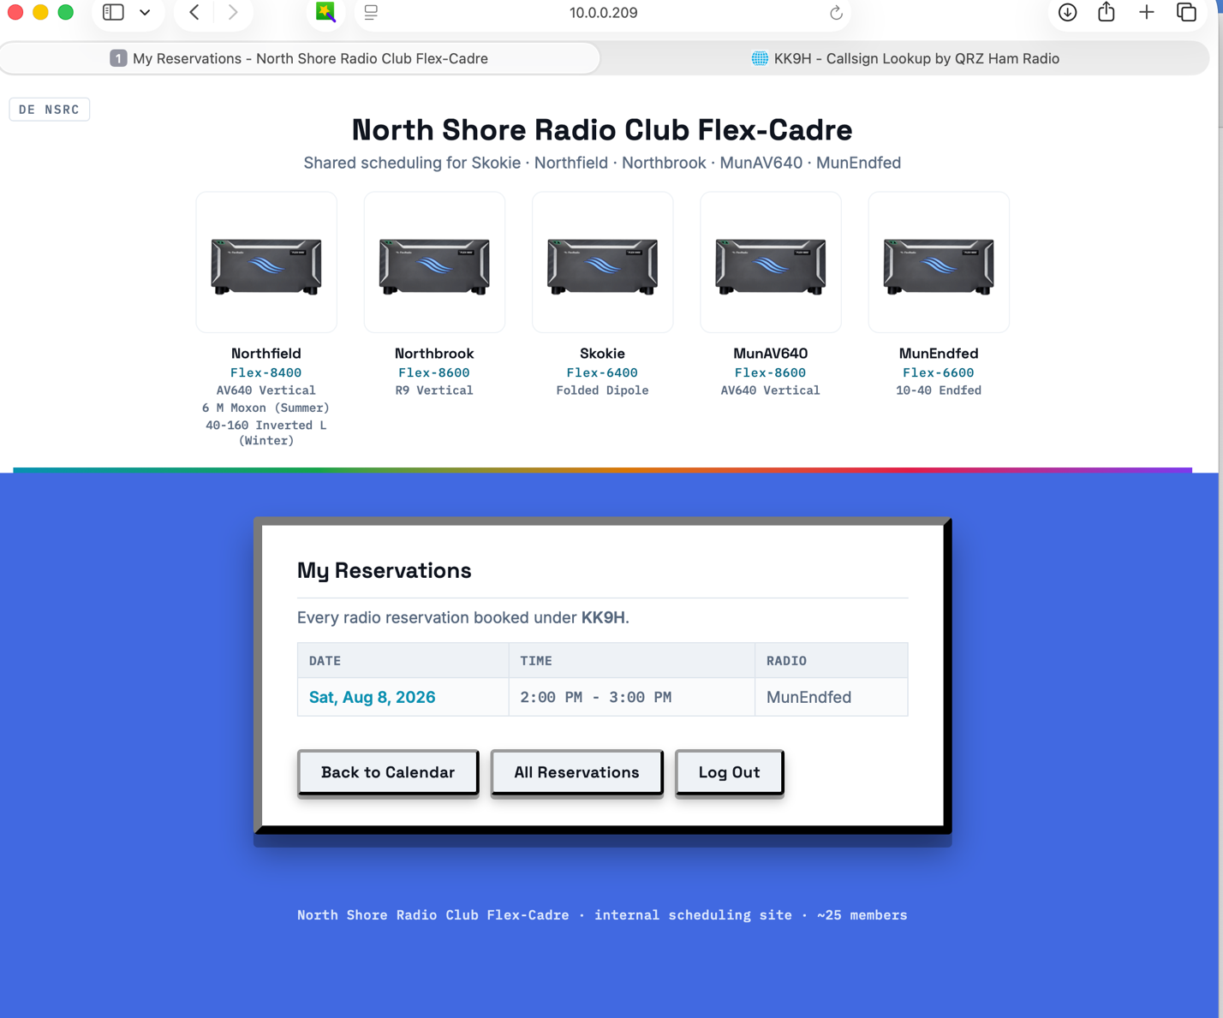

Clicking on All Reservations displays this page.

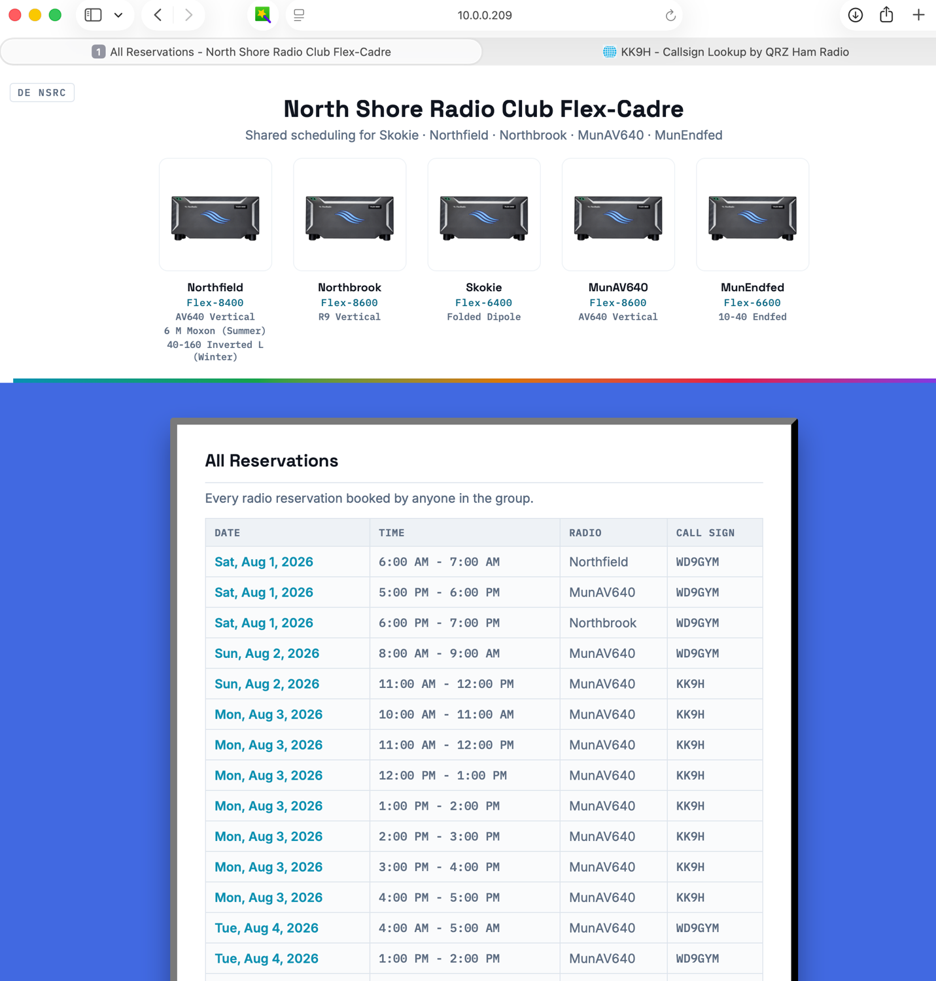

Clicking on Radio Activation on the Calendar page takes you to this page. Click on the radio you wish to see in SmartSDR. If it's reserved by another user, nothing opens - a message shows who has it reserved instead.
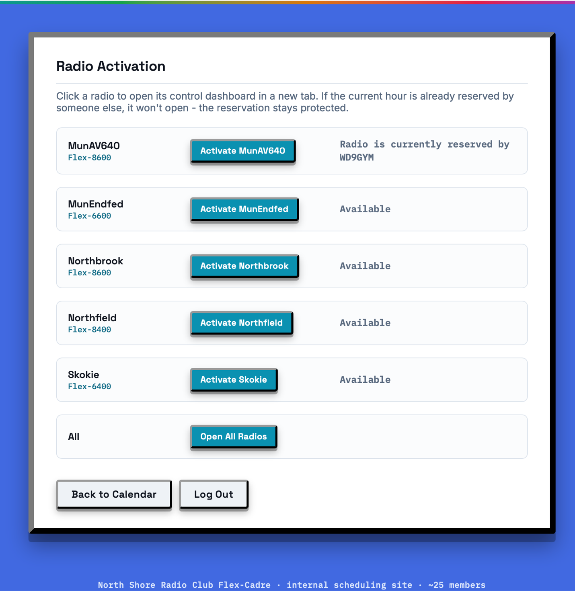

Note: the screens on the following pages belong to the club’s separate Node-RED radio control system, which opens in a new browser tab when a radio is available. They are shown here for reference and are not part of the scheduling site itself.
If a radio is available, you will be taken to this page for all radios or a reduced version when a specific radio is selected.
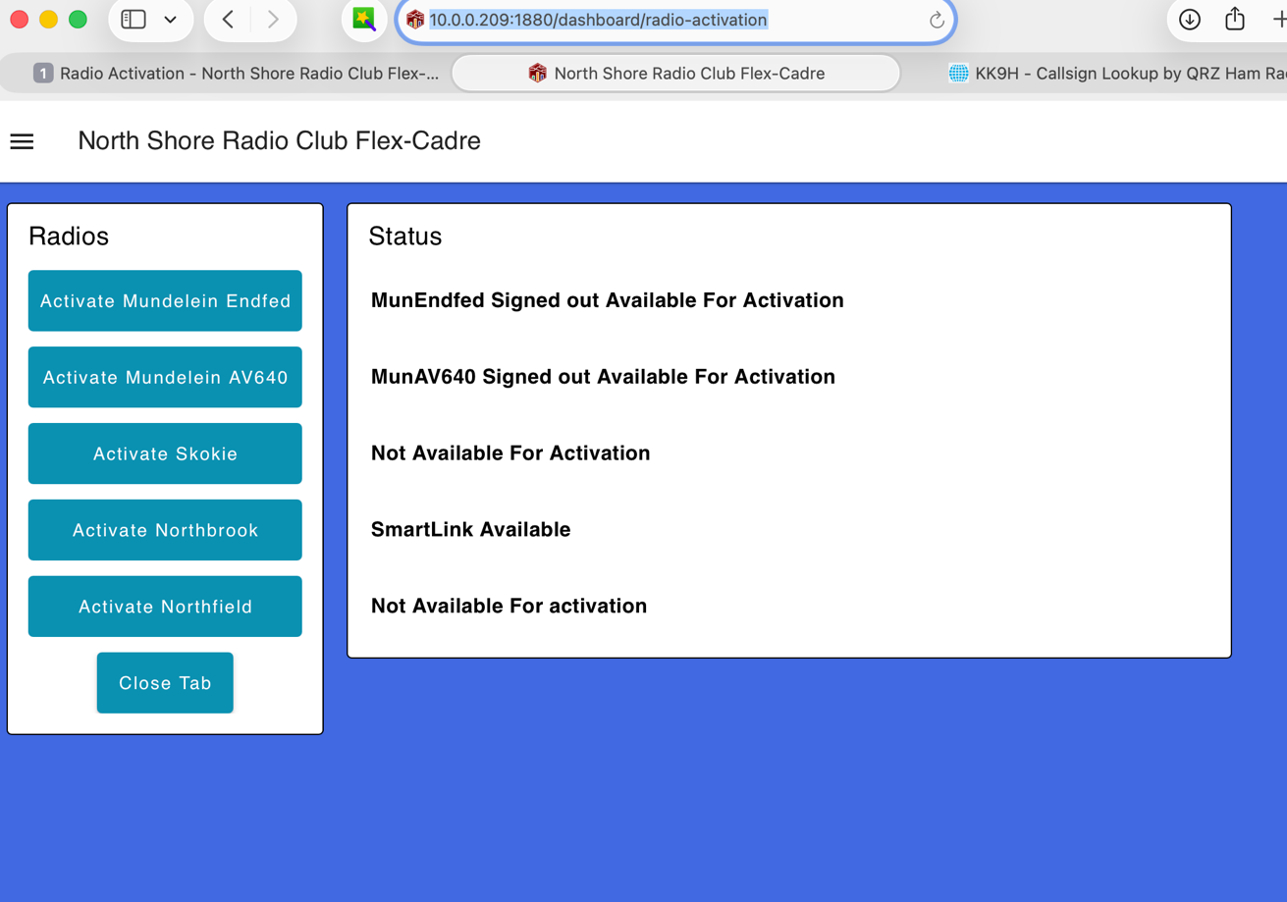

Clicking on an Activate radio button will display a count down until the radio will be available to SmartLink.

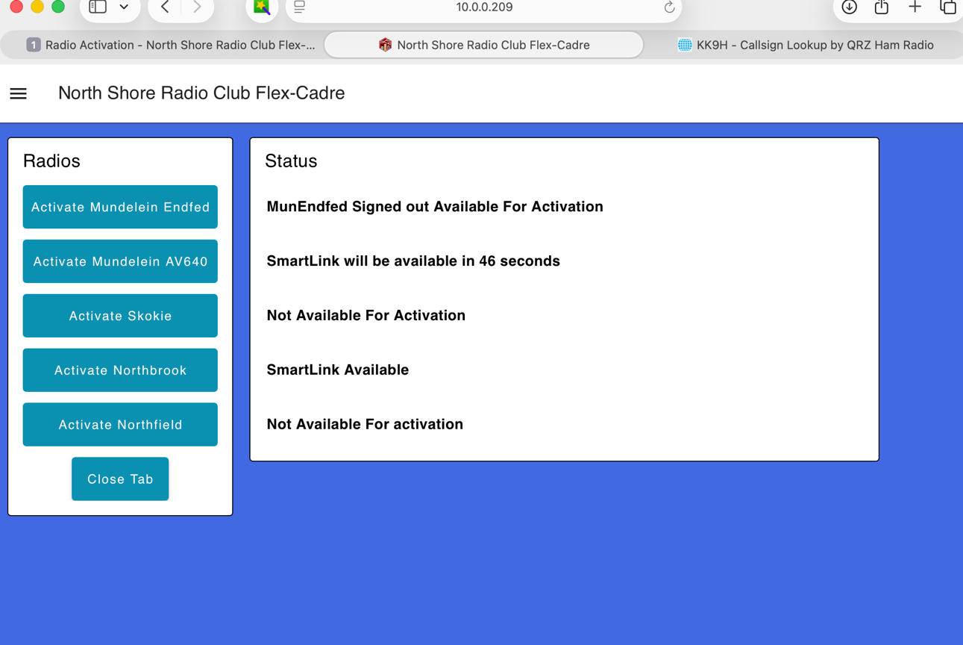

Once you see the SmartLink is available close the browser or the tab and then bring up SmartSDR application.
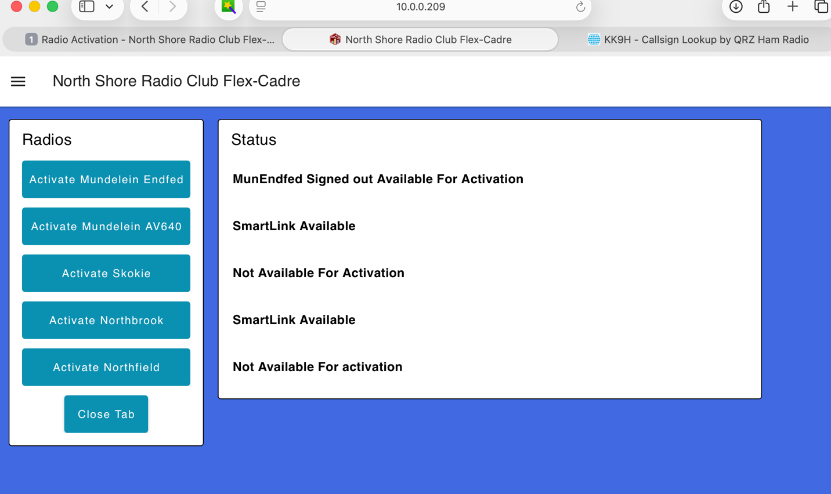

If a radio is in use, it is noted here.
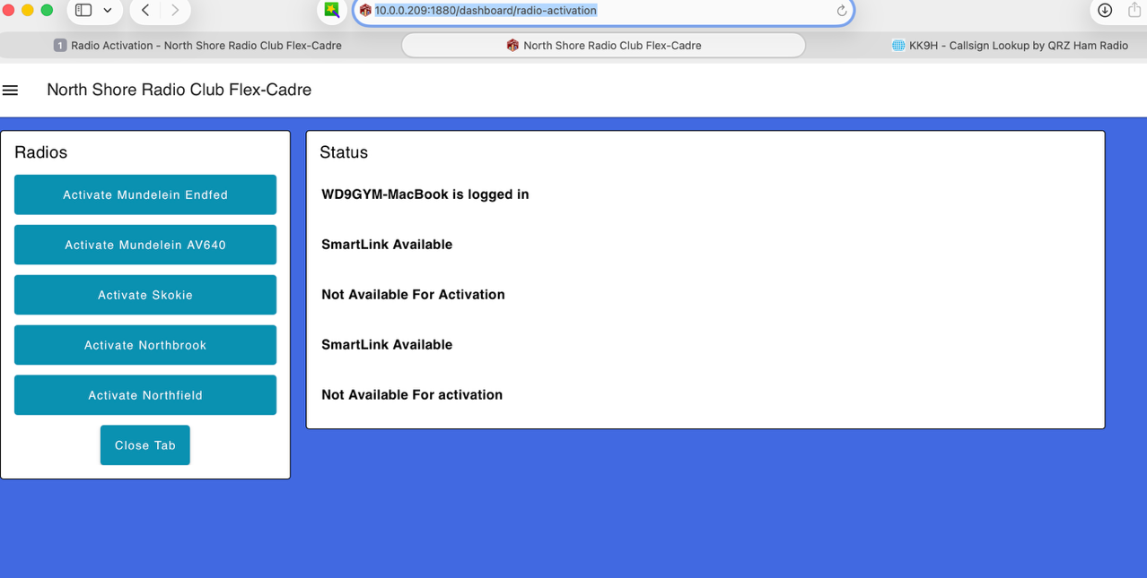

Administering the System
When an admin logs into the system the Calendar page has an admin button located on the bottom of the page.
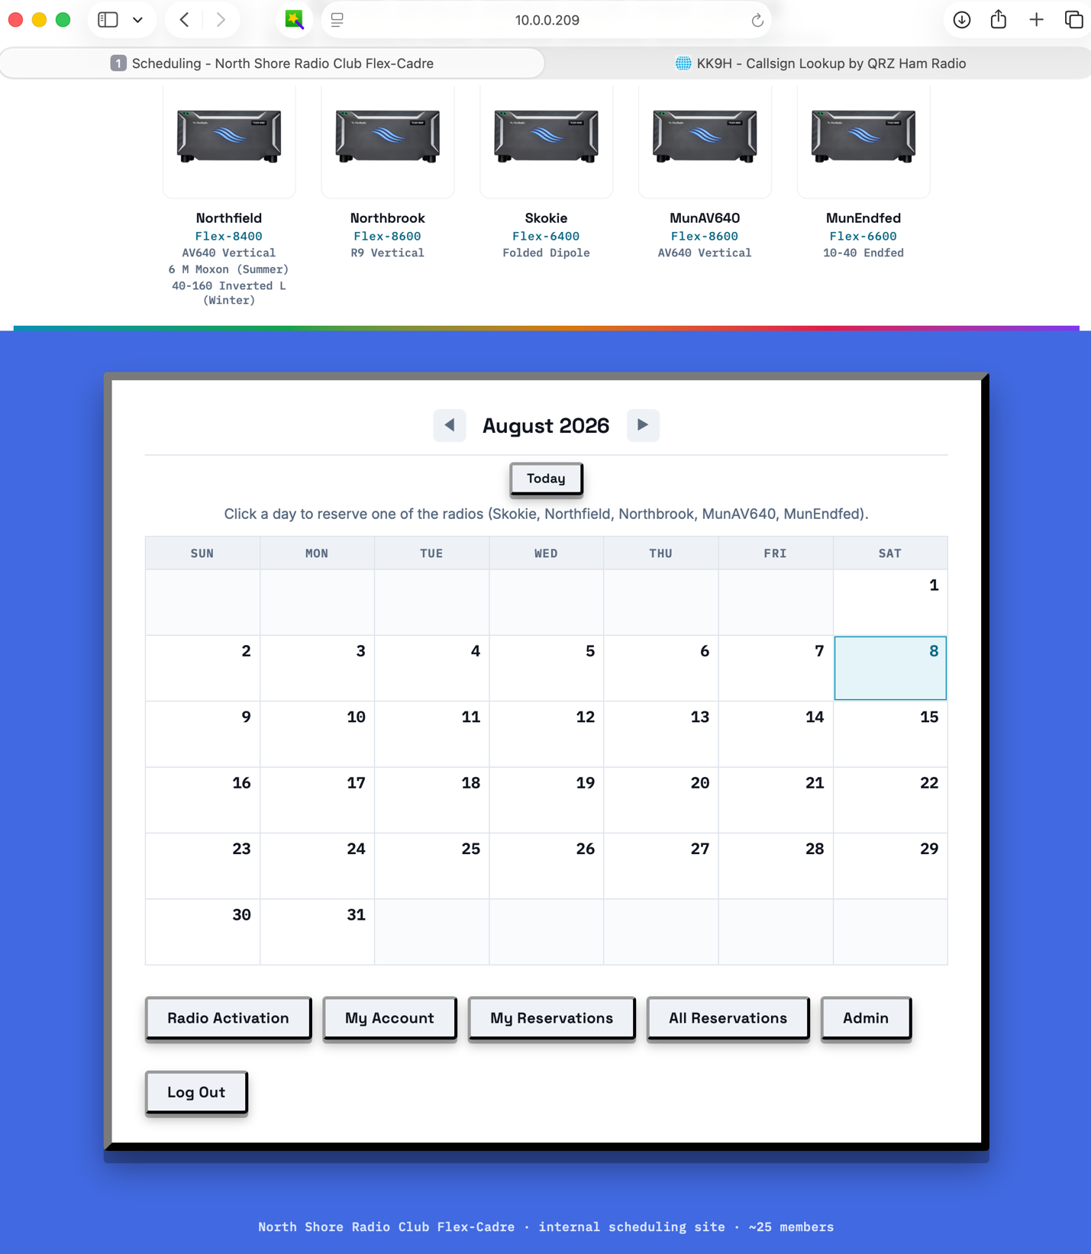

Clicking on the admin button takes you to this page.
An admin can grant or revoke admin privileges to any account, update any user information or delete an account. If the account has forgotten their password, the admin can reset it, then must let the member know the new password directly, as the system does not send this automatically.
An admin can also delete old reservations to free up space on the server.
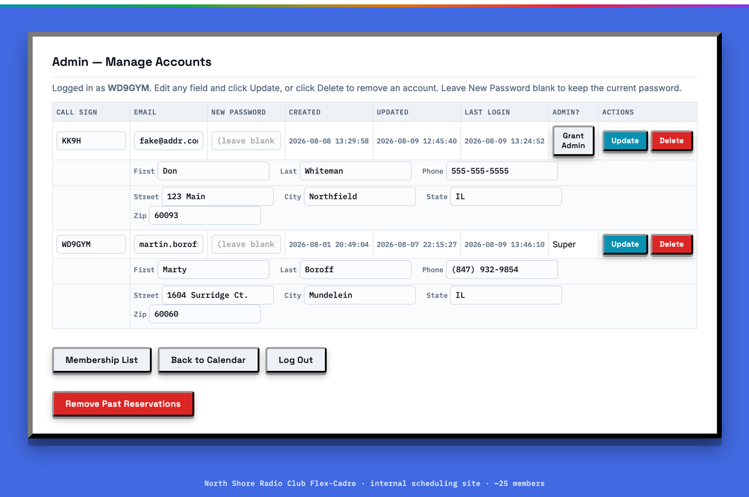
Selecting Membership displays this page. Use this page to upload an updated list of members of the North Shore Radio Club. A list can be downloaded from the club’s web site ns9rc.org. Export it to a .csv file, and remove any excess lines of information at the bottom before uploading. Select the file and then click on upload & import. This will replace the previous list.
Sometimes the member has paid their dues, but the update to the list has not been done, in which case an admin can use the Add / Mark Current option on this page to allow the user to create an account. When an account is created it is checked against this list.
