Validation-first EEG pipelines: how synthetic benchmarks mislead, and how pre-registration catches it
Samuel Ngigi Mbote
Independent Researcher, Nairobi, Kenya
ORCID: 0009-0003-2319-8873
Corresponding author: Samuel Ngigi Mbote, Nairobi, Kenya. E-mail: mbotesamuel9@gmail.com

Abstract
Background: EEG analysis pipelines are usually evaluated on benchmarks their authors design, with outcome measures chosen after the results, and language models summarise such output without checking its numbers.
New method: An open scalp-EEG pipeline (quality control, zero-phase filtering, aperiodic and periodic spectral parameterisation, debiased weighted phase-lag index, a rhythmic-event detector) was built under a validation-first protocol: hypotheses with numeric thresholds were committed before the code or data they concern, methods were tested against synthetic ground truth, and every number in a plain-language summary must cite a computed metric, verified by a rule-based checker.
Results: Four of six initial hypotheses were rejected. A synthetic benchmark on which the detector passed hid four failure modes, including the 1/f confound it targeted; on a held-out subject of the public CHB-MIT database the frozen detector found 4 of 7 seizures at 3.3 false detections per hour. A cloud language model met the citation contract on 30 of 30 recordings and a small local model on 0 of 30, with all faulty text blocked. The first checker missed 709 of 3334 mutated explanations; the corrected one caught all. A blinded audit found 3 of 20 accepted explanations misleading (limit 2): correct numbers attached to the wrong concept.
Comparison with existing methods: Patient-specific seizure detectors reach far higher sensitivity; the contribution is a protocol that makes such claims checkable, not a better detector.
Conclusions: Benchmarks and error models are researcher degrees of freedom; pre-registration and mutation testing make their failures visible.
Keywords: EEG; pre-registration; validation; synthetic benchmark; mutation testing; seizure detection

1. Introduction
The same EEG recording analysed by different teams gives different answers (Trübutschek et al., 2024), and preprocessing choices alone change downstream results (Robbins et al., 2020). Methods papers usually respond with a new pipeline and a benchmark on which it performs well. The benchmark is rarely fixed before the method is tuned, and when it is synthetic, it contains exactly the phenomena its author thought of. Leakage between development and evaluation data is a known source of irreproducible results in machine-learning-based science (Kapoor and Narayanan, 2023), and pre-registration is the standard remedy in empirical research (Nosek et al., 2018). Neither practice is routine in signal-processing methods work, where the “experiment” is a simulation the author designs.
This paper reports what happened when an EEG pipeline was built under a validation-first protocol, and treats the pipeline mainly as the case study. Three well-documented interpretation errors motivated it: a change in canonical band power read as a change in an oscillation when only the aperiodic (1/f) exponent moved (Donoghue et al., 2020); volume conduction read as connectivity (Nolte et al., 2004; Vinck et al., 2011); and, newer, plain-language summaries that state numbers nobody computed. For each, a hypothesis with a numeric threshold was written down first, and for the event detector, two more tested whether synthetic validation transfers to real data.
Our contributions are:
- an account of how a synthetic benchmark misled the development of an event detector four times, and which protocol element exposed each failure (Section 3.2);
- evidence that pre-registering the estimator, not only the measure, matters, from the small-sample bias of wPLI (Section 3.3);
- a citation contract for generated explanations, a mutation-testing evaluation of the checker that enforces it, and evidence that the checker’s error model, like a benchmark, encodes its author’s blind spots (Sections 3.5 and 3.8);
- a pre-registered evaluation of a cloud and a small local language model writing under that contract (Section 3.7);
- a short protocol for validation-first methods work that a reviewer can check from a repository (Section 4.1).

2. Materials and methods

2.1 Pipeline
The pipeline reads EDF/EDF+, BDF or BrainVision files through MNE-Python, refuses oversize or unsupported files before parsing, converts to microvolts and drops identifying header fields. Flat channels are marked on the raw data; the signal is then filtered with a Hamming-window FIR design applied in a single pass with delay compensation (zero phase, magnitude response H rather than the H² of forward-backward filtering; Widmann et al., 2015): a 50 Hz notch with harmonics and a 0.5-45 Hz band-pass. Noisy and low-amplitude channels are marked with median/MAD statistics, and referential montages are re-referenced to the common average of good channels (bipolar montages are left unchanged). Fig. 1A shows the stages.
Events are detected before spectra are estimated, so that spectra and coupling describe the background. The detector computes line length (Esteller et al., 2001) on the 1-20 Hz band in 2 s windows (1 s step), converts it to a robust z-score per channel (median/MAD over the recording), requires a fraction of channels to exceed a threshold, keeps runs of at least a minimum duration, merges runs separated by less than a gap, and finally gates each candidate on the fundamental frequency of its spectrum divided by the background spectrum of the same channels. All five thresholds were chosen by grid search on synthetic tuning seeds only (Section 2.3).
Spectra are Welch estimates (2 s Hann windows, 50 % overlap) excluding event windows. The aperiodic and periodic components are separated with a specparam-style model (Donoghue et al., 2020): a robust line in log-log space, greedy Gaussian peak detection and a joint bounded least-squares fit; specparam itself is used only as a test oracle. Fits with R² below 0.8 or an exponent outside [0, 4] are listed and excluded from averages. Phase coupling is reported as the debiased squared weighted phase-lag index (dwPLI; Vinck et al., 2011), with the phase-locking value (PLV) shown only as a contrast.
The software (Mbote, 2026b) is open source. The output is a JSON file of metrics that is byte-identical across runs, a set of figures, and an HTML report with a plain-language explanation (Section 2.5).

2.2 Pre-registration
Hypotheses H1-H5 were committed to the repository before the code that tests them (commit 1d92eb4, 26 minutes before the first code commit). H6 was committed after H5 failed and before any file of its test subject was downloaded (ed41812); the detector was frozen in a later commit (36b7964) and run once on that subject. Each hypothesis states the data, the measure and the numeric threshold (Table 1; Fig. 1C):
Table 1. Pre-registered hypotheses and their pass conditions. H5 and H7b were exploratory.
 | hypothesis | pass condition
H1 | aperiodic confound | exponent +0.5, alpha unchanged: 8-12 Hz band power changes ≥ 30 % in ≥ 95 % of cases, and fitted alpha peak power changes ≤ 0.05 log10 in ≥ 90 %
H2 | synthetic detection | 3 Hz spike-wave at ≥ 0 dB SNR: sensitivity ≥ 0.90, Wilson lower bound ≥ 0.80, ≤ 2 false detections/h
H3 | volume conduction | independent sources mixed into 19 sensors: PLV > 0.3 in ≥ 50 % of pairs; wPLI 95th percentile ≤ 0.15; a truly lagged pair has wPLI > 0.5
H4 | explanation faithfulness | checker rejects every live mutant (≥ 300 from ≥ 6 operators) and accepts every faithful explanation
H5 | transfer (exploratory) | CHB-MIT chb01: ≥ 5 of 7 seizures at ≤ 2 false/h, thresholds from synthetic data only
H6 | held-out subject | CHB-MIT chb03, frozen detector, one run: ≥ 60 % of seizures at ≤ 2 false/h
H7a | cloud language model as explainer | ≥ 24 of 30 explanations accepted by the checker after at most one repair
H7b | small local model (exploratory) | acceptance reported with Wilson intervals; no threshold
H7c | blinded audit of accepted text | ≤ 2 of 20 audited cloud-model explanations contain a false or misleading statement
A rejected hypothesis is reported as rejected; changes made after a result are described as exploratory and, where they affected a later test, that test was re-registered on new data. One deviation is recorded: the tuning rule’s false-detection constraint was relaxed from 1 to 2 per hour, H2’s own limit, after no grid point met it; the infeasible grid is kept as a result file. H7 was registered after release v0.1.1 and before any model call (821682b); the two models were recorded before the runs (3878ea7). When an outside report later showed a checker defect (Section 3.8), an amendment kept H7’s primary verdicts on the checker as registered, frozen as a hash-pinned copy, and added the corrected checker as a secondary analysis of the same saved replies.

2.3 Synthetic ground truth
Recordings are generated with a 19-channel 10-20 layout at 256 Hz. Each channel’s background is shaped noise with a random aperiodic exponent and offset and an optional alpha peak; flat and noisy channels, 50 Hz mains interference, blinks (frontal, about 15 per minute), muscle bursts, posterior alpha bursts and spindles can be added. Events are 3 Hz spike-wave trains with a small frequency glide, injected into a random subset of channels at a set SNR (0, 3, 6 or 10 dB). For H3, independent sources are mixed into sensors through a random lead field, with and without one truly lagged source pair. The generator writes the ground truth to a separate file that the pipeline never reads.
Tuning seeds (0-59) and evaluation seeds (1000-1199) are disjoint. In the final benchmark one recording in five contains no events. The benchmark evolved during development (Section 3.2); every version is in the repository history.

2.4 Real data
The CHB-MIT Scalp EEG Database v1.0.0 (Shoeb, 2009; Goldberger et al., 2000), paediatric recordings in a bipolar montage at 256 Hz, was retrieved from PhysioNet’s open-data mirror with SHA-256 verification. A pre-registered file rule selected, for each subject, every file with at least one seizure plus the first three seizure-free files. Subject chb01 (7 seizures, 9.6 h) was the H5 test and then became a development set; subject chb03 (7 seizures, 10 h) was the held-out H6 test. Detections were scored with the any-overlap rule (Ziyabari et al., 2017); false detections per hour are reported with a Poisson upper bound.
Ethics statement: this study used only the publicly available, de-identified CHB-MIT Scalp EEG Database (Shoeb and Guttag, 2010), distributed by PhysioNet under the Open Data Commons Attribution License v1.0. The recordings were collected and de-identified by the database’s creators (Shoeb, 2009); no new data were collected from human participants and no participant can be identified, so no further ethical approval was sought for this secondary analysis.

2.5 Explanations and the claim checker
The plain-language summary is written either by a deterministic template or, optionally, by a large language model that receives only the metrics. In both cases every number must carry a citation to the metric it comes from, written value [[metric.key]]. A checker that contains no model parses the text with regular expressions and rejects it if a cited key does not exist, a written value does not round to the cited metric at its written precision (with a strict rule at exact ties), a number has no citation, a channel name is not in the recording, diagnostic vocabulary appears, or the research-use notice is missing. Rejected text is replaced by the template and the failure is shown in the report (Fig. 1B).
The checker was evaluated by mutation (H4): first nine operators (perturb a number, scale it by 1000, swap a citation for another key, cite a non-existent key, add an uncited number, invent a channel, add a diagnosis, drop the notice, and drop a citation), later fourteen (a sign flip written with a typographic minus, a sign flip inside bold markup, two numbers trading citations, a zero-width character that adds a decimal, and an uncited number with a leading decimal point; Section 3.8), each applied four times to 60 faithful explanations of varied synthetic recordings. A mutant whose text is still true at the written precision is “equivalent” and excluded; equivalence is decided from the metric values by integer rounding, independently of the checker. The same principle, validating the validator with realistic wrong answers and mutation testing, was applied earlier to automated graders for AI agents on biomedical engineering tasks (Mbote, 2026a).
Language models were evaluated as explainers in H7 on 30 further synthetic recordings (seeds disjoint from H4’s), with the system prompt of the released explainer (pinned by hash), temperature 0 and at most one repair round in which the checker’s findings are returned to the model. The cloud model was gemini-3.8-flash on Google’s free API tier; the local model was qwen2.5:3b (4-bit, 1.9 GB, served by Ollama on the 8 GB laptop). Every reply was saved before it was checked, so runs interrupted by the free tier’s daily quota resumed without repeating a call. Up to 20 accepted explanations per model were sampled for a blinded audit by the author, who judged each for statements false or misleading given the metrics they cite: the semantic errors the checker cannot see.

2.6 Testing the tests
Beyond unit, property-based (linearity, time-shift equivariance), metamorphic (Parseval), differential (specparam) and ground-truth tests, one-line code mutants (seventeen at release, twenty-three after the bug hunt; for example, a causal filter, a forward-backward second pass, plain instead of debiased wPLI², a nondeterministic value in the output) were run against the test suite; a surviving mutant marks a blind spot. Before this version, a deliberate bug hunt added property-based fuzzing of the checker (arbitrary Unicode, number forms) and of the file readers (truncated, damaged and lying files), edge-case recordings, an independent read-only code review, and synthetic artifacts built to imitate rhythmic events (chewing, electrode pops, eye flutter, sweat drift; exploratory).

2.7 Statistics and theory checks
Proportions carry Wilson 95 % intervals, zero-failure rates the rule of three, and false-detection rates a Wilson-Hilferty Poisson upper bound. Where a decision rested on a statistical model, the model’s prediction was compared with the measurement: the Welch sampling distribution for H1, the null distribution of the imaginary cross-spectrum for wPLI bias, Whittle maximum likelihood for the log-space fit, the Fourier transform of a blink train for the gate floor, a Poisson process for blink merging, a contamination model for robust z-scores, and binomial power for H6.
All computation ran on one CPU core of a laptop with 8 GB of RAM; a one-hour, 32-channel recording is processed in 12.7 s with 1.5 GB peak memory.

3. Results

3.1 Confirmatory outcomes
Table 2 lists the outcome of every pre-registered hypothesis.
Table 2. Outcomes of the pre-registered hypotheses. Intervals are Wilson 95 % intervals; false-detection upper bounds are one-sided 95 % Poisson bounds.
 | result | verdict
H1 | band power changed ≥ 30 % in 200/200 cases (median −68 %); peak power within 0.05 log10 in 60.5 % | rejected
H2 | sensitivity 0.847 [0.803, 0.882] (271/320 events), 1.68 false/h (56 in 33.3 h) | rejected
H3 | PLV > 0.3 in 92 % of pairs; wPLI p95 0.193 at 2 min, 0.095 at 10 min; lagged pair 0.998 | rejected at 2 min, accepted at 10 min
H4 | 3334/3334 live mutants rejected (fourteen operators), 60/60 faithful accepted | accepted (rejected on the first run)
H5 | 2/7 seizures, 0.52 false/h | rejected
H6 | 4/7 seizures (Wilson [0.25, 0.84]), 3.30 false/h (upper bound 4.6) | rejected
H7a | gemini-3.8-flash: 30/30 accepted after at most one repair (24/30 first time) | accepted
H7b | qwen2.5:3b: 0/30 accepted (Wilson [0.00, 0.11]); all 30 replaced by the template | exploratory
H7c | 3/20 audited cloud explanations misleading (Wilson [0.05, 0.36]); all three attach a correct number to the wrong concept | rejected
Engineering requirements were met: aperiodic exponent median absolute error 0.014 on 200 synthetic spectra, agreement with specparam in 200/200, alpha peak frequency error 0.067 Hz, and perfect recall and precision for bad channels on 100 recordings.

3.2 How the synthetic benchmark misled
The detector’s development is a sequence of four failures, each invisible to the benchmark of the moment.
The 1/f trap, rebuilt inside the detector. The first detector gated candidates on the dominant frequency of their raw spectrum. Synthetic discharges were strong enough to dominate it; it passed the synthetic benchmark. On chb01 all seven seizures passed the line-length stage, but the raw spectra of real EEG peak at 1-2 Hz because of the aperiodic background, so the gate rejected five (H5 rejected, 2/7). This is the confound H1 was written to test, reproduced in our own code. Dividing the event spectrum by the background spectrum of the same channels recovered the rhythm (2.5-3.5 Hz in five of seven seizures). Because chb01 had now informed a design change, it became a development set and a new held-out test (H6) was registered on a subject not yet downloaded.
Normal rhythms. With the normalised gate, chb01 gave 5/7 seizures but 51 false detections (5.3/h), most at 8-13 Hz: posterior alpha bursts and spindles, which rise above a recording’s own background exactly as seizures do. The benchmark contained no such bursts. They were added to the generator first, so that the synthetic tuning rule, not chb01, chose the response: a delta-theta gate.
Harmonics. With normal rhythms in the benchmark, no grid point met the tuning constraint. Listing every candidate showed that dividing by a 1/f background lifts a spike-wave train’s harmonics above its fundamental; the gate now reads the lowest peak at least half the size of the largest.
Blink trains. On event-free recordings the detector made 6.4-6.6 false detections per hour at every threshold. A blink band-limited to 1-20 Hz is a wave of about 2 Hz, and at 15 blinks per minute a 5 s merge gap joined consecutive blinks into long “rhythmic” events. The benchmark hid this because every tuning recording contained real events, which raised the robust baseline. A Poisson model of supra-threshold blinks predicts 13.7 long merged runs per hour at a 5 s gap and 0.07 at 1 s (measured 21.9 and 0.3). One recording in five is now event-free and the gap is tuned.
The cost of realism was measured on the same detector family: the first campaign accepted H2 on the earlier benchmark (sensitivity 0.955 at 0.69/h; result file at commit 19198f7), and the final campaign rejected it (0.847 at 1.68/h; 0.95-0.96 at 6-10 dB, 0.71-0.76 at 0-3 dB). We report the final run as the verdict because the earlier benchmark lacked negatives known to occur in real EEG; both runs are in the repository (Fig. 2). On held-out chb03 the frozen detector found 4 of 7 seizures at 3.30/h (H6 rejected). The three seizure-free files produced no false detection; every false detection fell in a file containing a seizure. All three missed seizures exceeded the line-length threshold (peak z 5.8-12.2) but had fundamentals of 1.0-1.5 Hz, below the gate’s 2 Hz floor, a floor that exists to reject blinks (post hoc diagnosis; no change made). On chb01, now a development set, the same detector finds 6/7 at 1.66/h, a number that is optimistic by construction.

3.3 Pre-register the estimator, not only the measure
Under pure volume conduction (six independent sources, no coupling), PLV exceeded 0.3 in 92 % of sensor pairs, as expected. Plain wPLI, the measure named in H3, had a 95th percentile of 0.193 with two minutes of data (60 epochs), above the registered 0.15, and 0.095 with ten minutes. The bias is predicted by the null distribution of the imaginary cross-spectrum: expected wPLI 0.1457 at 60 epochs (measured 0.1455) and 0.0651 at 300 (measured 0.0655). The debiased estimator stayed at 0.021 and 0.006 and still detected a truly lagged pair (median 0.998; Fig. 3). H3 is rejected at two minutes as registered; the pipeline reports dwPLI.

3.4 The aperiodic confound holds; the registered tolerance did not
When only the aperiodic exponent rose by 0.5, 8-12 Hz band power fell by a median of 68 % and changed by at least 30 % in all 200 cases, with the oscillation unchanged; rotating about 20 Hz instead of 1 Hz raised band power by a median of 44 %, so the sign of a band-power change is not informative either. Fitted peak power, however, stayed within 0.05 log10 in only 60.5 % of cases (Fig. 4). A paired analysis (same noise realisation in both conditions) puts the method’s bias at 0.0012 log10. The Welch sampling distribution predicts a per-bin log-power noise of 0.0334 (measured 0.033) and a peak-height difference SD of 0.038 for an efficient estimator; the measured SD was 0.057, so the estimator runs about 1.5 times above the sampling floor. H1’s tolerance was tighter than two separate three-minute recordings allow. It was a design error in the hypothesis, recorded as a rejection rather than corrected after the fact.

3.5 The claim checker
On its first full run the checker caught 2152 of 2153 live mutants. The escape wrote “1” while citing a metric equal to 0.5: the checker accepted the tie, and the independent equivalence oracle (round half to even) did not. Both now use a strict rule, and the template adds a decimal rather than write a tie. After the fix, 2152/2152 were rejected, and after a later revision of the template wording 2157/2157, with 60/60 faithful explanations accepted. With the fourteen operators of Section 3.8 the current checker rejects 3334/3334 (26 equivalent; miss-rate upper bound 0.0009), while the checker as first released rejects 2625: it misses every typographic-minus, zero-width and leading-dot mutant (Fig. 5A). Two limits remain. The checker verifies that each number traces to a computed value, not that the cited key fits the sentence: a channel count citing a filter cutoff of the same value passes. And numbers written as words are outside the contract (60/60 such mutants passed). These are stated in every report.

3.6 The test suite’s blind spots
Three of seventeen code mutants survived the first run: a forward-backward second filter pass (no test measured the output at the cutoff), plain instead of debiased wPLI² (both are small under the null), and a timestamp in the output that rounding made identical across quick runs. Each led to a new test; the run at release killed 17 of 17, and with one mutant undoing each later fix, 23 of 23.

3.7 Language models under the citation contract (H7)
Table 3 summarises both runs.
Table 3. Language models writing under the citation contract (H7; 30 recordings each). Brackets: Wilson 95 % intervals.
 | gemini-3.8-flash (cloud) | qwen2.5:3b (local)
accepted at the first attempt | 24/30 [0.63, 0.90] | 0/30 [0.00, 0.11]
accepted after at most one repair | 30/30 [0.89, 1.00] | 0/30 [0.00, 0.11]
first-attempt findings | uncited numbers 14, value mismatch 2 (scientific notation split), unknown channel 2, missing value 1 | uncited numbers 709, missing notice 21, unknown channel 21, diagnostic word 1
median seconds per call | 106 | 307
The cloud model met the registered threshold (H7a; Fig. 5B). None of its six rejected first replies stated a wrong value; every finding came from format: LaTeX notation (“R^2”, “µV^2”) whose exponent the checker counts as an uncited number (three replies), correct values in scientific notation that the registered checker split into two numbers (two), replies cut off mid-sentence (two), a channel pair written as “C3-P7” and read as an unknown bipolar channel (one), and an incompletely stated channel list (one). Each was repaired in one round. The small local model never satisfied the contract: its replies averaged about 23 uncited numbers, and repair did not help (728 uncited numbers in the second attempts). Every one of its 30 explanations was therefore replaced by the deterministic template, which is the behaviour the design intends: no faulty text reached a report. The corrected checker (Section 3.8) changed no verdict: none of the 96 replies wrote a typographic minus, a zero-width character or a leading-dot number.
The blinded audit (H7c) rejected the hypothesis: 3 of 20 accepted cloud explanations contained a misleading statement (Wilson [0.05, 0.36]), above the registered limit of 2. All three had the same shape: a correct number, correctly cited, attached to the wrong concept. Twice the count of channels with an alpha peak was presented as the number of clean channels or as the coverage of the aperiodic fit (“robust aperiodic fitting across 18 channels”); the counts coincide when every good channel has an alpha peak, so the value matched and the checker accepted it. Once the detector’s line-length z-score was called a “peak amplitude statistic”. No audited explanation invented a finding, misread PLV as evidence of coupling or used diagnostic language. The checker verifies that a number equals the metric it cites, not that the metric is the one the sentence is about; this is the residual error it leaves to a reader. Because the local model had no accepted explanation, all audited items came from the cloud model, and hiding the model had no effect.

3.8 The error model is a researcher degree of freedom too
After release, an outside reader reported that the checker read “−0.30 [[key]]”, written with a typographic minus, as 0.30: a sign flip passed as traced. The mutation set had only ever written ASCII hyphens, so the gap lay outside everything H4 had tested. A deliberate bug hunt then found three more ways a wrong number could pass (a zero-width character inside a number, which displays 1.500 while the checker read 1; a number with a leading decimal point, which was invisible; and a minus inside bold markup, a regression introduced by the first fix and caught by the independent review), as well as defects outside the checker: damaged files crashing instead of being refused, a flat recording start measured twice, and a montage decision that one ECG channel could overturn. Each finding has a regression test and a mutant that undoes it; the H2, H4 (template), H5 and H6 results and the quality-control validation were re-run and are unchanged. Synthetic artifacts built to imitate rhythmic events exposed a new weakness of the detector: chewing at 1-3 Hz on temporal channels raised false detections from 2.40 to 6.00 per hour on event-free recordings (16 of 60 episodes reported; exploratory), while eye flutter (4 of 60), electrode pops (1 of 63) and sweat drift (none) did little.

4. Discussion
The detector is not the contribution. A per-recording, unsupervised line-length detector with fixed thresholds is weak; patient-specific detectors on CHB-MIT report far higher sensitivity (Shoeb, 2009). What the protocol produced is an evidence trail in which every failure was found, dated, explained and kept.
Three observations generalise. First, a synthetic benchmark is a hypothesis about what matters, and it encodes the developer’s blind spots: each of the four detector failures was absent from the benchmark until a real recording or a deliberately adversarial negative revealed it, and the headline sensitivity fell from 0.955 to 0.847 as the benchmark became more realistic. The benchmark is therefore a researcher degree of freedom in the same sense as an analysis choice, and its versions should be reported. Second, pre-registration did not prevent mistakes; it made them unambiguous. Without a committed threshold, the wPLI bias and the H1 tolerance would have read as “acceptable” results, and the chb01 numbers after redesign (6/7) would have been reported as a test. Third, the cheapest controls caught the most: event-free recordings, a held-out subject named before download, and mutants of the tests themselves. Fourth, the same holds one level up: a mutation set is a hypothesis about how text can be wrong, and the checker passed every error its author had imagined while missing 709 of 3334 that an outside reader and a deliberate search supplied. Validation of a validator is only as complete as its error model, which should be versioned and reported like a benchmark.
The language-model results support a narrow conclusion. A capable cloud model can follow a citation contract almost unaided, and a small local model cannot; in both cases the mechanical checker decided what a reader saw, so the small model’s failures cost fluency, not correctness. Accepted text was not always right in meaning: 3 of 20 audited explanations labelled a correct number with the wrong concept, which a value check cannot see. Constraining which metrics a sentence may cite, for example by section, is a mechanical step towards closing that gap.

4.1 A checkable protocol
We suggest the following minimum for methods papers whose evaluation is partly synthetic. Each item can be verified from a repository.
- Hypotheses with numeric thresholds, naming the estimator, committed before the code and data they concern.
- Disjoint tuning and evaluation seeds; the benchmark’s generator and every version of it in version control.
- Negatives the method is likely to confuse with its target, and records with no target at all.
- A real-data subject held out and named before download; any subject that informed a design change relabelled as development.
- Theory-based predictions for the key estimators, compared with simulation.
- Mutation testing of the test suite and of any automated checker, with the error model versioned, extended by fuzzing, and open to outside reports.
- Rejected hypotheses reported as rejected; deviations listed.

4.2 Comparison with existing methods
Each component has an established counterpart, and where one existed it was used as an oracle rather than replaced. The aperiodic fit agreed with specparam (Donoghue et al., 2020) on 200 of 200 synthetic spectra; the filters follow published FIR practice (Widmann et al., 2015); phase coupling uses the debiased estimator of Vinck et al. (2011), whose advantage over plain wPLI and over PLV (Nolte et al., 2004) is measured here (Fig. 3) rather than assumed. The event detector is deliberately simple: patient-specific detectors trained on CHB-MIT reach far higher sensitivity (Shoeb, 2009), and no claim of better detection is made. What differs from current practice is the evaluation. Multi-analyst studies show how far EEG results move with analysis choices (Robbins et al., 2020; Trübutschek et al., 2024); here the choices that usually stay implicit, the benchmark, the estimator and the error model of an automated checker, were fixed in advance and their failures reported. For generated text, the usual alternatives are no check at all or a second model acting as judge; the rule-based checker is narrower than a judge, since it cannot assess meaning (H7c), but its verdicts are deterministic and were themselves mutation-tested.

4.3 Limitations
Pre-registration here relied on commit history in the same repository, which a determined author could rewrite; an external registry such as OSF would be stronger and is planned for the next round. The work was done by one person over a short period, so decisions were not independently reviewed. The real-data base is small (two paediatric subjects, about 20 hours, 14 seizures, one used for development). With seven seizures, H6 was close to a coin flip by design: a detector with true sensitivity 0.60 passes its rule with probability 0.42. Showing a lower bound above 0.6 with 80 % power would take about 76 seizures if the true sensitivity were 0.75. The synthetic generator lacks sleep stages, interictal spikes and evolving ictal frequency content, and chewing remains a source of false detections. Non-EEG channels such as ECG are excluded from the montage decision and the average reference but still enter spectra and the detector’s channel vote. H7 used two models, one run each, at temperature 0, on synthetic metrics only; its audit was done by a single rater, the tool’s author, not an independent one, who read the items with a guide giving the same fixed description of each metric under every sentence. The tool is for research use only and is not a medical device.

4.4 Future work
A spatial cue to separate frontal, symmetric blinks from slow ictal delta, which would allow a lower gate floor, and an EMG cue against chewing; a confirmatory test sized by the power analysis on further CHB-MIT subjects, pre-registered externally; a local model used to generate realistic, subtly wrong explanations, to measure the checker’s semantic blind spot at scale; section-scoped citation rules aimed at the error H7c found; and a language-model judge evaluated against the human audit.

5. Conclusions
Building an EEG pipeline against pre-registered thresholds rejected four of six hypotheses and exposed four failures that a synthetic benchmark had hidden, including the exact confound the project was designed to avoid. The checker that guards its language-model explanations showed the same pattern one level up, and real models showed why it matters: the one that broke the contract every time never reached a reader. None of these would have been visible in a conventional benchmark-and-report workflow. Validation-first development costs little computation and makes methods results harder to overstate.

CRediT authorship contribution statement
Samuel Ngigi Mbote: Conceptualization, Methodology, Software, Validation, Formal analysis, Investigation, Data curation, Writing – original draft, Writing – review & editing, Visualization.

Declaration of competing interest
The author declares no known competing financial interests or personal relationships that could have appeared to influence the work reported in this paper.

Funding
This research did not receive any specific grant from funding agencies in the public, commercial, or not-for-profit sectors.

Data availability
Source code, the synthetic generators, the data-retrieval script with checksums, every result file with provenance and a SHA-256 manifest, and the build journal are archived on Zenodo (all versions: https://doi.org/10.5281/zenodo.23447346; release v0.1.2, used for this article: https://doi.org/10.5281/zenodo.23716723; MIT licence) and developed at https://github.com/mbote-droid/Neuro-signal. A preprint of this work is available at https://doi.org/10.5281/zenodo.23448015. The CHB-MIT Scalp EEG Database is available from PhysioNet under the Open Data Commons Attribution License v1.0.

References
Donoghue, T., Haller, M., Peterson, E.J., Varma, P., Sebastian, P., Gao, R., Noto, T., Lara, A.H., Wallis, J.D., Knight, R.T., Shestyuk, A., Voytek, B., 2020. Parameterizing neural power spectra into periodic and aperiodic components. Nat. Neurosci. 23, 1655–1665. https://doi.org/10.1038/s41593-020-00744-x
Esteller, R., Echauz, J., Tcheng, T., Litt, B., Pless, B., 2001. Line length: an efficient feature for seizure onset detection. In: Proceedings of the 23rd Annual International Conference of the IEEE Engineering in Medicine and Biology Society.
Goldberger, A.L., Amaral, L.A.N., Glass, L., Hausdorff, J.M., Ivanov, P.Ch., Mark, R.G., Mietus, J.E., Moody, G.B., Peng, C.-K., Stanley, H.E., 2000. PhysioBank, PhysioToolkit, and PhysioNet: components of a new research resource for complex physiologic signals. Circulation 101, e215–e220. https://doi.org/10.1161/01.CIR.101.23.e215
Kapoor, S., Narayanan, A., 2023. Leakage and the reproducibility crisis in machine-learning-based science. Patterns 4, 100804. https://doi.org/10.1016/j.patter.2023.100804
Mbote, S.N., 2026a. Validating the graders: physics-aware rewards for AI agents on biomedical engineering tasks [preprint]. Zenodo. https://doi.org/10.5281/zenodo.23309911
Mbote, S.N., 2026b. NeuroSignal: a validation-first EEG report pipeline with provenance-checked explanations, version 0.1.2 [software]. Zenodo. https://doi.org/10.5281/zenodo.23716723
Nolte, G., Bai, O., Wheaton, L., Mari, Z., Vorbach, S., Hallett, M., 2004. Identifying true brain interaction from EEG data using the imaginary part of coherency. Clin. Neurophysiol. 115, 2292–2307. https://doi.org/10.1016/j.clinph.2004.04.029
Nosek, B.A., Ebersole, C.R., DeHaven, A.C., Mellor, D.T., 2018. The preregistration revolution. Proc. Natl. Acad. Sci. U. S. A. 115, 2600–2606. https://doi.org/10.1073/pnas.1708274114
Robbins, K.A., Touryan, J., Mullen, T., Kothe, C., Bigdely-Shamlo, N., 2020. How sensitive are EEG results to preprocessing methods: a benchmarking study. IEEE Trans. Neural Syst. Rehabil. Eng. 28, 1081–1090. https://doi.org/10.1109/TNSRE.2020.2980223
Shoeb, A.H., 2009. Application of machine learning to epileptic seizure onset detection and treatment. PhD thesis, Massachusetts Institute of Technology.
[dataset] Shoeb, A., Guttag, J., 2010. CHB-MIT Scalp EEG Database, version 1.0.0. PhysioNet. https://doi.org/10.13026/C2K01R
Trübutschek, D., Yang, Y.F., Gianelli, C., et al., 2024. EEGManyPipes: a large-scale, grassroots multi-analyst study of electroencephalography analysis practices in the wild. J. Cogn. Neurosci. 36 (2).
Vinck, M., Oostenveld, R., van Wingerden, M., Battaglia, F., Pennartz, C.M.A., 2011. An improved index of phase-synchronization for electrophysiological data in the presence of volume-conduction, noise and sample-size bias. NeuroImage 55, 1548–1565. https://doi.org/10.1016/j.neuroimage.2011.01.055
Widmann, A., Schröger, E., Maess, B., 2015. Digital filter design for electrophysiological data: a practical approach. J. Neurosci. Methods 250, 34–46. https://doi.org/10.1016/j.jneumeth.2014.08.002
Ziyabari, S., Shah, V., Golmohammadi, M., Obeid, I., Picone, J., 2017. Objective evaluation metrics for automatic classification of EEG events [preprint]. arXiv:1712.10107. https://doi.org/10.48550/arXiv.1712.10107

Figure captions
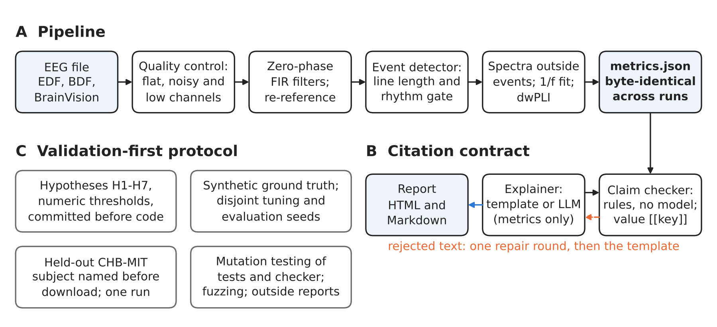
Fig. 1. Pipeline, citation contract and validation protocol. (A) The pipeline: each stage writes into a metrics file that is byte-identical across runs. (B) The citation contract: an explanation, from the template or a language model that sees only the metrics, must cite a metric for every number; a rule-based checker accepts it or returns its findings for one repair round, after which rejected text is replaced by the template. (C) The validation-first protocol around both.
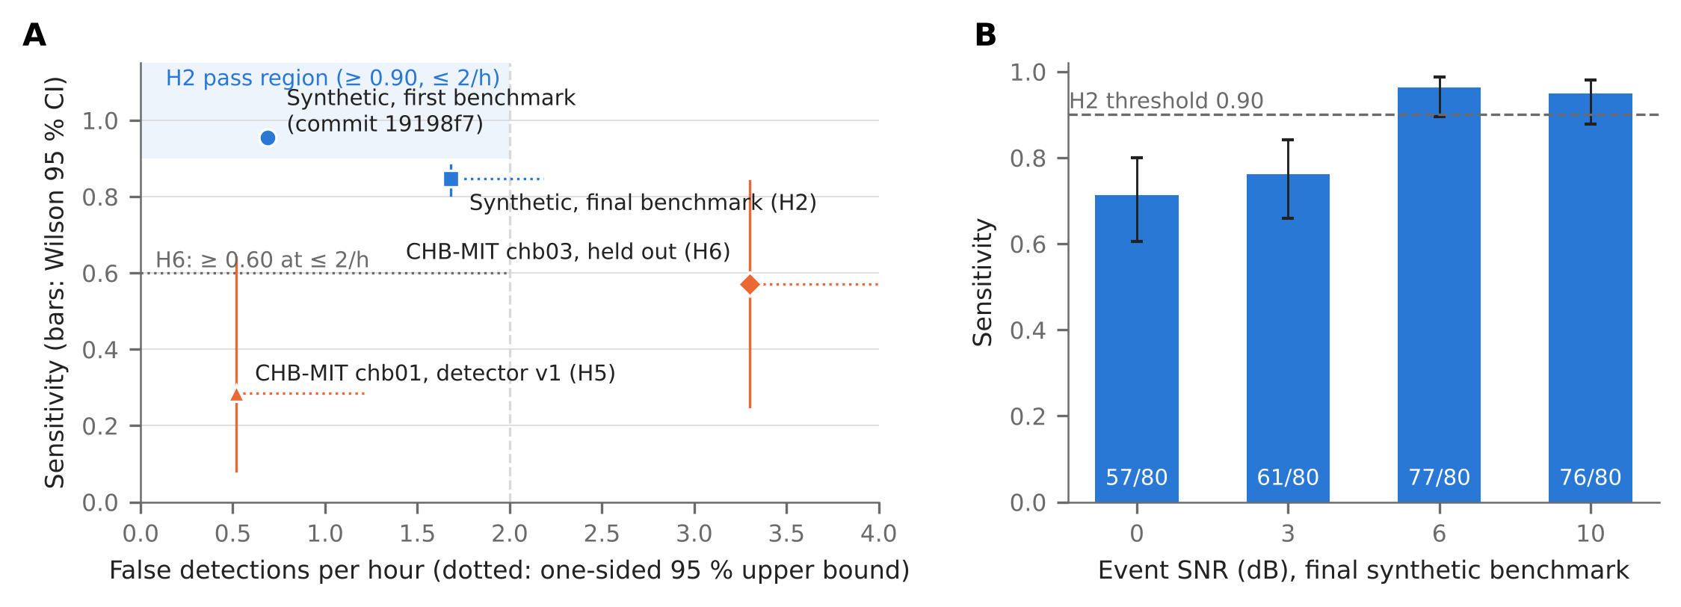
Fig. 2. Detector performance on synthetic and real recordings. (A) Sensitivity against false detections per hour for the first and final synthetic benchmarks and the two CHB-MIT subjects. Vertical bars: Wilson 95 % intervals; dotted horizontal lines: one-sided 95 % Poisson upper bounds on the false-detection rate. The shaded area is H2’s pass region; the dotted line marks H6’s sensitivity threshold. The first benchmark’s result file is kept at commit 19198f7. (B) Sensitivity by event signal-to-noise ratio on the final synthetic benchmark (200 recordings, 320 events), with Wilson 95 % intervals and hit counts.
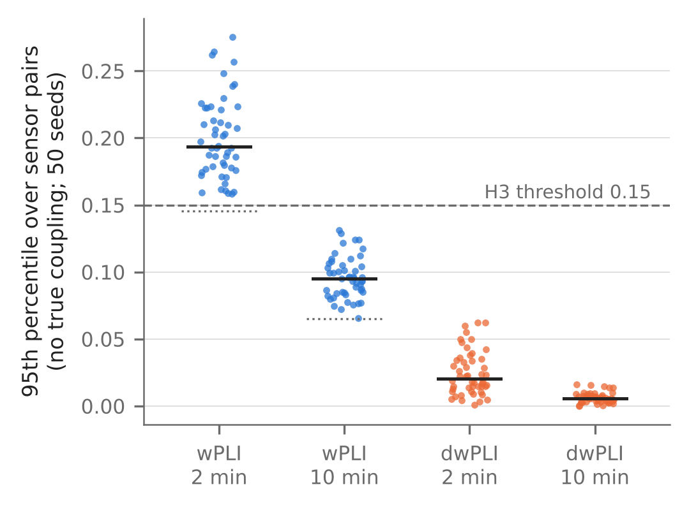
Fig. 3. Small-sample bias of plain wPLI. Pure volume conduction (six independent sources mixed into 19 sensors, no coupling). Each point is the 95th percentile over sensor pairs for one of 50 simulated recordings; black bars are medians. Dotted lines: the theoretical mean of wPLI without coupling, 2/√(πN) for N epochs. Dashed line: H3’s registered threshold.
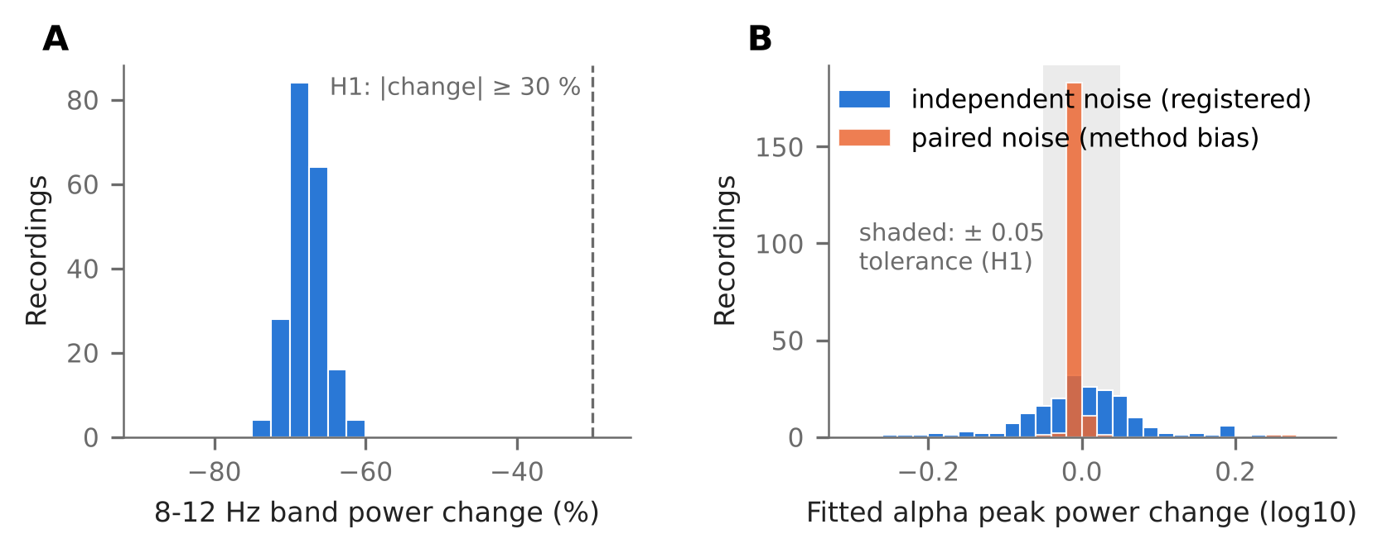
Fig. 4. The aperiodic confound (H1). The aperiodic exponent was raised by 0.5 with the alpha oscillation unchanged (200 recordings). (A) 8-12 Hz band power fell in every case, by a median of 68 %. (B) Change in fitted alpha peak power above the aperiodic fit, with independent noise in the two conditions (as registered) and with the same noise in both (paired, the method’s own bias). Shaded: the registered ± 0.05 log10 tolerance.
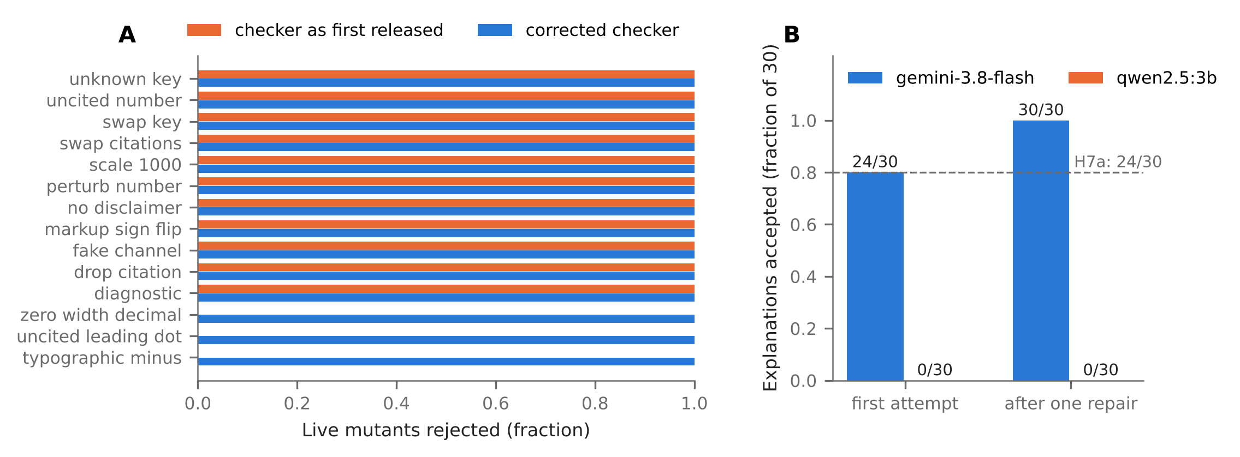
Fig. 5. Claim checker under mutation, and language models under the citation contract. (A) Fraction of live mutants rejected per mutation operator (60 faithful explanations, four mutants each), by the checker as first released and by the corrected checker. (B) Explanations accepted by the checker for a cloud (gemini-3.8-flash) and a small local model (qwen2.5:3b), at the first attempt and after at most one repair round; dashed line: H7a’s threshold.

