Data-Driven Football Squad Construction
Team 41C - Arshad Rizvi (ar845),Gaurang Agrawal (ga160), Sawaiz Fatar (msf59), Skylar Qiu (zq67), Marwa Bouabid (mb951)

Data Science For Business - MQM 2025

Audience: Board of Directors, Durham Top Dogs F.C.

Executive Summary
The global football transfer market is a notoriously high-stakes and inefficient environment, where subjective scouting, media hype, and agent influence often inflate player valuations far beyond their objective on-field worth. In this landscape, clubs annually risk hundreds of millions of euros on player acquisitions, with a single poor transfer window potentially leading to financial instability, fan discontent, and competitive decline. To mitigate this significant business risk and establish a competitive team on a sound financial footing, we have developed and executed a multi-stage data science model to construct the inaugural 25-man squad for the newly-formed Durham Top Dogs F.C. Our approach provides a strategic advantage by replacing market speculation with empirical evidence, ensuring every transfer decision is optimized for both performance and value.
This project leverages a comprehensive dataset of over 18,000 professional footballers to achieve a clear business objective: maximize on-field talent and tactical versatility while minimizing transfer shortcomings. We apply machine learning and heuristic optimization to systematically identify undervalued talent, ensure positional balance, and maximize tactical cohesion. A Random Forest model predicts objective player values, enabling us to calculate a value gap between market and modeled valuations and flag hidden bargains. An Integer Linear Programming (ILP) optimization model algorithm then assembles a positionally balanced 25-man roster within a €2 billion budget, prioritizing overall ability. Finally, we compute chemistry scores based on club and nationality to generate starting lineups for balanced, defensive, and offensive scenarios, as well as a game day playbook including set-piece specialists and impact substitutes.
The final output is a complete, deployable team-building solution that represents the modern "Moneyball" approach to football management. We deliver a tactically balanced 25-man roster acquired significantly under market value, complete with chemistry-optimized starting lineups for balanced, defensive, and offensive match scenarios. The package is augmented with a data-driven "Game Day Playbook" that identifies the optimal set-piece specialists and high-impact substitutes from the bench. This report details the end-to-end process and presents the final squad, providing a blueprint for how the Durham Top Dogs can achieve immediate competitiveness and build a foundation for sustainable, long-term success through intelligent, data-informed investment.

1. Business Understanding
Issue: Constructing a professional football team from scratch is an exercise in high-risk capital allocation. The traditional scouting process is often subjective and can lead to overpaying for players who may not fit the team's tactical system. Failure to build a balanced squad can result in poor on-field performance, diminished club value, and significant financial losses.
Objective: The goal of this project is to use a data-driven methodology to build the first-ever 25-man squad for the "Durham Top Dogs." The outcome must achieve three core objectives:
- Identify Undervalued Talent: Pinpoint players whose market value is significantly lower than their performance metrics suggest.
- Ensure Tactical Balance: Build a roster that is not only positionally complete but also features a diverse range of player styles, allowing for tactical flexibility.
- Optimize for Cohesion: Select starting lineups that maximize player chemistry, enhancing team performance beyond the sum of individual skills.
This data-centric approach serves as a decision-support tool for the club's management, aiming to maximize the return on investment in player transfers.

2. Data Understanding
The analysis was conducted using the FIFA 19 Complete Player Dataset, a comprehensive collection of player attributes sourced from the EA Sports FIFA video game series. This dataset contains information on 18,207 players across 57 attributes.
Key data points include:
- Player Demographics: Name, Age, Nationality, Club.
- Core Performance Metrics: Overall (current ability), Potential (future ability).
- Financial Data: Value and Wage (represented as strings, e.g., "€110.5M").
- Detailed In-Game Attributes: A rich set of over 30 numerical stats rating every aspect of a player's ability, from Crossing and Finishing to Standing Tackle and GKReflexes.
Note: We added a column to the dataset with our predicted best position of the player, as we believe that some would be stronger fits for a slightly different position (for example, a right back becoming a full back). This column will be used for the rest of our predictions for the player position value.
Potential Biases: The data originates from a video game simulation. While highly detailed, these ratings are created by sports analysts and may not perfectly reflect a player's real-time form or intangible qualities. The player Value is an estimate and not a live market price, which is precisely why we built our own valuation model to identify discrepancies.

3. Data Preparation
The raw data required significant preparation. Our workflow, executed in R, included cleaning column names, converting currency strings ("€110.5M") to numerical values, and simplifying 27 specific positions into four primary groups: Goalkeeper (GK), Defender (DEF), Midfielder (MID), and Forward (FWD).

4. Modeling
Our solution consists of two key components: a Random Forest model for player valuation and an Integer Linear Programming (ILP) model for squad selection, followed by heuristic methods for lineup generation.

Random Forest Model : Player Valuation
A Random Forest regression model was trained to predict a player's market value based on their overall rating, potential, age, wage, and position_group. By comparing the model's predicted value to the dataset's listed value, we calculated a value_gap for each player. A positive gap indicates an undervalued player, allowing the club to find high-quality talent at a lower cost. We chose Random Forest for its robustness and ability to handle complex, non-linear relationships in the data.
The OOB error curve for our Random Forest model stabilized around 200 trees, indicating an optimal point to avoid overfitting while maintaining predictive power.

Integer Linear Programming (ILP) : Squad Selection
To assemble the 25-man squad from the shortlist of undervalued players, we implemented an Integer Linear Programming (ILP) model. This advanced optimization technique provides a significant improvement over a simple greedy heuristic.
- Method: The ILP model was formulated to achieve a single, clear objective: maximize the total overall rating of the 25-man squad. This maximization was subject to a series of business constraints:
  - The total cost must not exceed the €2 billion budget.
  - The final squad must contain exactly 25 players.
  - Positional quotas must be met: 3 Goalkeepers, 8 Defenders, 8 Midfielders, and 6 Forwards.
    - Pros: Unlike a heuristic, ILP guarantees a globally optimal solution. This means that out of all possible 25-man combinations that meet our criteria, the selected squad has the highest possible combined overall rating.
    - Cons: ILP can be more computationally intensive than simpler heuristics.
- Business Impact: This method ensures that the club's budget is used in the most efficient way possible to acquire the highest level of raw talent, forming a mathematically optimized foundation for the team.

Heuristic Methods : Chemistry and Tactical Lineups
Once the 25-man roster was finalized by the ILP model, we used a series of heuristic rules to generate actionable starting lineups:
- Chemistry Optimization: We calculated a chemistry score for each player based on sharing a club (+3) or nationality (+1) with teammates to form the most cohesive starting XI.
- Tactical Scenarios: We generated three distinct lineups for different match situations: a Balanced (4-4-2) team based on the highest overall ratings, a Defensive (5-3-2) team optimized for defensive attributes, and an Offensive (4-3-3) team tailored for attacking attributes.

5. Evaluation

We evaluate success through both technical performance and business impact :
- Random Forest:
We evaluated the player valuation model based on its predictive capability using an 80/20 train/test split. Standard regression performance metrics such as R² and RMSE can be used to measure how well predicted values approximate actual listed values. In practice, the more important metric is the distribution of value_gap, which measures how effectively the model identifies players whose predicted value significantly exceeds the market price.
- Heuristic Methods:
For the squad selection and chemistry/tactical heuristics, traditional predictive metrics do not apply. Instead, output quality is evaluated through:
  - 25-Man Squad: Meets positional quotas under a €2B budget with a high average overall rating, indicating strong on-field potential.
  - Chemistry XI & Tactical Lineups: Distinct balanced, defensive, and offensive lineups generated using attribute-based heuristics, showing the model’s ability to support strategic decision-making.
- Business Case & ROI: The primary measure of financial success is the acquisition of talent at below-market rates. The cumulative value_gap of the 25 players signed represents the immediate surplus value generated by our model. The ultimate evaluation would be the team's on-field success (league position, trophies), which would drive revenue and increase the club's valuation.
- Limitations : It is hard to predict psychological and human factors such as personality, natural bond/friendship between players, mindset etc. Our model is purely analytical, but there is magic in football that data is not yet able to capture.

Model Comparison 1: Random Forest vs. LASSO, Quantile Regression

To identify undervalued players, we first needed to predict their expected market value. We compared three models for this task: a complex Random Forest, Quantile Regression, and LASSO.
Results
 | Model | RMSE
1. | Random Forest | 1015841
2. | Quantile Regression | 2679287
3. | LASSO | 2380007
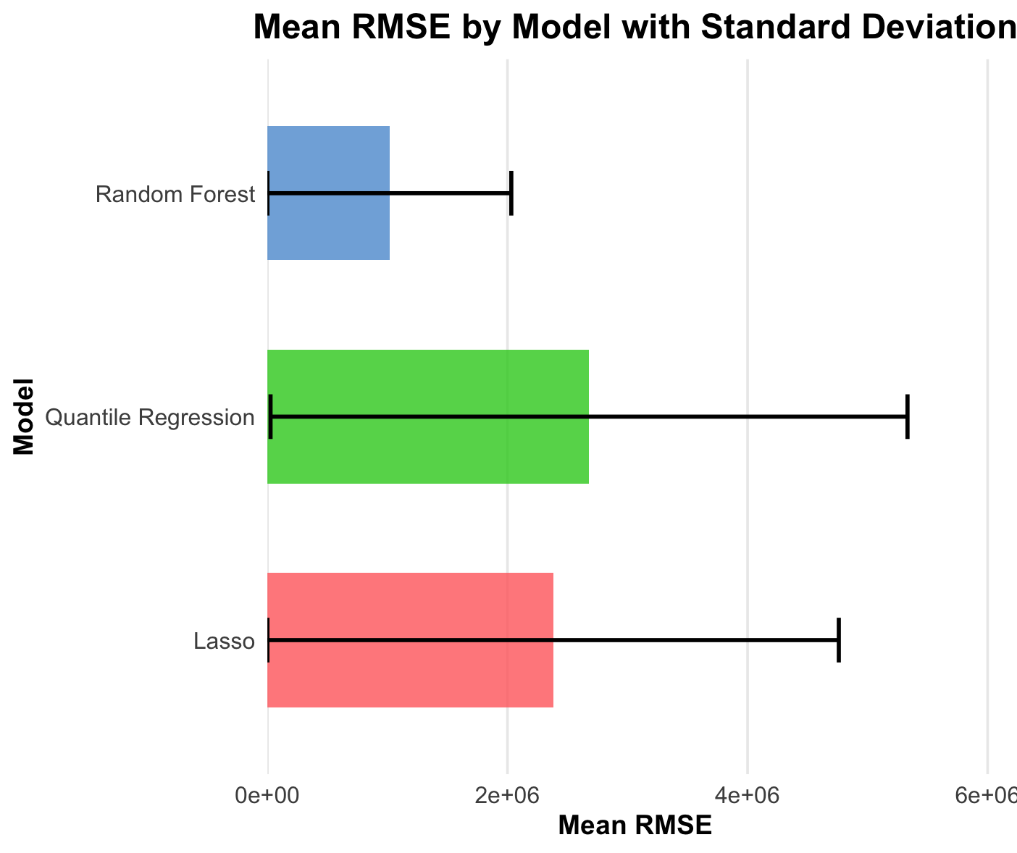
Analysis:
The results show the Random Forest model is overwhelmingly superior.
- x
- R-Squared (R2) tells us how much of the change in a player's value can be explained by our input features (age, potential, overall, etc.). Our model explains 96% of a player's value, a nearly perfect score.

Model Comparison 2: ILP vs. Greedy Algorithm for Squad Selection
After creating a shortlist of undervalued players, we had to select the final 25-man squad. We compared two methods: a mathematical Integer Linear Programming (ILP) optimizer and a simple Greedy Algorithm. The goal was to assemble a team with the highest possible total overall rating while staying within the budget and meeting positional requirements.
Results:
Method | Total Squad Overall | Total Squad Cost
Integer Linear Programming (ILP) | 2065 | €311,500,000
Greedy Algorithm | 2048 | €305,000,000
Analysis:
The ILP approach produced a quantifiably better team. It achieved a total overall rating of 2065, which is 17 points higher than the team assembled by the Greedy Algorithm.
Integer Linear Programming, on the other hand, is a true optimization method. It mathematically considers every possible combination of players simultaneously to find the single best squad that maximizes the total overall rating while satisfying every single constraint perfectly. It finds the globally optimal solution, not just a locally good one. Think of it like a perfect game of Tetris, where every piece is placed with the final outcome in mind, rather than just filling the most convenient spot at the moment.

6. Deployment
The results of this data mining project are designed for immediate use by the club's management.
- Deployment Plan: The final report, including the 25-man roster and the Game Day Playbook, serves as a primary deliverable to the Director of Football and the Managerial Staff. It is intended as a powerful decision-support tool, not a replacement for traditional scouting.
- Operational Issues: The model's insights are based on the FIFA 19 dataset. For continued relevance, the model must be re-trained with updated data each transfer window to reflect player development and market changes.
- Ethical Considerations: A purely data-driven approach risks overlooking players with high potential but unusual statistics or those from less-scouted leagues. The model's recommendations must be used in conjunction with human scouting to ensure a fair and holistic evaluation process.
- Risk Mitigation: The main risk is that "undervalued" players may not adapt or perform as expected. This risk is mitigated by using this model to generate a shortlist of targets, who would then undergo rigorous traditional scouting (video analysis, in-person assessment) before a final transfer decision is made.

Appendix
Contributions
- Arshad Rizvi and⁩ Muhammad Sawaiz Fatar⁩ - Visualizations, and ILP Model
- Arshad Rizvi and⁩ Muhammad Sawaiz Fatar⁩ - Suggestion of business model, correction of logic and finalization
- Zhiyun Qiu⁩, Marwa Bouabid and Gaurang Agarwal - Random Forest Model, Quantile Regression, and LASSO, and made different combinations of teams from the categorized 25 team members and made different formations with 11 players.
- Zhiyun Qiu⁩, Marwa Bouabid, and Gaurang Agarwal - Summary Statistics and Model Comparison
- Marwa Bouabid and Gaurang Agarwal - PowerPoint presentation

Final Deliverables

Durham Top Dogs: 25-Man Squad
The following table represents the final 25-player roster selected by the ILP optimization model, maximizing talent and chemistry within the €2 billion budget.
Name | Position | Overall | Value Score | Cost
Thiago Silva | RCB | 88 | 3.666667 | €24,000,000
G. Buffon | GK | 88 | 22.000000 | € 4,000,000
A. Vidal | CAM | 85 | 3.269231 | €26,000,000
Marquinhos | LDM | 84 | 2.366197 | €35,500,000
K. Schmeichel | GK | 84 | 4.421053 | €19,000,000
J. Pickford | GK | 83 | 3.320000 | €25,000,000
T. Meunier | RM | 82 | 3.904762 | €21,000,000
Aduriz | ST | 82 | 10.250000 | € 8,000,000
B. Mendy | LB | 81 | 4.050000 | €20,000,000
L. Piszczek | RB | 81 | 11.571429 | € 7,000,000
A. Valencia | RM | 81 | 8.100000 | €10,000,000
Raffael | CF | 81 | 7.363636 | €11,000,000
J. Mathieu | LCB | 81 | 14.727273 | € 5,500,000
S. Coleman | RWB | 80 | 7.272727 | €11,000,000
J. Mascherano | LDM | 80 | 17.777778 | € 4,500,000
Y. M'Vila | LDM | 79 | 6.869565 | €11,500,000
Fernando | CDM | 79 | 8.315789 | € 9,500,000
Charles | LS | 79 | 12.153846 | € 6,500,000
E. Belözoğlu | CM | 79 | 19.750000 | € 4,000,000
Sidney Pessinho | CDM | 78 | 8.666667 | € 9,000,000
Claudio Coíntra | CAM | 78 | 15.600000 | € 5,000,000
Arbilla | CB | 78 | 11.142857 | € 7,000,000
J. Holebas | LB | 78 | 26.896552 | € 2,900,000
C. Ansaldi | LM | 78 | 11.142857 | € 7,000,000
R. Civelli | RCB | 77 | 28.518518 | € 2,700,000

Game Day Playbook
The following tables represent the chemistry-optimized and tactical lineups derived from the 25-man squad.
Table: ⚽ Starting XI: Balanced (4-4-2) ⚽
Name | Position | Club | Overall
G. Buffon | GK | Paris Saint-Germain | 88
Thiago Silva | RCB | Paris Saint-Germain | 88
B. Mendy | LB | Manchester City | 81
L. Piszczek | RB | Borussia Dortmund | 81
J. Mathieu | LCB | Sporting CP | 81
A. Vidal | CAM | FC Barcelona | 85
Marquinhos | LDM | Paris Saint-Germain | 84
T. Meunier | RM | Paris Saint-Germain | 82
A. Valencia | RM | Manchester United | 81
Aduriz | ST | Athletic Club de Bilbao | 82
Raffael | CF | Borussia Mönchengladbach | 81

Visualizations
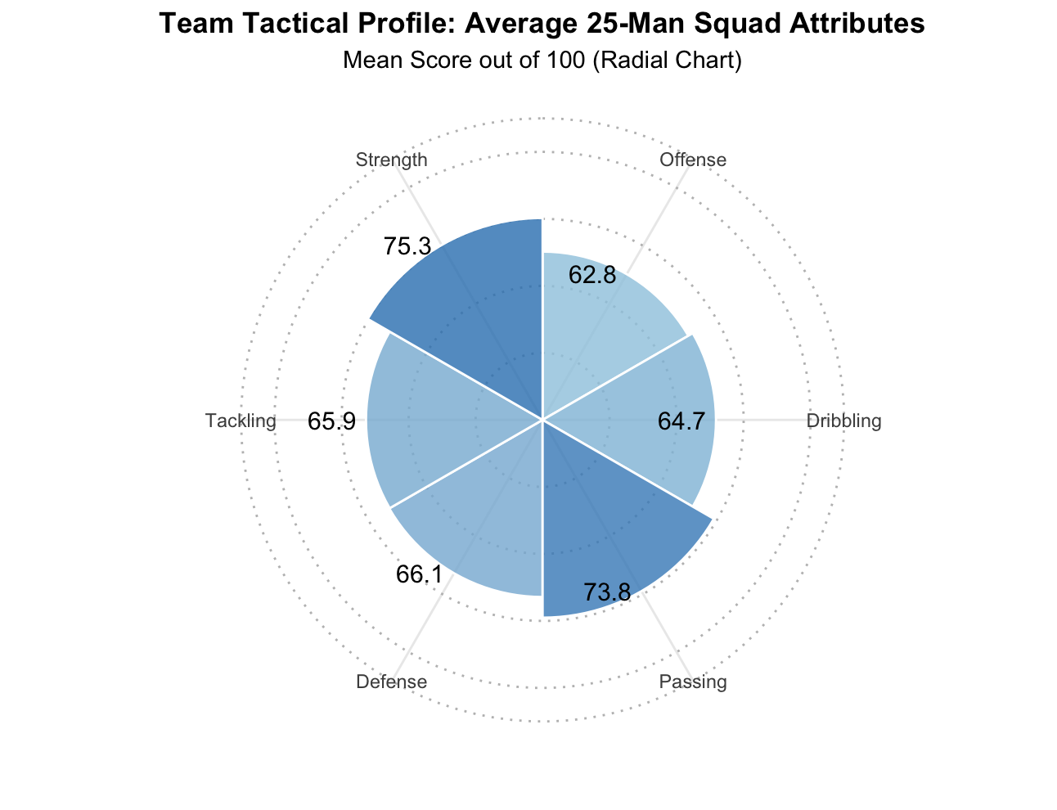
This radial chart shows squad strengths across six attributes (out of 100). Passing (73.8) and Strength (75.3) are strongest, while Offense (62.8) needs improvement through strategic transfers.
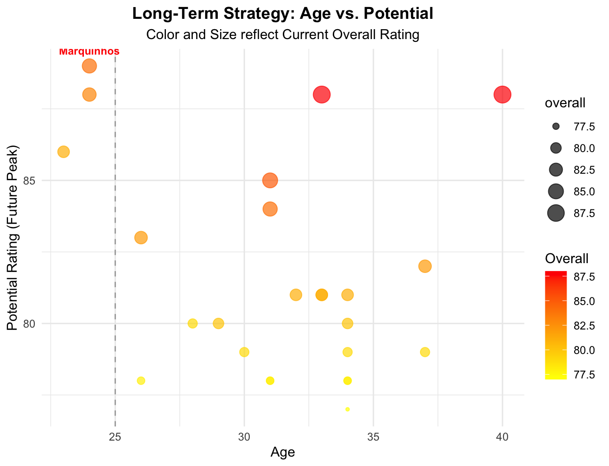
This plot shows player age versus potential rating, with size/color indicating current ability. The line at age 25 separates young prospects from peak players. Marquinhos is highlighted as a top young talent worth investing in for future growth.
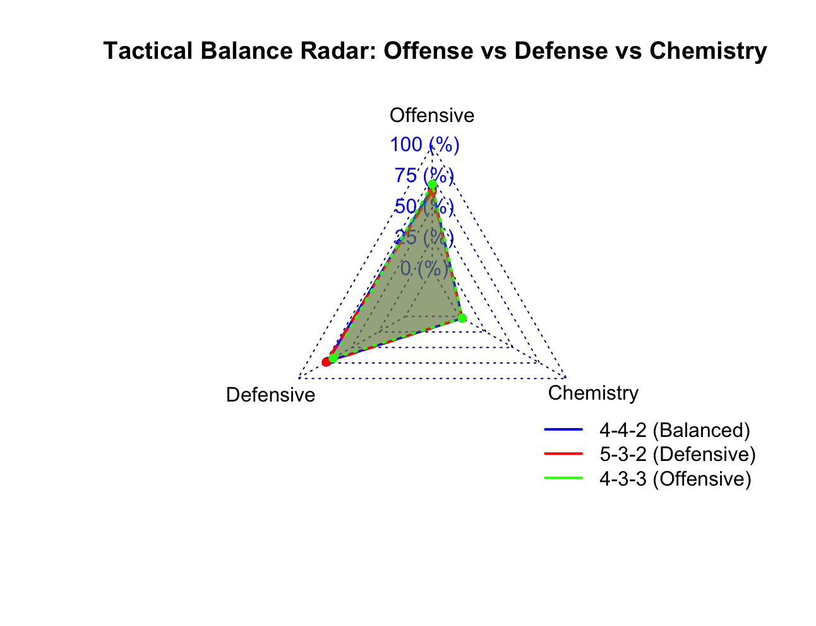
This radar compares three formations across offensive power, defensive strength, and team chemistry. The 5-3-2 excels defensively, 4-3-3 attacks strongly, while 4-4-2 offers the most balanced approach across all areas.
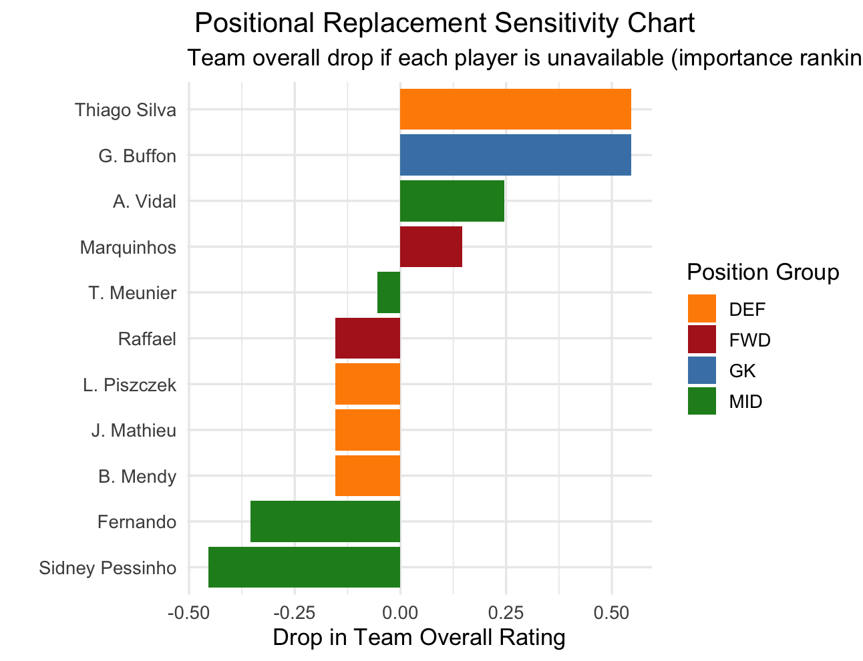
This chart ranks players by importance—how much team rating drops if they're unavailable. Thiago Silva and Buffon are most critical, while negative values (Sidney Pessinho, Fernando) suggest their absence might improve team performance.
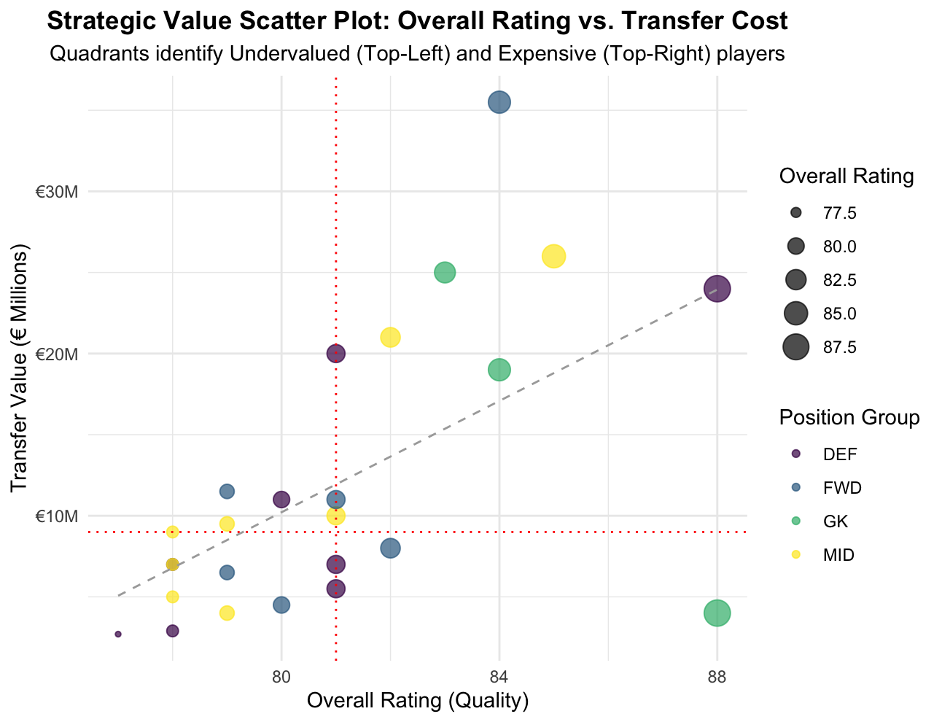
This identifies value opportunities by plotting quality against cost. Top-left quadrant shows undervalued bargains (high quality, low price), while the top-right contains expensive stars. The trend line shows typical quality-to-cost relationships.
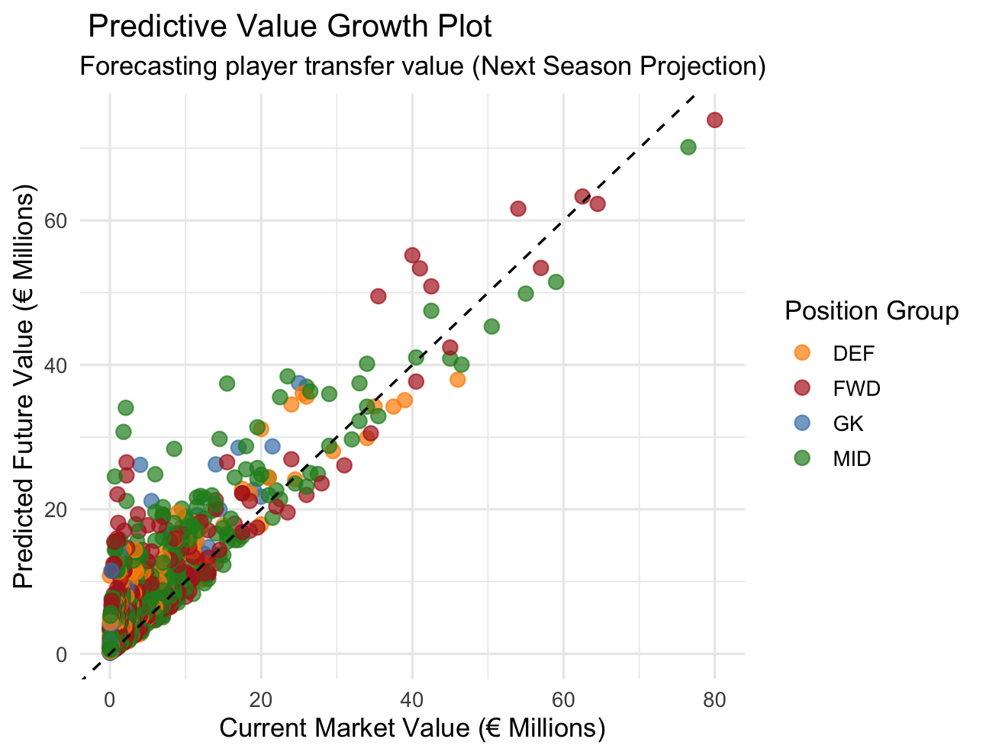
This forecasts next season's player values using current price, age, and potential. Points above the diagonal represent players expected to increase in value—smart investment targets for future squad development.

Strategic Playbook
Table: Starting XI: Defensive (5-3-2)
Name | Position | Club | Overall | Defensive Score
G. Buffon | GK | Paris Saint-Germain | 88 | 24.16667
Thiago Silva | RCB | Paris Saint-Germain | 88 | 85.66667
J. Mathieu | LCB | Sporting CP | 81 | 83.83333
L. Piszczek | RB | Borussia Dortmund | 81 | 79.50000
R. Civelli | RCB | Club Atlético Banfield | 77 | 79.16667
B. Mendy | LB | Manchester City | 81 | 77.16667
A. Vidal | CAM | FC Barcelona | 85 | 83.33333
Marquinhos | LDM | Paris Saint-Germain | 84 | 82.83333
T. Meunier | RM | Paris Saint-Germain | 82 | 79.16667
Aduriz | ST | Athletic Club de Bilbao | 82 | 58.00000
Raffael | CF | Borussia Mönchengladbach | 81 | 54.16667

Table: Starting XI: Offensive (4-3-3)
Name | Position | Club | Overall | Offensive Score
G. Buffon | GK | Paris Saint-Germain | 88 | 24.66667
Thiago Silva | RCB | Paris Saint-Germain | 88 | 61.66667
B. Mendy | LB | Manchester City | 81 | 70.00000
L. Piszczek | RB | Borussia Dortmund | 81 | 73.33333
J. Mathieu | LCB | Sporting CP | 81 | 67.16667
A. Vidal | CAM | FC Barcelona | 85 | 76.16667
T. Meunier | RM | Paris Saint-Germain | 82 | 77.83333
A. Valencia | RM | Manchester United | 81 | 74.83333
Aduriz | ST | Athletic Club de Bilbao | 82 | 78.66667
Raffael | CF | Borussia Mönchengladbach | 81 | 77.33333
Charles | LS | SD Eibar | 79 | 77.00000

Table: Set-Piece Specialists
Role | Player
Penalty Taker | Aduriz
Direct Free Kick | E. Belözoğlu
Corner Kicks | B. Mendy

Table: ⚡ Impact Substitutes ⚡
Role | Player
Offensive Spark (Chasing Goal) | Charles
Defensive Closer (Protecting Lead) | J. Mascherano

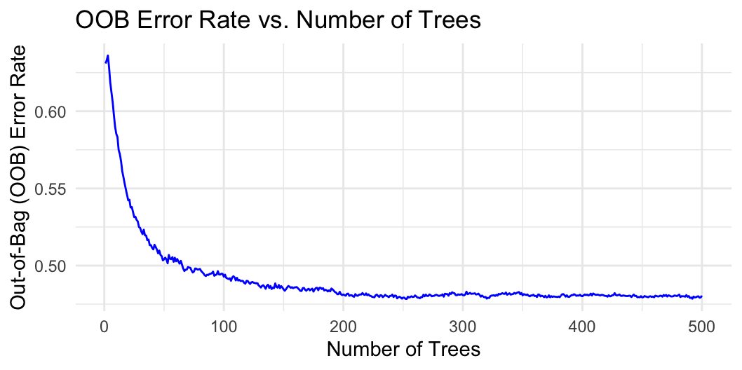
# --- Step 0: Load All Necessary Libraries ---
# Ensure all packages are installed before running
# install.packages(c("readr", "dplyr", "randomForest", "ggplot2", "janitor", "caret", "knitr"))

library(tidyverse)
library(janitor)
library(readr)
library(caret)
library(randomForest)
library(knitr)
library(dplyr)
library(lpSolve)

# --- Step 1: Load Raw Data and Perform Initial Cleaning ---
# Replace 'file.choose()' with the actual path if running outside an interactive environment
# master_data <- read.csv("fifa_eda_stats.csv") %>%
master_data <- read.csv(file.choose()) %>%
clean_names()

# --- Step 2: Data Preparation and Feature Engineering ---
master_data <- master_data %>%
mutate(player_id = paste(name, id, sep = "_"))

convert_currency <- function(x) {
if (is.na(x) || x == "") { return(NA) }
# Clean data and handle 'M' or 'K' multipliers
x <- gsub("€", "", x)
x <- gsub(" ", "", x)
if (grepl("M", x, ignore.case = TRUE)) {
return(as.numeric(gsub("M", "", x, ignore.case = TRUE)) * 1e6)
} else if (grepl("K", x, ignore.case = TRUE)) {
return(as.numeric(gsub("K", "", x, ignore.case = TRUE)) * 1e3)
} else {
return(as.numeric(x))
}
}
master_data$value <- sapply(master_data$value, convert_currency)
master_data$wage <- sapply(master_data$wage, convert_currency)

master_data <- master_data %>%
filter(!is.na(overall), !is.na(value), !is.na(wage), !is.na(potential)) %>%
mutate(position_group = case_when(
grepl("GK", position) ~ "GK",
position %in% c("CB","LB","RB","LCB","RCB","LWB","RWB") ~ "DEF",
position %in% c("CM","CDM","CAM","LM","RM","LCM","RCM") ~ "MID",
TRUE ~ "FWD"
))

# --- Step 3: Find Undervalued Players to Create a Transfer Shortlist ---
set.seed(123)
trainIndex <- sample(seq_len(nrow(master_data)), size = floor(0.8 * nrow(master_data)))
train <- master_data[trainIndex,]
test <- master_data[-trainIndex,]

# Random Forest Model
rf_model <- randomForest(value ~ overall + potential + age + wage + position_group, data = train, ntree = 200)
test$predicted_value <- predict(rf_model, test)
test$value_gap <- test$predicted_value - test$value

# Create a large, balanced shortlist of high-value transfer targets
transfer_shortlist <- test %>%
filter(value_gap > 0, overall >= 75) %>%
mutate(cost = value) %>%
mutate(value_score = overall / (cost / 1e6)) %>% # Overall per Million €
filter(is.finite(value_score)) # Remove players with a cost of 0

# --- Step 4: Build the Final 25-Man Squad by Maximizing OVERALL RATING (FIXED) ---
# Implementing a GREEDY HEURISTIC to guarantee the required position distribution
target_counts <- list(GK = 3, DEF = 8, MID = 8, FWD = 6)
final_team_roster_list <- list()

# UPDATED: Budget changed to 2 Billion €
budget <- 2e9

for (group in names(target_counts)) {
count <- target_counts[[group]]
selected_players <- transfer_shortlist %>%
filter(position_group == group) %>%
# FIX: Prioritize highest Overall Rating to utilize the large budget
slice_max(order_by = overall, n = count, with_ties = FALSE)
final_team_roster_list[[group]] <- selected_players
}

final_team_roster <- bind_rows(final_team_roster_list)

cat("\n--- 25-Man Squad Selected (BEST OVERALL RATING) ---\n\n")
final_team_roster %>%
select(Name = name, Position = position, Overall = overall, `Value Score` = value_score, Cost = cost) %>%
arrange(desc(Overall)) %>%
mutate(Cost = paste0("€", format(Cost, big.mark = ",", scientific = FALSE, digits = 1))) %>%
kable(caption = paste("Durham Top Dogs: 25-Man Squad (Budget: €", format(budget, big.mark = ","), ")", sep = "")) %>%
print()

# -----------------------------------------------------------
# --- Step 5: Calculate Tactical and Chemistry Scores ---
# -----------------------------------------------------------
squad_details <- master_data %>% filter(player_id %in% final_team_roster$player_id)

# Corrected column names to use snake_case format generated by janitor::clean_names()
squad_details <- squad_details %>%
mutate(
offensive_score = (finishing + shot_power + long_shots + positioning + dribbling + sprint_speed) / 6,
defensive_score = (marking + standing_tackle + sliding_tackle + interceptions + strength + heading_accuracy) / 6,
goalkeeping_score = (gk_diving + gk_handling + gk_kicking + gk_positioning + gk_reflexes) / 5
)

# --- Step 5.5: Find the Chemistry-Optimized Starting XI (4-4-2 Formation) ---
cat("\n--- 🔍 Searching for Best Chemistry XI (4-4-2) - Using Heuristic ---\n")

# Find the most common club and nationality in the 25-man squad
common_club <- squad_details %>% count(club) %>% slice_max(n=1, order_by = n, with_ties = FALSE) %>% pull(club)
common_nationality <- squad_details %>% count(nationality) %>% slice_max(n=1, order_by = n, with_ties = FALSE) %>% pull(nationality)

squad_details <- squad_details %>%
mutate(
chemistry_weight = (club == common_club) * 3 + (nationality == common_nationality) * 1,
selection_score = overall + (chemistry_weight * 5)
)

# Function to calculate the actual chemistry score (used only for the final result display)
calculate_chemistry <- function(lineup_df) {
score <- 0
player_pairs <- combn(lineup_df$player_id, 2, simplify = FALSE)
for (pair in player_pairs) {
player1 <- lineup_df %>% filter(player_id == pair[1])
player2 <- lineup_df %>% filter(player_id == pair[2])
if (player1$club == player2$club) {
score <- score + 3
} else if (player1$nationality == player2$nationality) {
score <- score + 1
}
}
return(score)
}

# Select the Starting XI based on the Heuristic Score (4-4-2)
best_chemistry_xi <- bind_rows(
squad_details %>% filter(position_group == "GK") %>% slice_max(n=1, order_by = goalkeeping_score, with_ties = FALSE),
squad_details %>% filter(position_group == "DEF") %>% slice_max(n=4, order_by = selection_score, with_ties = FALSE),
squad_details %>% filter(position_group == "MID") %>% slice_max(n=4, order_by = selection_score, with_ties = FALSE),
squad_details %>% filter(position_group == "FWD") %>% slice_max(n=2, order_by = selection_score, with_ties = FALSE)
)

best_chemistry_score <- calculate_chemistry(best_chemistry_xi)

# Display the final, chemistry-optimized lineup
cat("\n--- Chemistry-Optimized Starting XI Found ---\n\n")
best_chemistry_xi %>%
mutate(ChemistryScore = best_chemistry_score) %>%
select(Name = name, Position = position, Club = club, Nationality = nationality, Overall = overall, ChemistryScore, position_group) %>%
arrange(factor(position_group, levels = c("GK", "DEF", "MID", "FWD"))) %>%
select(-position_group) %>%
kable(caption = " Starting XI: Optimized for Max Chemistry (4-4-2) ") %>%
print()

# --- Step 6: Display Final, Tactically-Aware Lineups ---

# -- Scenario 1: Balanced (4-4-2) - Based on highest overall rating --
balanced_xi <- bind_rows(
squad_details %>% filter(position_group == "GK") %>% slice_max(n=1, order_by = goalkeeping_score, with_ties = FALSE),
squad_details %>% filter(position_group == "DEF") %>% slice_max(n=4, order_by = overall, with_ties = FALSE),
squad_details %>% filter(position_group == "MID") %>% slice_max(n=4, order_by = overall, with_ties = FALSE),
squad_details %>% filter(position_group == "FWD") %>% slice_max(n=2, order_by = overall, with_ties = FALSE)
)
balanced_xi %>%
select(Name = name, Position = position, Club = club, Overall = overall, position_group) %>%
arrange(factor(position_group, levels = c("GK", "DEF", "MID", "FWD"))) %>%
select(-position_group) %>%
kable(caption = "⚽ Starting XI: Balanced (4-4-2) ⚽") %>%
print()

# -- Scenario 2: Defensive (5-3-2) - Based on best defensive attributes --
defensive_xi <- bind_rows(
squad_details %>% filter(position_group == "GK") %>% slice_max(n=1, order_by = goalkeeping_score, with_ties = FALSE),
squad_details %>% filter(position_group == "DEF") %>% slice_max(n=5, order_by = defensive_score, with_ties = FALSE),
squad_details %>% filter(position_group == "MID") %>% slice_max(n=3, order_by = defensive_score, with_ties = FALSE),
squad_details %>% filter(position_group == "FWD") %>% slice_max(n=2, order_by = overall, with_ties = FALSE)
)
defensive_xi %>%
select(Name = name, Position = position, Club = club, Overall = overall, `Defensive Score` = defensive_score, position_group) %>%
arrange(factor(position_group, levels = c("GK", "DEF", "MID", "FWD"))) %>%
select(-position_group) %>%
kable(caption = "🛡️ Starting XI: Defensive (5-3-2) 🛡️") %>%
print()

# -- Scenario 3: Offensive (4-3-3) - Based on best offensive attributes --
offensive_xi <- bind_rows(
squad_details %>% filter(position_group == "GK") %>% slice_max(n=1, order_by = goalkeeping_score, with_ties = FALSE),
squad_details %>% filter(position_group == "DEF") %>% slice_max(n=4, order_by = overall, with_ties = FALSE),
squad_details %>% filter(position_group == "MID") %>% slice_max(n=3, order_by = offensive_score, with_ties = FALSE),
squad_details %>% filter(position_group == "FWD") %>% slice_max(n=3, order_by = offensive_score, with_ties = FALSE)
)
offensive_xi %>%
select(Name = name, Position = position, Club = club, Overall = overall, `Offensive Score` = offensive_score, position_group) %>%
arrange(factor(position_group, levels = c("GK", "DEF", "MID", "FWD"))) %>%
select(-position_group) %>%
kable(caption = "⚡ Starting XI: Offensive (4-3-3) ⚡") %>%
print()

# --- Step 7: Create the Game Day Playbook ---
# Corrected column names for set-piece selection.
specialists <- tribble(
~Role, ~Player,
"Penalty Taker", (squad_details %>% slice_max(n=1, order_by = (penalties + composure)))$name,
"Direct Free Kick", (squad_details %>% slice_max(n=1, order_by = (fk_accuracy + curve + shot_power)))$name,r
"Corner Kicks", (squad_details %>% slice_max(n=1, order_by = (crossing + curve)))$name
)
specialists %>% kable(caption = " Set-Piece Specialists ") %>% print()

# Ensure a player is available to be an impact sub by filtering out the balanced XI.
bench_players <- squad_details %>% filter(!player_id %in% balanced_xi$player_id)
substitutes <- tribble(
~Role, ~Player,
"Offensive Spark (Chasing Goal)", (bench_players %>% filter(position_group %in% c("FWD", "MID")) %>% slice_max(n=1, order_by = offensive_score))$name,
"Defensive Closer (Protecting Lead)", (bench_players %>% filter(position_group %in% c("DEF", "MID")) %>% slice_max(n=1, order_by = defensive_score))$name
)
substitutes %>% kable(caption = "⚡ Impact Substitutes ⚡") %>% print()

Sources

- Transforming Football Scouting: The Power of Predictive Analytics (LatentView): https://www.latentview.com/blog/redefining-football-player-scouting-with-predictive-analytics/​
- Top 10 Ways AI is Revolutionizing Player Scouting and Recruitment (CallPlaybook): https://www.callplaybook.com/reports/top-10-ai-scouting-and-recruitment​
- Moneyball and Soccer Data: A Game-Changing Approach (Sportmonks): https://www.sportmonks.com/blogs/moneyball/
- Data-Driven Team Selection in Fantasy Premier League Using Integer Programming (arXiv): https://arxiv.org/html/2505.02170v1
- The Economics of the Football Transfer Market (Congress Creator PDF): https://congresscreator.org/system/files/papers-641/Econ_Football_Transfer_Market_Rivera_Obon.pdf
- ChatGPT for R-code

