**XGBoost Model Report - House Prices**

By Patriciah N. Mboya

Date:14/01/2023

**Explaining the Model with SHAP:**

The SHAP (SHapley Additive exPlanations) library was used to gain insights into the model's decision-making process. A TreeExplainer was used to compute SHAP values for the features. The SHAP summary plot below visually represents the importance of different features for predicting house prices. Each dot represents a specific prediction, and the color indicates the feature value (red for high, blue for low).

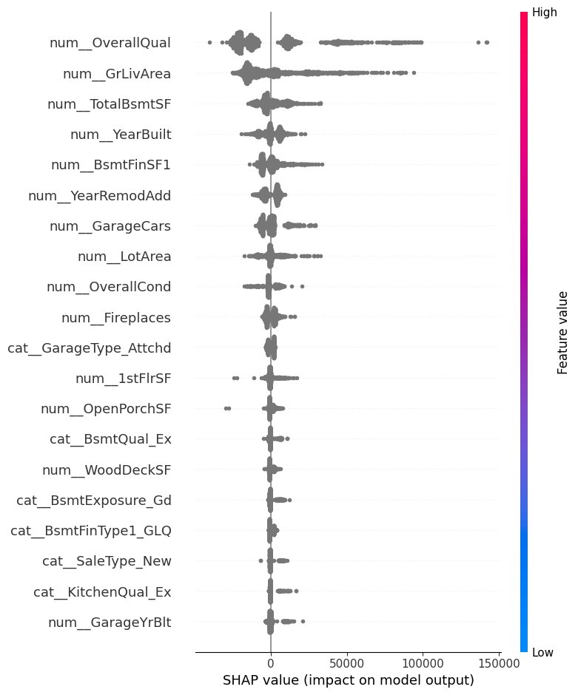

The interpretation of the SHAP Plot on the left is based on how different features influence the predicted sale price of a house.

1. The most important feature in this model is "num_OverallQual", which represents the overall quality of the house. This makes sense, as a higher quality house would generally be expected to sell for a higher price.
2. Other important features include "GrLivArea" (living room area), "num_TotalBsmtSF" (total basement square footage), "num_YearBuilt" (year the house was built), and "num_BsmtFinSF1" (finished basement square footage on the first floor). These features all contribute to the overall liveability and size of the house, which naturally impacts its value.