# Title of Culminating Experience

A Choose an item. submitted to the faculty of  
San Francisco State University  
In partial fulfillment of  
the requirements for  
the Degree

Click to choose Degree  
In  
Click to choose Major: Concentration

by  
  
First Middle Last Name  
  
San Francisco, California  
  
Click to choose Semester 20XX

Copyright by  
First Middle Last Name  
20XX

## Certification of Approval

I certify that I have read Title of Culminating Experience by First Middle Last Name, and that in my opinion this work meets the criteria for approving a thesis submitted in partial fulfillment of the requirement for the degree (Example) Master of Science in Biology: Conservation Biology at San Francisco State University.

Name of the professor,Choose degree

Click to choose the faculty rank,

Thesis Committee Chair

Name of the professor,Choose degree

Click to choose the faculty rank

Name of the professor, Choose degree

Click to choose the faculty rank

Name of the professor,Choose degree

Click to choose the faculty rank

## Abstract

Begin your abstract here.

Insert a section break at the end of the Abstract by placing your cursor after the final punctuation and going to Layout > Breaks > Next Page (under Section Breaks). For corresponding screenshots, please consult [Microsoft’s support page](https://support.microsoft.com/en-us/office/insert-a-section-break-eef20fd8-e38c-4ba6-a027-e503bdf8375c).

## Preface

Including a Preface for your work is optional. If you do not have one, please delete this page.

[Insert a **page break** at the end of the Preface by placing your cursor after the final punctuation and going to Insert > Page Break.}

## Acknowledgements

Normally the Acknowledgements section gives you the opportunity to thank those to whom you are indebted for assistance in the project. This should be done briefly and in good taste.

[Insert a **page break** at the end of the Acknowledgements by placing your cursor after the final punctuation and going to Insert > Page Break.]

## Table of Contents

List of Tables ix

List of Figures x

List of Appendices xi

Introduction 1

Method 2

Chapter 1 3

Chapter 1 Heading 3 (Subheading) 4

Chapter 1 Heading 4 (Sub-subheading) 5

Chapter 2 6

References/Bibliography/Works Cited 9

Appendix/Appendices 10

[If your work **includes** a List of Tables, List of Figures, and/or List of Appendices, insert a **page break** at the end of the Table of Contents by placing your cursor at the bottom of the page and going to Insert > Page Break.

If your work **does not include** a List of Tables, List of Figures, and/or List of Appendices, insert a **section break** at the end of the Table of Contents by placing your cursor at the bottom of the page and going to Layout > Breaks > Next Page (under Section Breaks). For corresponding screenshots, please consult [Microsoft’s support page](https://support.microsoft.com/en-us/office/insert-a-section-break-eef20fd8-e38c-4ba6-a027-e503bdf8375c).]

## List of Tables

Table 1. Number of Students, 2016-2019 6

Table 2. Responses to Survey Question 1 7

[If your work **includes** a List of Figures and/or List of Appendices, insert a **page break** at the end of the List of Tables by placing your cursor at the bottom of the page and going to Insert > Page Break.

If your work **does not include** a List of Figures and/or List of Appendices, insert a **section break** at the end of the List of Tables by placing your cursor at the bottom of the page and going to Layout > Breaks > Next Page (under Section Breaks). For corresponding screenshots, please consult [Microsoft’s support page](https://support.microsoft.com/en-us/office/insert-a-section-break-eef20fd8-e38c-4ba6-a027-e503bdf8375c).]

## List of Figures

Figure 1. A sketch of Doullens town hall 4

Figure 2. Marine Algae in Sweden 7

[If your work **includes** a List of Appendices, insert a **page break** at the end of the List of Figures by placing your cursor at the bottom of the page and going to Insert > Page Break.

If your work **does not include** a List of Appendices, insert a **section break** at the end of the List of Figures by placing your cursor at the bottom of the page and going to Layout > Breaks > Next Page (under Section Breaks). For corresponding screenshots, please consult [Microsoft’s support page](https://support.microsoft.com/en-us/office/insert-a-section-break-eef20fd8-e38c-4ba6-a027-e503bdf8375c).]

## List of Appendices

Appendix A: List of California State University Campuses 9

Appendix B: Abbreviations of California State University Campuses 10

[Insert a **section break** at the end of the List of Appendices by placing your cursor at the bottom of the page and going to Layout > Breaks > Next Page (under Section Breaks). For corresponding screenshots, please consult [Microsoft’s support page](https://support.microsoft.com/en-us/office/insert-a-section-break-eef20fd8-e38c-4ba6-a027-e503bdf8375c).]

## Introduction

Lorem ipsum dolor sit amet, consectetuer adipiscing elit. Maecenas porttitor congue massa. Fusce posuere, magna sed pulvinar ultricies, purus lectus malesuada libero, sit amet commodo magna eros quis urna. Nunc viverra imperdiet enim. Fusce est. Vivamus a tellus.

Pellentesque habitant morbi tristique senectus et netus et malesuada fames ac turpis egestas. Proin pharetra nonummy pede. Mauris et orci. Aenean nec lorem. In porttitor. Donec laoreet nonummy augue.

Suspendisse dui purus, scelerisque at, vulputate vitae, pretium mattis, nunc. Mauris eget neque at sem venenatis eleifend. Ut nonummy. Fusce aliquet pede non pede. Suspendisse dapibus lorem pellentesque magna. Integer nulla.

### Method

Donec blandit feugiat ligula. Donec hendrerit, felis et imperdiet euismod, purus ipsum pretium metus, in lacinia nulla nisl eget sapien. Donec ut est in lectus consequat consequat. Etiam eget dui. Aliquam erat volutpat. Sed at lorem in nunc porta tristique.

Proin nec augue. Quisque aliquam tempor magna. Pellentesque habitant morbi tristique senectus et netus et malesuada fames ac turpis egestas. Nunc ac magna. Maecenas odio dolor, vulputate vel, auctor ac, accumsan id, felis. Pellentesque cursus sagittis felis.

[Insert a **page break** at the end of each major section by placing your cursor after the final punctuation and going to Insert > Page Break.]

## Chapter 1

Pellentesque porttitor, velit lacinia egestas auctor, diam eros tempus arcu, nec vulputate augue magna vel risus. Cras non magna vel ante adipiscing rhoncus. Vivamus a mi. Morbi neque. Aliquam erat volutpat. Integer ultrices lobortis eros.

Pellentesque habitant morbi tristique senectus et netus et malesuada fames ac turpis egestas. Proin semper, ante vitae sollicitudin posuere, metus quam iaculis nibh, vitae scelerisque nunc massa eget pede. Sed velit urna, interdum vel, ultricies vel, faucibus at, quam. Donec elit est, consectetuer eget, consequat quis, tempus quis, wisi. In in nunc. Class aptent taciti sociosqu ad litora torquent per conubia nostra, per inceptos hymenaeos.

Figure 1. A sketch of Doullens town hall

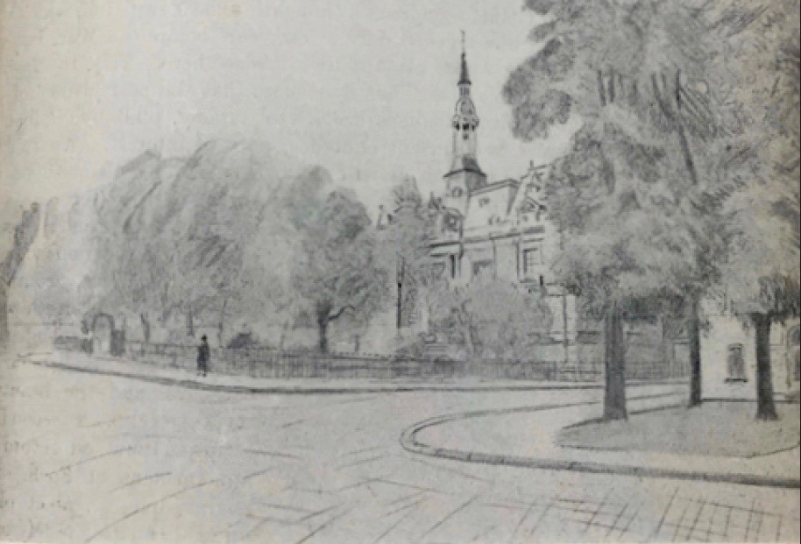

This sketch by W. Basil Worsfold was first published in "United Empire," Volume XX, London: Isaac Pitman, 1929, pg. 237. The image is in the public domain.

Donec ullamcorper fringilla eros. Fusce in sapien eu purus dapibus commodo. Cum sociis natoque penatibus et magnis dis parturient montes, nascetur ridiculus mus.

### Chapter 1 Heading 3 (Subheading)

Cras faucibus condimentum odio. Sed ac ligula. Aliquam at eros. Etiam at ligula et tellus ullamcorper ultrices. In fermentum, lorem non cursus porttitor, diam urna accumsan lacus, sed interdum wisi nibh nec nisl. Ut tincidunt volutpat urna. Mauris eleifend nulla eget mauris. Sed cursus quam id felis. Curabitur posuere quam vel nibh. Cras dapibus dapibus nisl.

Vestibulum quis dolor a felis congue vehicula. Maecenas pede purus, tristique ac, tempus eget, egestas quis, mauris. Curabitur non eros. Nullam hendrerit bibendum justo. Fusce iaculis, est quis lacinia pretium, pede metus molestie lacus, at gravida wisi ante at libero. Quisque ornare placerat risus. Ut molestie magna at mi. Integer aliquet mauris et nibh. Ut mattis ligula posuere velit. Nunc sagittis.

#### Chapter 1 Heading 4 (Sub-subheading)

Curabitur varius fringilla nisl. Duis pretium mi euismod erat. Maecenas id augue. Nam vulputate. Duis a quam non neque lobortis malesuada. Praesent euismod. Donec nulla augue, venenatis scelerisque, dapibus a, consequat at, leo. Pellentesque libero lectus, tristique ac, consectetuer sit amet, imperdiet ut, justo. Sed aliquam odio vitae tortor. Proin hendrerit tempus arcu. In hac habitasse platea dictumst. Suspendisse potenti.

[Insert a **page break** at the end of each major section by placing your cursor after the final punctuation and going to Insert > Page Break.]

## Chapter 2

Vivamus vitae massa adipiscing est lacinia sodales. Donec metus massa, mollis vel, tempus placerat, vestibulum condimentum, ligula. Nunc lacus metus, posuere eget, lacinia eu, varius quis, libero. Aliquam nonummy adipiscing augue. Lorem ipsum dolor sit amet, consectetuer adipiscing elit. Maecenas porttitor congue massa. Fusce posuere, magna sed pulvinar ultricies, purus lectus malesuada libero, sit amet commodo magna eros quis urna. Nunc viverra imperdiet enim.

Table 1. Number of Students, 2016-2019

| **Year** | **Number of Students** |
| --- | --- |
| 2016 | 12,923 |
| 2017 | 13,012 |
| 2018 | 11,065 |
| 2019 | 12,743 |

Table 1. A caption is optional, but it can be helpful to summarize the data and explain how a table relates to the surrounding text.

Fusce est. Vivamus a tellus. Pellentesque habitant morbi tristique senectus et netus et malesuada fames ac turpis egestas. Proin pharetra nonummy pede. Mauris et orci. Aenean nec lorem. In porttitor.

Donec laoreet nonummy augue. Suspendisse dui purus, scelerisque at, vulputate vitae, pretium mattis, nunc. Mauris eget neque at sem venenatis eleifend. Ut nonummy. Fusce aliquet pede non pede. Suspendisse dapibus lorem pellentesque magna. Integer nulla. Donec blandit feugiat ligula.

Table 2. Responses to Survey Question 1

Table 1. A caption is optional, but it can be helpful to summarize the data and explain how a table relates to the surrounding text.

Donec hendrerit, felis et imperdiet euismod, purus ipsum pretium metus, in lacinia nulla nisl eget sapien. Donec ut est in lectus consequat consequat. Etiam eget dui. Aliquam erat volutpat. Sed at lorem in nunc porta tristique. Proin nec augue. Quisque aliquam tempor magna. Pellentesque habitant morbi tristique senectus et netus et malesuada fames ac turpis egestas.

Figure 2. Marine Algae in Sweden

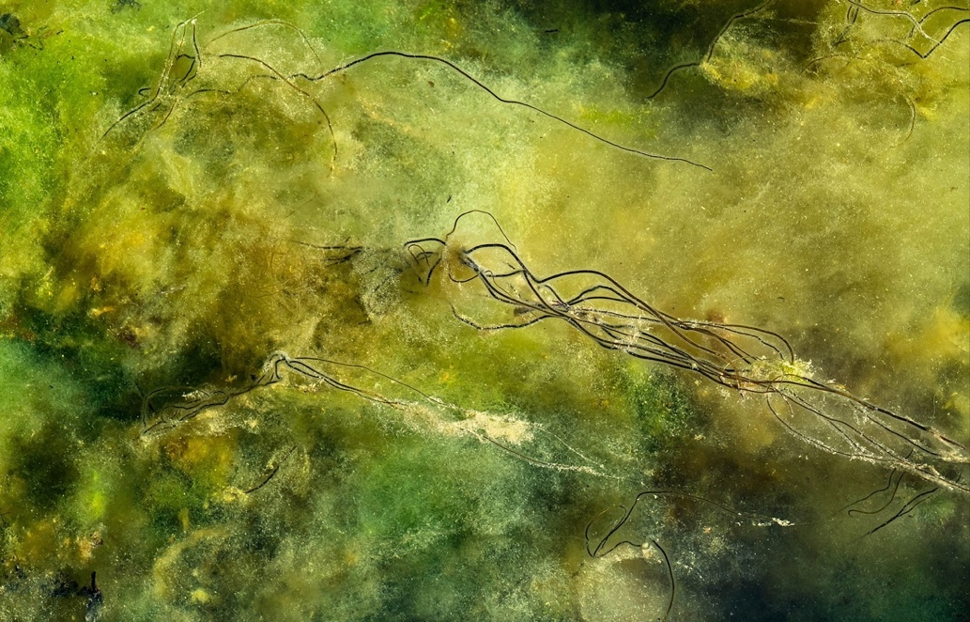

Figure 2. The Dead Man's Rope (Chorda filum) shown in this photograph are about 3.3 ft. high, and the bottom is covered with soft blanket weed (Cladophora glomerata). Photo by W.carter, CC0 1.0 Universal.

Nunc ac magna. Maecenas odio dolor, vulputate vel, auctor ac, accumsan id, felis. Pellentesque cursus sagittis felis. Pellentesque porttitor, velit lacinia egestas auctor, diam eros tempus arcu, nec vulputate augue magna vel risus. Cras non magna vel ante adipiscing rhoncus. Vivamus a mi. Morbi neque. Aliquam erat volutpat. Integer ultrices lobortis eros. Pellentesque habitant morbi tristique senectus et netus et malesuada fames ac turpis egestas.

Proin semper, ante vitae sollicitudin posuere, metus quam iaculis nibh, vitae scelerisque nunc massa eget pede. Sed velit urna, interdum vel, ultricies vel, faucibus at, quam. Donec elit est, consectetuer eget, consequat quis, tempus quis, wisi. In in nunc. Class aptent taciti sociosqu ad litora torquent per conubia nostra, per inceptos hymenaeos. Donec ullamcorper fringilla eros. Fusce in sapien eu purus dapibus commodo.

[Insert a **page break** at the end of each major section by placing your cursor after the final punctuation and going to Insert > Page Break.]

## References/Bibliography/Works Cited

Grady, J. S., Her, M., Moreno, G., Perez, C., & Yelinek, J. (2019). Emotions in storybooks: A comparison of storybooks that represent ethnic and racial groups in the United States. *Psychology of Popular Media Culture*, *8*(3), 207–217.

Shulte, Bret. “Putting a Price on Pollution.” *US News & World Report*, vol. 142, no. 17, 14 May 2007, p. 37.*Ebsco,*Access no: 24984616.

[Insert a **page break** at the end of each major section by placing your cursor after the final punctuation and going to Insert > Page Break.]

## Appendix/Appendices

Appendix A: List of California State University Campuses

California State University, Bakersfield  
California State University Channel Islands  
California State University, Chico  
California State University, Dominguez Hills  
California State University, East Bay  
California State University, Fresno  
California State University, Fullerton  
Humboldt State University  
California State University, Long Beach  
California State University, Los Angeles  
California State University Maritime Academy  
California State University, Monterey Bay  
California State University, Northridge  
California State Polytechnic University, Pomona  
California State University, Sacramento  
California State University, San Bernardino  
San Diego State University  
San Francisco State University  
San José State University  
California Polytechnic State University, San Luis Obispo  
California State University San Marcos  
Sonoma State University  
California State University, Stanislaus

Appendix B: Abbreviations of California State University Campuses

CSU Bakersfield

CSU Channel Islands

Chico State

CSU Dominguez Hills

Cal State East Bay

Fresno State

Cal State Fullerton

Humboldt State

Cal State Long Beach

Cal State LA

Cal Maritime

CSU Monterey Bay

CSUN

Cal Poly Pomona

Sacramento State

Cal State San Bernardino

San Diego State

San Francisco State

San José State

Cal Poly San Luis Obispo

CSU San Marcos

Sonoma State

Stanislaus State