Buoy 22: Environmental Variables ONLY

Code:

model1 <- gam(BWpresence>0 ~ depth + sst_mean + mldTemp + ttDepth + sal400,data = fulltrack22, family = binomial, method = "REML")

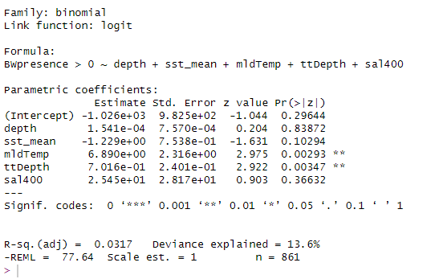

Buoy 22: Environmental + Soundscape metrics

Code:

model2 <- gam(BWpresence>0 ~ depth + sst_mean + mldTemp + ttDepth + sal400 + TOL_125 + TOL_2000, data = fulltrack22, family = binomial, method = "REML")

