IST 263

# Lab 12

## This lab covers:

1. Locating JavaScript Nodes
2. Manipulating Nodes
3. Review CSS floats and display property

## SETUP

Create a folder in your Github repository called lab12. I've placed a practice file in blackboard. Download it and save it in your lab12 folder. Examine the HTML and CSS and follow the directions below.

## overview

In this lab we will create a JavaScript slideshow. The possibilities for how a slideshow works are endless. For our slide show we will provide thumbnail images for the user to change the slides.

Here's what the slideshow is going to look like when it's done:

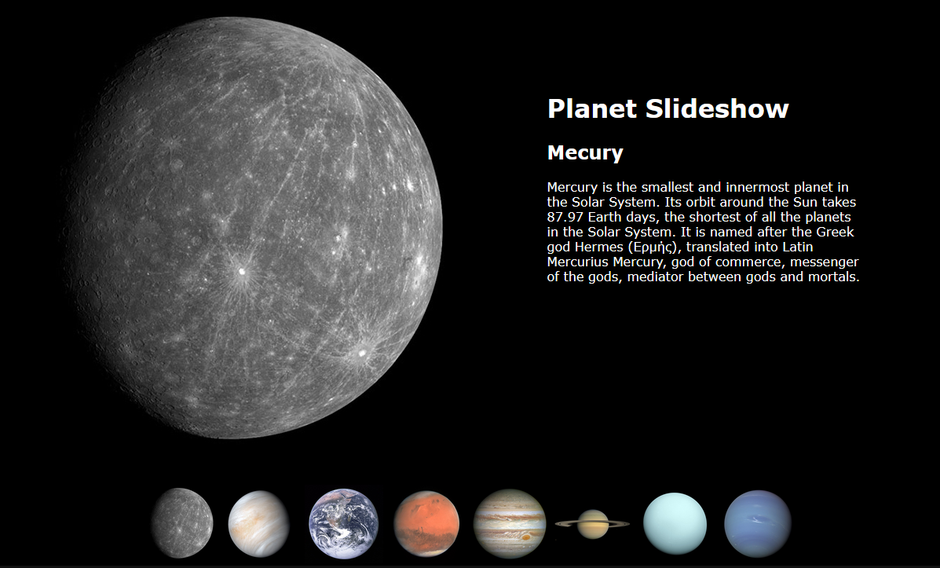

When you click on one of the thumbnail planet images it will change the large planet image and the text to the right with details about the planet.

Examine the HTML and CSS you’ve been given before you do the steps below.

## thinking about the problem - Steps to Accomplish our Slideshow

A slide show HTML page contains all the images and text that will display in the slideshow. You use JavaScript to control which image and text displays at which times. The practice file I gave you has all the images and text for the slideshow showing right now. The process we will go through is all about laying out all those pieces and hiding and displaying them.

Here's an overview of the steps to make this slideshow work.

* **CSS**
  + Display Mercury's picture and text when the slideshow loads and turn off the display of all the other large images and associated texts.
  + Work on layout of page now that you have one image and text.
* **JavaScript**
  + Create a JavaScript event when a thumbnail is clicked.
  + Make the slideshow pictures and text change when a user clicks on a thumbnail:
    - remove the current image from display
    - remove the current text from display
    - display new large planet image
    - display planet text

## let's make a slideshow!

|  |
| --- |
| Display Mercury's picture and text when the slideshow loads and turn off the display of all the other large images and associated texts. |

Recall in this week's lecture we worked with the CSS property display using the values none and block. None makes an element disappear from the browser. You can use the value block in your JavaScript to make it reappear.

1. To start we want to remove every planet photo and every planet text from the page minus Mercury. The planet photos and planet text all have their own unique id values. For example here's venus:  
     
     
     
   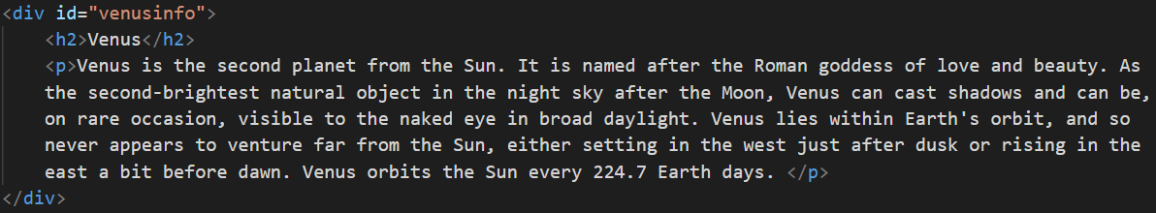  
     
     
   Use CSS and the planet id selectors to take the images and text off the page. If you want to write a lot less code, you can use a grouped selector to remove them all with one CSS property and value. Your page should look like this when you are done.  
     
   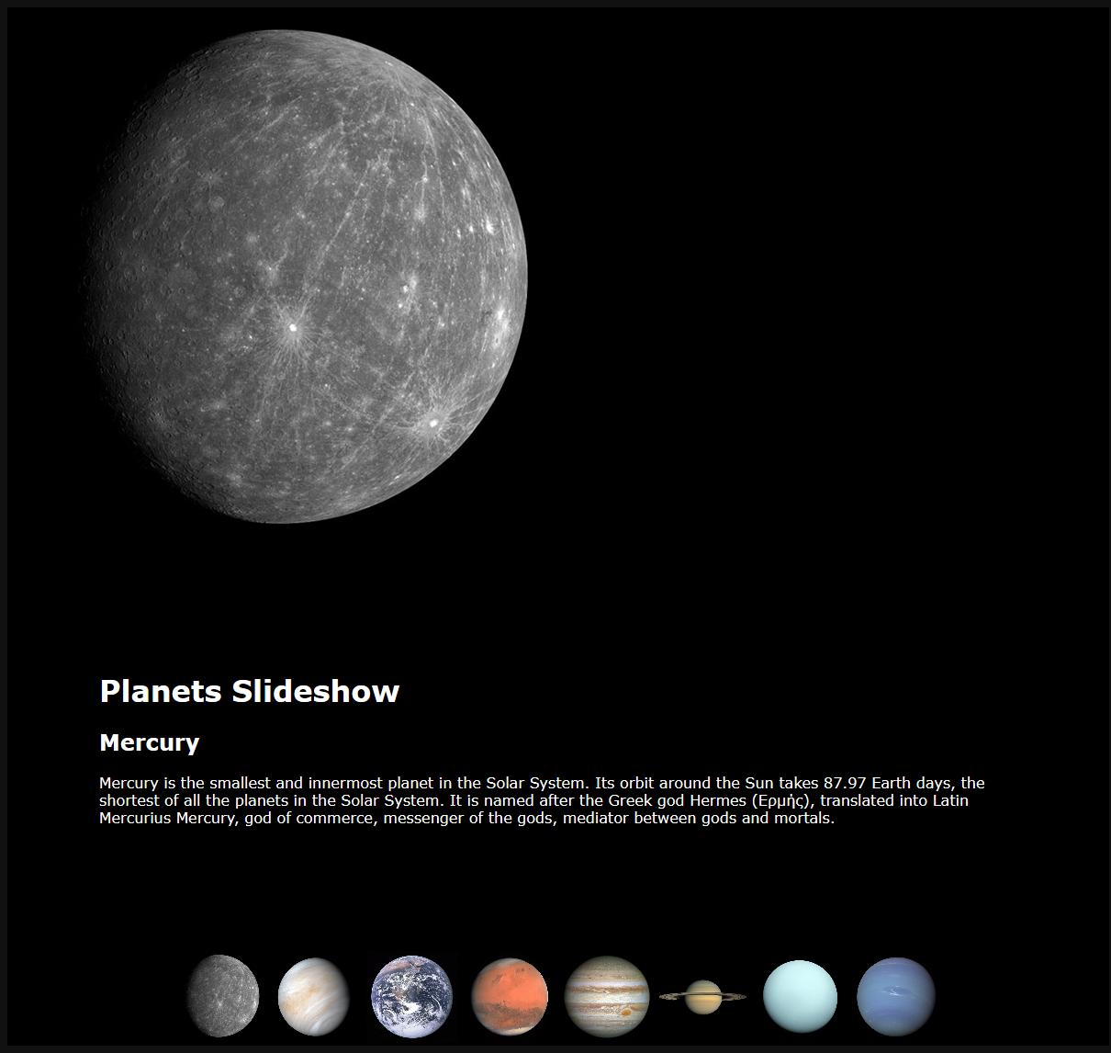

|  |
| --- |
| Work on layout of page now that you have one image and text. |

Recall the properties and values for floats.

|  |  |
| --- | --- |
| **CSS property** | **Value(s)** |
| float | left, right |
| clear | both |

1. Using only the properties above, write the CSS styles to make the current page look like the page layout displayed in the overview. You will want to style the parent containers for the planets and planet text when you do this so it will work for all the planets in the slide show. For example, don’t float mercuryinfo, float planetinfo.   
     
   You might want to review the floats lab 8, read the W3Schools info about floats <https://www.w3schools.com/cssref/pr_class_float.asp> or ask questions. Leave the styles I've provided alone. You should just be adding to the provided CSS.

|  |
| --- |
| Create a JavaScript event when a thumbnail is clicked. |

1. There are 8 planet thumbnails. When any of them is clicked we need to trigger and event that calls the JavaScript function PlanetsOff. This instruction uses skills from last week. Review the events list from lab 11 if needed. Add the event into the 8 thumbnail image tags and call the PlanetsOff function (using correct syntax) in the event attribute. We'll create that function and write the JavaScript for it below.

|  |
| --- |
| To make the slideshow pictures and text change, when a user clicks on a thumbnail: remove the current image from display |

Let's dissect the JavaScript locator and its methods below. We are going to use the id locator to change the display style value of the planets and their associated text.



* document.getElementById('mercury') is the locator. If finds any HTML element with id="mercury"
* style.display is a method that allows you to manipulate the node. AKA change the property value for the display of that element
* = 'none; is where we are setting the new value of the display property

1. Add the PlanetsOff function inside the script tag. If you need a reminder of the function syntax check last week's example files. We'll add JavaScript inside the function next.
2. One planet is displaying so we only need to turn one planet of when there's a click right? That would require us to know which planet is turned on. It's easier to just turn them all off every time. Use the line above to turn off mercury. Add 7 more lines like this to the PlanetsOff function turn off the other planets. The only thing that will change on each line is the value of the id.  
     
   Note: If you've done this step correctly, there will be no large image after you click on a thumbnail.

|  |
| --- |
| To make the slideshow pictures and text change, when a user clicks on a thumbnail: remove the current text from display |

1. We also want to turn off the planets text. Find the id values for those div tags. Add 8 more lines like the ones above to turn off the planets text.

|  |
| --- |
| To make the slideshow pictures and text change, when a user clicks on a thumbnail: display new large planet image and display planet text |

1. Examine the following function. It changes the display property of mercury to turn it on. Add it inside the script tag just after the closing curly brace for PlanetsOff.  
     
   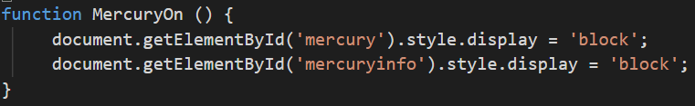
2. Create 7 more functions like this to turn the other planets on.
   1. Change the name of the function to match the planet you are working on. Don't forget that JavaScript is case sensitive.
   2. Change the value of the id for getElementById so it is correct for the planet you are working on.

Why isn't the planet displaying now? We written functions to display the planets, but we haven't used them yet. To do this I'm going to show you how to have more than one function run in an event attribute.

1. In the thumbnails add a second function to the onclick event. Here's the syntax for mercury. Add the second function to all the planets using the correct planet name. You can have as many function run inside the event as you would like.  
     
   

## What will You hand IN?

Create a word document, pdf or use the "write submission" option in blackboard to provide the following:

1. Submit the url for the slideshow.

<https://mbpaninski.github.io/ist263/lab12/lab12.html>

1. Answers to the following question:
   1. Our slideshow is very basic. What functionality could you add to make it a better slideshow? List at least 3 improvements. I'm not looking for code here just your thoughts.

* Have transitions between each planet/info
* Add more elements to each page about the planets
* Have a homepage to start on that does not begin with a planet

1. Submit answers to the following:
   1. What questions did you have about the lab? What didn't you fully understand?

I had some trouble with the floats and having things be in line correctly, but figured out a way that worked in the end.

* 1. What was the hardest part of the lab?

Writing all of the functions and making sure each part that was needed was there

* 1. Rate your comfort level with this week's topics.  
     1 ==> I can do this on my own and explain how to do it.  
     2 ==> I can do this on my own without any help.  
     3 ==> I can do this with help or guidance from others.   
      If you choose this level, please indicate HOW this person helped you.  
     4 ==> I don't understand this at all yet and need extra help.