Matthew Peden

CS396

September 25th, 2022

**Project Report - Phase 1**

**Project Description**

This project was started with the goal in mind of creating a discussion forum website that allows users to create new boards, posts, and comments, with the unique views for each post being displayed. There is also a resources tab that currently contains a file management system where users can upload, view, and delete files to the website, as well as a link to google calendars (other public website links can be added in the future). There is also an admin system setup that allows an administrator user to manage boards, posts, comments, users, and files, as well as anything else that may be added in the future.

**Functions Implemented**

Many different functions are used throughout this project, but I have listed some of the more notable ones below:

* new_board: This function creates a new discussion board with a name and description specified by the user.
* new_topic: This function creates a new topic within a given discussion board with a name and message specified by the user.
* reply_topic: This function is what enables a user to post a reply to a given discussion board topic.
* Signup: This function creates an account for a user with a username, email, and password.
* Uploadfile: This function uploads a file to the website with a name and file specified by the user.

Shown below are images depicting the code for each function listed above.

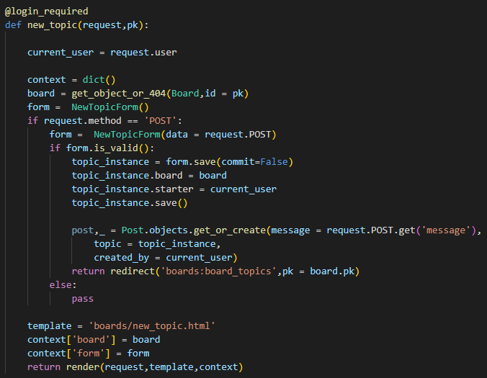

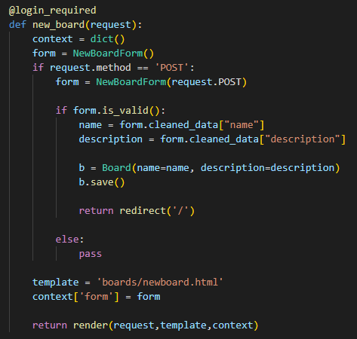

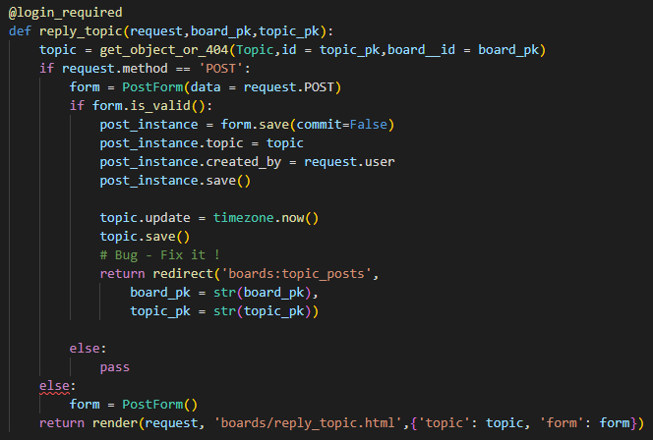

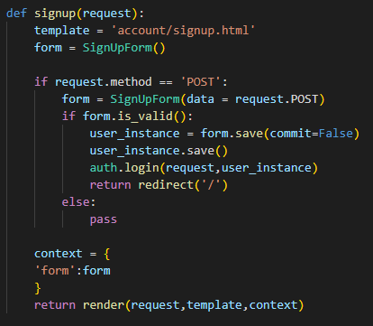

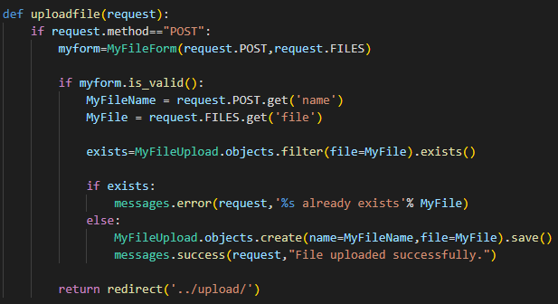

**Technical Details**

The database framework used for this project is SQLite, which is written in the C programming language. One interesting fact about SQLite is that it does not enforce type checking by default, so if we wanted to we could insert an integer into a string column, for example. The languages used for this project are Python, CSS, HTML, and a very small amount of JavaScript. Bootstrap is used for the client-side design of the website, and it makes everything look very smooth. It is also very easy to use. All of these things are accomplished through Django, which is a Python-based web framework that uses models, templates, and views. The Django admin system is also utilized in this project to incorporate an administrator system to manage the website, and the Django Debug toolbar is also used to provide helpful statistics and information.

**Notable Features**

One feature I want to point out is the use of the discussion board system in my website. Not only can users create posts, but they can create specific discussion boards where posts all relate to a certain thing. This is something that could be very useful for many applications in the real world such as a student discussion forum for a class, or perhaps a forum for employees in a company to discuss their current projects and goals.

Another feature that I want to point out is my file management system that allows users to view, upload, and delete files of their choosing to the website. This is something that could also be very useful for both students and employees in a company, as within it students could store class project files, and employees could store work project files.

**Discussion**

When I first started this project, I knew I wanted to make something that was very user friendly and looked very nice. So, I decided to use bootstrap and custom CSS design to implement this website. Bootstrap, a free, open-source CSS framework used for front-end web development, is very simple to use and can make any project look very nice. It was very useful in designing especially when I was creating things like tables, the navigation bar, and the breadcrumbs bar.

Another important thing I had in mind when making this project was that all implemented features were actually fully working as intended, because I don’t like the idea of submitting a project with portions of its implementation that don’t even work correctly. I spent a lot of time on phase one of this project making sure all implementations were correctly working as they are supposed to.