**Design Focus: Architecture and System Design Process**

**Group 15**

Rebecca Parker, Matt Pilgrim, Kaitlyn Zahn

**Table of Contents**

1. Use Case Diagram and Use Case Description – Student Login/Logout
2. Activity Diagram – Instructor Login/Logout
3. Activity Diagram – Student Uploading Files
4. Activity Diagram - Instructor Creating/Editing/Deleting any Course/Section
5. Class Diagram
6. Entity Relationship Diagram
7. Sequence Diagram
8. State Machine Diagram

Use Case Diagram- Student Login/Logout



**Contributors:**

Independent Design: Matt

Careful Review: Kaitlyn



This is an activity diagram for Instructor Login and Logout

**Contributors:**

Independent Design: Rebecca

Careful Review: Kaitlyn

Activity Diagram- Instructor Login/Logout

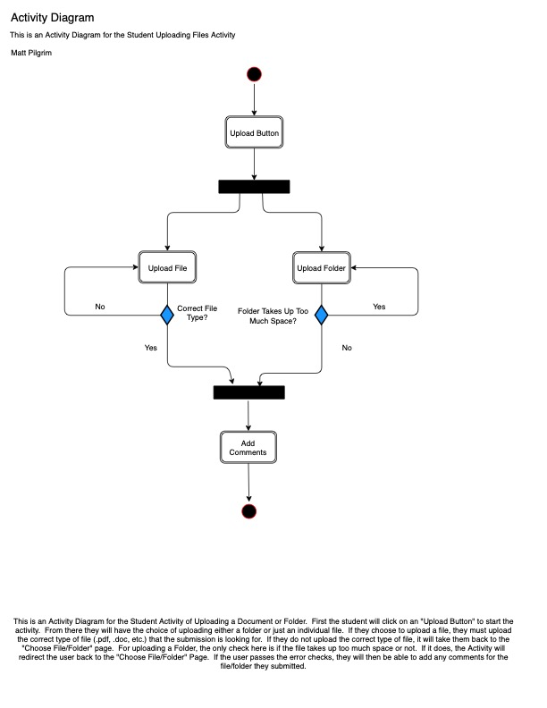

**Contributors:**

Independent Design: Matt

Careful Review: Rebecca

Activity Diagram- Student Uploading Files

Activity Diagram- Instructor Creating/Editing/Deleting any Course/Section



This is an activity diagram that depicts the Instructor’s different choices when accessing a Course Web Page

**Contributors:**

Independent Design: Kaitlyn

Careful Review: Matt



This is a class diagram that depicts the system’s capabilities for users

**Contributors:**

Independent Design: Rebecca

Careful Review: Matt

Class Diagram



This is an Entity Relationship Diagram that explains the relationship between aspects of the system and its capabilities

**Contributors:**

Kaitlyn, Rebecca, Matt design collaboration

Entity Relationship Diagram

Sequence Diagram- TA Can Search Students in Course



This is a sequence diagram that explains the process that the system goes through when a TA searches for students

**Contributors:**

Independent Design: Kaitlyn

Careful Review: Rebecca

State Machine Diagram- System Administrator Add/Edit/Remove/Disable Instructor



**Contributors:**

Independent Design: Rebecca

Careful Review: Matt, Kaitlyn