AAI ↔ FIRMS / Dust-Catalog Event Validation
Version 1.0 — 30 May 2026. Authored against the post-M-DIAG-A1 engine state. Single source of truth for this validation. Data: analysis/aai_firms_validation.csv (308 per-day rows) + analysis/aai_firms_event_summary.csv (15 cases). Reproduce: analysis/aai_firms_extract.py → analysis/aai_firms_validation.ipynb.

§1 Summary
Does AAI catch known smoke/dust events post-M-DIAG-A1? — Partly, and the answer depends on which AAI metric you ask about.
- The M-DIAG-A1 fix is confirmed live and behaving as intended. Across all 15 cases the per-day high-frequency flag hf is intermediate (0.14–0.56), never saturated at 0 or 1 — the pre-fix tropical artefact (every day firing) is gone. The per-day series reconstructed in this validation matches the engine’s official hf to machine precision in all 15 cases, so the reconstruction is engine-faithful and the conclusions below transfer directly to production.
- High sensitivity at the per-day level. The documented peak window contained at least one hot AAI day (z ≥ 2.0) in 9 of 10 events (90 %) — fires 5/5 (100 %), dust 4/5 (80 %).
- Poor specificity at the per-day level. All 5 negative controls (100 %) also fired at least one hot day during their known-clean window. The per-day z ≥ 2.0 flag is therefore a sensitive but non-specific detector — it lights up on quiet days too.
- The aggregate z never reaches the 2.0 screening threshold for any event (max +1.04) or control (max +1.20), and it goes negative on real events (Dakar −3.39, NSW Black Summer −0.85). As an aggregate flag at threshold 2.0, AAI would have missed every one of these major events.
The net read: post-M-DIAG-A1 AAI does respond to real smoke/dust — raw AAI and per-day z rise clearly during fires — but the engine’s anomaly construction (local site-vs-25 km-ring, baseline computed over the same window) neither cleanly fires at the aggregate level nor stays quiet on controls. The behaviour is dominated by a small-bg_std regime that inflates per-day z and a contaminated-ring regime that suppresses aggregate z. Both are calibration issues, not data issues, and both are concrete inputs to the calibration sweep (§7–§8).

§2 Method

Event-based design
We ask “did AAI fire when and where a documented event occurred,” not “does AAI correlate with something continuously.” 10 events (5 fires, 5 dust) + 5 negative controls.

Hard constraint — AAI start date
The engine’s AAI asset is COPERNICUS/S5P/OFFL/L3_AER_AI (Sentinel-5P, OFFL only), band absorbing_aerosol_index. Sentinel-5P AER_AI data begins ~2018-07. Three events proposed in the original brief (2017 Portugal, 2010 Russia, 2009 Sydney) have no AAI data at all and were replaced with post-2018 equivalents (Dixie 2021, Evros 2023, etc.).

FIRMS — ground truth, not an engine input
FIRMS is not in the GSCO engine catalog (the brief assumed it was). It is read here directly as a public EE asset, ee.ImageCollection("FIRMS") (bands T21, confidence, line_number), purely to confirm fire events happened where/when expected. Fire-pixel counts are summed over a 50 km buffer per UTC day. Dust events have no FIRMS signal by nature.

Engine fidelity — why the per-day series is reconstructed
The screening engine computes the per-day is_hot flag server-side in engine/core/repeatable_core.py::_server_side_hf::per_image and returns only the aggregate hf = n_hot_days/n_valid_days to callers. To plot a per-day z time series we re-run the identical reduction in analysis/aai_firms_extract.py:
- Build the scaled IC via engine.air._build_image_collection.
- Background (bg_median, bg_std) via engine.core.repeatable_core.background_value over the land-masked annulus 5–25 km (background_ring, Indicators_Computation_v4 §6.2), computed over the same event window — the engine has no climatology baseline for AAI, and the seasonal filter is a no-op (seasonality.py does not exist).
- Per-granule z = (site_mean − bg_median)/bg_std; is_hot = z ≥ 2.0 ∧ valid; a UTC day is hot if any granule that day fires — exactly per_image after the M-DIAG-A1 {band}_mean-key fix.
The notebook asserts |recon_hf − engine_hf| < 1e-9 for all 15 cases (it passes), and carries the engine-official aggregate z/hf from compute_pollutant_snapshot(…, "aai", …) alongside as an independent cross-check.

Parameters
radius_km = 5 (the production-seed standard, demo/saved_analyses/*.json); ANOMALY_Z_THRESHOLD = 2.0; event window = peak − 5 d … peak + 5 d; control window = ~30 d ending before the event.

Event set (locked)
# | Type | Location (lat, lon) | Peak window | Source
1 | Fire | Quebec, CA (49.7, −76.0) | 2023-06-01 → 06-08 | 2023 Canadian wildfires
2 | Fire | SF Bay Area (37.7, −122.2) | 2020-09-09 → 09-16 | CA Aug/Sep 2020 complex (“orange sky”)
3 | Fire | NSW, AU (−35.5, 150.0) | 2019-12-30 → 2020-01-04 | Black Summer
4 | Fire | N. California (40.0, −121.2) | 2021-08-05 → 08-15 | Dixie Fire
5 | Fire | NE Greece (41.0, 26.2) | 2023-08-21 → 08-28 | Evros wildfires
6 | Dust | Puerto Rico (18.2, −66.5) | 2020-06-22 → 06-25 | “Godzilla” Saharan plume
7 | Dust | Beijing (39.9, 116.4) | 2021-03-15 → 03-16 | Beijing dust storm
8 | Dust | Baghdad (33.3, 44.4) | 2022-05-15 → 05-18 | Iraq sandstorm
9 | Dust | Phoenix (33.4, −112.0) | 2021-07-09 → 07-10 | Monsoon haboob
10 | Dust | Dakar (14.7, −17.4) | 2021-03-13 → 03-17 | Sahel/Bodélé dust outbreak
Controls: Quebec (2023-05), Bay Area (2020-07-15→08-14, before the 08-16 siege), Puerto Rico (2020-05-15→06-14), Beijing (2021-02), Phoenix (2021-06, pre-monsoon).

§3 Per-event findings
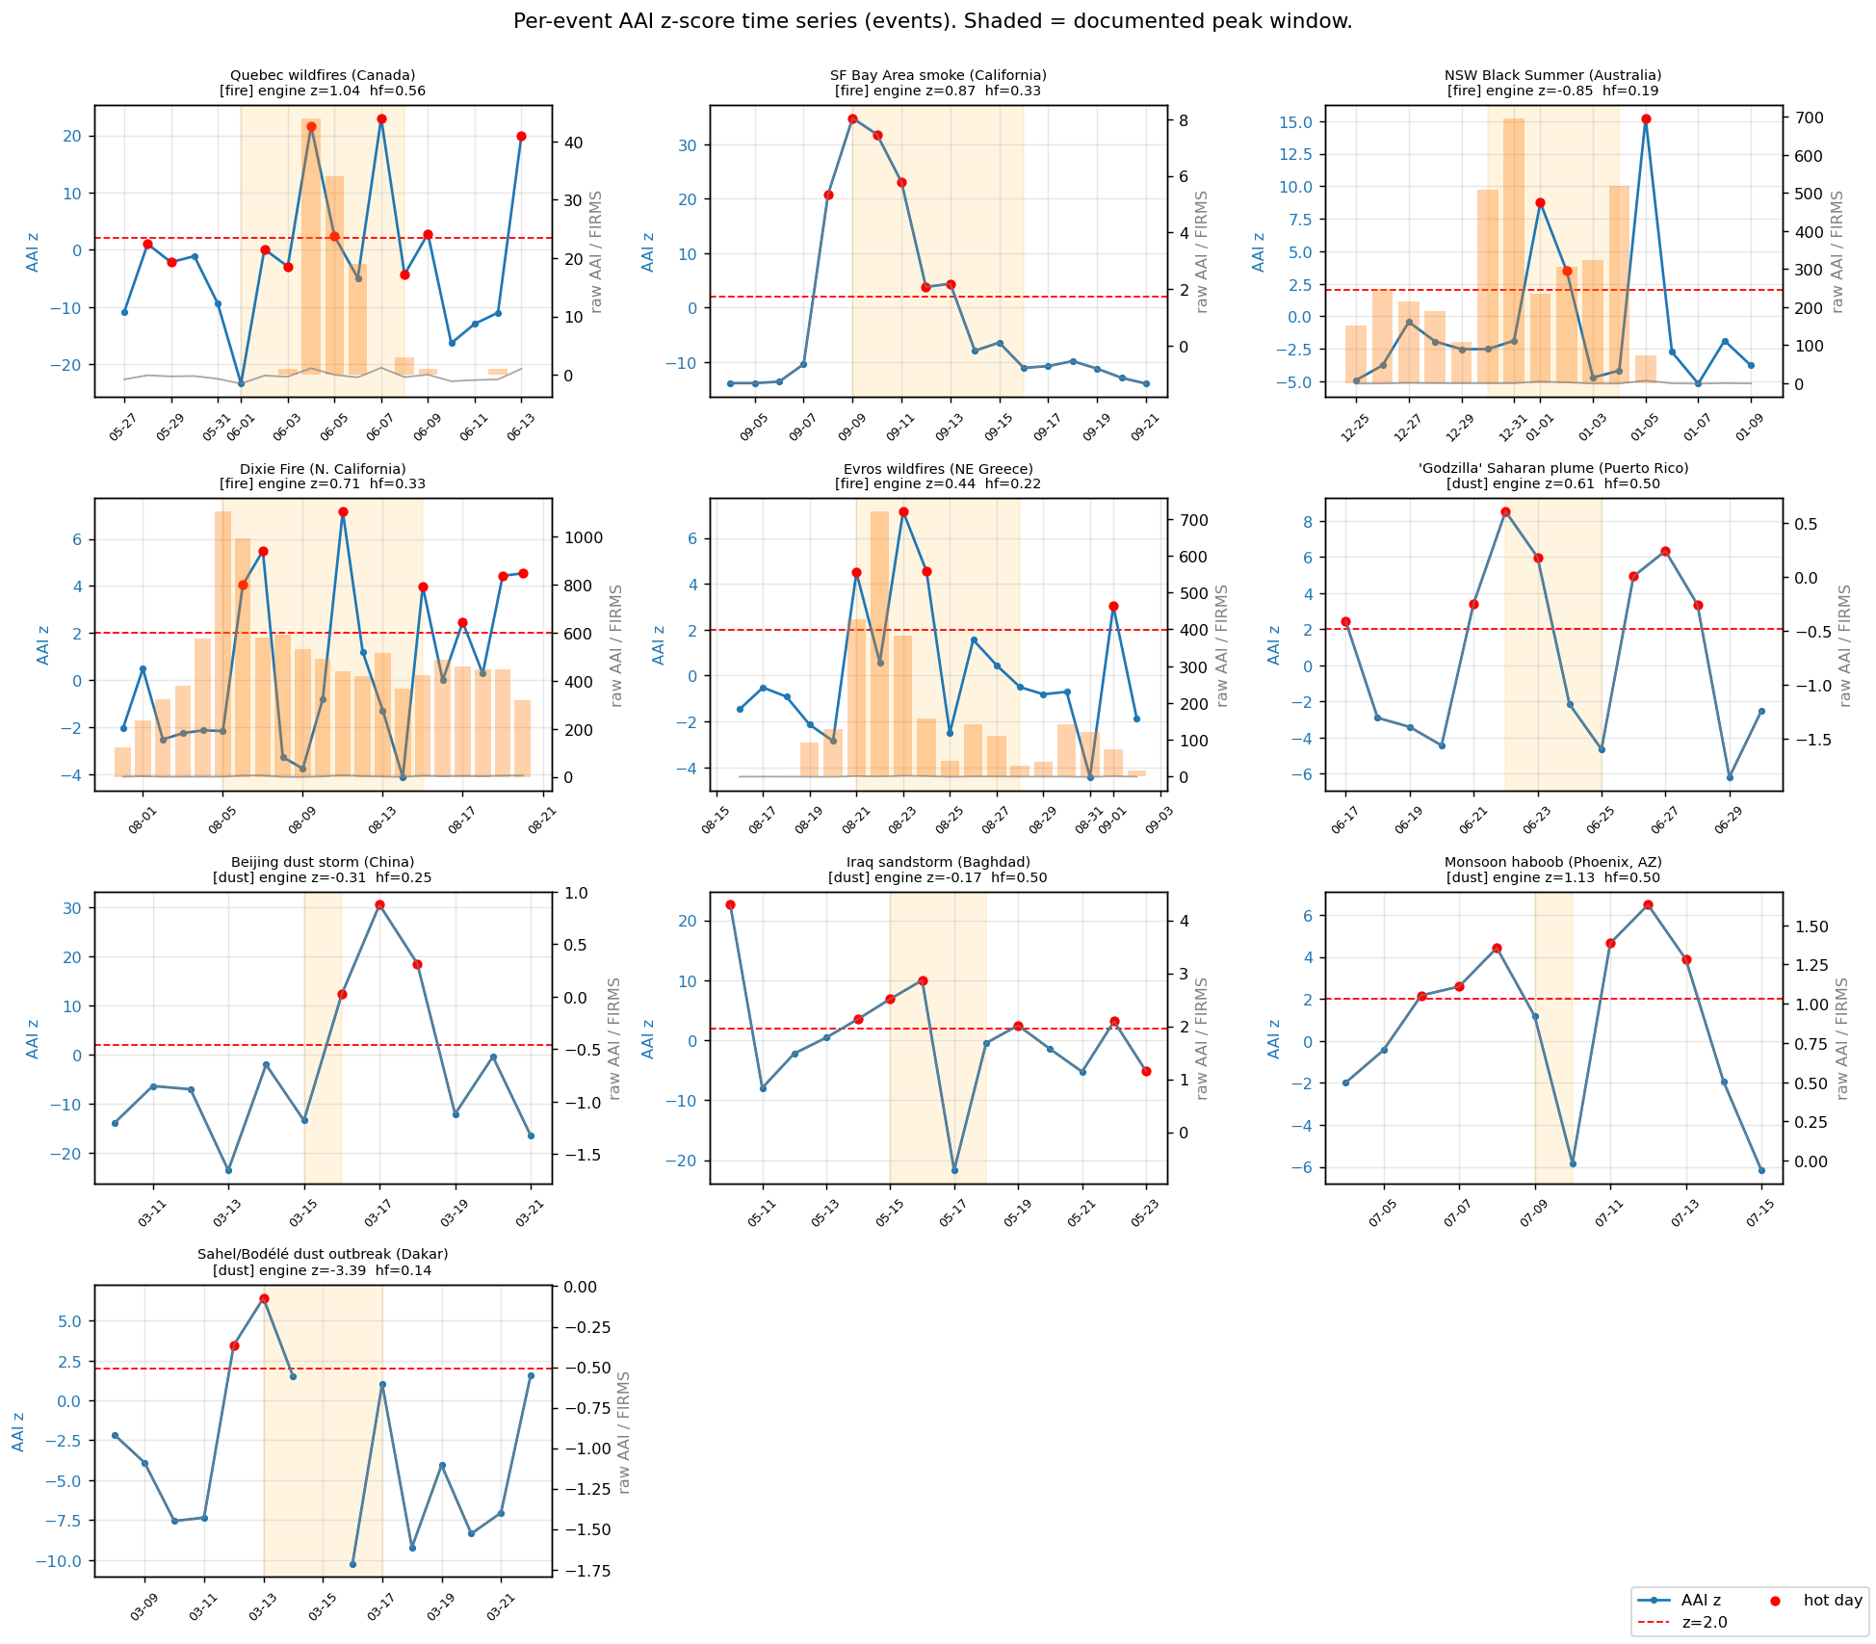
Per-event AAI z time series
Blue = per-day AAI z (left axis); red dashed = z = 2.0; red dots = hot days; grey = raw AAI (right axis); orange bars = FIRMS fire pixels; shaded = documented peak window.
Per-event detail (analysis/aai_firms_event_summary.csv):
Event | Type | Peak hit? | max z in peak | peak raw AAI | FIRMS px (peak) | engine z | engine hf | bg_std
Quebec 2023 | fire | ✓ | 23.0 | 1.19 | 101 | 1.04 | 0.56 | 0.059
SF Bay Area 2020 | fire | ✓ | 34.8 | 8.04 | 0 (transported) | 0.87 | 0.33 | 0.192
NSW Black Summer | fire | ✓ | 8.7 | 4.43 | 2 588 | −0.85 | 0.19 | 0.389
Dixie 2021 | fire | ✓ | 7.2 | 6.95 | 6 439 | 0.71 | 0.33 | 0.666
Evros 2023 | fire | ✓ | 7.2 | 2.22 | 2 017 | 0.44 | 0.22 | 0.281
Godzilla (PR) 2020 | dust | ✓ | 8.5 | 0.61 | — | 0.61 | 0.50 | 0.168
Beijing 2021 | dust | ✓ | 12.3 | 0.02 | — | −0.31 | 0.25 | 0.047
Baghdad 2022 | dust | ✓ | 10.0 | 2.87 | — | −0.17 | 0.50 | 0.113
Phoenix 2021 | dust | ✗ MISS | 1.18 | 0.92 | — | 1.13 | 0.50 | 0.134
Dakar 2021 | dust | ✓ | 6.4 | −0.07 | — | −3.39 | 0.14 | 0.099
Notable cases:
- SF Bay Area (transported smoke). Zero FIRMS pixels within 50 km — the CZU/SCU fires were 60–150 km away — yet AAI fired hard (raw AAI 8.04, peak z 34.8). AAI correctly caught the transported smoke pall, which is exactly the proxy claim and is a genuine strength.
- Phoenix (the one miss). A single-day haboob; the peak window is only two days and the local 5 km vs 25 km contrast over a uniformly dusty scene never crossed z = 2.0 (max z 1.18). Short, spatially-uniform events are the worst case for a local, same-window anomaly.
- Dakar (aggregate z = −3.39). The 5 km site sat inside a region whose 5–25 km ring was even dustier (Bodélé source to the interior), so the local anomaly is strongly negative during a real dust outbreak. The per-day flag still caught it (2 hot days) on transient within-window variation.
- Beijing (raw AAI ≈ 0 but z huge). Clean-air AAI here is strongly negative (bg_median −0.55) with a tiny bg_std (0.047); a modest absolute rise produces z up to 30. Illustrates the small-bg_std amplification (§5).

§4 Catch rate
Per-day z ≥ 2.0 during the documented peak window:
Cohort | Catch rate
Overall | 9 / 10 = 90 %
Fires | 5 / 5 = 100 %
Dust | 4 / 5 = 80 %
Aggregate z ≥ 2.0 (the engine’s headline anomaly): 0 / 10. No event’s aggregate z reaches 2.0 (max +1.04). The catch rate is entirely carried by the per-day flag, not the aggregate.
Event-type comparison. Fires score a perfect per-day catch and produce clearly elevated raw AAI (1.2–8.0). Dust catches one fewer (Phoenix) and — importantly — produces only modest raw AAI at these sites (−0.07 to 2.87); dust is detected mostly through the negative-baseline contrast, not a large absolute signal. AAI is theoretically equally sensitive to smoke and dust, but in this local-anomaly construction fires are the more reliably-caught class.

§5 False-positive rate
Per-day z ≥ 2.0 during the known-clean control window:
Control | hot days | per-day hf | max day z | engine z | bg_std
Quebec (pre-season) | 14/30 | 0.47 | 16.4 | 0.64 | 0.054
Bay Area (pre-siege) | 6/30 | 0.20 | 10.4 | 0.77 | 0.270
Puerto Rico | 9/30 | 0.30 | 4.4 | −0.01 | 0.212
Beijing (winter) | 12/30 | 0.40 | 31.6 | −0.46 | 0.040
Phoenix (pre-monsoon) | 11/29 | 0.38 | 14.4 | 1.20 | 0.125
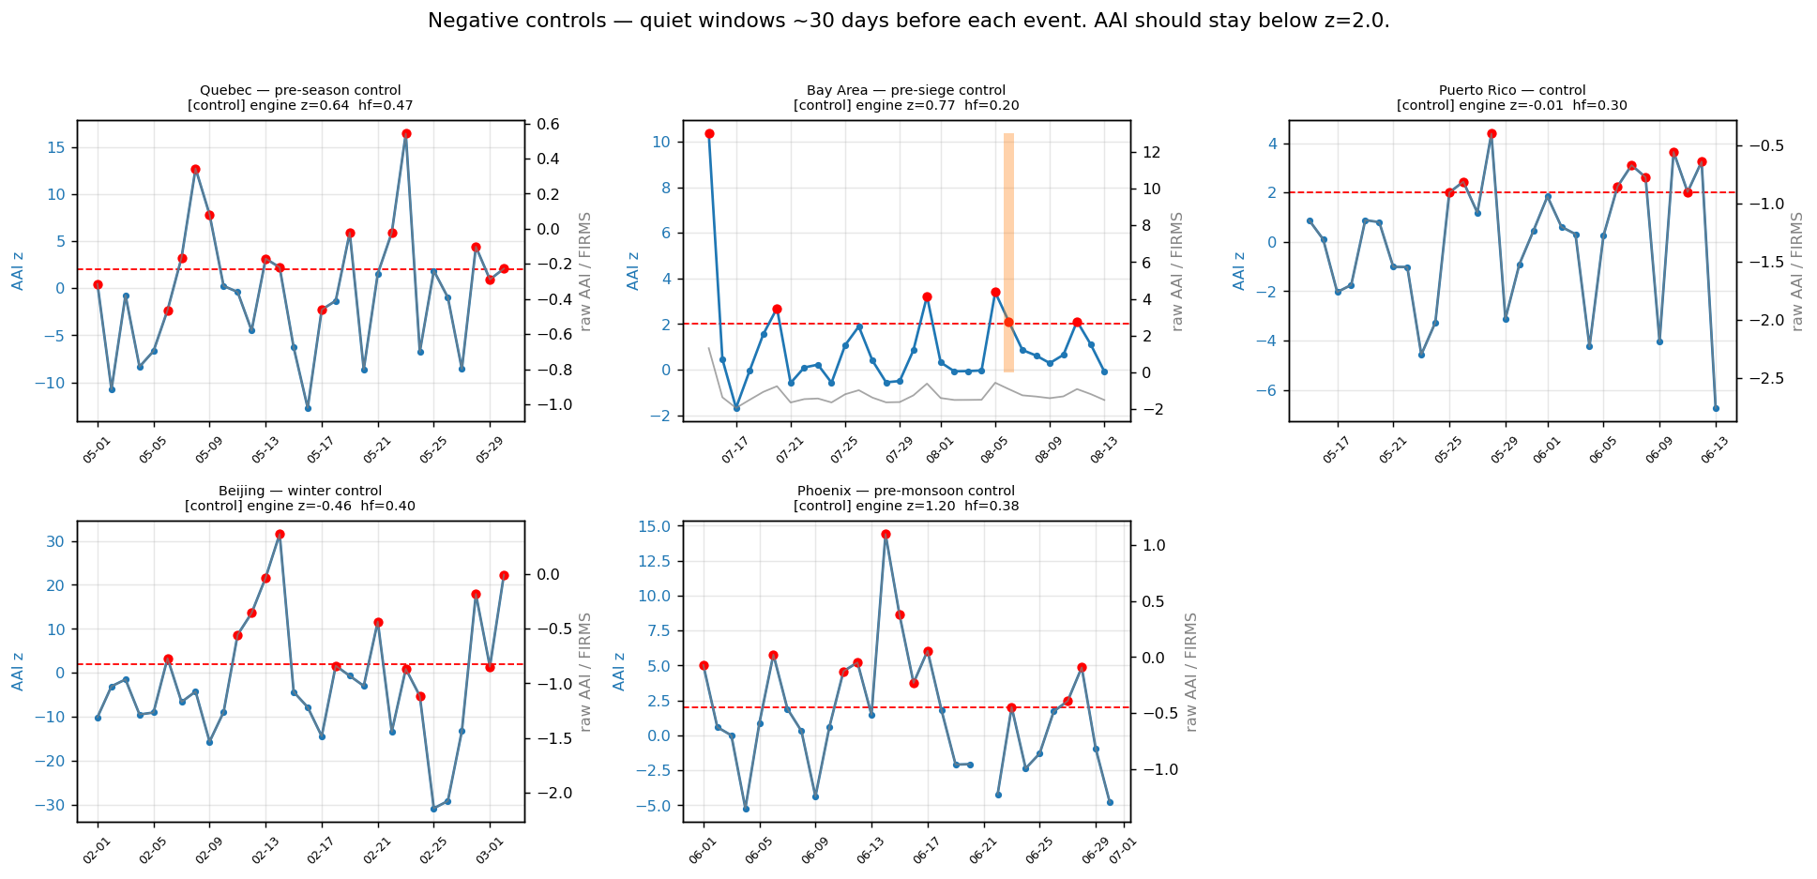
Negative-control AAI z time series
False-positive rate = 5 / 5 controls (100 %) fired at least one hot day. The per-day flag is not specific. (Aggregate z ≥ 2.0: 0/5 controls — the aggregate is quiet on controls, but it is also quiet on events, so that is not discrimination.)
Separability is weak on both metrics:
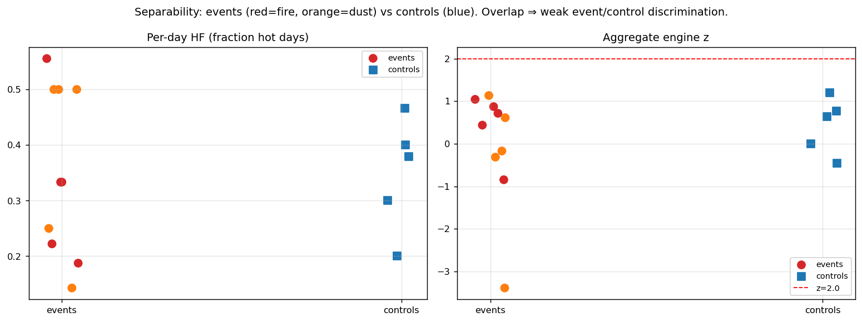
Separability
- Per-day hf: events 0.14–0.56, controls 0.20–0.47 — fully overlapping.
- Aggregate z: events −3.39…+1.04, controls −0.46…+1.20 — overlapping, both far below 2.0.
The driver is a collapsing bg_std (0.04–0.27 across cases; e.g. Beijing control bg_std = 0.040 → max day z 31.6). A near-zero denominator turns ordinary clean-air fluctuation into a “hot” day. This is the same denominator-collapse family that M-DIAG-A1 diagnosed, but on the background-std side; M-DIAG-A1 fixed the numerator (the silently-zeroed site_mean) and explicitly did not touch the small-bg_std regime (see docs/M-DIAG-A1_diagnosis_report.md §7 and the engine/constants.py Q-WA-1 note).

§6 Where AAI diverges (honest about both)
Misses (false negatives): - Phoenix haboob — only miss at the per-day level: a single-day, spatially-uniform desert dust event never crosses z = 2.0 against its own 5–25 km ring. - Every event at the aggregate level — no aggregate z reaches 2.0; NSW (−0.85) and Dakar (−3.39) are negative during unambiguous events because the background ring is contaminated by (or more intense than) the same regional plume.
False alarms (false positives): - All 5 controls fire ≥ 1 hot day. Beijing-winter and Quebec-pre-season are the worst (max day z 31.6 and 16.4) — both have tiny bg_std, so clean-air noise is amplified into hot days.
Structural reading. AAI’s data clearly responds to real events (raw AAI and per-day z rise during fires; transported smoke is caught at Bay Area). The failures are properties of the anomaly construction, not the AAI data: 1. Same-window background → sustained/regional events raise both site and ring, cancelling the anomaly (suppresses aggregate z, can go negative). 2. Small bg_std → per-day z is over-sensitive at clean, low-variance locations (inflates per-day hf, kills specificity).

§7 Implications for calibration
- Floor bg_std (regime-aware z). A minimum-bg_std floor (or a robust scale estimate) would stop the per-day flag from firing on near-zero-variance clean air. Beijing/Quebec controls would stop false-firing. This is the most direct fix and is the natural extension of the M-DIAG-A1 line of work to the denominator.
- Climatological, not same-window, baseline for AAI. Compute bg_median/bg_std from a prior reference period (e.g. same calendar month, previous year, or a trailing 90 d) rather than the event window. This would prevent regional plumes from contaminating their own baseline and would let the aggregate z actually rise on events like NSW and Dakar. (Requires the deferred engine/core/seasonality.py or a climatology fallback for AAI.)
- An absolute-AAI gate for widespread events. A simple “raw AAI ≥ X” co-trigger would catch spatially-uniform events (Phoenix, regional dust) that the local-contrast detector structurally cannot. Fires already show clearly elevated raw AAI; dust at some sites does not, so the gate would need to be tuned per regime.
- The per-day flag is sensitive, the aggregate z is (currently) inert. If AAI screening leans on aggregate z at threshold 2.0 it will miss real events; if it leans on per-day hf it will over-fire. The calibration sweep should decide which metric carries the AAI proxy and set its threshold against this event/control set.
- The M-DIAG-A1 fix itself is not implicated. It does what its name implies — per-day hf is now intermediate and engine-faithful. The remaining misbehaviour is upstream (baseline construction) and downstream (threshold choice), not the per-day key-naming fix.

§8 Open questions for the calibration-sweep spec
- Which AAI metric is the proxy — aggregate z, per-day hf, raw absolute AAI, or a composite? This validation shows the first is inert at 2.0 and the second is non-specific.
- What bg_std floor (and estimated how — fixed minimum, MAD-based, percentile) removes control false-positives without killing event sensitivity? Sweep against the 5 controls here.
- Same-window vs climatological baseline for AAI — is a climatology baseline worth the seasonality/fallback work, given how badly the same-window baseline performs on regional events (Dakar, NSW)?
- Regime-aware thresholds — should fire vs dust (or column-loading regime) use different z thresholds or different metrics, given fires produce large raw AAI and dust often does not?
- AOI radius sensitivity — all results use radius_km = 5. Does pushing the background ring out (larger site, ring at 100–200 km) restore event/control separability for regional plumes, and is that compatible with the production AOI contract?
- Should this event/control set be folded into the standing calibration fixtures, alongside the diagnostic seeds, so threshold changes are regression-tested against known events?

Deliverables: this report (docs/aai_firms_validation.md), the notebook (analysis/aai_firms_validation.ipynb), the per-day table (analysis/aai_firms_validation.csv), the per-event summary (analysis/aai_firms_event_summary.csv), and the extraction harness (analysis/aai_firms_extract.py). No engine code was modified. Word export at docs/aai_firms_validation.docx (Step F).

