Table of Contents

GHG ↔ ODIAC + OCO-2/OCO-3 — Empirical Validation Report
Investigation milestone. Status: DRAFT (Step G complete; pending operator review of §9). Date authored: 30 May 2026. Authority pointer: GHG↔ODIAC+OCO-2/OCO-3 Validation brief (operator-side, 30 May 2026). Scope guard: empirical validation only. No engine code, thresholds, score logic, or seeds were changed. Analysis artefacts live in analysis/ and docs/, never in engine/ or ui/. Supporting evidence: analysis/ghg_odiac_validation.ipynb (executed), analysis/ghg_odiac_validation.csv (the data table), analysis/plots/*.png (the seven figures).

§1. Summary
The GHG pillar’s VIIRS activity proxy is validated; its CH₄ anomaly-z proxy is not. Across 25 stratified locations, VIIRS nightlights track ODIAC fossil-CO₂ emissions with a moderate-to-good rank correlation (Spearman 0.70 overall, n=25) — the two industrial-activity signals agree, as a working proxy should. The CH₄ anomaly z-score, by contrast, shows no relationship to ODIAC (Pearson −0.00, Spearman −0.01, n=23) and — the headline gap — fired its z>1.5 threshold at only 1 of 25 sites (Mpumalanga, coal), missing every oil/gas site and every landfill, the two regimes it is meant to detect. Landfills, the most CH₄-diagnostic regime in the design, sit low on the CH₄ axis: at the 5 km screening radius, Sentinel-5P TROPOMI’s ~7 km native CH₄ footprint and the site-minus-background construction wash the point-source plume into the local background.
Against atmospheric CO₂ (OCO-2/OCO-3 XCO₂), the picture is the one atmospheric transport predicts: XCO₂ column enhancement does not track the activity proxy in general (overall |Spearman| ≤ 0.17) — local emissions rarely produce a clean local column signal because the column is dominated by well-mixed background and is smeared by wind. The one regime where it does work is coal-fired power, the cleanest fossil-CO₂ point sources, where both VIIRS (Spearman 1.0) and raw CH₄ concentration (Spearman 0.8) track the AOI-vs-background XCO₂ delta. Oil/gas and landfills correctly show no XCO₂ tracking — consistent with them being CH₄, not CO₂, emitters.
The headline number for “does it work”: VIIRS↔ODIAC Spearman 0.70 (activity proxy validated); CH₄-z↔ODIAC ≈ 0 with a 1/25 firing rate (CH₄ proxy gap confirmed); XCO₂ agreement confined to the coal regime (transport-limited elsewhere). The proxy captures industrial activity well through VIIRS and captures fossil-CO₂ point sources where ODIAC and XCO₂ agree; it misses diffuse and CH₄-dominated sources (landfills, oil/gas) through the CH₄ channel at the current radius and thresholding.
N=25, operator-picked — these findings are illustrative, not statistically conclusive, and the per-regime correlations (n=4–5 each) are noise-prone. They are strong enough to motivate the calibration-sweep questions in §8–§9.

§2. Method

2.1 Locations
Twenty-five locations, five per source-type regime, chosen to span the proxy’s expected behaviour (see analysis/locations.py for coordinates):
Regime | Locations | Design expectation
Urban CO₂-dominant | London, Mexico City, Mumbai, Lagos, Seoul | CH₄ low, VIIRS high, ODIAC high, XCO₂ elevated
Oil/gas CH₄-dominant | Permian, Bakken, Hassi Messaoud, Tengiz, Comodoro | CH₄ high, VIIRS mod-high, ODIAC moderate
Coal-fired power | Bełchatów, Tuoketuo, Vindhyachal, Mpumalanga, Kendal | CH₄ moderate, VIIRS high, ODIAC high, XCO₂ high
Landfill / waste | Sudokwon, Bordo Poniente, Apex (NV), Puente Hills, Olusosun | CH₄ very high, VIIRS low-mod, ODIAC low — most diagnostic
Rural / clean | Patagonia, C. Sahara, C. Australia, Greenland coast, Siberian taiga | all-low
Comodoro reuses the existing engine seed coordinates (−45.8645, −67.4969).

2.2 Windows (locked at Step B, operator confirmation)
- CH₄ + VIIRS: 2025-06-01 → 2025-12-01 (recent, production-style). All at the 5 km production radius.
- ODIAC: 2023 annual (projects/supply-chain-observatory/assets/odiac, 48 monthly grids covering 2020–2023; 2023 is the latest vintage). ODIAC stops at 2023, so it necessarily lags the CH₄/VIIRS window by ~2.5 years — a temporal-aggregation mismatch (see §7).
- OCO XCO₂: 2025-06-01 → 2025-12-01 (aligned with CH₄/VIIRS). Per-location soundings pooled from a ±0.25° (~25 km) box, OCO-2 (v11.2r) and OCO-3 (v11r) combined, good-quality only (xco2_quality_flag == 0).

2.3 What each input and benchmark is
- GHG raw inputs were read directly from the engine’s stateless snapshot functions (engine.ghg.compute_ch4_snapshot, compute_viirs_activity, compute_co2_snapshot) at the production radius — the same code the screening run executes. The raw z (not the bucketed severity) and raw VIIRS (not the bucketed value) were used. The GHG composite (ghg.core_audit_support, CH₄+VIIRS — ODIAC is demoted from the live composite per M5.5b) is carried for context only.
- ODIAC (NIES Japan) is a bottom-up fossil-fuel CO₂ emissions inventory, not an observation. National statistics are allocated to a 1 km grid using point-source databases and nightlights. It answers “where is fossil CO₂ emitted”. The engine samples it as an AOI-mean over the buffer; for this validation a centre-point sample was added so both point and AOI-mean are surfaced (annualised t CO₂/cell, identical units).
- OCO-2 / OCO-3 XCO₂ (NASA ACOS L2 Lite FP) is the column-averaged atmospheric CO₂ dry-air mole fraction retrieved from reflected sunlight. It answers “what is the CO₂ concentration in the air column”. OCO-2 flies a narrow nadir/glint swath; OCO-3 adds Snapshot Area Map (SAM) targeting that densely samples cities and point sources. OCO is not available in Earth Engine (confirmed in Step A across the official catalog, the community mirror, and direct asset probing); XCO₂ was sourced outside EE via earthaccess from NASA GES DISC.

2.4 Extraction and analysis
analysis/extract_part_a.py runs the engine per location (ODIAC on its 2023 window, CH₄/VIIRS on the 2025 window) and writes the Part A columns. analysis/extract_part_b.py scans every OCO-2 (173) and OCO-3 (180) daily-global granule in the window — there is no per-location server-side subsetting for these sounding products — and for each location pools good-quality soundings inside the AOI box and a 0.25°–1.0° background annulus. The XCO₂ delta = AOI-box mean − background-annulus mean; because AOI and ring soundings come from the same overpasses, the seasonal/latitudinal column gradient largely cancels in the delta. A location needs ≥5 AOI and ≥20 background soundings to report a delta. Analysis and the seven figures are produced by analysis/analysis_plots.py and rendered in the notebook.

§3. Part A findings — activity validation (vs ODIAC)

3.1 VIIRS tracks ODIAC; CH₄ anomaly z does not
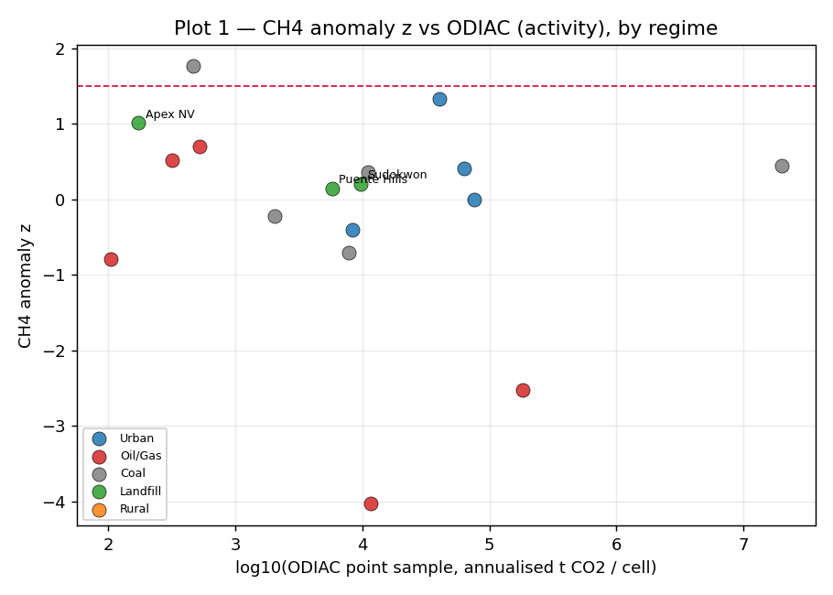
Plot 1 — CH4 anomaly z vs ODIAC
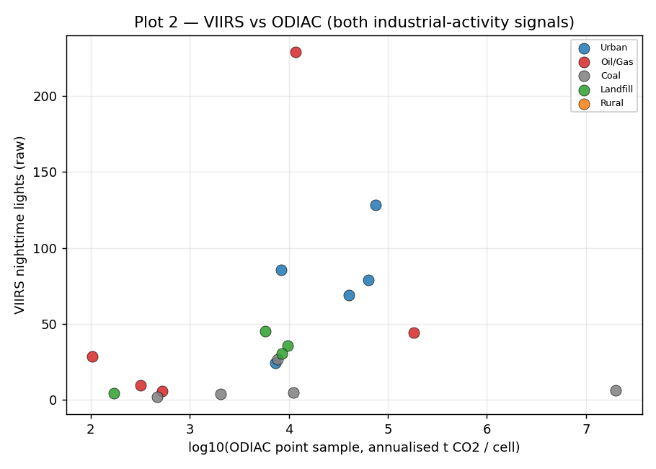
Plot 2 — VIIRS vs ODIAC
Per-regime and overall correlations (vs log₁₀ ODIAC point sample):
Regime | CH₄–ODIAC Pearson | CH₄–ODIAC Spearman | n | VIIRS–ODIAC Pearson | VIIRS–ODIAC Spearman | n
Urban | 0.44 | 0.20 | 4 | 0.66 | 0.70 | 5
Oil/Gas | −0.72 | −0.50 | 5 | 0.42 | 0.50 | 5
Coal | −0.15 | −0.10 | 5 | 0.03 | 0.70 | 5
Landfill | −0.63 | −0.60 | 4 | −0.12 | −0.10 | 5
Rural | n/a (ODIAC=0) | n/a | 5 | n/a (ODIAC=0) | n/a | 5
ALL | −0.00 | −0.01 | 23 | 0.38 | 0.70 | 25
VIIRS↔ODIAC is the proxy-works signal: both are industrial-activity measures and they agree in rank (Spearman 0.70 overall, 0.70 within urban and coal). The Pearson is lower (0.38) because a handful of mega-emitter ODIAC cells (Bełchatów’s point sample hits ~2×10⁷ t CO₂/cell) stretch the linear axis; rank correlation is the honest statistic here.
CH₄ anomaly z↔ODIAC is flat-to-negative (overall ≈ 0; oil/gas −0.72, landfill −0.63). The negative within-regime slopes are not a hidden inverse signal — they are noise around a detector that is not responding to the emission field at all (§6.1).

3.2 Divergence cases — does CH₄ fire where it should?
CH₄ anomaly z firing at the z>1.5 threshold, by regime:
Regime | Fired (z>1.5) | Did not fire
Urban | (none) | London, Mexico City, Mumbai, Seoul — correct (urban is CO₂/VIIRS-driven, not CH₄)
Oil/Gas | (none) | Permian, Bakken, Hassi Messaoud, Tengiz, Comodoro — should have fired
Coal | Mpumalanga | Bełchatów, Tuoketuo, Vindhyachal, Kendal
Landfill | (none) | Sudokwon, Bordo Poniente, Apex, Puente Hills — should have fired (most diagnostic)
Rural | (none) | all five — correct
The detector is right for the wrong-direction regimes and wrong for the right-direction regimes: it correctly stays silent at urban and rural sites, but it also stays silent at every oil/gas and every landfill site — exactly where a CH₄ proxy must speak. Only Mpumalanga (z=1.76) clears the bar, and the single highest z in the whole set is 1.76. This is the central proxy gap (diagnosed in §6.1). Hassi Messaoud, a gas-flaring site bright in VIIRS (228.8, the set maximum), returns CH₄ z = −4.03 — the detector reads it as anomalously clean (see §6.1 for why the desert background ring does this).

3.3 ODIAC sampling robustness (point vs AOI-mean)
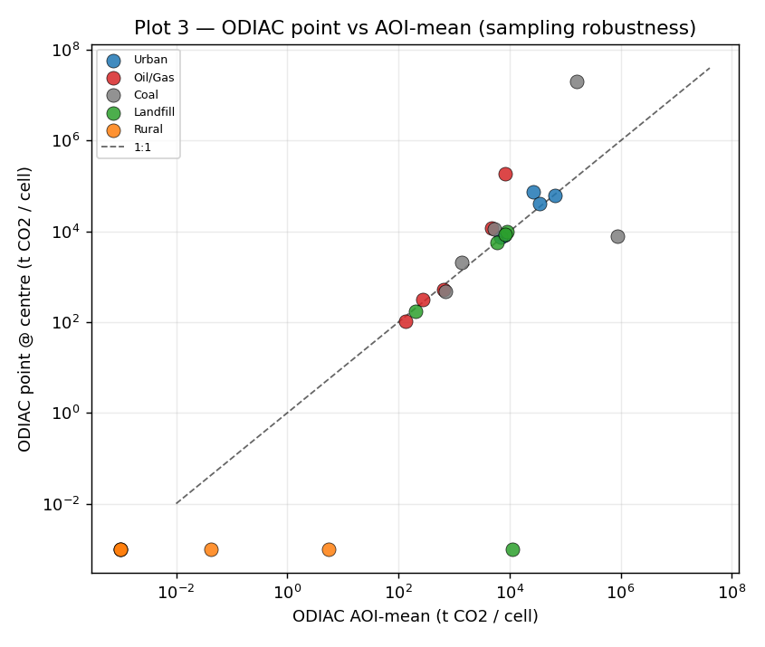
Plot 3 — ODIAC point vs AOI-mean
The centre-point ODIAC sample and the radius-averaged AOI-mean agree well in rank (Spearman 0.81, n=19 non-zero), so the validation is not an artefact of which sampling the engine uses. They diverge sharply at point sources, in both directions: Bełchatów’s point cell (~2×10⁷ t CO₂/cell) far exceeds its AOI-mean (~1.6×10⁵) because the buffer dilutes one mega-emitter cell, whereas Vindhyachal’s AOI-mean (~8.7×10⁵) far exceeds its point sample (~7.8×10³) because the centre coordinate fell beside the plant cell. This sub-pixel sensitivity is itself a caution for any ODIAC-based scoring (§7).

3.4 The proxy’s two axes
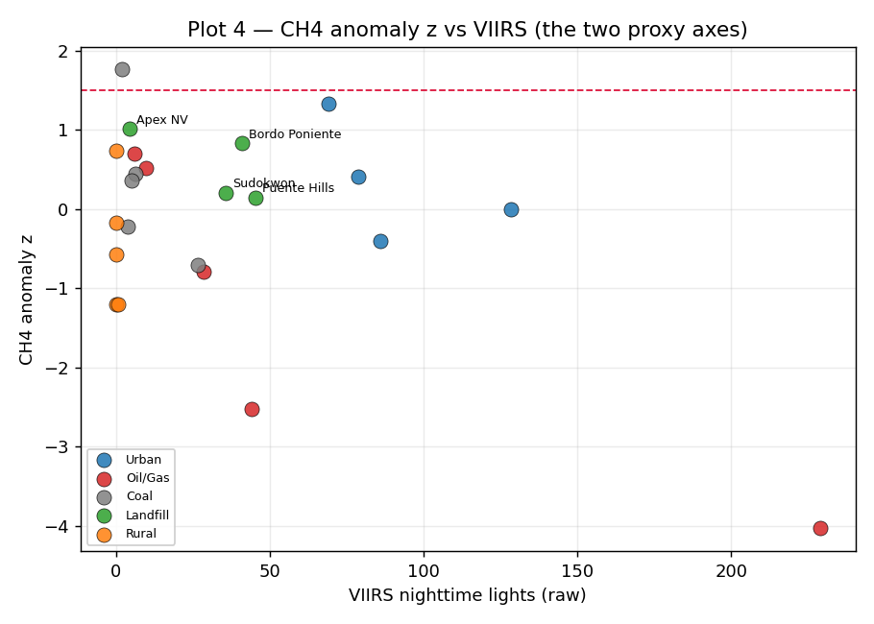
Plot 4 — CH4 anomaly z vs VIIRS
Plotting the two GHG raw axes against each other shows the regimes separate horizontally (VIIRS) but not vertically (CH₄ z) — the vertical spread is ~±1 z for almost every regime, with no regime lifted into the firing band. The proxy’s discriminating power in this set comes almost entirely from VIIRS.

§4. Part B findings — concentration validation (vs OCO-2/OCO-3 XCO₂)

4.1 Coverage (honest first)
Full-window scanning recovered usable XCO₂ at 24 of 25 locations — better than the narrow-swath sampling feared at Step A. Only Siberian taiga returned zero good soundings in the window. Coverage is highly uneven, and the conclusions weigh it accordingly:
Coverage tier | Locations (good AOI soundings)
Dense (>2000) | Puente Hills 16160 (OCO-3 SAM over the LA basin), Seoul 3661, Mexico City 3502, Bordo Poniente 3465, Kendal 2496, Bełchatów 2247
Moderate (200–2000) | Tuoketuo, Tengiz, Permian, London, C. Australia, Mpumalanga, Apex, Patagonia, Comodoro, Vindhyachal, Bakken
Sparse (<200) | C. Sahara 184, Sudokwon 127, Olusosun 53, Lagos 50, Mumbai 46, Greenland 20, Hassi Messaoud 16
None | Siberian taiga 0
Sparse-coverage deltas (Sudokwon, Mumbai, Greenland, Hassi Messaoud) are weak evidence and are flagged as such wherever they appear in a conclusion.

4.2 XCO₂ enhancement does not track activity — except at coal
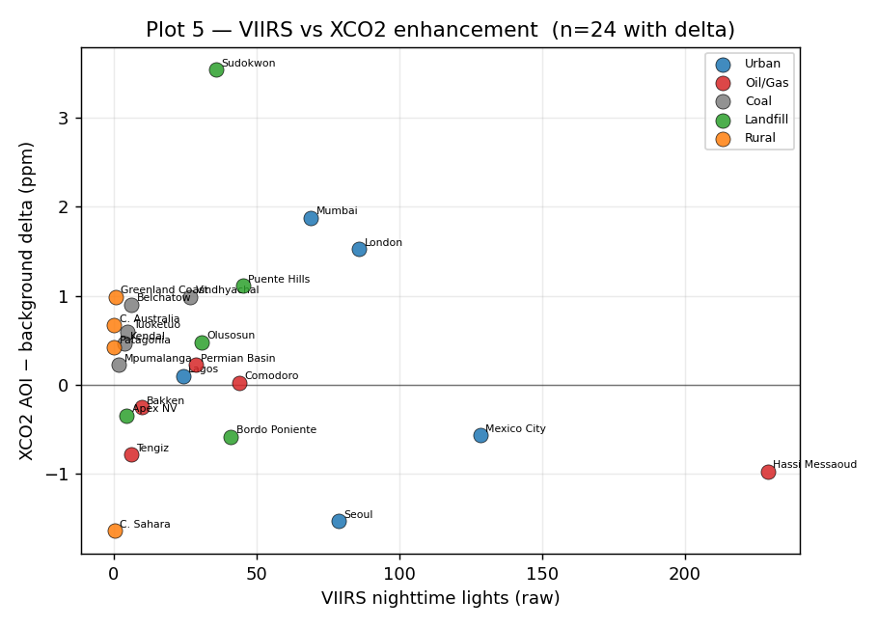
Plot 5 — VIIRS vs XCO2 enhancement
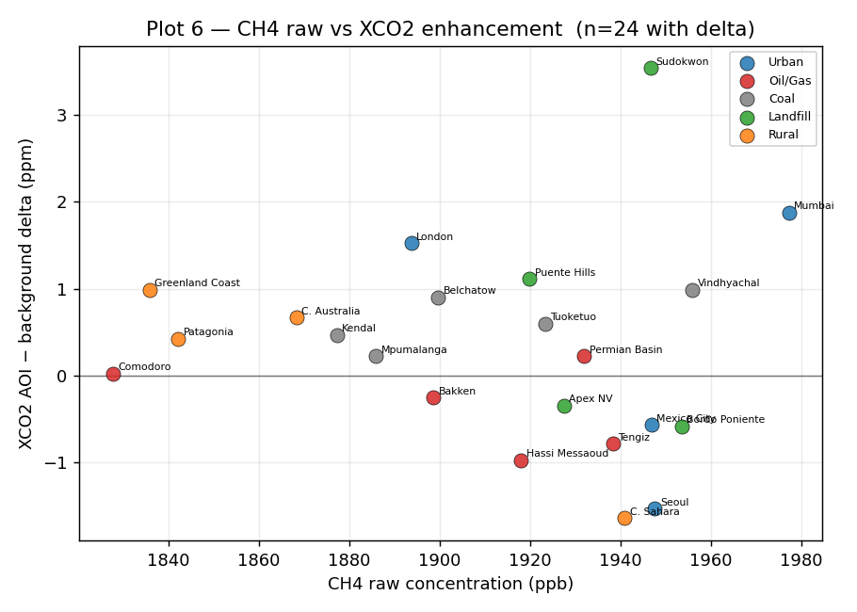
Plot 6 — CH4 raw vs XCO2 enhancement
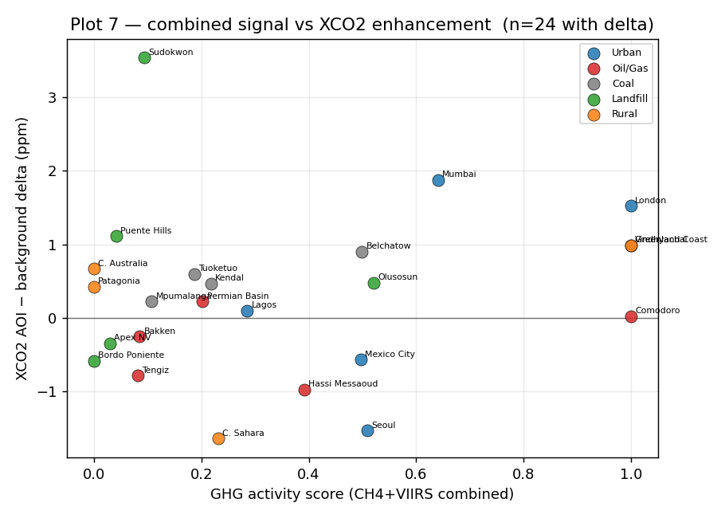
Plot 7 — combined signal vs XCO2 enhancement
Per-regime and overall correlations (vs XCO₂ AOI-minus-background delta):
Regime | VIIRS–XCO₂ Pearson | VIIRS–XCO₂ Spearman | n | CH₄–XCO₂ Pearson | CH₄–XCO₂ Spearman | n
Urban | −0.18 | −0.30 | 5 | −0.10 | 0.20 | 4
Oil/Gas | −0.57 | −0.10 | 5 | −0.40 | −0.20 | 5
Coal | 0.74 | 1.00 | 5 | 0.71 | 0.80 | 5
Landfill | 0.32 | 0.20 | 5 | 0.10 | −0.40 | 4
Rural | 0.29 | 0.40 | 4 | −0.95 | −0.80 | 4
ALL | −0.17 | −0.00 | 24 | −0.06 | −0.12 | 22
The XCO₂ deltas are small and mixed (range −1.64 to +3.54 ppm; most within ±1 ppm), which is the expected fingerprint of a transport-dominated, well-mixed column. Overall there is no correlation between either GHG input and the XCO₂ enhancement.
The exception is coal-fired power, where both VIIRS (Spearman 1.0) and raw CH₄ concentration (Spearman 0.8) track the XCO₂ delta. Coal plants are the cleanest large fossil-CO₂ point sources in the set, and their enhancements (Bełchatów +0.90, Vindhyachal +0.99, Tuoketuo +0.60, Kendal +0.47, Mpumalanga +0.22 ppm) are all positive and ordered with the activity signal. This is a genuine — if n=5, illustrative — concentration-side confirmation that the proxy captures real CO₂ where a strong CO₂ point source exists.
Correctly, oil/gas and landfills show no positive XCO₂ tracking (oil/gas slopes are negative; landfill rank ≈ 0). These regimes emit CH₄, not CO₂, so the absence of a CO₂ column enhancement is the right answer, not a failure. The rural CH₄–XCO₂ Spearman of −0.80 is spurious: four near-zero deltas (±background noise) with no physical emission to track. The largest single enhancement, Sudokwon +3.54 ppm, rests on only 127 soundings and sits in the Seoul CO₂ plume, so it is not cleanly attributable to the landfill.

§5. Where the proxy works
Confirmed agreement against at least one benchmark, weighted by evidence strength:
- VIIRS as an industrial-activity proxy — validated against ODIAC (Spearman 0.70, n=25, dense evidence). This is the proxy’s load-bearing channel and it does what it claims.
- Fossil-CO₂ point sources — coal-fired power — validated against both benchmarks. ODIAC is high at coal sites and the XCO₂ delta tracks the activity proxy there (VIIRS Spearman 1.0, CH₄ 0.8). Two independent benchmarks agree for this regime.
- Correct silence where it should be silent. CH₄ z correctly does not fire at urban or rural sites; XCO₂ correctly shows no enhancement at CH₄-only sources (oil/gas, landfill) and at clean rural sites. The proxy’s negatives are largely trustworthy.
- ODIAC point/AOI-mean equivalence (Spearman 0.81) — the activity comparison is robust to the sampling choice.

§6. Where the proxy diverges, and why

6.1 Structural gap — CH₄ anomaly z underperforms at oil/gas and landfills
The dominant divergence. CH₄ z fired at 1/25 sites and is uncorrelated with ODIAC. Three compounding causes:
- Footprint mismatch. Sentinel-5P TROPOMI CH₄ has a ~7 km native ground pixel; the screening AOI is a 5 km radius. A landfill or well-pad plume occupies a fraction of one TROPOMI pixel, so the AOI mean is dominated by regional background CH₄, not the source.
- Site-minus-background self-cancellation. The z-score is (site − background) / bg_std. When the coarse CH₄ pixel that covers the site also covers much of the background ring, site and background move together and the numerator collapses toward zero — or goes negative when the background ring happens to sit over locally higher CH₄ (the Hassi Messaoud z = −4.03 case: a desert background ring with high CH₄ variance and a flaring-but-not-CH₄-elevated centre).
- Threshold tuned above the achievable signal. The single largest z in the set is 1.76; the z>1.5 bar is effectively unreachable for diffuse and sub-pixel CH₄ sources at this radius.
This is a structural limitation of column CH₄ at the screening scale, not a coding bug — the snapshot path executes correctly (verified end-to-end).

6.2 Atmospheric-transport effects — XCO₂ decoupled from local emissions
Part B’s overall null is the same attributability story M-WIND-A1 told for air quality, now for CO₂. A satellite XCO₂ retrieval measures the whole air column, which is dominated by the well-mixed global background (~420+ ppm) with only a thin local enhancement that wind advects away from the source. Under any appreciable wind the column peak decouples from the emitting cell. Hence small, sign-mixed deltas everywhere except where a source is strong and persistent enough to imprint the column — coal power (§4.2).

6.3 Benchmark-limitation divergences
- ODIAC sub-pixel sensitivity (§3.3): the point sample can over- or under-state a site by orders of magnitude depending on whether the centre coordinate lands on the emitter cell.
- OCO coverage gaps (§4.1): sparse regimes (rural, some landfills) yield weak deltas; Siberian taiga yields none.
- Coverage failures on the GHG side too: Lagos and Olusosun returned SiteBufferNoDataError for CH₄ — Sentinel-5P CH₄ retrieval is routinely absent over the bright/coastal Lagos region — so both Lagos-area sites have no CH₄ datapoint at all.

§7. Caveats about the benchmarks themselves
- N=25, operator-picked, not sampled. Findings are illustrative. Per-regime correlations rest on n=4–5 and are noise-prone; the coal XCO₂ Spearman of 1.0 is striking but is five points.
- ODIAC is a bottom-up inventory, not an observation. Per-cell values are a modelled allocation of national statistics, partly using nightlights themselves — so a VIIRS↔ODIAC correlation is partly benchmarking VIIRS against a VIIRS-informed product. The provenance block carries data_type="emissions_inventory_allocation" for exactly this reason. ODIAC↔VIIRS agreement is necessary-but-not-sufficient evidence.
- Temporal-aggregation mismatch. ODIAC is annual and stops at 2023; the GHG pillar window is 2025. The comparison assumes the spatial pattern of emissions is roughly stationary over ~2.5 years, which is reasonable for fixed infrastructure but not guaranteed.
- OCO measures column concentration, not surface concentration or emissions. XCO₂ is a column-averaged mole fraction; it is not directly comparable to either ODIAC (emissions) or to a surface CH₄ reading.
- Footprint-vs-AOI mismatch. The XCO₂ comparison pools soundings over a ±0.25° (~25 km) box, far larger than the 5 km screening AOI, to obtain usable counts. At high latitudes (Greenland, Siberian) a 0.25° longitude box is narrower in km than at the equator. Both effects mean the XCO₂ “AOI” is not the screening AOI.
- Atmospheric transport decouples sources from concentration peaks (§6.2) — do not read the Part B null as “the proxy is wrong”; read it as “column concentration is the wrong benchmark for local activity except at strong point sources.”
The honest framing: ODIAC and OCO measure different things, and neither is ground truth. Together — emissions allocation plus column concentration — they triangulate the proxy question more credibly than either could alone, and they agree with each other (and with the proxy) precisely where the physics says they should: strong fossil-CO₂ point sources.

§8. Implications for calibration
For the upcoming calibration sweep spec:
- CH₄ anomaly z needs re-thresholding or re-scoping. At a 5 km radius the z>1.5 bar is unreachable for the diffuse/sub-pixel CH₄ sources it targets (1/25 firing rate). Options for the sweep to weigh: (a) lower the threshold and re-characterise the false-positive rate; (b) widen the CH₄ AOI to match the ~7 km TROPOMI footprint so site and background stop cancelling; (c) demote CH₄ z to a context indicator and stop treating non-firing as “clean”, the way ODIAC was demoted. The current behaviour quietly reports CH₄-heavy landfills and well-fields as unremarkable.
- VIIRS buckets appear defensible. VIIRS tracks ODIAC (0.70) and tracks XCO₂ at coal sites (1.0). The sweep should still confirm the bucket boundaries against this continuous evidence, but the signal itself is sound.
- Flag known-weak regimes explicitly in the M-UX-A1 parameter-transparency surface. The score should declare, for landfill/waste and oil/gas sites, that the CH₄ channel is operating below its detection floor at this radius — i.e. surface “CH₄ proxy known-weak for this source type” rather than implying a confident low reading.
- Do not build an ODIAC- or XCO₂-severity score. Both benchmarks have disqualifying limitations for scoring (ODIAC vintage + allocation circularity; XCO₂ transport-decoupling + coverage gaps). They are validation evidence, not score inputs.

§9. Open questions for the calibration-sweep spec
- CH₄ radius vs threshold: should the sweep widen the CH₄ AOI to the TROPOMI footprint, lower the z threshold, or reframe CH₄ z as context-only? (Evidence points away from “keep z>1.5 at 5 km”.)
- Landfill detectability: is there any satellite CH₄ configuration in the current stack that fires at these five landfills, or is landfill CH₄ simply below the achievable floor for column TROPOMI — implying the regime should be flagged known-weak rather than tuned?
- VIIRS bucket boundaries: what continuous VIIRS↔(ODIAC, XCO₂) evidence should set the bucket cuts, given VIIRS is the validated channel?
- ODIAC circularity: how much should a VIIRS↔ODIAC agreement count as independent validation, given ODIAC’s diffuse allocation uses nightlights? Does the sweep need a non-VIIRS-derived emissions benchmark (e.g. EDGAR, GRA²PES) to break the circularity?
- Coal-only XCO₂ success — generalise or special-case? Is the coal-regime XCO₂ agreement robust enough (beyond n=5) to claim concentration-side validation, or should the spec commission OCO-3 SAM-targeted extractions at more point sources before relying on it?
- Wind conditioning for Part B: M-WIND-A1 conditioned air-quality attributability on wind. Should an XCO₂ re-run filter to low-wind overpasses to test whether the coal signal sharpens and other regimes emerge?
These feed the calibration-sweep spec, the next milestone after this validation.

§10. Reproducibility
# 1. Activity extraction (Earth Engine; writes the CSV)
python analysis/extract_part_a.py
# 2. Concentration extraction (earthaccess/GES DISC; adds XCO2 columns)
# Requires a NASA Earthdata login (~/.netrc) with the GES DISC app authorised.
python analysis/extract_part_b.py
# 3. Analysis, figures, correlation tables
python analysis/analysis_plots.py
# 4. (Re)build + execute the notebook
python analysis/build_notebook.py
jupyter nbconvert --to notebook --execute --inplace analysis/ghg_odiac_validation.ipynb
Figures embed from analysis/plots/*.png (referenced relatively as ../analysis/plots/… from this report); regenerate them with step 3 before re-exporting the .docx. The committed analysis/ghg_odiac_validation.csv is the single data table behind every number above.
OCO-2/OCO-3 data: NASA ACOS L2 Lite FP, distributed by NASA GES DISC. ODIAC: NIES Japan. Sentinel-5P CH₄ and VIIRS via Google Earth Engine.

