Step 1: Open pgAdmin on your machine and create a new server. Name your server, and go to the Connection tab. On the connection tab you fill in the Host name (RDS endpoint for DB created) and enter the username and password you gave your RDS database and then click save.

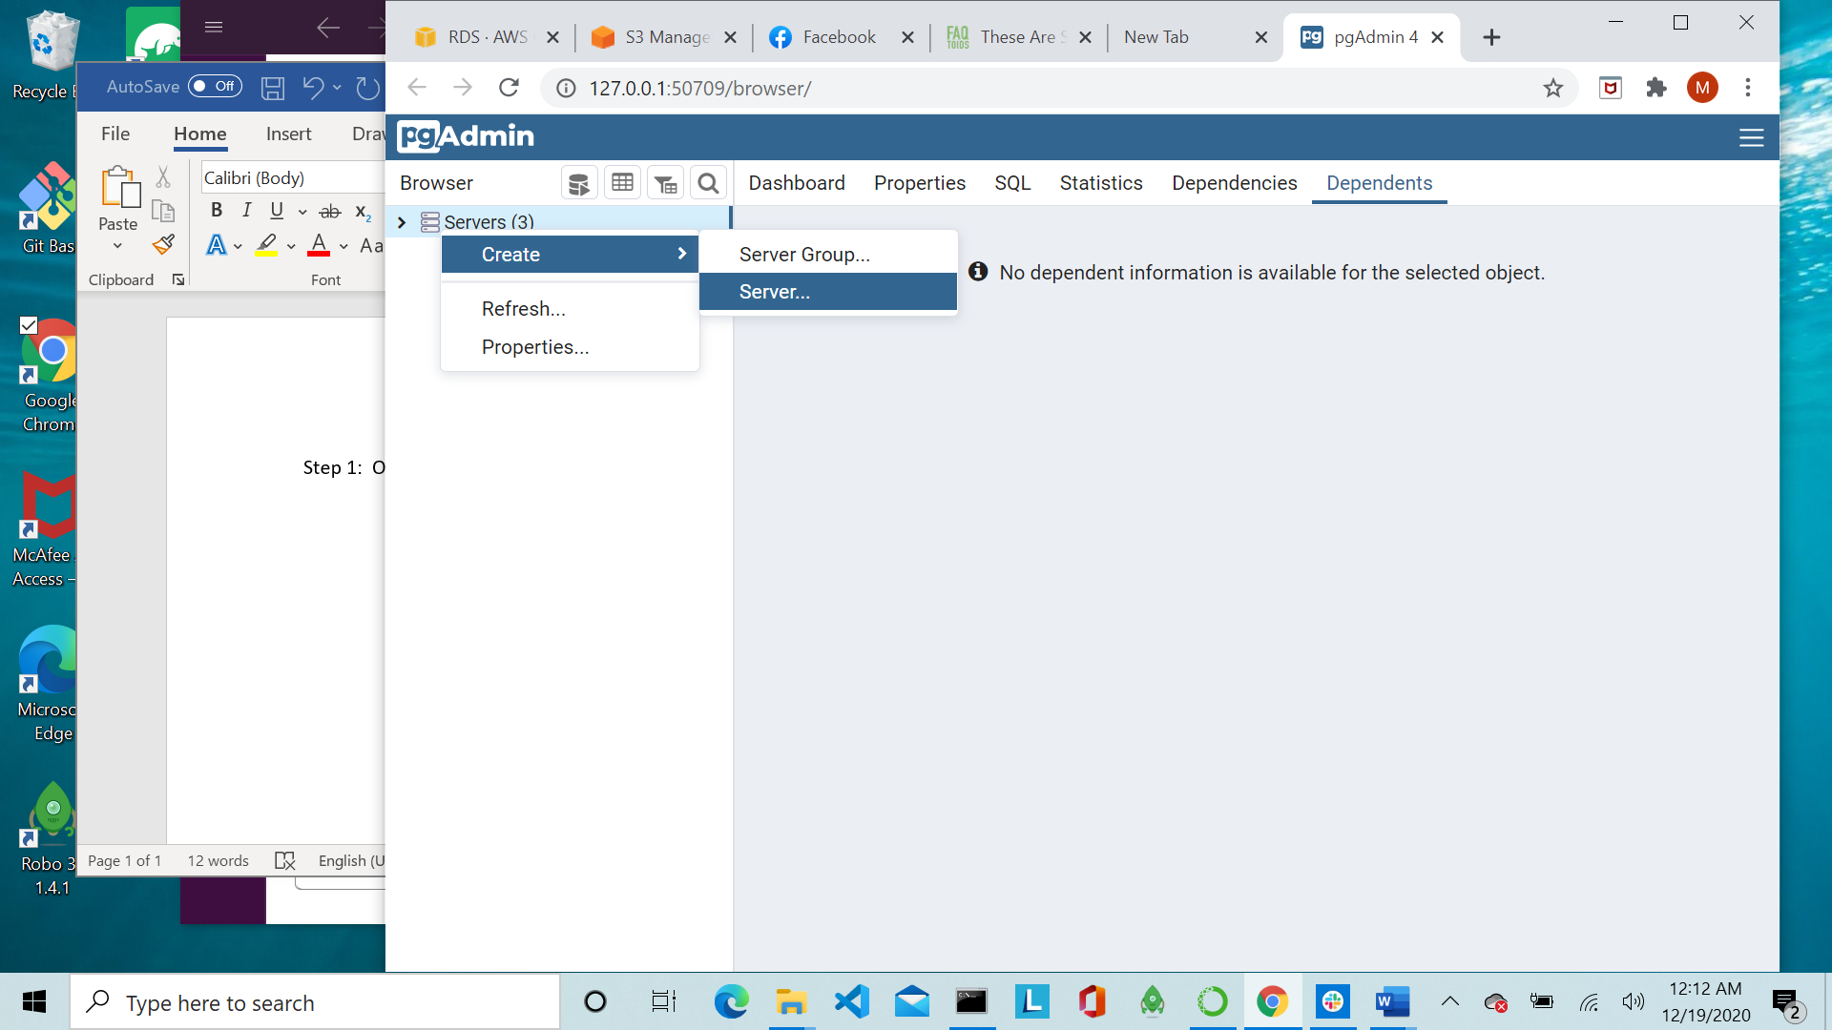

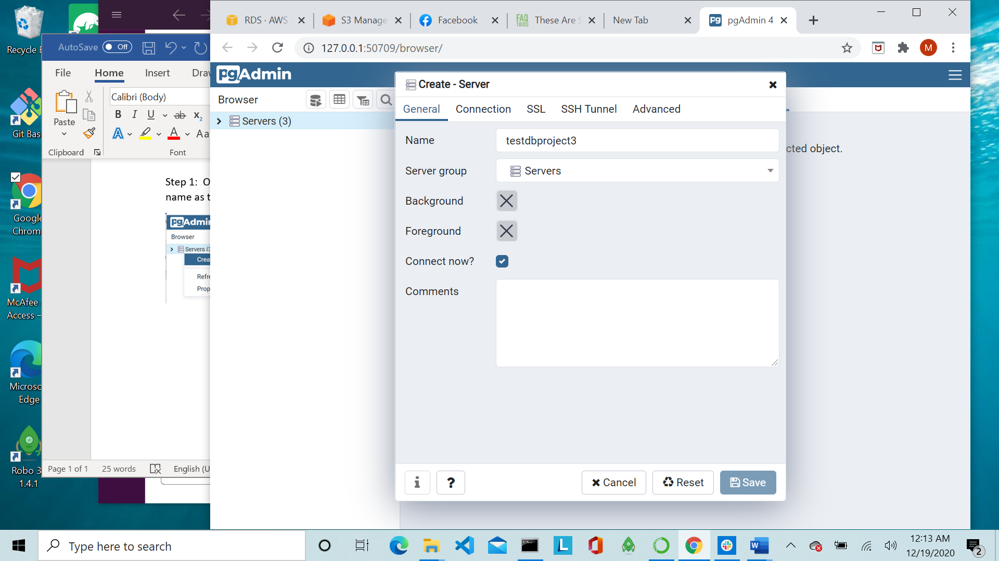 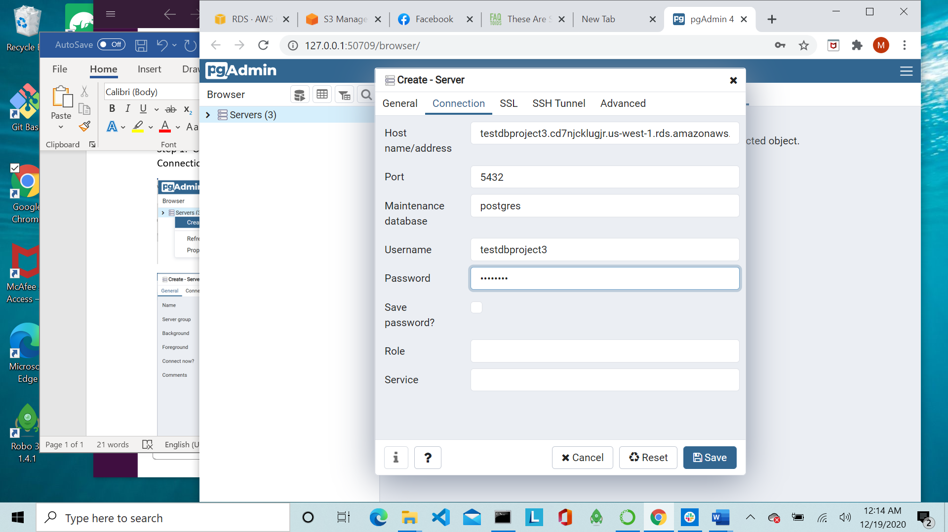

Step 2: You are now ready to run your queries in pgAdmin to add the tables to your Amazon RDS database