# For A/D noise characterization:

1. Download and install the following packages from [VI Package Manager](http://www.ni.com/tutorial/54770/en/):
   1. STM - [vipm://ni_lib_stm?repo_url=http://ftp.ni.com/evaluation/labview/lvtn/vipm](vipm://ni_lib_stm?repo_url=http:/ftp.ni.com/evaluation/labview/lvtn/vipm)
   2. SHE - [vipm://ni_lib_seh?repo_url=http://ftp.ni.com/evaluation/labview/lvtn/vipm](vipm://ni_lib_seh?repo_url=http:/ftp.ni.com/evaluation/labview/lvtn/vipm)
2. **Run RT Code and then PC code**. Open AIChar.lvproj and then Run RT_AIChar_v2.viand after it is running, also run the PC_AIChar_v2.vi. The Histogram and PSD is in the PC_AIChar VI. You can select various options for AI sampling in the RT_AIChar VI.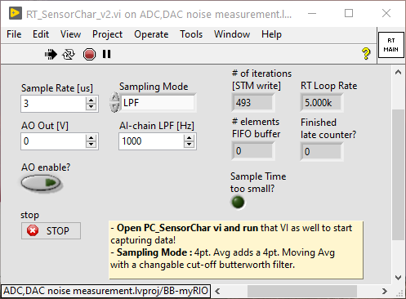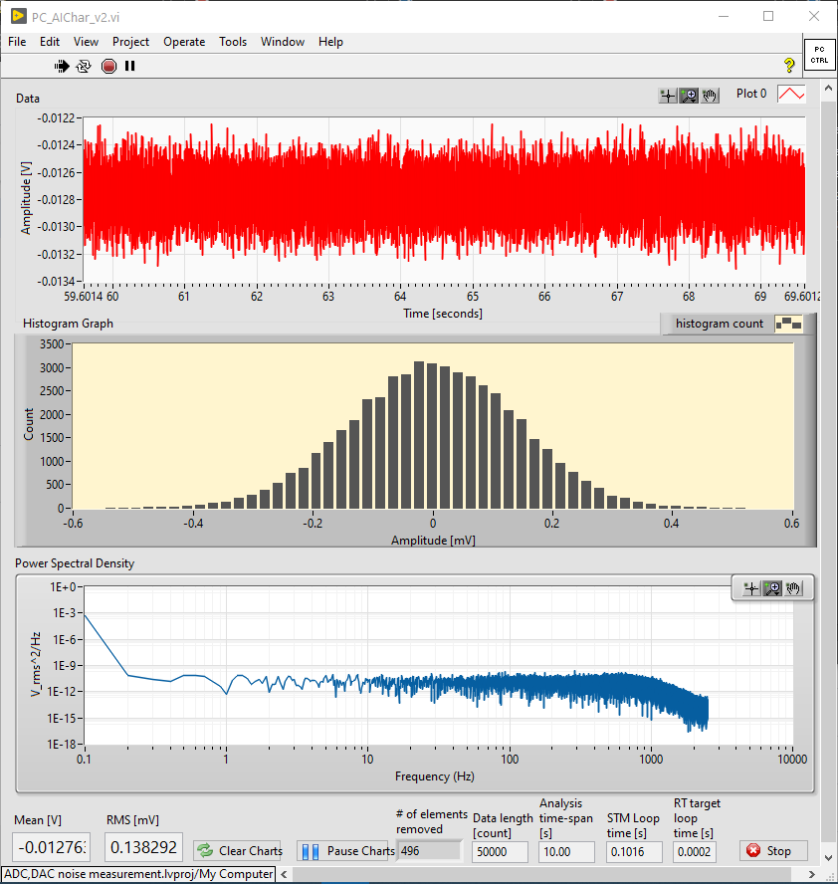

# For the Double Integrator code:

1. As usual, run the Digital Controller with DSA_v2.vi code. AI options can now be selected for the analog input chain such as the AI sampling rate, sampling mode and Low pass filter cut-off frequency can be selected.

