**OBJECTIVE:** Software Professional with complete Software Development Life-Cycle experience

**SKILLS:**

*Technologies*: Kafka, Spring Cloud Kafka Streams, Spring WebFlux, Feign REST

Spring Boot, Spring Data JPA, JUnit, Mockito, JOOQ

Avro, gRPC, Protocol Buffers

AWS EC2, AWS RDS, AWS SES, AWS SQS

*Docker Technologies*: Docker CLI, Docker-Compose, Kubernetes, AWS EKS, Helm

*Tools*: Postman, Maven Gradle, Splunk, GitHub*,* GitHub Actions, IntelliJ, BloomRPC, Fabric8 maven plugin.

*Databases:* Elasticsearch, Postgres, Redis, MySQL, MongoDB, Oracle, MS SQL Server

*Project Skills:* Working as individual contributor or a team lead

Collaborate with Project Stakeholders on System Design

Excellent analytical, problem solving and communication skills

**EXPERIENCE:**

May 2023 – Dec 2023 **Backend Software Engineer - Contract,** **Equinix**, Remote

* Working on Virtual Data Centers projects.
* SpringBoot Domain Driven Design using Hexagonal ( Port/Adapter ) pattern.
* Java 17, SpringBoot 3, Spring 6, SpringBoot GraphQL, Spring Data JPA with projections, JOOQ, Spring Validations including Custom Validators.
* Test coverage with Junit5, AspectJ, ArchUnit, Jacoco. Postgres migrations using Liquibase with both XML and YAML. GitHub Actions including using external libraries.

Oct 2020 – Mar 2023 **Backend Software Engineer – Full Time,** **Revenue.io**, Remote

* Working on event-driven application to process Zoom, Twilio and MSTeams calls.
* Technologies: Elasticsearch Search Engine, Java, Docker Containers, AWS Java SDK, AWS SQS, AWS SES, AWS S3, AWS EC2, Vavr framework, Papertrail, Postman.
* Dockerized Spring Boot microservices with Postgres and Flyway containers into Docker Compose.
* Integration with Zoom and Twilio via SQS Webhooks and REST API.
* Integration with MSTeams Bot via SQS messages
* Application deployed on AWS using Auto Scaling Group.

March 2020 – October 2020 **Team Lead - Contractor,** **LogRhythm**, Remote

* Developing microservices with Java, Quarkus framework, gRPC, JDBI and PostgreSQL. Application is deployed to AWS with Kubernetes and Istio Service Mesh.

May 2019 – Dec 2019 **Software Engineering Contractor**, **GuidedChoice,** San Diego, CA

* Refactored legacy monolithic application into Event Driven app with Spring Cloud Microservices and Kafka
* Technologies: Java, Spring Cloud Streams, Spring Cloud Config Server, Eureka Discovery, Feign,

Ribbon Load Balancer, Spring Cloud Gateway, Spring Cloud Bus, Spring Data JPA,

Kafka Streams, Spring Cloud Streams, Actuator and Micrometer,

Spring Security, Sleuth/Zipkin, Docker, Spring Boot Quartz Scheduler

* Spring Boot Unit Testing. Integration tests with Postman and Newma

Jun 2017 – May 2019 **Principal Software Engineer, Engage FT,** San Diego, CA

* Hands-on Team Lead. Developed solution for Mobile clients to perform bank check deposit via Ensenta. Solution successfully deployed in Production. Technologies: Java, Spring, Tomcat, Hibernate, JavaScript.
* Hands-on Team Lead. Developed backend solution to support Front End investments application. Solution successfully deployed in Production. Technologies: Java, Spring, Tomcat, Hibernate, JavaScript.

Oct. 2016 – June 2017 **Software Engineering Contractor, Intuit,** San Diego, CA

* Developed Web Service to manage Customer Consent leveraging Java, Spring, REST Web Services, Tomcat
* Refactored a number of existing Integration Tests

Aug. 2016 – Oct. 2016 **Software Engineering Contractor, Engage FT,** San Diego, CA

* Developed a set of web services to process customer data. Project leveraged Java, REST Web Services, Spring, Hibernate 4, Tomcat.

Dec 2014 – July 2016 **Software Engineering Contractor, Intuit,** San Diego, CA

* Developed REST web service application to sync data between different geo locations. Project leveraged Java, AWS RDS, Jersey, Tomcat, Spring JDBC, JSON, Encryption framework, TestNG.

Jun 2014 – Dec 2014 **Software Engineering Contractor*,* Takeda Pharmaceutical,** San Diego, CA

* Developed application to import CSV file with employee data from SAP into local database and Active Directory.
* Technologies: Java, JAXB, Dozer, Hibernate.

Aug 2013 – May 2014 **Software Engineering Contractor*,* Intuit*,*** San Diego, CA

* Developed a set of REST web service clients to exchange data between new and legacy applications.
* Technologies: Java, Spring, Tomcat, Hibernate, JavaScript.

Nov 2012 – Jul. 2013 **Software Engineering Contractor*,* SAIC*,*** San Diego, CA

* Refactored and enhanced existing self-service Portal Application.
* Technologies: Java, JavaScript, Portal Container, Portlets.

Jul 2010 – Nov 2012 **Java Enterprise** **Architect**, **HD Supply*,*** San Diego, CA

* Hands-on Java EE Architect with complete Software Development Life-Cycle experience
* Lead a team of Developers to provide new Search capabilities for [hdsupplysolutions.com](http://hdsupplysolutions.com) web site.

March 2008 – April 2010 **Team Lead, Insurance Company of the West (ICW),** San Diego, CA

* Designed and implemented a set of Web Services for submitting insurance policy documents from the external Policy Processor to SAP. Implemented solution using Java, IBM Datapower, XSLT, Axis2, iBatis, Tomcat, MS SQL.

## 

## EDUCATION:

###### Master of Science in Electronics Engineering

Technical University of Moldova, Kishinev, Moldova

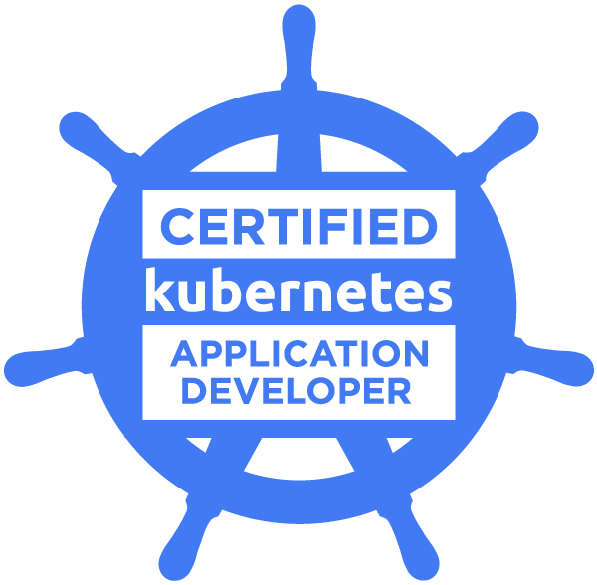

[Certified Kubernetes Application Developer](https://www.credly.com/badges/27646233-ec92-484d-8532-f7d66322dae5)



[AWS Certified Developer – Associate](https://www.credly.com/badges/f1c058ac-d099-4827-bb86-f9f5ee2ff3be)

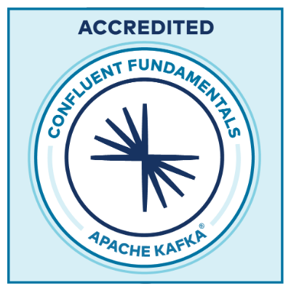 [Confluent Fundamentals Accreditation](https://www.credential.net/a40d12c6-0608-4efb-bf10-9cc1dd74970f#gs.w8of9g)