|  |  |  |  |  |  |
| --- | --- | --- | --- | --- | --- |
| \\storage\Computing\Electronics\Libraries\Logos\Computing Logo\bluelogo.png | Computing division | | | | |
| *Created : 4.4.2017* | | *Modified : 4.4.2017* | | *Rev. No .: 1.0* |
| Em# First Installation and update  Abstract  This document describes how to install the first Em# software version on a new Em# | | | | | |
| Prepared by:  Manuel Broseta | | Checked by:  Guifré Cuní  Oscar Matilla | | Approved by: | |

|  |  |  |  |
| --- | --- | --- | --- |
| History of Changes | | | |
| Rev. No. | Date | Pages | Description of changes |
| 1.0 | 4.4.2017 |  | Initial Document |

Table of Contents

1 Introduction 4

1.1 Requirements & preparation 4

2 BIOS configuration and Update 5

2.1 BIOS Update 5

2.2 BIOS Configuration 5

3 First Installation 7

3.1 USB preparation 7

3.2 Software installation 7

4 Electrometer update 10

4.1 USB preparation 10

# Introduction

This document describes how to install and update software for the first time in a completely new Em#

## Requirements & preparation

The following material and source code is needed to proceed with the installation of the software:

* HDMI Monitor and HDMI cable
* Keyboard (USB)
* At least 1USB key (minimum size 2GB), 2 recommended (1 for installation, 1 for update).
* Access to ALBA alfresco website, software folder ([link](https://alfresco.cells.es/share/page/site/alba-em/documentlibrary#filter=path%7C%2FProduction%2F1.%2520ALBA%2520Em%2523%2520Production%2520201610%2F7.%2520Firmware%7C&page=1)), and download and copy the following files to its corresponding USB:
  + From InstallationUSB_V0.3.7 download the following file to your HDisk. It will be explained later how to prepare ***installation_USB***
    - Electrometer1.0.e3815.hddimg.bz2
  + From UpdateUSB_v0.4.16 download and unzip files to USB2 (***update_USB***)
    - Alin-0.4.16.tar.gz
    - Backports_abc-0.5.tar.gz
    - Certifi-2016.9.26.tar.gz
    - Scpi-0.3.4.3.tar.gz
    - Singledispatch-3.4.0.3.tar.gz
    - Tornado-4.4.2.tar.gz
    - TY0041.BIO

# BIOS configuration and Update

The fisrt step is to update the NUC DE3815 BIOS to a proper version checked and confirmed working for the electrometer. This corresponds to version TYBYT10H.86A.0041.2014.1224.1255 (Version TY0041).

## BIOS Update

The Intel NUCDE3815 contains several peripherals that we use in the electremeter (like the I2C buses, the MMC or the power button control) Although there are several BIOS version for the NUCDE3815, we found that some of these versions are not usefull for the expect behaviour we want forthe electrometer. After investigation, we found that actually only version TY0041.BIO, which is not the latest one, is the one that works as expected.

So the first step to do in a new fresh installation is to update the BIOS to the desired version.

**STEP 1:** Connect the HDMI monitor and Keyboard to the corresponding connectors in the rear side of the electrometer.

**STEP 2:** Switch on the electrometer and inmediatly after, press “**F2 to Enter in Setup**” menu.

**STEP 3:** Plug the USB2 (***Update_USB*** ) that contains the TY0041.BIO file, to the USB input in the back side of the electrometer and go to the BIOS tools option menu (the wrench icon), “**Update BIOS**” option from menu.

**STEP 4:** Navigate to the file browser menu to find the TY0041.BIO file and proceed to update the BIOS. Once finish, reboot the system and press again “**F2 to Enter in Setup**” menu.

## BIOS Configuration

Once the BIOS has been updated to the proper version, the next step is to configure the BIOS to use the peripheral settings we want/need. This means to confiure the number of I2C buses and its order, the internal MMC to be use as hard disk or to enable the USB as the primary boot input.

So these are the next steps to follow:

**STEP 5:** Confgure the number of I2C buses. This is related with the OS system selected. Go to “**Advanced menu->Boot->Boot Configuration->”**

From “**UEFI Boot”**  select:

* **LINUX** as the OS.
* **Boot USB devices first** set as Enabled (ticked)
* Boot Network devices Last set as Disabled

From “**Boot devices”**  select:

* **USB** selected.
* **Network Boot** set as Disable

**STEP 6:** Confgure the use of the MMC going to “Advanced menu->Device and Peripherals->Onboard Devices” and select:

* 4GB eMMC Built-in Storage as enabled.

After this point save the configuration, restart the system and enter again in the BIOS configuration menu pressing ““**F2 to Enter in Setup**”.

**STEP 7:** Confgure the Boot priority going to “Advanced menu->Boot->Boot Priority”

From “UEFI Boot Priority” select:

* **UEFI Boot** set as enabled
* Boot Drive Order as No Boot Drive

From “Legacy Boot Priority” select:

* **Legacy Boot** select as Enabled.
* **Boot Drive order** selec tehe USB first

Then save and restart the system

# First Installation

Actually we only have prepared the USB installation file based in an old software version (0.3.7). This file installs the different softwares need to run the electrometer. It includes:

* Linux version 4.4.16
* Spec drivers
* Alin main software
* Spec binary file
* Other system tools…..

## USB preparation

In this step we are going to preapre the ***installation_USB*** using the previously downloaded file to your hard disk Electrometer1.0.e3815.hddimg.bz2

**STEP 8:** Unzip the file into your disk using the following command from your command line:

#bzip2 -d electrometer1.0.e3815.hddimg.bz2

**STEP 9:**  Plug the ***installation_USB*** in your pc and create the bootable USB using the following command:

#dd if=electrometer1.0.mbroseta-e3815.hddimg of=<**your_USB_location**>

Once finish, remove the USB from your machine and connect it to the electrometer

## Software installation

Once the ***installation_USB*** is ready, then lets proceed to write the software into the electrometer.

**STEP 10:**  Plug the ***installation_USB*** to the electrometer and restart the equipment.

**STEP 11:**  If the USB is not detected automatically, then reboot again and select “**F10 to Enter in Boot Menu”.** From this menu, choose to Boot up from the USB input and f everythong goes well, the electrometer install menu appear.

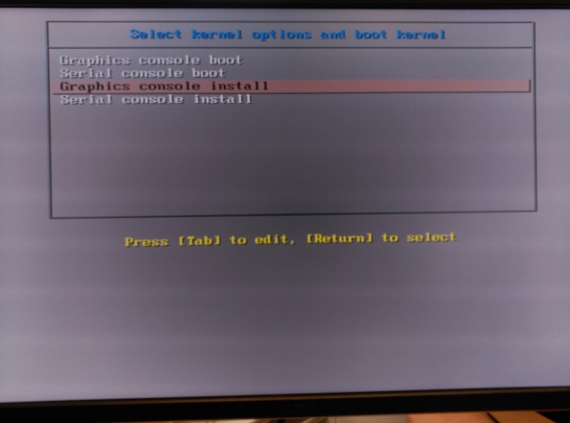

Figure 1. Electrometer software installation menu

**WARNING:**  If this menu is not visible, then check if the USB is properly generated. It has to be set as bootable USB. Any other problem, contact with ALBA controls group.

**STEP 12:**  Select “**Graphics console install”** to proceed with the installation (debug print will appear in the display monitor).

At this point, in te electrometer display should appaer the following display:

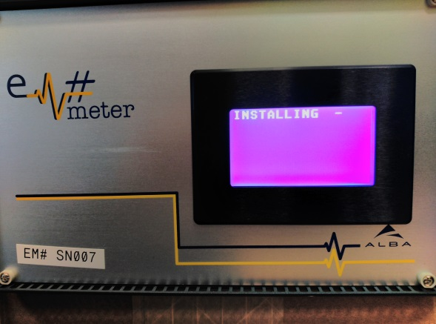

Figure 2. Installing process

Once it finish, the following message will appear in both, the electrometer display and the display monitor “**Installation finished. Please extract USB”**.

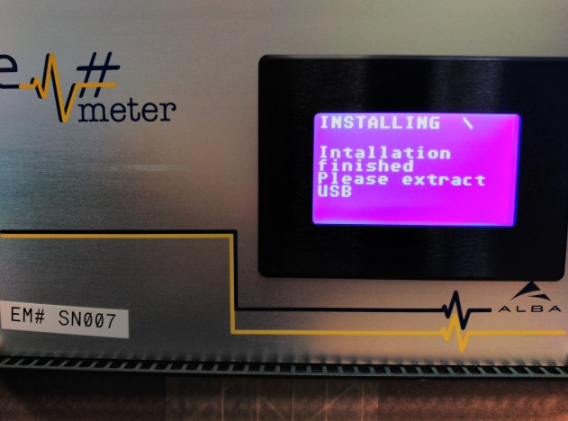

Figure 3. Installation complete message

**STEP 13:**  Unplug the ***installation_USB*** from the electrometed and the system will be rebooted automatically. After that wait for 30 secons (aprox) and the ALBA logo will appear on the electrometer display.

From here you can check the MAC address navigating thorugh the electrometar displays menus or lacally using the display monitor, opening a sesion with user: root (no password required) and checking it using the linux command *ifconfig.*

**WARNING:**  Sometimes, due to conectivy problems the spec is not recognized and the software doesn’t run. So if the system is not runing, check if the psec has been detected usning the *lspci* command. It should appear:

*02:00.0 Non-VGA unclassified device: CERN/ECP/EDU Device 018d (rev 03)*

Or check if the spec.ko linux driver is running with *dmesg | grep spec* command. It should appear:

*[ 4.779606] spec 0000:02:00.0: probe for device 0002:0000*

*[ 4.951151] spec 0000:02:00.0: got file "fmc/spec-init.bin", 3318464 (0x32a2c0) bytes*

*[ 5.380711] spec 0000:02:00.0: FPGA programming successful*

*[ 5.383757] spec 0000:02:00.0: Can't find SDB magic*

# Electrometer update

Once the electrometer software has been installed for the first time, it is possible to upgrade to the latest version using the python setup tools. So use the ***update_USB***  to update the main software, the scpi driver and to install the tornado web server.

Unzip the files included in the ***update_USB*** key into the electrometer */home/root/* folder. And do the following steps.

## Main software update

Main software alin version 0.4.16 has to be installed in the equipment. It includes main software version 0.4.16 and the FPGA binary version 1.10. As the binary file in the FPGA will be also updated, it is need first to stop the main software and the spec driver.

**STEP 14:**  Stop main software running using the instruction ***alinmainoff*** from the electrometer command line.

**STEP 15:**  Stop also the spec driver typing the linux command ***rmmod spec*** .

**STEP 16:**  Do cd to the folder where the ***Alin-0.4.16.tar.gz***file has been uncompressed. And type:

#*python setup.py install*

If only main software needs to be updated then it is just enough to reboot the equipment. But for the first installation, please continue the installation of the other software packages needed.

## SCPI driver update

SCPI driver is used by the main software to allow the remote control of the equipment by the user. Latest version of this driver, that is required by the Alim main software version 0.4.16 is the Scpi driver version 0.3.4.3.

**STEP 17:**  Do cd to the folder where the ***Scpi-0.3.4.3.tar.gz***  file has been uncompressed. And type:

#*python setup.py install*

If only main software needs to be updated then it is just enough to reboot the equipment. But for the first installation, please continue the installation of the other software packages needed.

## Tornado webserver

Main software version 0.4.16 uses websocket protocol for the webserver. It uses the tornado python library to run this protocol.

At the same time, tornado python library requires other python libraries like backport, certifi ans singledispatch. All the installation file, have been provided and included in the ***update_USB***.

**STEP 18:**  Do cd to the folder where the ***Backports_abc-0.5.tar.gz***  file has been uncompressed. And type:

#*python setup.py install*

**STEP 19:**  Do cd to the folder where the ***Certifi-2016.9.26.tar.gz***  file has been uncompressed. And type:

#*python setup.py install*

**STEP 20:**  Do cd to the folder where the ***Singledispatch-3.4.0.3.tar.gz***  file has been uncompressed. And type:

#*python setup.py install*

**STEP 21:**  Do cd to the folder where the ***Tornado-4.4.2.tar.gz***  file has been uncompressed. And type:

#*python setup.py install*

# Final verification

Once all the software have been installed, proceed with the last step:

**STEP 22:**  Connect the equipment to network and do a system reboot:

* By command line *reboot –f*
* Or using the electrometer power OFF/ power ON button

After reboot, electrometer takes almost 20 seconds to power up. So after this time, “Em meter” logo should have appear in the screen.

Navigate throught the menus in the electrometer touch-display to get the Mac and IP address. And do a final verification of the web server

**STEP 23:**  From you pc, type in your web browser the following address *<ip>:8888* and confirm the software versions installed from the “**Equipment** Info” tab.