1. First of all, click the file from the email and have it download to your computer.
2. Go to Google Drive (the square matrix in the top right-hand corner of screen, and click ‘Drive’

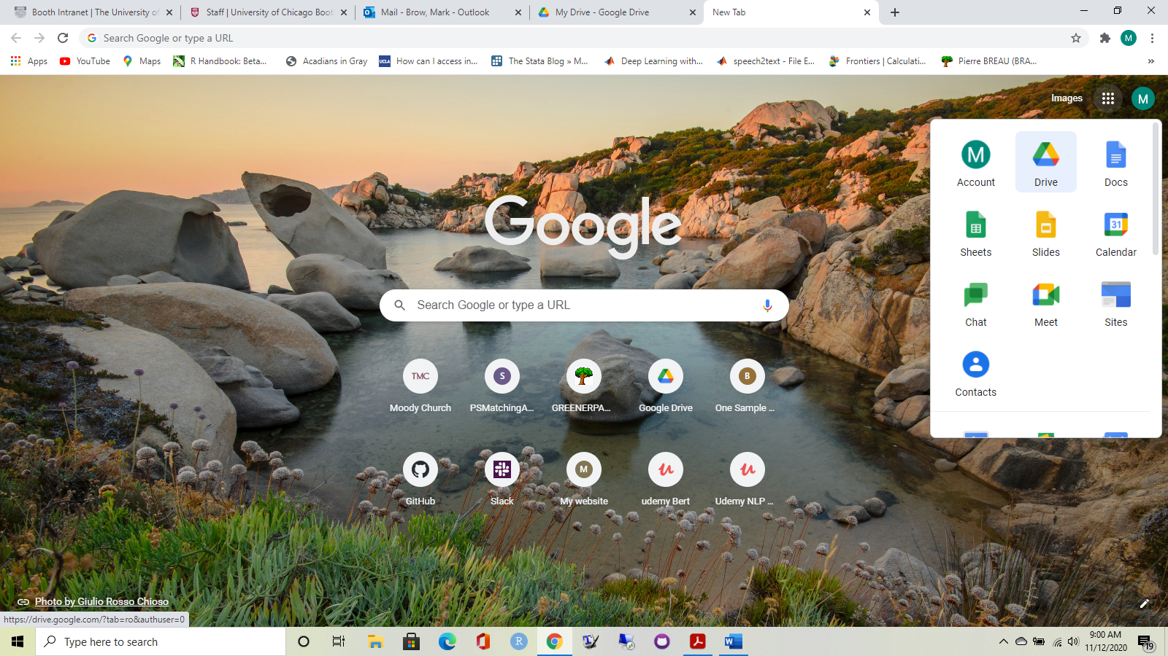

1. When in Google Drive, in the left-hand corner click the <<New>> button, go down to <<More>>, and shift to the right to <<Connect more apps>>

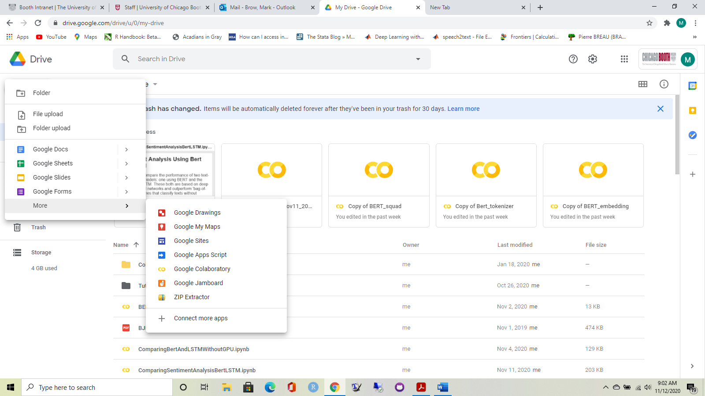

1. In the search box up on top, type “Colaboratory” and you will see the app like below.

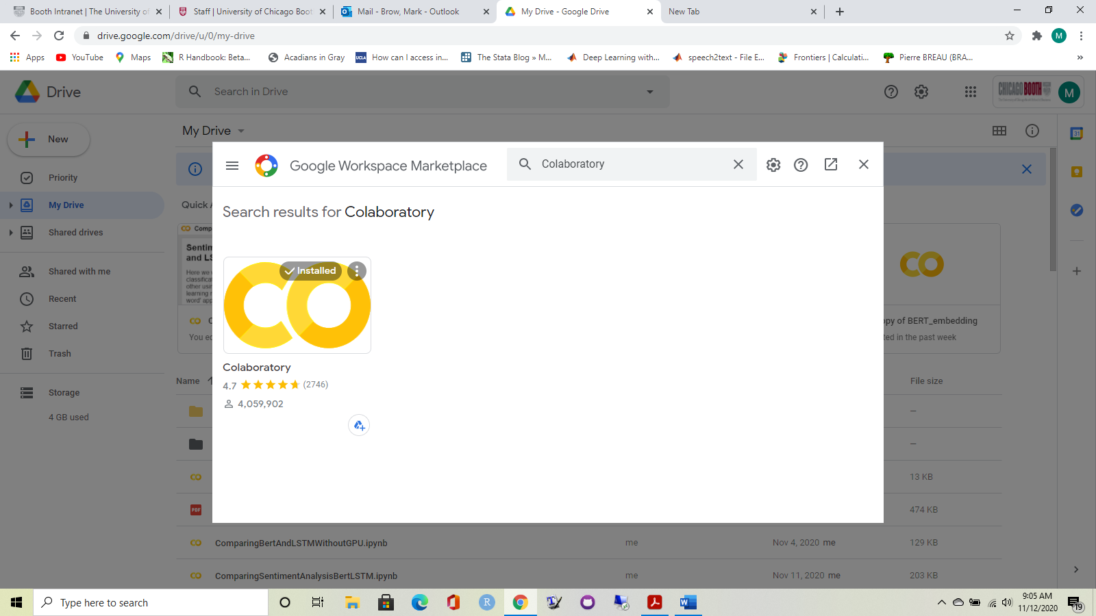

(I have already installed this. You want to install app)

1. After you have installed the app, go back to Drive and click the <<New>> button again. This time click <<file upload>>

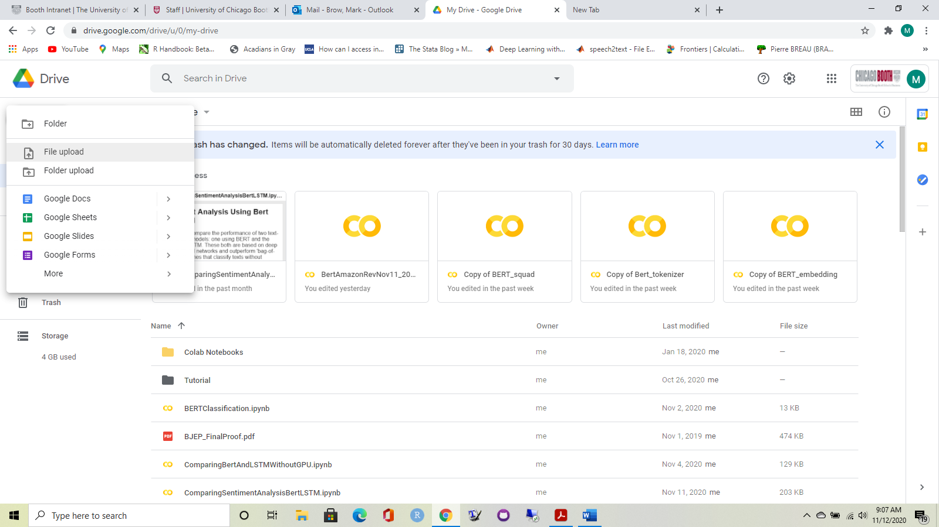

1. Upload the Colab notebook (the file you downloaded earlier) from Downloads on your computer.

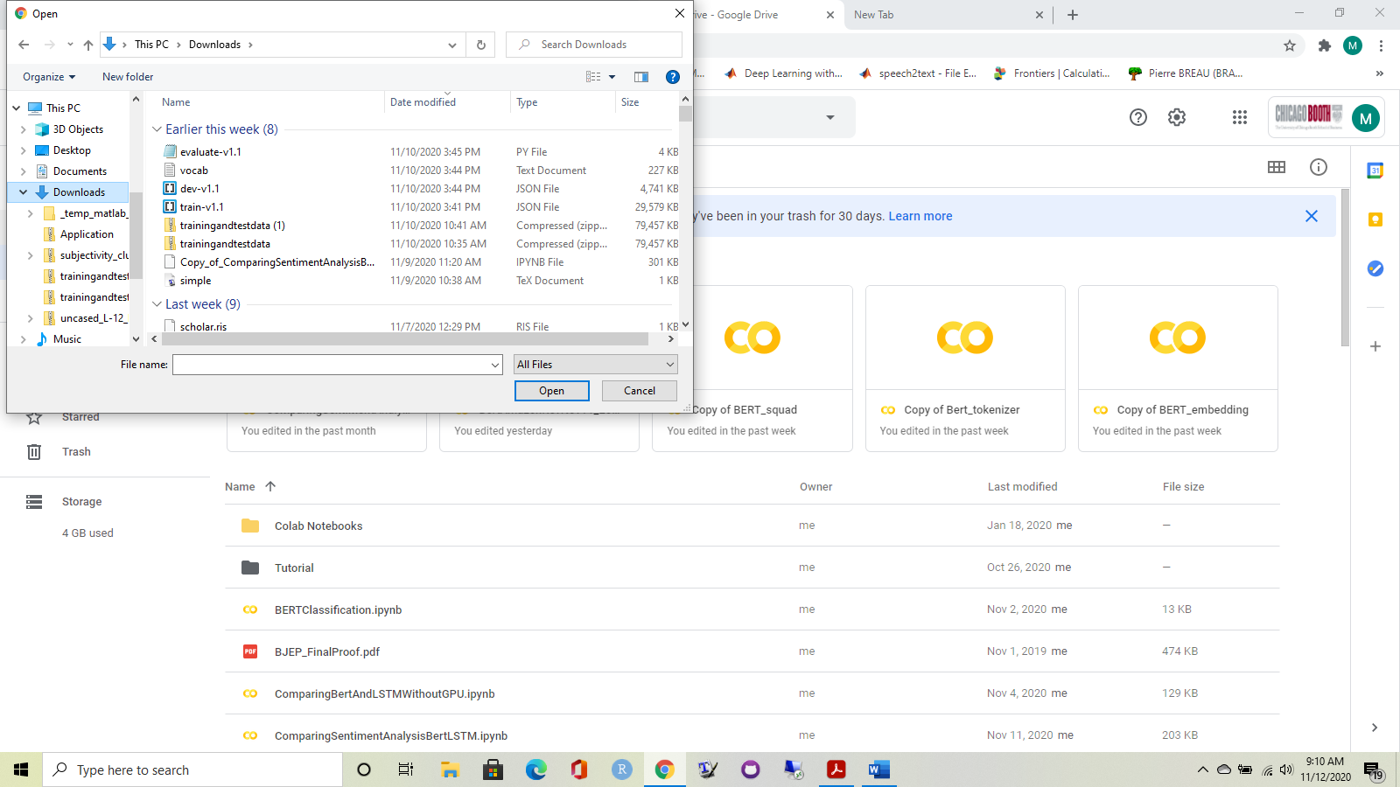

1. After uploading file, go to the file in your Drive and open it. Choose to open with Google Colab (the button on the top)

