Project Report

## Title of your game

*Obstacle Odyssey*

## Your name

*Matthew Brown*

## Is your game 2D or 3D?

*2D*

## What genre is your game?

*Side Scrolling Platformer*

## What is the most relevant game to yours (insert images here)

## Geometry Dash | Geometry Dash Wiki | Fandom

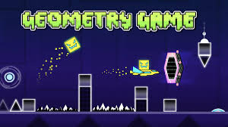

## Detailed description of Gameplay

## *The games’ objective will be to avoid obstacles on an obstacle course and reach the end of the level. The game will auto-side scroll, and the player will have to jump to avoid obstacles on the screen. The user will not be able to control the speed of the player, the player will move at a fixed pace. The player will only be able to jump. There are currently two levels in the game. Once the player beats both levels the game resets to level 1.*

## List of all User Controls (don’t miss any)

*Space Bar: Jump*

*Escape: Open Pause Menu in a level*

*Left Click: Click buttons in menus and at the start of the level*

## Object of the game (how to win the game)

*The objective of the game is to complete both levels in order to beat the game.*

## How to lose the game (how to die)

*Hitting any spikes on the level will kill the player. This will cause a level reset.*