# Mutaforma Document Conversion

## Inline Styles

Some paragraph text with inline formattings such as *Italic*,**Bold** and Underlined.

*A paragraph that is completely in Italic. Let’s see how it is represented in the XML file.*

## Carriage Returns

A paragraph with carriage return at its end  
Text after a carriage return

## Simple Bullet List

* List Item 1
* List Item 2
* List Item 3
* List Item 4

## Simple Numbered List

1. List Item 1
2. List Item 2
3. List Item 3
4. List Item 4

## Image #1 without caption

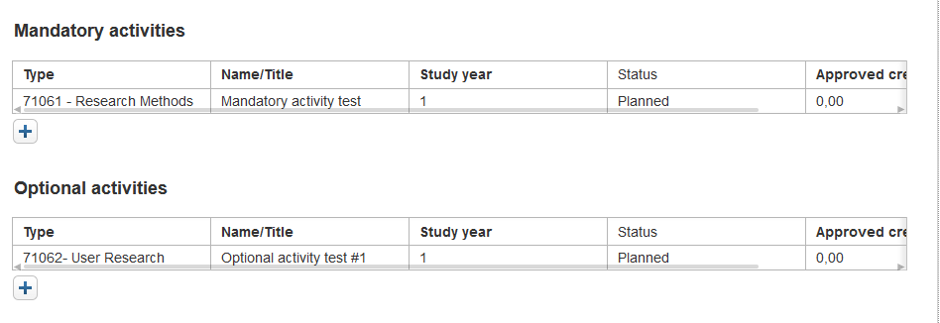

## Image #2 with caption

Figure 2: Select peer reviewed

## Image #3 with caption

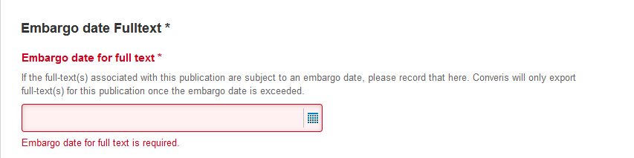

Figure 3: Embargo date Fulltext

## Symbols

⬩≥≠ΩHello World ©

## Equations

$${\left(x+a\right)}^{n}=\sum_{k=0}^{n}{\left({n \atop k}\right)x^{k}a^{n-k}}$$

### Simple Table

|  |  |  |  |  |
| --- | --- | --- | --- | --- |
| **Table Header 1** | **Table Header 2** | **Table Header 3** | **Table Header 4** | **Table Header 5** |
| Table Cell 1 | Table Cell 2 | Table Cell 3 | Table Cell 4 | Table Cell 5 |
| Table Cell 6 | Table Cell 7 | Table Cell 8 | Table Cell 9 | Table Cell 10 |
| Table Cell 11 | Table Cell 12 | Table Cell 13 | Table Cell 14 | Table Cell 15 |

## Table with horizontally merged cells

|  |  |  |  |  |
| --- | --- | --- | --- | --- |
| **Table Header 1/5** | | | | |
| Table Cell 1/2 | | Table Cell 3 | Table Cell 4 | Table Cell 5 |
| Table Cell 6 | Table Cell 7 | Table Cell 8/9 | | Table Cell 10 |
| Table Cell 11 | Table Cell 12 | Table Cell 13 | Table Cell 14/15 | |

## Table with vertically merged cells

|  |  |  |  |  |
| --- | --- | --- | --- | --- |
| **Table Header 1** | **Table Header 2** | **Table Header 3** | **Table Header 4** | **Table Header 5** |
| Table Cell 1/6 | Table Cell 2 | Table Cell 3 | Table Cell 4 | Table Cell 5 |
| Table Cell 7 | Table Cell 8/13 | Table Cell 9 | Table Cell 10/15 |
| Table Cell 11 | Table Cell 12 | Table Cell 14 |

## Table with horizontally and vertically merged cells

|  |  |  |  |  |
| --- | --- | --- | --- | --- |
| **Table Header 1/5** | | | | |
| Table Cell 1/2/6/7 | | Table Cell 3 | Table Cell 4 | Table Cell 5/10 |
| Table Cell 8/9 | |
| Table Cell 11 | Table Cell 12 | Table Cell 13 | Table Cell 14/15 | |
| Table Cell 16 | Table Cell 17/18/21/22/25/26 | | Table Cell 19 | |
| Table Cell 20 | Table Cell 23 | |
| Table Cell 24 | Table Cell 27 | |

## Footnotes

This is a paragraph with one footnote[1], another footnote[2] and yet another one[3].

## Endnotes

This is a paragraph with an endnote[4]

## Empty Paragraphs

1. And this is the footnote
2. And yet another footnote
3. The last footnote
4. And this is the endnote