# Images

## Image embedded without alt and caption

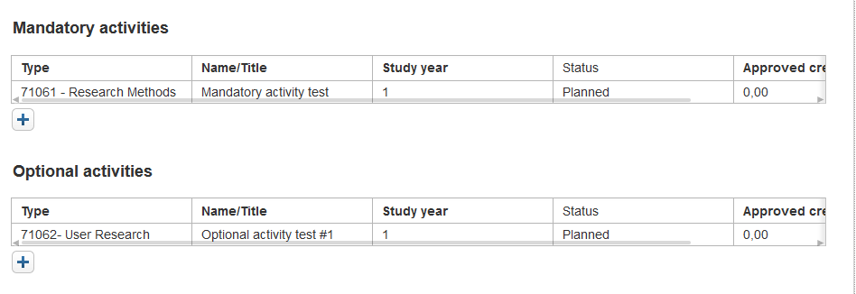

## Image embedded with alt text

## Image embedded with alt text and caption

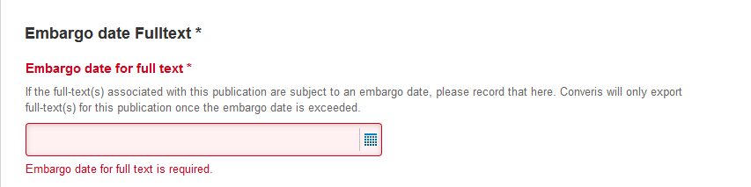

Figure 1: Screenshot of the embargo date fulltext