Project Iteration 1
Activity 4
User-Centric Computing II
COMP4600
Spring 2025
IA, ID document
Project Name: Project 4
Team Name: FreshStart
Trello board URL: https://trello.com/b/3FZeDMuj/fresh-start
Github repo URL: https://github.com/mbrunne1/FreshStart
Member information
# | Name
1 | Matthew Brunner
2 | Quince Cooper
3
4

All the works of all the team members
Content inventory

Matthew Brunner
Home
- Welcome message
- Overview of FreshStart services
- Featured resources

Programs & Services
- Career counseling
- Resume building resources
- Job search assistance
- Skill development workshops

Resources
- Articles about career transitions
- Resume templates
- Interview preparation guides
- Career planning tools

Community
- Mentorship opportunities
- Success stories
- Networking events

Contact
- Contact form
- Email information
- Social media links

Quince Cooper
- Personality and career test
- Degree program finder
- Career path recommendations
- Career path guides related to interest
- Salary and Job information
- Analyzer for transferable skills
- Related skill related articles
- Career roadmaps
- Local training program finder
- Discussion Forums
- Goal Setting tools
- Career progress finder
- Contact info
Final list of content inventory
Final Content Inventory

Home
- Website introduction
- Featured services

Career Services
- Career counseling
- Resume assistance
- Interview preparation

Resources
- Career articles
- Resume templates
- Job search tools

Community
- Mentorship program
- Success stories
- Networking opportunities

About
- Organization mission
- Team information

Contact
- Contact form
- Email
- Social media links

The final sitemap created by the whole team based on the final content inventory

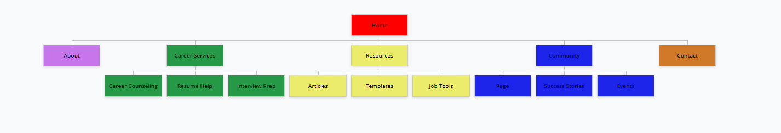
MORE CLEAR PICTURE IN GITHUB
Tree test tasks decided by the team
1. Find where you would go to get help improving your resume.

2. Locate where users can read career advice articles.

3. Find where you would go to contact FreshStart.

4. Locate where mentorship opportunities are listed.

5. Find where users can prepare for job interviews.

Tree Test results
Matthew Brunner
Task 1: 12 seconds
Task 2: 8 seconds
Task 3: 10 seconds
Task 4: 15 seconds
Task 5: 11 seconds

Quince Cooper
Task: 10 seconds
Task: 9 seconds
Task: 12 seconds
Task: 14 seconds
Task: 10 seconds

Tree test interview questions and answers
Matthew Brunner
List the answers you received from the user after Tree test below -
- Did you find the pages where you thought they should? If not, which pages were not where you expected them to be in the menu hierarchy? ANS: Yes, most pages were easy to locate, but the resources section took a moment to find.
- Did it take more time than you thought it would take? If so, why do you think it took longer? ANS: It took slightly longer for the mentorship section because I wasn't sure if it would be under Community or Resources.
- Were menu items labeled properly to indicate relevant resources? If not, what was mislabeled and how would you correct it? ANS: Yes, most labels were clear, but "Resources" could maybe be called "Career Resources".
- Do you have any suggestions to make the site navigation easier? ANS: Adding a dropdown menu might help users navigate faster.
Quince Cooper
List the answers you received from the user after Tree test below -
- Did you find the pages where you thought they should? If not, which pages were not where you expected them to be in the menu hierarchy? ANS: Yes, the pages were where I expected them.
- Did it take more time than you thought it would take? If so, why do you think it took longer? ANS: Resources took a little more time because I thought events might be under resources instead of community
- Were menu items labeled properly to indicate relevant resources? If not, what was mislabeled and how would you correct it? ANS:
Do you have any suggestions to make the site navigation easier? ANS: Yes, adding a search bar for easier searching

Team’s assessment of the sitemap
Team Assessment of the Sitemap

The sitemap performed well during the tree testing process. Most users were able to locate pages quickly and understood the menu structure. The organization of Career Services and Resources helped group similar content together.

However, one weakness noticed was that some users were unsure whether mentorship belonged under Community or Resources. To improve clarity, the team may consider renaming or reorganizing this section.

Overall, the navigation structure is clear and supports easy user access to important website content.

oLabels/titles
Labels / Titles

Home
About
Career Services
Resources
Community
Contact

