Case 5 - Multiple Regression in Biology & Analytics
Mohammed bin Salem
2026-04-01
Table of Contents
1. Introduction 2
2. Load Packages 2
3. Load Data 2
4. Data Understanding and Cleaning 4
4.1 Check missing values 4
4.2 Convert categorical variables 4
4.3 Check outliers 4
4.4 Transform the response variable 5
5. Exploratory Data Analysis 6
5.1 Correlation among numeric variables 6
5.2 Scatterplots against the response 7
6. Model Specification 8
6.1 Full multiple regression model 8
6.2 Optional model with categorical controls 9
6.3 Optional interaction example 10
7. Multicollinearity Check 10
8. Model Diagnostics 11
8.1 Residual plots 11
8.2 Breusch-Pagan test for homoscedasticity 12
8.3 Normality check for residuals 12
9. Model Selection 13
9.1 Compare candidate models 13
9.2 Stepwise regression 13
10. Validation 14
10.1 Train/Test split 14
10.2 Fit selected model on training data 14
10.3 Predict on test data 15
11. Interpretation Template 15
12. Conclusion Template 15
13. Optional: Save Key Outputs 16

1. Introduction
This case study examines how environmental conditions are associated with ecosystem stress using the Forest Fires dataset. The response variable is burned area (area), which is used here as a proxy for environmental impact. The analysis applies multiple regression, diagnostic testing, model selection, and validation.

2. Load Packages
library(dplyr)
library(tidyr)
library(tidyverse)
library(car)
library(MASS)
library(caret)
library(lmtest)
library(GGally)

3. Load Data
# Update the path if your file is stored somewhere else
fires <- read.csv("~/Library/CloudStorage/OneDrive-UAEUniversity/Uni/STAT 482/Case 5/forest+fires/forestfires.csv")
# Quick inspection
dim(fires)
## [1] 517 13
str(fires)
## 'data.frame': 517 obs. of 13 variables:
## $ X : int 7 7 7 8 8 8 8 8 8 7 ...
## $ Y : int 5 4 4 6 6 6 6 6 6 5 ...
## $ month: chr "mar" "oct" "oct" "mar" ...
## $ day : chr "fri" "tue" "sat" "fri" ...
## $ FFMC : num 86.2 90.6 90.6 91.7 89.3 92.3 92.3 91.5 91 92.5 ...
## $ DMC : num 26.2 35.4 43.7 33.3 51.3 ...
## $ DC : num 94.3 669.1 686.9 77.5 102.2 ...
## $ ISI : num 5.1 6.7 6.7 9 9.6 14.7 8.5 10.7 7 7.1 ...
## $ temp : num 8.2 18 14.6 8.3 11.4 22.2 24.1 8 13.1 22.8 ...
## $ RH : int 51 33 33 97 99 29 27 86 63 40 ...
## $ wind : num 6.7 0.9 1.3 4 1.8 5.4 3.1 2.2 5.4 4 ...
## $ rain : num 0 0 0 0.2 0 0 0 0 0 0 ...
## $ area : num 0 0 0 0 0 0 0 0 0 0 ...
summary(fires)
## X Y month day
## Min. :1.000 Min. :2.0 Length:517 Length:517
## 1st Qu.:3.000 1st Qu.:4.0 Class :character Class :character
## Median :4.000 Median :4.0 Mode :character Mode :character
## Mean :4.669 Mean :4.3
## 3rd Qu.:7.000 3rd Qu.:5.0
## Max. :9.000 Max. :9.0
## FFMC DMC DC ISI
## Min. :18.70 Min. : 1.1 Min. : 7.9 Min. : 0.000
## 1st Qu.:90.20 1st Qu.: 68.6 1st Qu.:437.7 1st Qu.: 6.500
## Median :91.60 Median :108.3 Median :664.2 Median : 8.400
## Mean :90.64 Mean :110.9 Mean :547.9 Mean : 9.022
## 3rd Qu.:92.90 3rd Qu.:142.4 3rd Qu.:713.9 3rd Qu.:10.800
## Max. :96.20 Max. :291.3 Max. :860.6 Max. :56.100
## temp RH wind rain
## Min. : 2.20 Min. : 15.00 Min. :0.400 Min. :0.00000
## 1st Qu.:15.50 1st Qu.: 33.00 1st Qu.:2.700 1st Qu.:0.00000
## Median :19.30 Median : 42.00 Median :4.000 Median :0.00000
## Mean :18.89 Mean : 44.29 Mean :4.018 Mean :0.02166
## 3rd Qu.:22.80 3rd Qu.: 53.00 3rd Qu.:4.900 3rd Qu.:0.00000
## Max. :33.30 Max. :100.00 Max. :9.400 Max. :6.40000
## area
## Min. : 0.00
## 1st Qu.: 0.00
## Median : 0.52
## Mean : 12.85
## 3rd Qu.: 6.57
## Max. :1090.84
head(fires)
## X Y month day FFMC DMC DC ISI temp RH wind rain area
## 1 7 5 mar fri 86.2 26.2 94.3 5.1 8.2 51 6.7 0.0 0
## 2 7 4 oct tue 90.6 35.4 669.1 6.7 18.0 33 0.9 0.0 0
## 3 7 4 oct sat 90.6 43.7 686.9 6.7 14.6 33 1.3 0.0 0
## 4 8 6 mar fri 91.7 33.3 77.5 9.0 8.3 97 4.0 0.2 0
## 5 8 6 mar sun 89.3 51.3 102.2 9.6 11.4 99 1.8 0.0 0
## 6 8 6 aug sun 92.3 85.3 488.0 14.7 22.2 29 5.4 0.0 0

4. Data Understanding and Cleaning

4.1 Check missing values
colSums(is.na(fires))
## X Y month day FFMC DMC DC ISI temp RH wind rain area
## 0 0 0 0 0 0 0 0 0 0 0 0 0

4.2 Convert categorical variables
fires$month <- factor(fires$month,
levels = c("jan", "feb", "mar", "apr", "may", "jun",
"jul", "aug", "sep", "oct", "nov", "dec"),
ordered = TRUE)
fires$day <- factor(fires$day,
levels = c("mon", "tue", "wed", "thu", "fri", "sat", "sun"),
ordered = TRUE)
str(fires)
## 'data.frame': 517 obs. of 13 variables:
## $ X : int 7 7 7 8 8 8 8 8 8 7 ...
## $ Y : int 5 4 4 6 6 6 6 6 6 5 ...
## $ month: Ord.factor w/ 12 levels "jan"<"feb"<"mar"<..: 3 10 10 3 3 8 8 8 9 9 ...
## $ day : Ord.factor w/ 7 levels "mon"<"tue"<"wed"<..: 5 2 6 5 7 7 1 1 2 6 ...
## $ FFMC : num 86.2 90.6 90.6 91.7 89.3 92.3 92.3 91.5 91 92.5 ...
## $ DMC : num 26.2 35.4 43.7 33.3 51.3 ...
## $ DC : num 94.3 669.1 686.9 77.5 102.2 ...
## $ ISI : num 5.1 6.7 6.7 9 9.6 14.7 8.5 10.7 7 7.1 ...
## $ temp : num 8.2 18 14.6 8.3 11.4 22.2 24.1 8 13.1 22.8 ...
## $ RH : int 51 33 33 97 99 29 27 86 63 40 ...
## $ wind : num 6.7 0.9 1.3 4 1.8 5.4 3.1 2.2 5.4 4 ...
## $ rain : num 0 0 0 0.2 0 0 0 0 0 0 ...
## $ area : num 0 0 0 0 0 0 0 0 0 0 ...

4.3 Check outliers
numeric_vars <- fires %>%
dplyr::select(where(is.numeric))
numeric_vars %>%
pivot_longer(cols = everything(), names_to = "variable", values_to = "value") %>%
ggplot(aes(x = variable, y = value)) +
geom_boxplot() +
coord_flip() +
labs(title = "Boxplots of Numeric Variables")
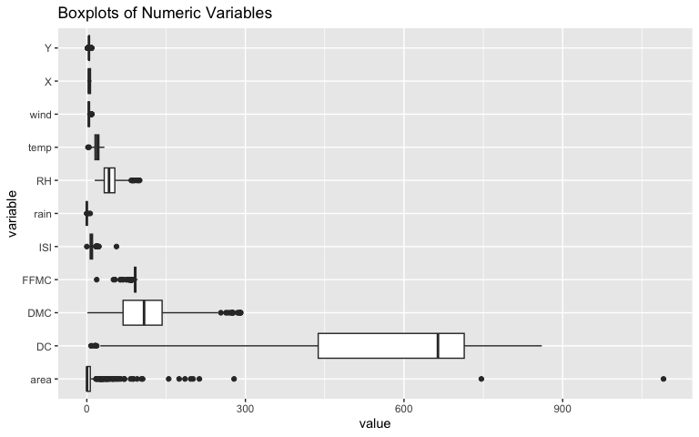

4.4 Transform the response variable
The variable area is heavily right-skewed, so we use log(area + 1).
fires$log_area <- log(fires$area + 1)
par(mfrow = c(1, 2))
hist(fires$area, main = "Original area", xlab = "area")
hist(fires$log_area, main = "Log-transformed area", xlab = "log(area + 1)")
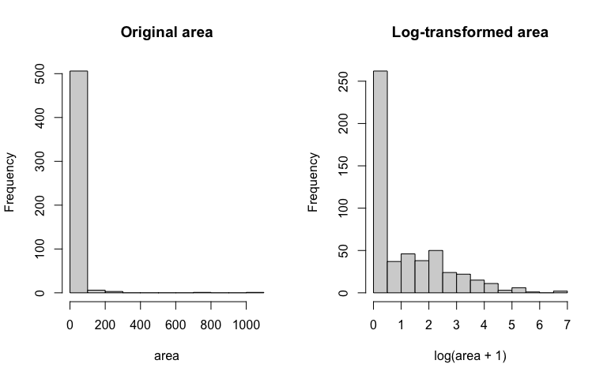
par(mfrow = c(1, 1))

5. Exploratory Data Analysis

5.1 Correlation among numeric variables
cor_data <- fires %>%
dplyr::select(FFMC, DMC, DC, ISI, temp, RH, wind, rain, area, log_area)
cor_matrix <- cor(cor_data, use = "complete.obs")
round(cor_matrix, 2)
## FFMC DMC DC ISI temp RH wind rain area log_area
## FFMC 1.00 0.38 0.33 0.53 0.43 -0.30 -0.03 0.06 0.04 0.05
## DMC 0.38 1.00 0.68 0.31 0.47 0.07 -0.11 0.07 0.07 0.07
## DC 0.33 0.68 1.00 0.23 0.50 -0.04 -0.20 0.04 0.05 0.07
## ISI 0.53 0.31 0.23 1.00 0.39 -0.13 0.11 0.07 0.01 -0.01
## temp 0.43 0.47 0.50 0.39 1.00 -0.53 -0.23 0.07 0.10 0.05
## RH -0.30 0.07 -0.04 -0.13 -0.53 1.00 0.07 0.10 -0.08 -0.05
## wind -0.03 -0.11 -0.20 0.11 -0.23 0.07 1.00 0.06 0.01 0.07
## rain 0.06 0.07 0.04 0.07 0.07 0.10 0.06 1.00 -0.01 0.02
## area 0.04 0.07 0.05 0.01 0.10 -0.08 0.01 -0.01 1.00 0.52
## log_area 0.05 0.07 0.07 -0.01 0.05 -0.05 0.07 0.02 0.52 1.00
GGally::ggcorr(cor_data, label = TRUE)
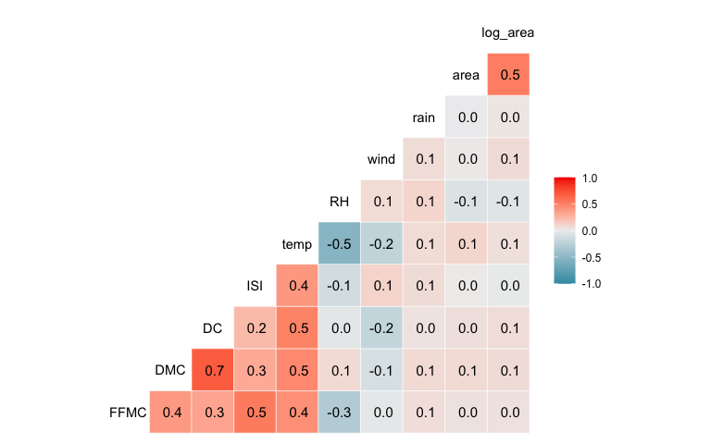

5.2 Scatterplots against the response
fires %>%
pivot_longer(cols = c(FFMC, DMC, DC, ISI, temp, RH, wind, rain),
names_to = "predictor",
values_to = "value") %>%
ggplot(aes(x = value, y = log_area)) +
geom_point(alpha = 0.6) +
geom_smooth(method = "lm", se = FALSE) +
facet_wrap(~ predictor, scales = "free_x") +
labs(title = "Predictors vs Log Burned Area", y = "log(area + 1)")
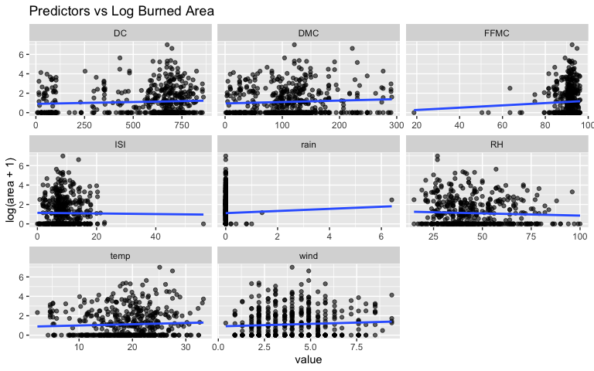

6. Model Specification

6.1 Full multiple regression model
full_model <- lm(log_area ~ FFMC + DMC + DC + ISI + temp + RH + wind + rain,
data = fires)
summary(full_model)
##
## Call:
## lm(formula = log_area ~ FFMC + DMC + DC + ISI + temp + RH + wind +
## rain, data = fires)
##
## Residuals:
## Min 1Q Median 3Q Max
## -1.5203 -1.1129 -0.6158 0.8787 5.7121
##
## Coefficients:
## Estimate Std. Error t value Pr(>|t|)
## (Intercept) 0.2224140 1.3604350 0.163 0.870
## FFMC 0.0077082 0.0144884 0.532 0.595
## DMC 0.0011915 0.0014642 0.814 0.416
## DC 0.0002737 0.0003570 0.767 0.444
## ISI -0.0239494 0.0169248 -1.415 0.158
## temp 0.0024618 0.0172593 0.143 0.887
## RH -0.0051729 0.0051889 -0.997 0.319
## wind 0.0757669 0.0366155 2.069 0.039 *
## rain 0.0965122 0.2121461 0.455 0.649
## ---
## Signif. codes: 0 '***' 0.001 '**' 0.01 '*' 0.05 '.' 0.1 ' ' 1
##
## Residual standard error: 1.395 on 508 degrees of freedom
## Multiple R-squared: 0.01988, Adjusted R-squared: 0.004446
## F-statistic: 1.288 on 8 and 508 DF, p-value: 0.2472

6.2 Optional model with categorical controls
model_time <- lm(log_area ~ FFMC + DMC + DC + ISI + temp + RH + wind + rain + month + day,
data = fires)
summary(model_time)
##
## Call:
## lm(formula = log_area ~ FFMC + DMC + DC + ISI + temp + RH + wind +
## rain + month + day, data = fires)
##
## Residuals:
## Min 1Q Median 3Q Max
## -1.9115 -1.0352 -0.5310 0.7901 5.2962
##
## Coefficients:
## Estimate Std. Error t value Pr(>|t|)
## (Intercept) -0.046193 1.617344 -0.029 0.9772
## FFMC 0.007537 0.016660 0.452 0.6512
## DMC 0.004073 0.001863 2.187 0.0292 *
## DC -0.001876 0.001258 -1.491 0.1367
## ISI -0.013408 0.017982 -0.746 0.4562
## temp 0.037199 0.022252 1.672 0.0952 .
## RH 0.001599 0.006212 0.257 0.7970
## wind 0.061519 0.038424 1.601 0.1100
## rain 0.051398 0.214711 0.239 0.8109
## month.L 1.206085 1.040426 1.159 0.2469
## month.Q 0.353297 0.902257 0.392 0.6955
## month.C 0.710602 0.845895 0.840 0.4013
## month^4 0.631993 0.677071 0.933 0.3511
## month^5 1.105487 0.888276 1.245 0.2139
## month^6 1.190056 0.778713 1.528 0.1271
## month^7 1.354255 0.699810 1.935 0.0535 .
## month^8 -0.093554 0.543601 -0.172 0.8634
## month^9 0.233368 0.388468 0.601 0.5483
## month^10 0.255285 0.545244 0.468 0.6398
## month^11 -0.431065 0.470931 -0.915 0.3605
## day.L -0.013194 0.160342 -0.082 0.9345
## day.Q 0.095974 0.165602 0.580 0.5625
## day.C 0.100508 0.166607 0.603 0.5466
## day^4 -0.217867 0.168655 -1.292 0.1970
## day^5 -0.108609 0.170895 -0.636 0.5254
## day^6 -0.069246 0.176305 -0.393 0.6947
## ---
## Signif. codes: 0 '***' 0.001 '**' 0.01 '*' 0.05 '.' 0.1 ' ' 1
##
## Residual standard error: 1.384 on 491 degrees of freedom
## Multiple R-squared: 0.06842, Adjusted R-squared: 0.02098
## F-statistic: 1.442 on 25 and 491 DF, p-value: 0.07785

6.3 Optional interaction example
model_interaction <- lm(log_area ~ FFMC + DMC + DC + ISI + temp * RH + wind + rain,
data = fires)
summary(model_interaction)
##
## Call:
## lm(formula = log_area ~ FFMC + DMC + DC + ISI + temp * RH + wind +
## rain, data = fires)
##
## Residuals:
## Min 1Q Median 3Q Max
## -1.5795 -1.1004 -0.6119 0.8728 5.6610
##
## Coefficients:
## Estimate Std. Error t value Pr(>|t|)
## (Intercept) -0.3390215 1.5469937 -0.219 0.8266
## FFMC 0.0103761 0.0149097 0.696 0.4868
## DMC 0.0011780 0.0014649 0.804 0.4217
## DC 0.0003040 0.0003593 0.846 0.3980
## ISI -0.0259566 0.0171347 -1.515 0.1304
## temp 0.0215696 0.0304078 0.709 0.4784
## RH 0.0023608 0.0111507 0.212 0.8324
## wind 0.0797857 0.0370069 2.156 0.0316 *
## rain 0.1255872 0.2156236 0.582 0.5605
## temp:RH -0.0004941 0.0006473 -0.763 0.4456
## ---
## Signif. codes: 0 '***' 0.001 '**' 0.01 '*' 0.05 '.' 0.1 ' ' 1
##
## Residual standard error: 1.396 on 507 degrees of freedom
## Multiple R-squared: 0.02101, Adjusted R-squared: 0.003628
## F-statistic: 1.209 on 9 and 507 DF, p-value: 0.287

7. Multicollinearity Check
vif(full_model)
## FFMC DMC DC ISI temp RH wind rain
## 1.695255 2.330688 2.078205 1.578258 2.661897 1.899989 1.140610 1.044801
Interpretation guideline: - VIF < 5: usually acceptable - VIF 5-10: moderate concern - VIF > 10: serious multicollinearity concern

8. Model Diagnostics

8.1 Residual plots
par(mfrow = c(2, 2))
plot(full_model)
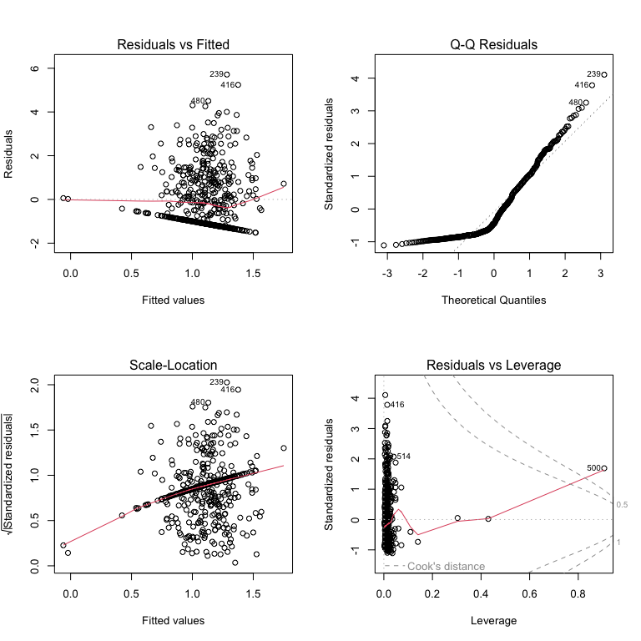
par(mfrow = c(1, 1))

8.2 Breusch-Pagan test for homoscedasticity
bptest(full_model)
##
## studentized Breusch-Pagan test
##
## data: full_model
## BP = 11.27, df = 8, p-value = 0.1868

8.3 Normality check for residuals
{
qqnorm(resid(full_model))
qqline(resid(full_model))
}
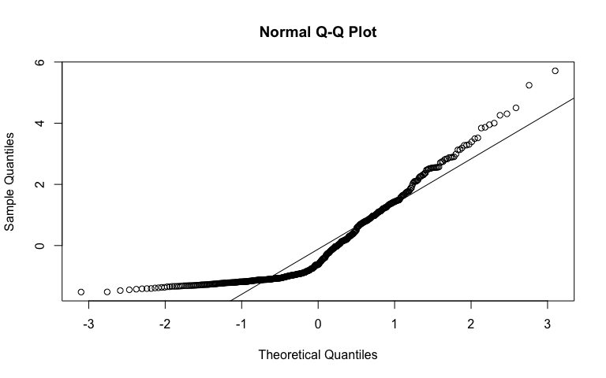
shapiro.test(resid(full_model))
##
## Shapiro-Wilk normality test
##
## data: resid(full_model)
## W = 0.85423, p-value < 2.2e-16

9. Model Selection

9.1 Compare candidate models
model_comparison <- tibble(
Model = c("Full Model", "Time Controls", "Interaction Model"),
Adjusted_R2 = c(summary(full_model)$adj.r.squared,
summary(model_time)$adj.r.squared,
summary(model_interaction)$adj.r.squared),
AIC = c(AIC(full_model), AIC(model_time), AIC(model_interaction)),
BIC = c(BIC(full_model), BIC(model_time), BIC(model_interaction))
)
model_comparison
## # A tibble: 3 × 4
## Model Adjusted_R2 AIC BIC
## <chr> <dbl> <dbl> <dbl>
## 1 Full Model 0.00445 1823. 1865.
## 2 Time Controls 0.0210 1830. 1945.
## 3 Interaction Model 0.00363 1824. 1871.

9.2 Stepwise regression
step_model <- stepAIC(full_model, direction = "both", trace = FALSE)
summary(step_model)
##
## Call:
## lm(formula = log_area ~ DMC + RH + wind, data = fires)
##
## Residuals:
## Min 1Q Median 3Q Max
## -1.5093 -1.1071 -0.6537 0.9216 5.7712
##
## Coefficients:
## Estimate Std. Error t value Pr(>|t|)
## (Intercept) 0.9129363 0.2433065 3.752 0.000195 ***
## DMC 0.0017552 0.0009657 1.817 0.069731 .
## RH -0.0055830 0.0037785 -1.478 0.140138
## wind 0.0624134 0.0345109 1.809 0.071112 .
## ---
## Signif. codes: 0 '***' 0.001 '**' 0.01 '*' 0.05 '.' 0.1 ' ' 1
##
## Residual standard error: 1.392 on 513 degrees of freedom
## Multiple R-squared: 0.01425, Adjusted R-squared: 0.008485
## F-statistic: 2.472 on 3 and 513 DF, p-value: 0.06101
AIC(step_model)
## [1] 1815.518
BIC(step_model)
## [1] 1836.758

10. Validation

10.1 Train/Test split
set.seed(202031137)
train_index <- createDataPartition(fires$log_area, p = 0.80, list = FALSE)
train_data <- fires[train_index, ]
test_data <- fires[-train_index, ]
dim(train_data)
## [1] 416 14
dim(test_data)
## [1] 101 14

10.2 Fit selected model on training data
train_model <- lm(log_area ~ FFMC + DMC + DC + ISI + temp + RH + wind + rain,
data = train_data)
summary(train_model)
##
## Call:
## lm(formula = log_area ~ FFMC + DMC + DC + ISI + temp + RH + wind +
## rain, data = train_data)
##
## Residuals:
## Min 1Q Median 3Q Max
## -1.5831 -1.0618 -0.5655 0.9072 5.3127
##
## Coefficients:
## Estimate Std. Error t value Pr(>|t|)
## (Intercept) 0.2581721 1.4067582 0.184 0.8545
## FFMC 0.0045570 0.0148461 0.307 0.7590
## DMC 0.0004967 0.0015905 0.312 0.7550
## DC 0.0006025 0.0003765 1.600 0.1103
## ISI -0.0298885 0.0174809 -1.710 0.0881 .
## temp 0.0062346 0.0186917 0.334 0.7389
## RH -0.0029577 0.0055909 -0.529 0.5971
## wind 0.0828639 0.0395539 2.095 0.0368 *
## rain -0.8911564 0.7521886 -1.185 0.2368
## ---
## Signif. codes: 0 '***' 0.001 '**' 0.01 '*' 0.05 '.' 0.1 ' ' 1
##
## Residual standard error: 1.349 on 407 degrees of freedom
## Multiple R-squared: 0.03022, Adjusted R-squared: 0.01116
## F-statistic: 1.585 on 8 and 407 DF, p-value: 0.1271

10.3 Predict on test data
pred_log <- predict(train_model, newdata = test_data)
rmse_value <- RMSE(pred_log, test_data$log_area)
mae_value <- MAE(pred_log, test_data$log_area)
validation_results <- tibble(
Metric = c("RMSE", "MAE"),
Value = c(rmse_value, mae_value)
)
validation_results
## # A tibble: 2 × 2
## Metric Value
## <chr> <dbl>
## 1 RMSE 1.71
## 2 MAE 1.30

11. Interpretation Template
Use this section after running the model:
- Coefficient signs: Explain whether each significant predictor increases or decreases expected log(area + 1).
- Magnitude: For each 1-unit increase in a predictor, the response changes by the corresponding coefficient, holding all other variables constant.
- Most influential factors: Focus on predictors with statistically significant p-values and practical relevance.
- Biological meaning: Relate factors such as temperature, humidity, rainfall, and drought indicators to ecosystem stress.
- Business implications: Discuss implications for agricultural planning, wildfire risk mitigation, and controlled ecosystem management.

12. Conclusion Template
This analysis applies multiple regression to evaluate how environmental variables influence ecosystem impact. After checking assumptions, selecting the best model, and validating performance, the final model can be used to identify the most influential environmental drivers and support data-driven decision-making.

13. Optional: Save Key Outputs
write.csv(model_comparison, "model_comparison.csv", row.names = FALSE)
write.csv(validation_results, "validation_results.csv", row.names = FALSE)

