R-Code : Case 1
Mohammed Baobaid - 202031137
2026-01-14

1. Package Installation (run once)
packages <- c(
"tidyverse",
"caret",
"pROC",
"ROCR",
"glmnet",
"randomForest",
"xgboost",
"vroom",
"data.table",
"janitor"
)

2. Setup
set.seed(202031137)
library(tidyverse)
library(caret)
library(pROC)
library(janitor)

3. Load Data
df <- read_csv("WA_Fn-UseC_-Telco-Customer-Churn.csv", na = c("", "NA", " "))
glimpse(df)
## Rows: 7,043
## Columns: 21
## $ customerID <chr> "7590-VHVEG", "5575-GNVDE", "3668-QPYBK", "7795-CFOCW…
## $ gender <chr> "Female", "Male", "Male", "Male", "Female", "Female",…
## $ SeniorCitizen <dbl> 0, 0, 0, 0, 0, 0, 0, 0, 0, 0, 0, 0, 0, 0, 0, 0, 0, 0,…
## $ Partner <chr> "Yes", "No", "No", "No", "No", "No", "No", "No", "Yes…
## $ Dependents <chr> "No", "No", "No", "No", "No", "No", "Yes", "No", "No"…
## $ tenure <dbl> 1, 34, 2, 45, 2, 8, 22, 10, 28, 62, 13, 16, 58, 49, 2…
## $ PhoneService <chr> "No", "Yes", "Yes", "No", "Yes", "Yes", "Yes", "No", …
## $ MultipleLines <chr> "No phone service", "No", "No", "No phone service", "…
## $ InternetService <chr> "DSL", "DSL", "DSL", "DSL", "Fiber optic", "Fiber opt…
## $ OnlineSecurity <chr> "No", "Yes", "Yes", "Yes", "No", "No", "No", "Yes", "…
## $ OnlineBackup <chr> "Yes", "No", "Yes", "No", "No", "No", "Yes", "No", "N…
## $ DeviceProtection <chr> "No", "Yes", "No", "Yes", "No", "Yes", "No", "No", "Y…
## $ TechSupport <chr> "No", "No", "No", "Yes", "No", "No", "No", "No", "Yes…
## $ StreamingTV <chr> "No", "No", "No", "No", "No", "Yes", "Yes", "No", "Ye…
## $ StreamingMovies <chr> "No", "No", "No", "No", "No", "Yes", "No", "No", "Yes…
## $ Contract <chr> "Month-to-month", "One year", "Month-to-month", "One …
## $ PaperlessBilling <chr> "Yes", "No", "Yes", "No", "Yes", "Yes", "Yes", "No", …
## $ PaymentMethod <chr> "Electronic check", "Mailed check", "Mailed check", "…
## $ MonthlyCharges <dbl> 29.85, 56.95, 53.85, 42.30, 70.70, 99.65, 89.10, 29.7…
## $ TotalCharges <dbl> 29.85, 1889.50, 108.15, 1840.75, 151.65, 820.50, 1949…
## $ Churn <chr> "No", "No", "Yes", "No", "Yes", "Yes", "No", "No", "Y…
summary(df)
## customerID gender SeniorCitizen Partner
## Length:7043 Length:7043 Min. :0.0000 Length:7043
## Class :character Class :character 1st Qu.:0.0000 Class :character
## Mode :character Mode :character Median :0.0000 Mode :character
## Mean :0.1621
## 3rd Qu.:0.0000
## Max. :1.0000
##
## Dependents tenure PhoneService MultipleLines
## Length:7043 Min. : 0.00 Length:7043 Length:7043
## Class :character 1st Qu.: 9.00 Class :character Class :character
## Mode :character Median :29.00 Mode :character Mode :character
## Mean :32.37
## 3rd Qu.:55.00
## Max. :72.00
##
## InternetService OnlineSecurity OnlineBackup DeviceProtection
## Length:7043 Length:7043 Length:7043 Length:7043
## Class :character Class :character Class :character Class :character
## Mode :character Mode :character Mode :character Mode :character
##
##
##
##
## TechSupport StreamingTV StreamingMovies Contract
## Length:7043 Length:7043 Length:7043 Length:7043
## Class :character Class :character Class :character Class :character
## Mode :character Mode :character Mode :character Mode :character
##
##
##
##
## PaperlessBilling PaymentMethod MonthlyCharges TotalCharges
## Length:7043 Length:7043 Min. : 18.25 Min. : 18.8
## Class :character Class :character 1st Qu.: 35.50 1st Qu.: 401.4
## Mode :character Mode :character Median : 70.35 Median :1397.5
## Mean : 64.76 Mean :2283.3
## 3rd Qu.: 89.85 3rd Qu.:3794.7
## Max. :118.75 Max. :8684.8
## NA's :11
## Churn
## Length:7043
## Class :character
## Mode :character
##
##
##
##
tabyl(df$Churn)
## df$Churn n percent
## No 5174 0.7346301
## Yes 1869 0.2653699

4. Fix Data Types
df <- df %>%
mutate(TotalCharges = as.numeric(TotalCharges))
sum(is.na(df$TotalCharges))
## [1] 11

5. Missing Value Handling
df <- df %>%
mutate(TotalCharges = as.numeric(TotalCharges)) %>%
mutate(TotalCharges = if_else(
is.na(TotalCharges),
median(TotalCharges, na.rm = TRUE),
TotalCharges
))

6. Data Cleaning & Recoding
df <- df %>%
mutate(
across(where(is.character), as.factor),
SeniorCitizen = factor(SeniorCitizen, levels = c(0,1), labels = c("No","Yes")),
Churn = factor(Churn, levels = c("No","Yes"))
) %>%
select(-customerID)

7. Exploratory Data Analysis
prop.table(table(df$Churn))
##
## No Yes
## 0.7346301 0.2653699
ggplot(df, aes(x = tenure, fill = Churn)) +
geom_density(alpha = 0.5) +
labs(title = "Tenure by Churn")
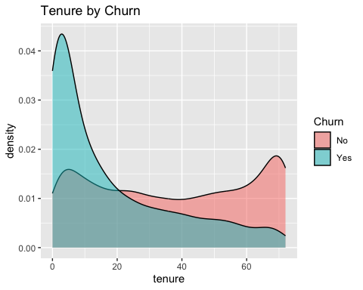
ggplot(df, aes(x = MonthlyCharges, fill = Churn)) +
geom_density(alpha = 0.5) +
labs(title = "Monthly Charges by Churn")
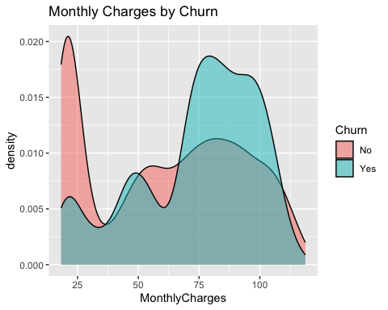

8. Feature Engineering
df <- df %>%
mutate(
tenure_group = case_when(
tenure <= 12 ~ "0-12",
tenure <= 24 ~ "13-24",
tenure <= 48 ~ "25-48",
tenure <= 60 ~ "49-60",
TRUE ~ "61+"
),
tenure_group = factor(
tenure_group,
levels = c("0-12","13-24","25-48","49-60","61+")
)
)

9. Train-Test Split
train_index <- createDataPartition(df$Churn, p = 0.75, list = FALSE)
train_df <- df[train_index, ]
test_df <- df[-train_index, ]

10. Dummy Encoding (Optional)
dummies <- dummyVars(Churn ~ ., data = train_df, fullRank = TRUE)
x_train <- predict(dummies, train_df) %>% as.data.frame()
x_test <- predict(dummies, test_df) %>% as.data.frame()
y_train <- train_df$Churn
y_test <- test_df$Churn

11. Logistic Regression Model
glm_fit <- glm(
Churn ~ tenure + MonthlyCharges + TotalCharges +
Contract + InternetService + tenure_group,
data = train_df,
family = binomial(link = "logit")
)
summary(glm_fit)
##
## Call:
## glm(formula = Churn ~ tenure + MonthlyCharges + TotalCharges +
## Contract + InternetService + tenure_group, family = binomial(link = "logit"),
## data = train_df)
##
## Coefficients:
## Estimate Std. Error z value Pr(>|z|)
## (Intercept) -0.1118603 0.2250487 -0.497 0.6192
## tenure -0.0542342 0.0107506 -5.045 4.54e-07 ***
## MonthlyCharges 0.0009615 0.0041036 0.234 0.8147
## TotalCharges 0.0001601 0.0000868 1.845 0.0651 .
## ContractOne year -0.8349944 0.1217922 -6.856 7.09e-12 ***
## ContractTwo year -1.8646980 0.2116066 -8.812 < 2e-16 ***
## InternetServiceFiber optic 1.1089214 0.1502548 7.380 1.58e-13 ***
## InternetServiceNo -0.9622809 0.1776636 -5.416 6.08e-08 ***
## tenure_group13-24 -0.2963519 0.1549252 -1.913 0.0558 .
## tenure_group25-48 -0.0853391 0.2719455 -0.314 0.7537
## tenure_group49-60 0.3995459 0.4348560 0.919 0.3582
## tenure_group61+ 0.5080897 0.5402313 0.941 0.3470
## ---
## Signif. codes: 0 '***' 0.001 '**' 0.01 '*' 0.05 '.' 0.1 ' ' 1
##
## (Dispersion parameter for binomial family taken to be 1)
##
## Null deviance: 6113.6 on 5282 degrees of freedom
## Residual deviance: 4463.7 on 5271 degrees of freedom
## AIC: 4487.7
##
## Number of Fisher Scoring iterations: 6
exp(coef(glm_fit))
## (Intercept) tenure
## 0.8941692 0.9472102
## MonthlyCharges TotalCharges
## 1.0009620 1.0001601
## ContractOne year ContractTwo year
## 0.4338769 0.1549430
## InternetServiceFiber optic InternetServiceNo
## 3.0310872 0.3820206
## tenure_group13-24 tenure_group25-48
## 0.7435257 0.9182009
## tenure_group49-60 tenure_group61+
## 1.4911474 1.6621130

12. Model Evaluation
test_pred_prob <- predict(glm_fit, newdata = test_df, type = "response")
test_pred_class <- ifelse(test_pred_prob > 0.5, "Yes", "No") %>%
factor(levels = levels(df$Churn))
confusionMatrix(test_pred_class, test_df$Churn, positive = "Yes")
## Confusion Matrix and Statistics
##
## Reference
## Prediction No Yes
## No 1181 282
## Yes 112 185
##
## Accuracy : 0.7761
## 95% CI : (0.7559, 0.7954)
## No Information Rate : 0.7347
## P-Value [Acc > NIR] : 3.441e-05
##
## Kappa : 0.3503
##
## Mcnemar's Test P-Value : < 2.2e-16
##
## Sensitivity : 0.3961
## Specificity : 0.9134
## Pos Pred Value : 0.6229
## Neg Pred Value : 0.8072
## Prevalence : 0.2653
## Detection Rate : 0.1051
## Detection Prevalence : 0.1688
## Balanced Accuracy : 0.6548
##
## 'Positive' Class : Yes
##

13. ROC Curve & AUC
roc_obj <- roc(
response = test_df$Churn,
predictor = test_pred_prob,
levels = c("No","Yes")
)
auc(roc_obj)
## Area under the curve: 0.8218
plot(roc_obj, main = paste("AUC =", round(auc(roc_obj), 3)))
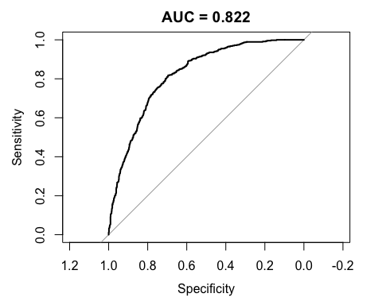

14. Threshold Tuning
coords(
roc_obj,
x = "best",
best.method = "youden",
ret = c("threshold", "sensitivity", "specificity")
)
## threshold sensitivity specificity
## 1 0.2418706 0.8179872 0.6952823

15. Variable Importance (GLM Approximation)
glm_summary <- summary(glm_fit)
zvals <- coef(glm_summary)[, "z value"]
sort(abs(zvals), decreasing = TRUE)
## ContractTwo year InternetServiceFiber optic
## 8.8120957 7.3802709
## ContractOne year InternetServiceNo
## 6.8558919 5.4163077
## tenure tenure_group13-24
## 5.0447445 1.9128716
## TotalCharges tenure_group61+
## 1.8445189 0.9405039
## tenure_group49-60 (Intercept)
## 0.9188003 0.4970491
## tenure_group25-48 MonthlyCharges
## 0.3138094 0.2343162

16. Save Outputs
saveRDS(glm_fit, "glm_telco_model.rds")
write_csv(
test_df %>%
mutate(
pred_prob = test_pred_prob,
pred_class = test_pred_class
),
"predictions_test.csv"
)

