Case 3

Forecasting Product Demand for Inventory Planning
Course: STAT 482
Instructor: Ibrahim Abdullah Alfaki

Mohammed Salem 2031137
Hamed Al saedi 202008437
Majid Tayfour 202219094

Executive Summary
Effective inventory planning requires balancing product availability with the financial risks associated with overstocking and stockouts. As outlined in the case description, management requires reliable short-term demand forecasts to determine appropriate inventory levels for the upcoming months. This analysis develops and evaluates forecasting models using historical sales data to support data-driven inventory decisions.
Using five years of daily sales data (2013–2017) from the Kaggle Store Item Demand dataset, we analyzed a representative store–item combination and aggregated daily transactions to monthly totals, producing 60 monthly observations. Exploratory analysis revealed two dominant patterns: (1) a consistent upward trend in demand and (2) strong recurring seasonality, with peak sales occurring mid-year and lower sales during winter months. Seasonal amplitude increased as overall demand grew, indicating multiplicative seasonal behavior.
Two forecasting approaches were developed: Seasonal ARIMA and Exponential Smoothing (ETS). The ARIMA model selected was ARIMA(0,1,1)(0,1,0)[12], incorporating both first-order and seasonal differencing to address trend and seasonality. The ETS model selected was ETS(M,Ad,M), capturing multiplicative error and seasonality with a damped additive trend.
Out-of-sample validation using a six-month holdout period showed that the ARIMA model achieved superior relative forecasting accuracy, with a Mean Absolute Percentage Error (MAPE) of approximately 4.46% compared to 4.77% for ETS. Although ETS produced a slightly lower RMSE, MAPE was prioritized due to its interpretability and relevance for inventory planning. Consequently, ARIMA was selected as the final forecasting model.
The six-month forecast projects continued seasonal growth, with expected demand rising from approximately 500 units to 865 units over the forecast horizon. However, prediction intervals widen over time; for the final forecasted month, the 95% prediction interval spans roughly 783 to 946 units. This range highlights increasing uncertainty and underscores the importance of incorporating safety stock in inventory decisions.
Overall, the selected model demonstrates strong predictive performance suitable for short-term planning. Management should align base inventory levels with forecasted demand while incorporating buffers during peak seasonal months to mitigate stockout risk. Continuous monitoring and model updates are recommended to maintain forecast reliability.

Business Context and Problem Definition
Retail firms operate in an environment where inventory decisions directly impact profitability, customer satisfaction, and operational efficiency. As described in the case scenario , companies must balance two competing financial risks:
Overstocking increases holding costs, ties up valuable working capital in unsold inventory, raises storage and warehousing expenses, and exposes the firm to the risk of product obsolescence or markdowns. On the other hand, stockouts result in lost sales, dissatisfied customers, reduced customer loyalty, and potential long-term reputational damage. Together, these competing risks highlight the importance of accurate demand forecasting in achieving an optimal balance between inventory availability and cost efficiency.
Accurate demand forecasting is therefore central to inventory planning, production scheduling, and cash-flow management. Even modest forecasting errors can significantly affect operational performance, particularly when products exhibit seasonal demand fluctuations.
The organization in this case sells a single product category nationwide and requires reliable short-term forecasts for the next several months. Historical sales data demonstrate both trend and seasonality, making time series analysis an appropriate methodological framework.
This study focuses on a representative store–item combination to develop and evaluate forecasting methodology. Daily sales data from 2013 to 2017 were aggregated into monthly totals to align with managerial planning cycles. The primary objective is to answer the following question:
How much inventory should be stocked over the next six months to meet expected demand while minimizing financial risk?
To address this question, the analysis aims to:
- Identify and model underlying trend and seasonal components.
- Develop statistically sound forecasting models (ARIMA and ETS).
- Evaluate predictive performance using quantitative accuracy metrics (MAPE and RMSE).
- Quantify forecast uncertainty using prediction intervals.
- Translate forecast results into actionable inventory recommendations.
Because demand exhibits increasing seasonal amplitude over time, forecasting models must account for both structural growth and seasonal variability. Additionally, managers must understand not only expected demand levels but also the range of plausible outcomes. Prediction intervals therefore play a critical role in supporting risk-aware inventory decisions.
In summary, the business problem is not merely to generate forecasts, but to transform statistical outputs into operational guidance that optimizes inventory levels under uncertainty. The remainder of this report details the methodology, model selection process, forecast results, and managerial implications derived from the analysis.

Methodology

Description of Techniques and Assumptions
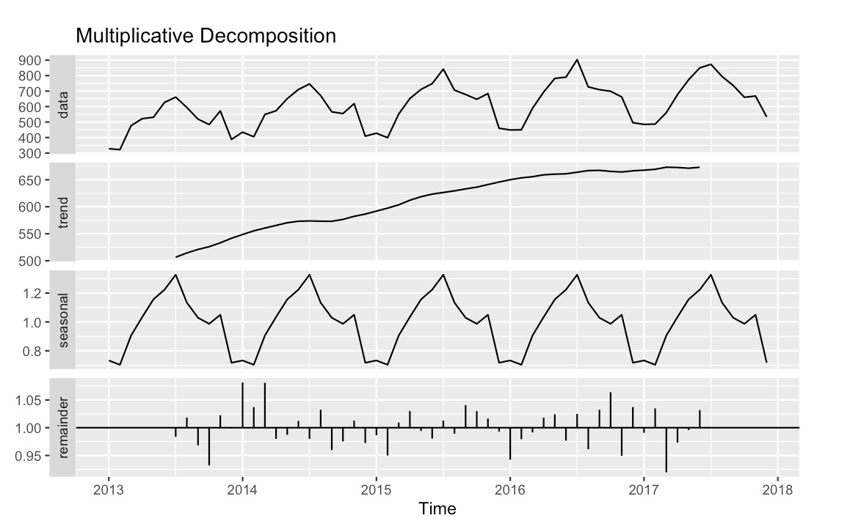

Data Preparation and Time Series Construction
Daily sales data from 2013–2017 were aggregated to monthly totals to align with managerial planning cycles and reduce high-frequency noise. The resulting time series consists of 60 monthly observations with frequency 12, capturing five full seasonal cycles. No missing values were present in the dataset, and no imputation was required.
Monthly aggregation assumes that within-month fluctuations do not materially affect medium-term inventory decisions, which are typically planned on a monthly basis.
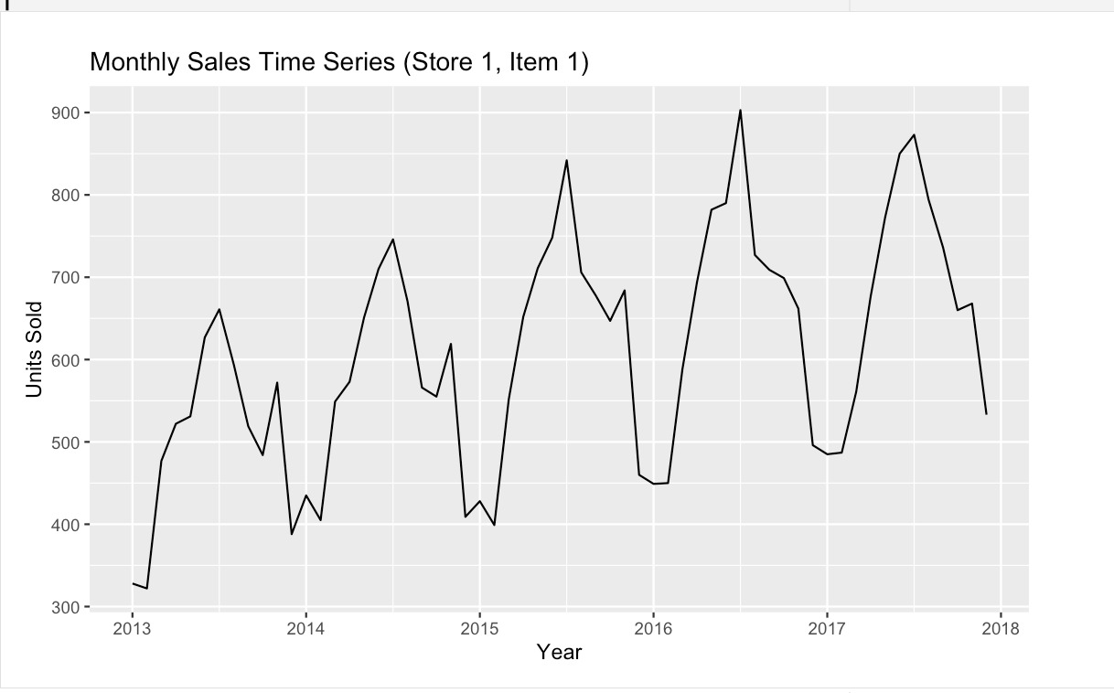

Exploratory Time Series Analysis
Visual inspection of the time series plot revealed:
- A clear upward trend in demand over time.
- Strong recurring seasonal patterns.
- Increasing seasonal amplitude as overall sales levels increased.
A seasonal plot confirmed consistent mid-year peaks and lower sales during winter months. To formally examine structure, both additive and multiplicative decompositions were performed. The multiplicative decomposition produced substantially lower residual variability (SD ≈ 0.036) compared to the additive model (SD ≈ 24.24), indicating that seasonal effects scale proportionally with the level of demand.
This finding supports the assumption of multiplicative seasonality.
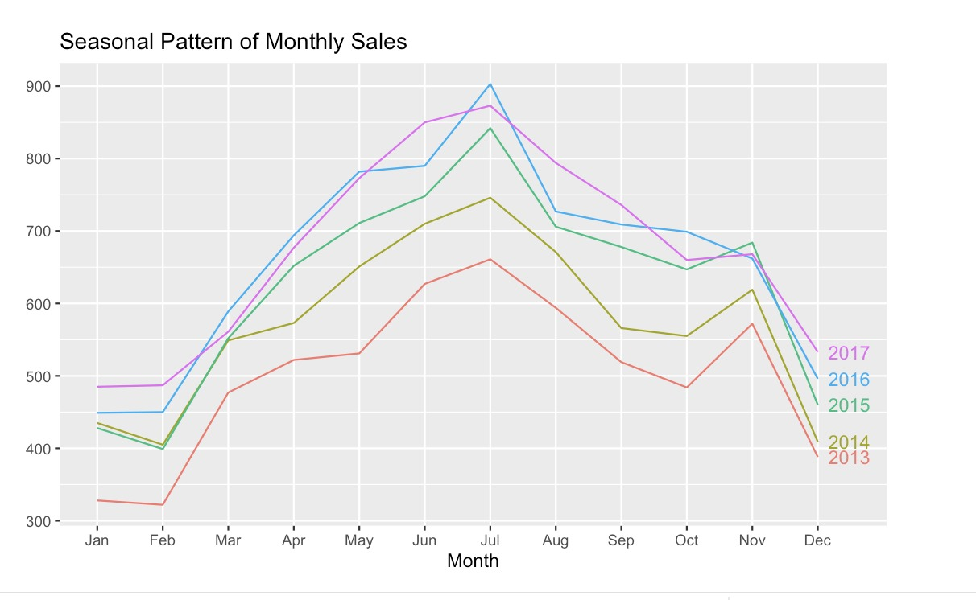

Stationarity and Differencing
Stationarity was assessed using:
- Augmented Dickey-Fuller (ADF) test
- KPSS test
The ADF test rejected the null hypothesis of a unit root (p = 0.01), while the KPSS test rejected level stationarity (p ≈ 0.03). Given the visible trend and seasonal structure, the series was treated as non-stationary.
Accordingly:
- First-order differencing (d = 1) was applied to remove trend.
- Seasonal differencing (D = 1, lag = 12) was applied to remove annual seasonality.
This ensures that the modeling framework operates on a stationary transformed series, satisfying core ARIMA assumptions.

Forecasting Horizon and Validation Strategy
A six-month forecast horizon was selected to match short-term inventory planning needs, consistent with case requirements .
To evaluate predictive performance, a rolling-origin holdout approach was used:
- First 54 months → training set
- Final 6 months → test set
This out-of-sample validation ensures that model performance reflects real forecasting conditions rather than in-sample fit.

Model Assumptions
The methodology relies on several key assumptions:
- Historical trend and seasonal patterns will continue in the short term.
- No structural breaks occurred during the historical period.
- Errors are independently distributed (validated via Ljung-Box test).
- No external regressors (e.g., promotions, pricing, macroeconomic factors) materially alter short-term demand.
These assumptions are reasonable for short-horizon operational forecasting.

Model Description and Justification

ARIMA Model
The selected ARIMA specification was:
ARIMA(0,1,1)(0,1,0)[12]
This model incorporates:
- First-order differencing to remove trend (d = 1)
- Seasonal differencing to remove annual seasonality (D = 1)
- A non-seasonal moving average component MA(1)
The MA(1) coefficient (−0.702, SE = 0.125) is statistically significant, indicating meaningful short-term error correction.
Model adequacy was evaluated using residual diagnostics. The Ljung-Box test yielded:
p-value = 0.5873
Since this exceeds 0.05, we fail to reject the null hypothesis of no autocorrelation. Residual ACF plots show no significant remaining structure, indicating that residuals behave as white noise. This confirms model validity.
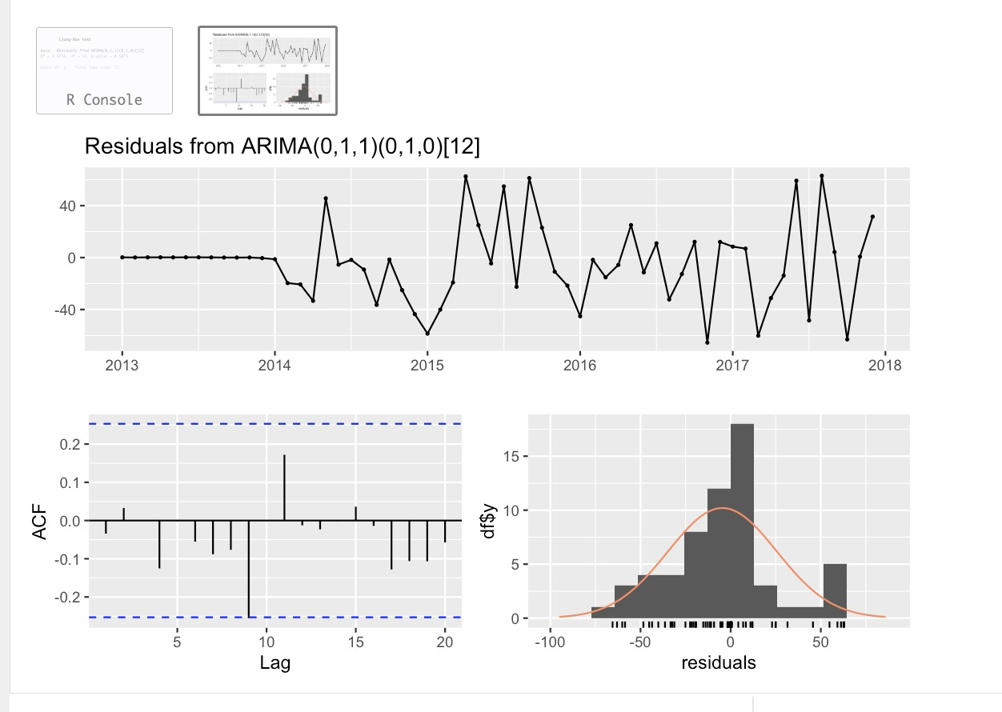

ETS Model
An alternative Exponential Smoothing model was also estimated:
ETS(M,Ad,M)
This specification includes:
- Multiplicative errors
- Additive damped trend
- Multiplicative seasonality
The multiplicative seasonal structure aligns with earlier decomposition results, making ETS a theoretically appropriate comparator model.

Model Comparison and Final Selection
Out-of-sample performance (test set):
Model | MAPE | RMSE
ARIMA | 4.46% | 38.48
ETS | 4.77% | 35.19
Although ETS achieved slightly lower RMSE, ARIMA produced lower MAPE. Because MAPE is scale-independent and more interpretable for inventory planning decisions, it was prioritized as the primary evaluation metric.
Therefore, ARIMA(0,1,1)(0,1,0)[12] was selected as the final forecasting model.

Forecast Characteristics
The six-month forecast projects increasing seasonal demand:
- Month 1 forecast: ≈ 500 units
- Month 6 forecast: ≈ 865 units
The 95% prediction interval for the final month ranges from approximately 783 to 946 units, reflecting widening uncertainty over time.
The inclusion of prediction intervals allows management to incorporate risk considerations into inventory decisions.

Results and Interpretation

Exploratory Findings
The monthly sales series demonstrates two dominant structural patterns: a sustained upward trend and strong recurring seasonality. Demand increases steadily from 2013 through 2017, indicating consistent growth in product sales. Seasonal peaks occur mid-year (June–August), while troughs appear during early winter months (January–February).
Seasonal amplitude increases proportionally with overall sales levels, supporting multiplicative seasonal behavior. This observation was confirmed during decomposition analysis, where the multiplicative model exhibited substantially lower residual variability than the additive specification.

Differencing and Stationarity Confirmation
Formal differencing recommendations were obtained using automated statistical procedures:
- ndiffs(sales_ts) = 1
- nsdiffs(sales_ts) = 1
These results confirm the need for:
- First-order differencing (d = 1) to remove trend.
- Seasonal differencing (D = 1, period = 12) to remove annual seasonality.
This provides empirical justification for the ARIMA specification selected.

Model Estimation Results

ARIMA Model
The selected model was:
ARIMA(0,1,1)(0,1,0)[12]
Key results:
- MA(1) coefficient = −0.702
- Standard error = 0.125
- AIC = 470.11
The negative MA coefficient indicates meaningful short-term error correction dynamics. Information criteria support strong model fit.
Residual diagnostics confirm model adequacy:
- Ljung-Box Q* = 9.3756
- p-value = 0.5873
Since the p-value exceeds 0.05, residual autocorrelation is not statistically significant. The residual ACF plot shows no systematic pattern, and the histogram approximates normality, indicating that the model has effectively captured the underlying time-series structure.

ETS Model
The alternative model selected was:
ETS(M,Ad,M)
(Multiplicative error, additive damped trend, multiplicative seasonality)
AIC comparison:
- ARIMA AIC = 470.11
- ETS AIC = 670.22
The substantially lower AIC for ARIMA suggests superior in-sample fit relative to ETS.

Out-of-Sample Forecast Accuracy
To assess predictive performance under realistic forecasting conditions, the final six months were reserved as a test set.

Test-Set Performance
ARIMA:
- ME = −10.11
- RMSE = 38.48
- MAE = 32.33
- MAPE = 4.46%
- Theil’s U = 0.403
ETS:
- ME = −5.32
- RMSE = 35.19
- MAE = 32.60
- MAPE = 4.77%
- Theil’s U = 0.447
Although ETS achieved slightly lower RMSE, ARIMA produced lower MAPE. Because MAPE measures relative percentage error and is more interpretable for operational inventory planning, it was prioritized as the primary evaluation metric.
A MAPE of 4.46% indicates that, on average, forecasts deviate from actual demand by less than 5%, reflecting strong short-term predictive accuracy.
The ARIMA forecast versus actual comparison during the test period further confirms close tracking of realized demand, with no systematic bias evident.
Based on these results, ARIMA(0,1,1)(0,1,0)[12] was selected as the final forecasting model.

Six-Month Forecast Results
The ARIMA model was used to generate a six-month forecast with 95% prediction intervals.
Month | Forecast | Lower 95% | Upper 95%
1 | 499.87 | 432.09 | 567.64
2 | 501.87 | 431.15 | 572.59
3 | 575.87 | 502.32 | 649.42
4 | 691.87 | 615.59 | 768.14
5 | 787.87 | 708.96 | 866.77
6 | 864.87 | 783.42 | 946.31
The forecast reflects:
- Continued seasonal escalation toward mid-year peak demand.
- Sustained upward baseline growth.
- Increasing forecast uncertainty over time.
Notably, the 95% prediction interval widens as the horizon extends. By the sixth month, demand could plausibly range from approximately 783 to 946 units. This widening band reflects accumulating uncertainty, which is inherent in time-series forecasting.
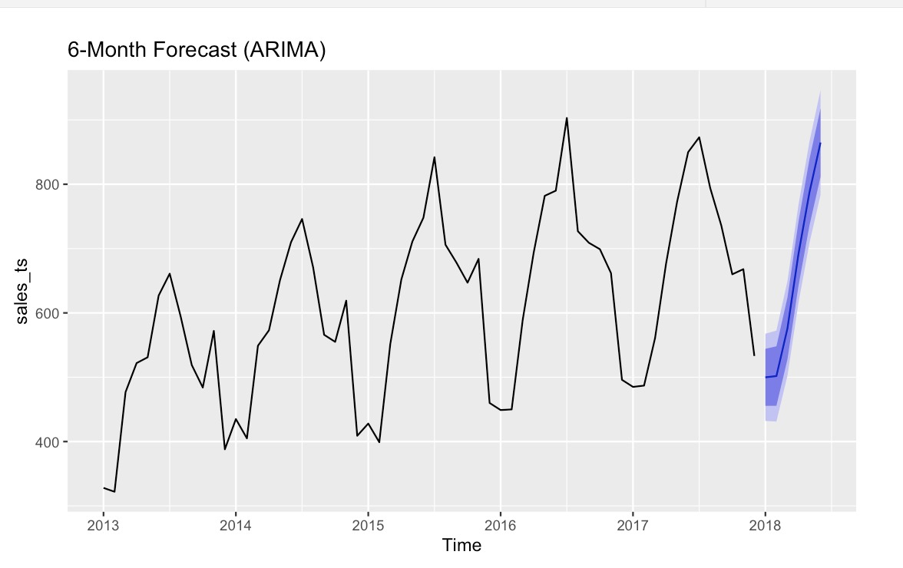

Interpretation of Demand Dynamics
The empirical results suggest that demand is both structurally increasing and predictably seasonal. Seasonal effects scale with demand levels, meaning that inventory requirements during peak periods grow proportionally over time.
The low forecast error (MAPE < 5%) indicates that short-term forecasts are reliable for operational planning. However, widening prediction intervals emphasize that forecast uncertainty must be incorporated into inventory decisions, particularly during high-demand months.
Overall, the results demonstrate that the selected ARIMA model provides statistically sound and operationally meaningful forecasts suitable for short-term inventory planning.

Managerial Implications & Inventory Recommendation

Translating Forecasts into Inventory Decisions
The objective of this analysis is not merely to produce statistically accurate forecasts, but to convert those forecasts into actionable inventory decisions. The six-month ARIMA forecast projects steadily increasing seasonal demand, with expected monthly sales rising from approximately 500 units to 865 units.
However, point forecasts alone are insufficient for operational decision-making. Inventory planning must incorporate forecast uncertainty to reduce the risk of stockouts. Even a 5% forecasting error during peak months could translate into a revenue shortfall of 40–50 units per month.

Safety Stock and Service Level Implications
To quantify uncertainty, 95% prediction intervals were generated. The difference between the point forecast and the upper 95% bound represents the safety stock required to achieve approximately a 95% service level.
Calculated safety stock requirements are as follows:
Month | Forecast | Safety Stock (95%)
January | ~500 | 67.78 units
February | ~502 | 70.72 units
March | ~576 | 73.55 units
April | ~692 | 76.27 units
May | ~788 | 78.90 units
June | ~865 | 81.45 units
Several important managerial insights emerge:
- Safety stock increases over time as forecast uncertainty accumulates.
- Peak-season months require both higher base inventory and higher safety buffers.
- The required buffer rises from approximately 68 units to 81 units across the forecast horizon.
This implies that inventory decisions should scale proportionally with seasonal growth rather than remain fixed.

Relative Uncertainty and Risk Exposure
The width of the 95% prediction interval relative to expected demand declines slightly over time:
- January uncertainty ratio ≈ 27% of forecast
- June uncertainty ratio ≈ 19% of forecast
This indicates that while absolute uncertainty increases, relative uncertainty declines as demand grows. In practical terms, forecast reliability improves proportionally during higher-demand months.
Nevertheless, absolute risk exposure is greater during peak periods because demand volumes are higher. A forecasting error of 5% during a 500-unit month has smaller operational impact than the same percentage error during an 865-unit month.

Recommended Inventory Policy
Assuming a one-month lead time and monthly replenishment cycle, the following inventory policy is recommended:
- Base Stock Level: Align inventory with the point forecast for expected demand.
- Safety Stock: Add approximately 70–80 units above the forecast to achieve a 95% service level.
- Peak Season Adjustment: During high-demand months (April–June), consider carrying safety stock closer to the upper bound (75–81 units) to mitigate elevated revenue risk.
- Continuous Monitoring: Update forecasts monthly and revise safety stock dynamically as new sales data become available.

Risk Trade-Off Analysis
The inventory decision involves balancing two competing risks:
- Understocking Risk: Lost sales, reduced customer satisfaction, and potential reputational damage.
- Overstocking Risk: Higher holding costs, tied-up working capital, and potential markdowns.
Given the relatively low forecast error (MAPE ≈ 4.46%), the risk of severe forecast deviation is limited in the short term. However, because seasonal peaks involve large demand volumes, stockouts during these periods would be financially costly.
Therefore, a slightly conservative stocking approach—closer to the upper bound of the 95% interval—is recommended during peak months.

Strategic Implications
The results indicate that demand is both growing and multiplicatively seasonal. This has three strategic implications:
- Inventory planning systems must scale buffers proportionally as baseline demand increases.
- Safety stock should not remain constant year-over-year.
- Forecast uncertainty should be explicitly incorporated into operational decision-making rather than relying solely on point forecasts.

Summary Recommendation
For the next six months, management should:
- Plan inventory according to ARIMA point forecasts.
- Maintain approximately 70–80 units of safety stock per month.
- Increase caution during seasonal peak months.
- Re-evaluate forecasts monthly to adjust safety stock dynamically.
This approach balances service-level objectives with cost control and aligns inventory planning with statistically validated demand projections.

Limitations & Future Improvements

Limitations
While the ARIMA(0,1,1)(0,1,0)[12] model demonstrates strong short-term accuracy (MAPE ≈ 4.46%), several limitations should be noted.
First, the analysis relies solely on historical sales data. External factors such as promotions, pricing changes, economic conditions, or competitive actions were not incorporated. As a result, the model assumes demand patterns remain internally driven and stable.
Second, the model assumes structural continuity. Sudden market shifts, supply chain disruptions, or changes in consumer behavior could reduce forecast reliability.
Third, the study focuses on a single store–item combination. Although the methodology is scalable, demand patterns may vary across locations and products, requiring broader validation before enterprise-wide implementation.
Fourth, daily sales were aggregated to monthly totals. While appropriate for inventory planning, this may mask short-term volatility that could affect operational decisions.
Finally, the model is optimized for a six-month horizon. Forecast uncertainty increases over time, making the model most suitable for short-term planning rather than long-term projections.

Future Improvements
Several enhancements could strengthen forecasting performance and decision-making:
- Incorporating external variables (ARIMAX or regression-based models) to capture promotions and pricing effects.
- Implementing hierarchical forecasting across stores and product categories.
- Exploring machine learning or hybrid models to capture nonlinear demand patterns.
- Adopting a rolling recalibration framework to update forecasts regularly.
- Integrating forecasts with formal inventory optimization models (e.g., service-level or cost-based frameworks).

