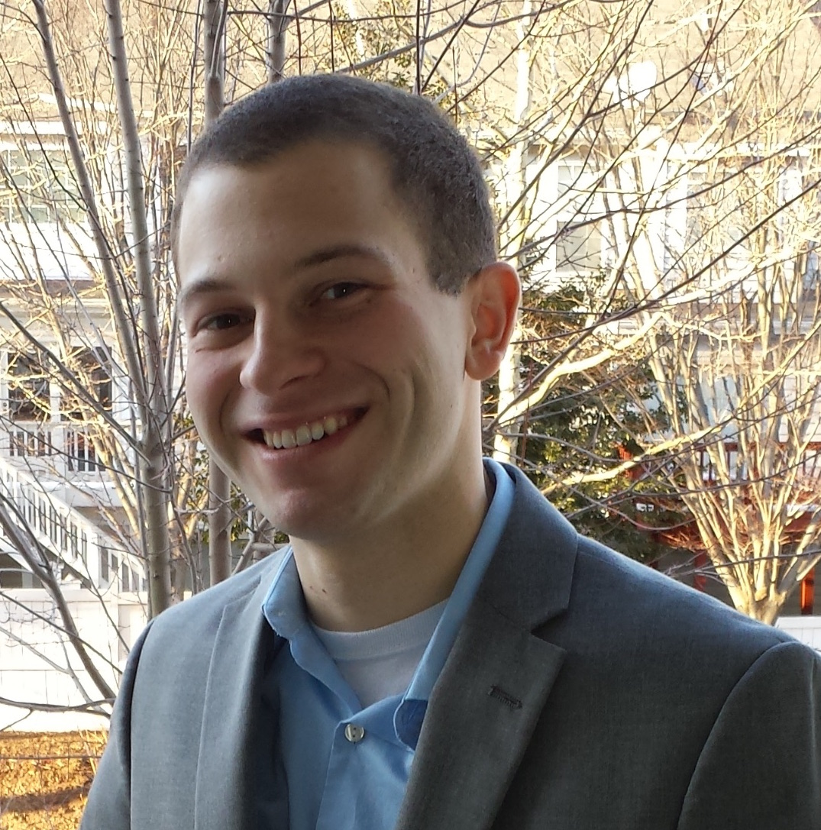**Education**

**The George Washington University**, Washington, DC August 2012-Present

PhD (pursuing, coursework complete), Aerospace Engineering, GPA 3.82/4.00

***Thesis***: Geometric Control of a Fully-Actuated UAV, Data Association, and SLAM Path Planning

***Relevant Coursework***: Analytical Mechanics, System Dynamics, Modeling, and Control, Linear and Nonlinear Control, Spacecraft Attitude Control, Optimal Control and Estimation, Orbital Mechanics, Stochastic Processes in Engineering, Mobile Robotics/Robotic Systems

**Bucknell University**, Lewisburg, PA August 2008-May 2012

BS, Mechanical Engineering, Minor in Economics, GPA 3.71/4.00

***Project***: Hydrokinetic turbine variable resistance system design and control

***Relevant Coursework***: System Controls, Dynamics

**Publications**

E. Kaufman, T. Lee, Z. Ai, and I. S. Moskowitz, "Bayesian Occupancy Grid Mapping via an Exact Inverse Sensor Model," The 2016 *American Control Conference*, 2016. Accepted.

T. Wu, E. Kaufman, and T. Lee, "Globally Asymptotically Stable Attitude Observer on SO(3)," *The 54th IEEE Conference on Decision and Control*, 2015. pp. 2164-2168.

E. Kaufman, T. A. Lovell, and T. Lee, "Nonlinear Observability Measure for Relative Orbit Determination with Angles-Only Measurements," *The Journal of the Astronautical Sciences*, 2016. Accepted.

T. Wu, E. Kaufman, and T. Lee, "Globally Asymptotically Stable Attitude Observer on the Special Orthogonal Group," *Automatica*, 2016. In revision process.

E. Kaufman, T. A. Lovell, and T. Lee, "Minimum Uncertainty JPDA Filters and Coalescence Avoidance for Multiple Object Tracking," *The Journal of the Astronautical Sciences*, 2016. In revision process.

E. Kaufman, T. A. Lovell, and T. Lee, "Nonlinear Observability Measure for Relative Orbit Determination with Angles-Only Measurements," in *Proceedings of the 25th AAS/AIAA Space Flight Mechanics Meeting, Williamsburg, VA*, 2015. Paper number 451.

E. Kaufman, T. A. Lovell, and T. Lee, "Minimum Uncertainty JPDA Filter and Coalescence Avoidance Performance Evaluations," in *Proceedings of the 25th AAS/AIAA Space Flight Mechanics Meeting, Williamsburg, VA*, 2015. Paper number 432.

E. Kaufman, K. Caldwell, D. Lee, and T. Lee, "Design and Development of a Free-Floating Hexrotor UAV for 6-DOF Maneuvers," in *Proceedings of the IEEE Aerospace Conference*, 2014. Paper number 2527.

E. Kaufman, T. A. Lovell, and T. Lee, "Optimal Joint Probabilistic Data Association Filter Avoiding Coalescence in Close Proximity," in *Proceedings of the European Control Conference*, 2014. pp. 2709-2714.

**Experiences**

**Student Researcher**, U.S. Naval Research Lab (NRL), Washington, DC January 2015-Present

***Project Title***: Autonomous Aerial Exploration

***Goal***: Path planning and control for a group of aerial vehicles exploring uncertain environments cooperatively and autonomously. The exploration approach employs a highly accurate and computationally efficient occupancy grid mapping algorithm. Trajectory planning is based on minimizing expected map uncertainty and collision avoidance. These results are demonstrated with numerical examples and indoor flight experiments.

***Duties***: Deriving novel optimal exploration algorithms, validated with numerical simulations in MATLAB. Then these algorithms are tested at the GWU Motion Capture Laboratory and the NRL Prototyping High Bay with flying robots using onboard cameras and depth sensors.

**Research Assistant**, The George Washington University, Washington, DC August 2012-Present

***Focus***: Design and development of a free-floating UAV testbed for complex rotational spacecraft maneuvers. Novel variable-pitch hexrotor platform and controller is fully-actuated and capable of hover over a wide range of attitudes.

***Duties***: Run experimentation involving flight of UAVs at GW’s Motion Capture Laboratory, programming in C/C++ for onboard real-time controls, CAD modeling and machining/3D printing parts, electrical and computer science engineering tasks of embedded systems, development of optimal estimation algorithms, geometric control around various regions of attitude.

**Air Force Research Lab**, Space Vehicles Directorate, Albuquerque, NM June-July 2013 & 2014

***Student Researcher, Summer Faculty Fellowship Program (2013):*** Focused on satellite tracking and data association. Research included comparison of modern data association techniques and designing the C-JPDAF algorithm, which prevents satellite estimates from becoming ambiguous.

***Space Scholar, AFRL Scholars Program (2014):*** Research duties included deriving an analytic solution that decreases the estimate uncertainties of the popular JPDA algorithm as well as advancing the C-JPDAF data association technique; the algorithm extended to multi-planar motion, a wide range of satellite orbits, a variety of sensor types, and realistic measurement data. Additional work included fusion of initial orbit determination (IOD) and relative orbit determination filtering using angles-only line-of-sight measurements between satellites.

**Teaching Assistant**, Washington, DC and Lewisburg, PA August 2011-May 2015 ***Duties***: Lecturing, Grading, and Homework/Laboratory Assistance

***Coursework:*** Fluid Dynamics, Finite Element Analysis, and CAD Modeling

**Air Products and Chemicals**, Middletown, OH May 2011-July 2011

***Title***: Mechanical Engineering Intern

***Projects***: Root-cause analysis of plant operational issues, preparation for an OSHA review

**Technical Skills**

Programming and Simulation: MATLAB, Simulink, C/C++, Arduino, Minitab, LaTeX

Design and Analysis: Pro/Engineer, AutoCAD, SolidWorks, ANSYS, LabVIEW

Other: Linux, Microsoft Office, Electronics, Machining

**Awards**

Member of Golden Key International, The George Washington University 2015

Graduate Research Fellowship, The George Washington University 2012-Present

Graduated Magna Cum Laude, Bucknell University 2012

Member of Tau Beta Pi Honor Society, Bucknell University 2011

Best Student Organization, FLAG&BT Student Group, Bucknell University 2011

Member of Alpha Lambda Delta Honor Society, Bucknell University 2009