Michael Streed

Assignment 1.2

10-18-2022

This is my [Github link](https://github.com/mbstreed19/csd-310)

This is a screenshot of my GitHub Repo.

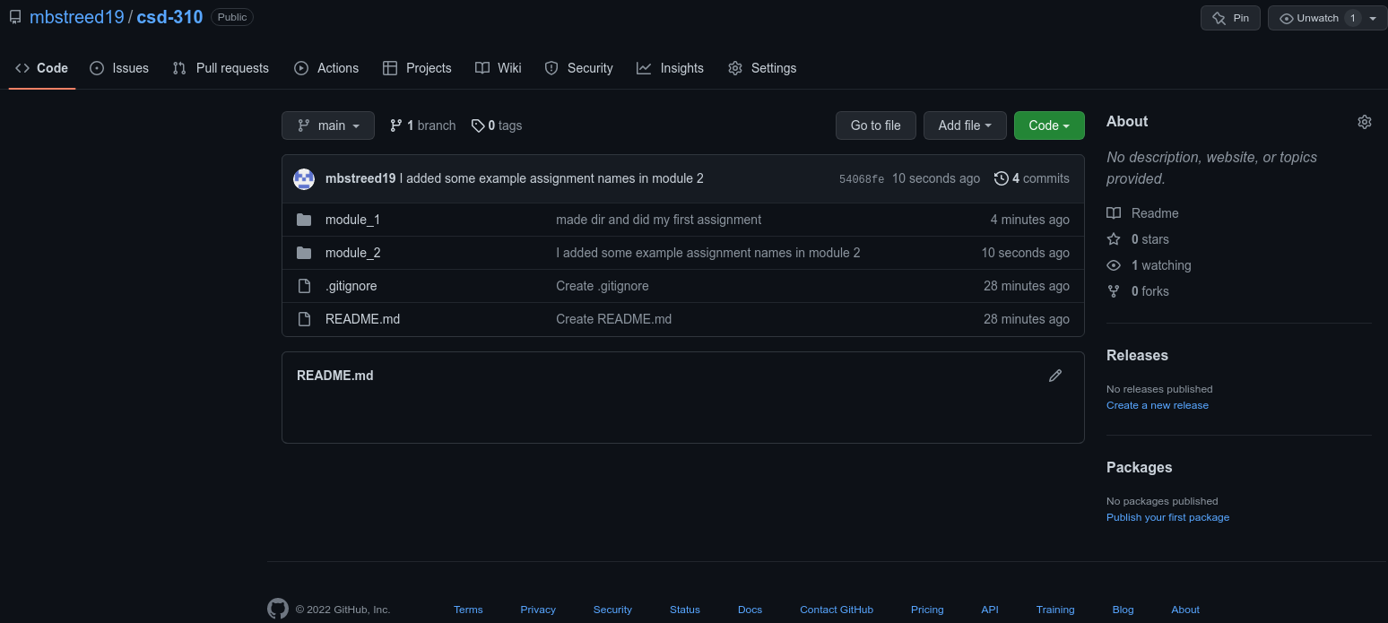

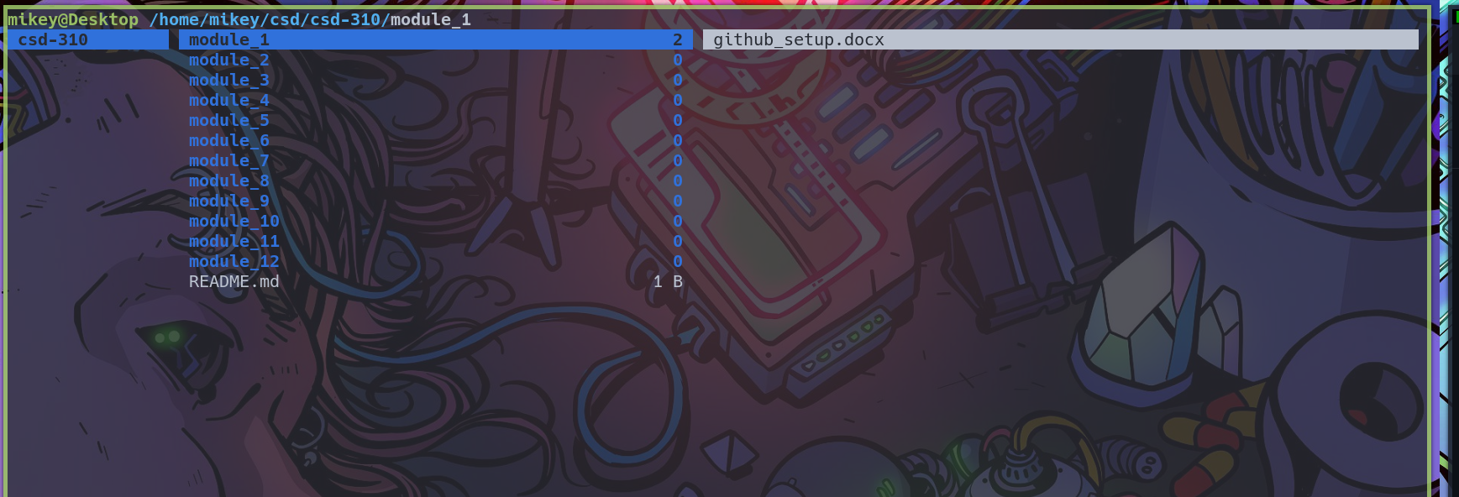This is a screenshot of my local directory.