**Internal movement challan**

**Dashboard**

**Masters**

Plot

Vessel

Customer

Cargo

Transporter

Movement

**Challan generation**(composed of 2 steps)

Create Challan

Print challan

**At gate**

Check out

Breakdown

**At yard(destination)**

Complete trip

**Reports**

Genearted Challan Vehicles list

Gate Outed Vehicles List

Completed Trip Vehicles List

**Edit challans**

**BRIEF IDEA ABOUT APPLICATION:**

In the challan application the following are provided:

* **Dashboard**

It represents the statistical report of the current day, showing number of trips completed, gate out and created with respect to a particular movement.

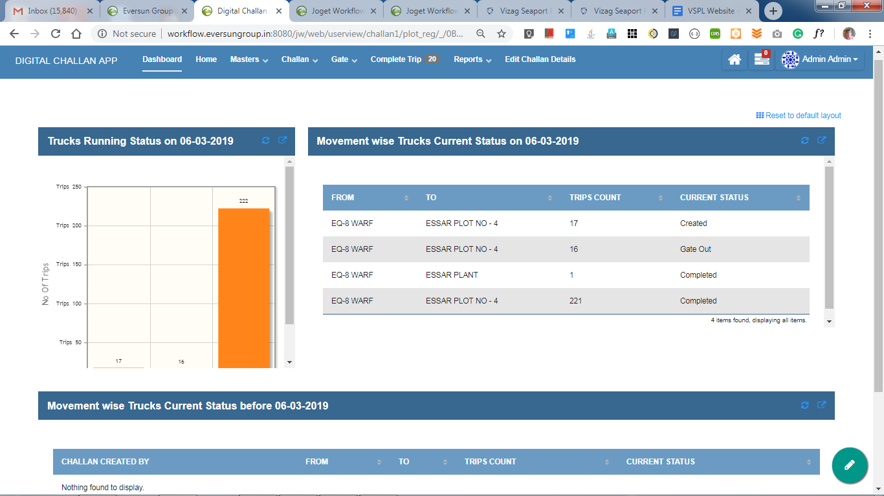

This is how a dashboard looks…

* **Masters**

Maters provided in this application are PLOT, VESSEL, CUSTOMER, CARGO, TRANSPORTER and MOVEMENT. Each master consists of all the details required. While creating a movement for which a series a challans will be generated, these masters’ data can simply be integrated through select box. “**Add New**” button is provided for each master individually inorder to create a new master. “**Edit**” option is also provided corresponding to each row in few masters.

* **Challan generation**

It is mainly composed of 2 steps:

* Challan creation
* Print challan

Challan creation: Here is where all the details regarding a challan will be given. A unique id will be generated for each challan with respect to the date. Through movement master details that are specific to a movement can be included in the challan which reduces the effort and time to create challan. After filling all the fields in Challan form, one can submit. Soon after submitting the user will be redirected to “Print Challan”. After a challan is created, its status will be updated as *created.*

Print Challan: Here is where the user can print a challan. It is actually a list where a challan can be selected to print. This list consists of all the challans which are not yet crossed gate. User gets two copies of a challan when he tries to print, out of which a copy is to be given at gate and other at yard.

* **At gate**

For users at gate a separate home page has been made which contains “**Gate Out**” and “**Break Down**” portals only.

Through “**Gate Out**” portal the user can select a challan and verify its details to allow the vehicle respective to that challan, to cross the gate. It consists of all the challans whose status is *created*. Here the status of challan will be updated to Gate Out.

Through “**Break down**” portal the user can change the details of the vehicle in challan in case of breakdown of current vehicle for which the challan has been generated. It consists of all the challans whose status hasn’t been updated to *completed*.

* **At yard**

For users at yard a separate home page has been made which contains “**Complete Trip**” portal only.

Through this “**Complete Trip**” portal the user can select a challan and update its status to *completed* by verifying all the details. It consists of all the challans whose status is set as *gate out*.

* **Reports**

3 lists are presented namely,

* Genearted Challan Vehicles list

This list consists of all the challans whose status is *created*. That is, it consists of list of all the challans that are generated and are not marked as *gate out.*

* Gate Outed Vehicles List

This list consists of all the challans whose status is *gate out.* That is, it consists of list of all the challas that are out of gate but not yet reached destination.

* Completed Trip Vehicles List

This list consists of all the challans whose status is *completed.*

* **Edit challan**

It is the portal which provides the edit option for generated challans. The challans are editable until they cross the gate which means one cannot edit the challan if it is out of gate.

**FLOW OF ACTIONS FOR CHALLAN GENERATION:**

Login to portal to view home page

Create masters

Create movement

Create challan

Print challan

If any of the masters doesn’t exist

all masters are available & movement has already created

all masters are available & movement doesn’t exist

If a new movement

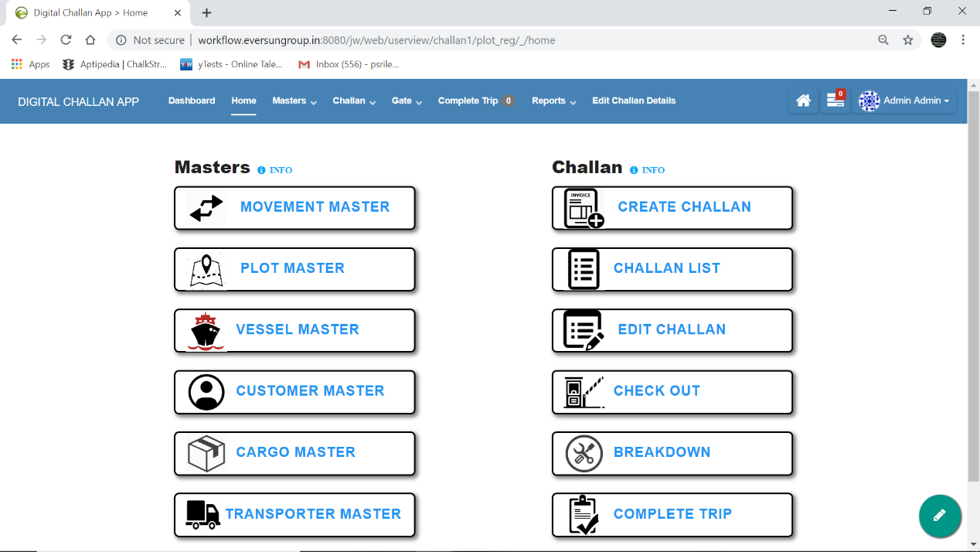

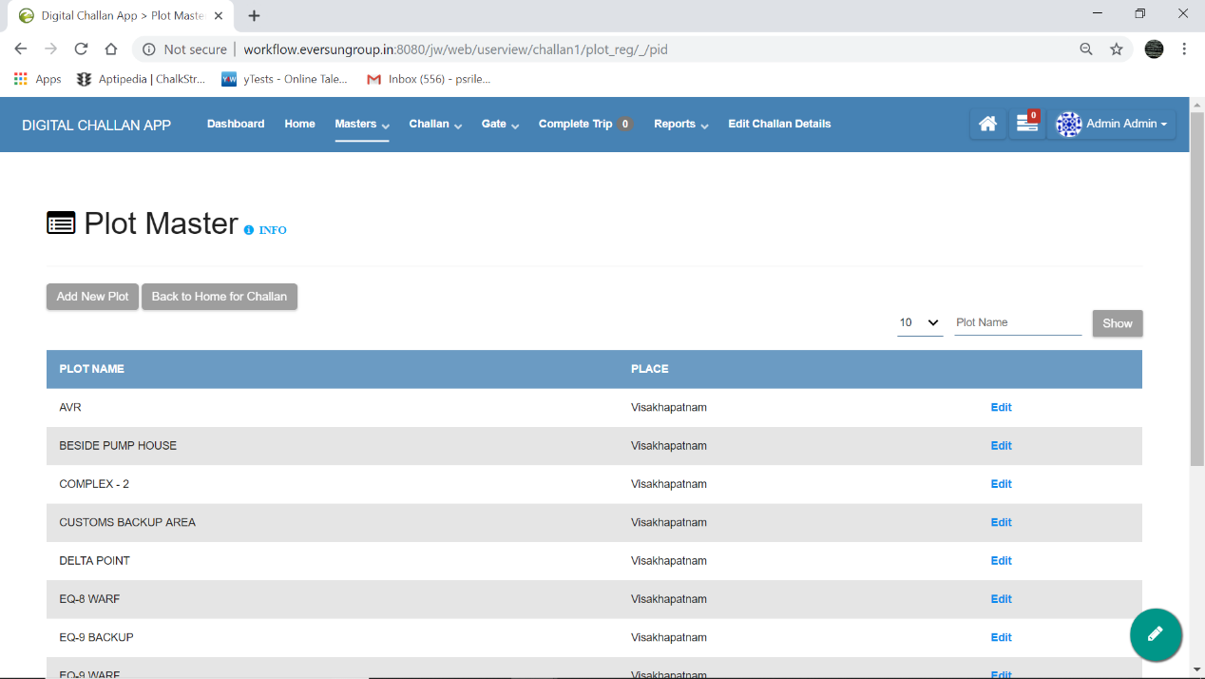

**NAVIGATION: Home >> Plot Master** (or) in header, **Masters >> Plot Master**

* **‘Add New Plot’ button**: It is provided at top left corner (marked by . red arrow ). It can be used to add new plot details.
* **‘Back to Home for Challan’ button**: It is provided at top left corner (marked by . yellow arrow). It can be used to go back to Home Page.
* **INFO** : It is provided at top left corner(marked by . blue arrow). It gives a brief idea on how to use and traverse through the respective page.
* On the top right corner, fields (marked by . green colour shape) have been provided which can be used to filter the data provided over there. On filling either one or more of the fields provided there and hitting the ‘**show’** button, filters the data accordingly or the respective data will be displayed.
* **Edit** : A edit option has also been provided with respect to each plot data(marked by . dark yellow shape). It allows the user to change the entered plot details if required.

**‘Add New Plot’ , ‘Back to home for Challan’** buttons are also provided at bottom left corner.

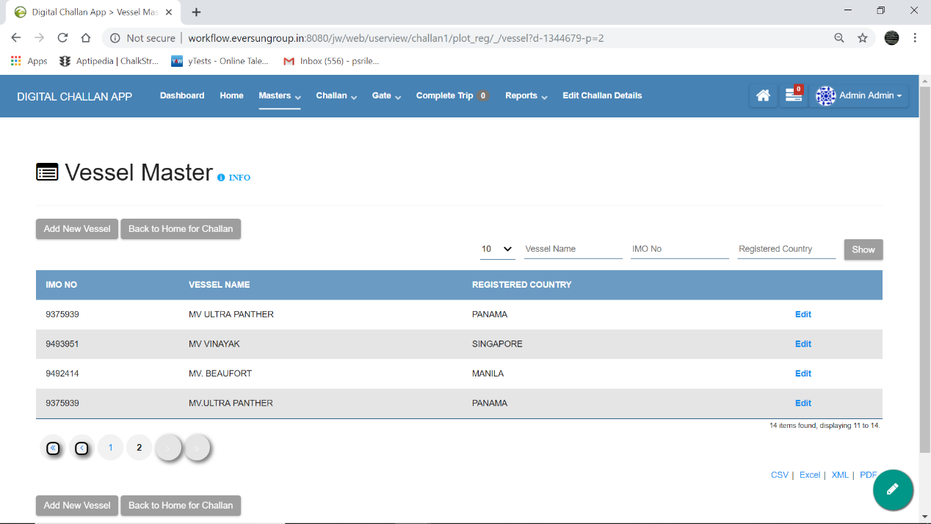

**NAVIGATION: Home >> Vessel Master** (or) in header, **Masters >> Vessel Master**

* **‘Add New Vessel’ button**: It is provided at top left corner(marked by . red arrow ). It can be used to add new vessel details.
* **‘Back to Home for Challan’ button**: It is provided at top left corner(marked by . yellow arrow). It can be used to go back to Home Page.
* **INFO** : It is provided at top left corner(marked by . blue arrow). It gives a brief idea on how to use and traverse through the respective page.
* On the top right corner, fields (marked by . green colour shape) have been provided which can be used to filter the data provided over there. On filling either one or more of the fields provided there and hitting the ‘**show’** button, filters the data accordingly or the respective data will be displayed.
* **Edit** : A edit option has also been provided with respect to each vessel data(marked by . dark yellow shape). It allows the user to change the entered Vessel details if required.

**‘Add New Vessel’ , ‘Back to home for Challan’** buttons are also provided at bottom left corner.

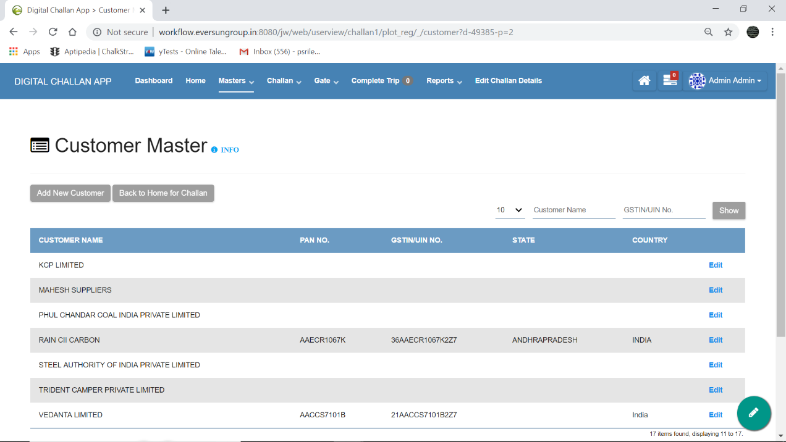

**NAVIGATION: Home >> Customer Master** (or) in header, **Masters >> Customer Master**

* **‘Add New Customer’ button** : It is provided at top left corner(marked by . red arrow ). It can be used to add new customer details.
* **‘Back to Home for Challan’ button** : It is provided at top left corner(marked by . yellow arrow). It can be used to go back to Home Page.
* **INFO** : It is provided at top left corner(marked by . blue arrow). It gives a brief idea on how to use and traverse through the respective page.
* On the top right corner, fields (marked by . green colour shape) have been provided which can be used to filter the data provided over there. On filling either one or more of the fields provided there and hitting the ‘**show’** button, filters the data accordingly or the respective data will be displayed.
* **Edit** : A edit option has also been provided with respect to each customer data(marked by . dark yellow shape). It allows the user to change the entered Customer details if required.

**‘Add New Customer’ , ‘Back to home for Challan’** buttons are also provided at bottom left corner.

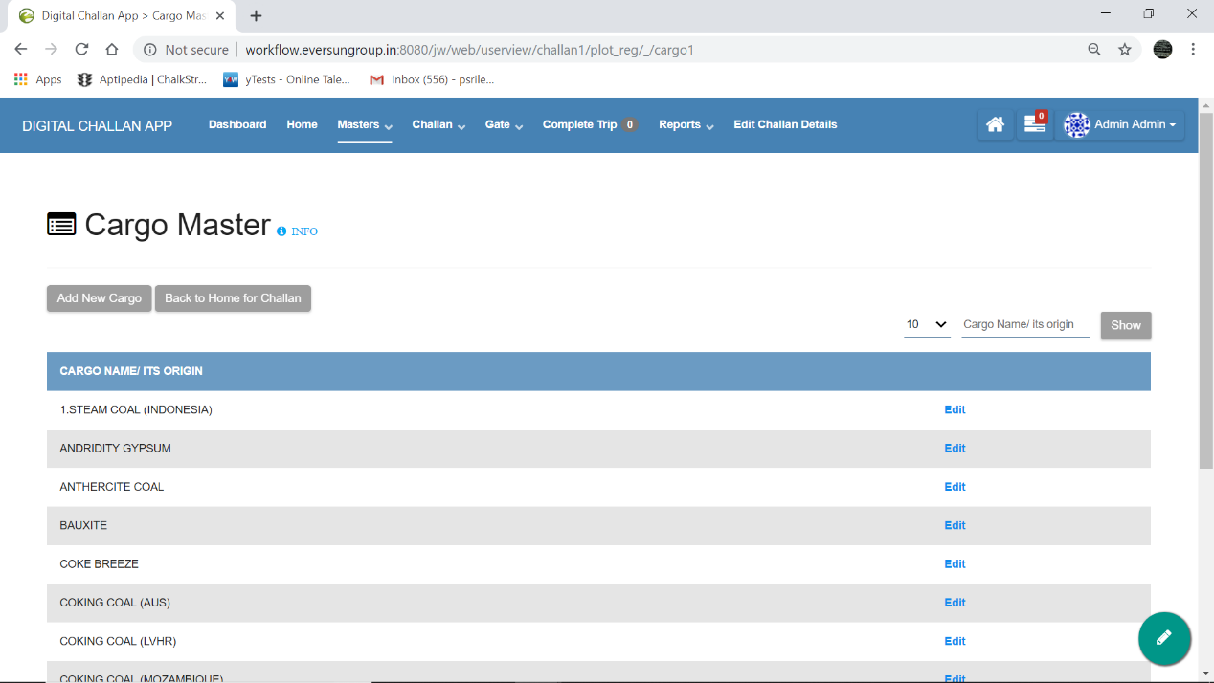

**NAVIGATION: Home >> Cargo Master** (or) in header, **Masters >> Cargo Master**

* **‘Add New Cargo’ button** : It is provided at top left corner(marked by . red arrow ). It can be used to add new cargo details.
* **‘Back to Home for Challan’ button** : It is provided at top left corner(marked by . yellow arrow). It can be used to go back to Home Page.
* **INFO** : It is provided at top left corner(marked by . blue arrow). It gives a brief idea on how to use and traverse through the respective page.
* On the top right corner, fields (marked by . green colour shape) have been provided which can be used to filter the data provided over there. On filling either one or more of the fields provided there and hitting the ‘**show’** button, filters the data accordingly or the respective data will be displayed.
* **Edit** : A edit option has also been provided with respect to each cargo data(marked by . dark yellow shape). It allows the user to change the entered Cargo details if required.

**‘Add New Cargo’, ‘Back to home for Challan’** buttons are also provided at bottom left corner.

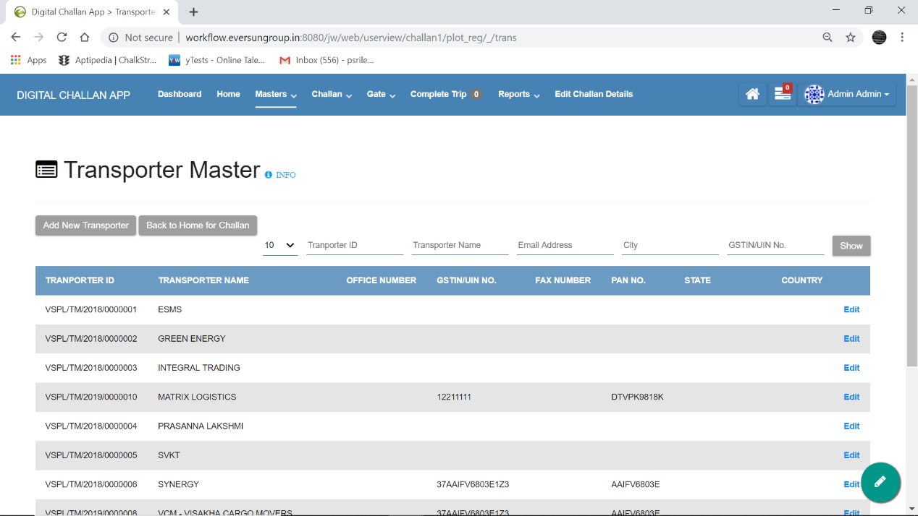

**NAVIGATION: Home >> Transporter Master** (or) in header, **Masters >> Transporter Master**

* **‘Add New Transporter’ button** : It is provided at top left corner(marked by . red arrow ). It can be used to add new Transporter details.
* **‘Back to Home for Challan’ button** : It is provided at top left corner(marked by . yellow arrow). It can be used to go back to Home Page.
* **INFO** : It is provided at top left corner(marked by . blue arrow). It gives a brief idea on how to use and traverse through the respective page.
* On the top right corner, fields (marked by . green colour shape) have been provided which can be used to filter the data provided over there. On filling either one or more of the fields provided there and hitting the ‘**show’** button, filters the data accordingly or the respective data will be displayed.
* **Edit** : A edit option has also been provided with respect to each Transporter data(marked by . dark yellow shape). It allows the user to change the entered Transporter details if required.

**‘Add New Transporter , ‘Back to home for Challan’** buttons are also provided at bottom left corner.

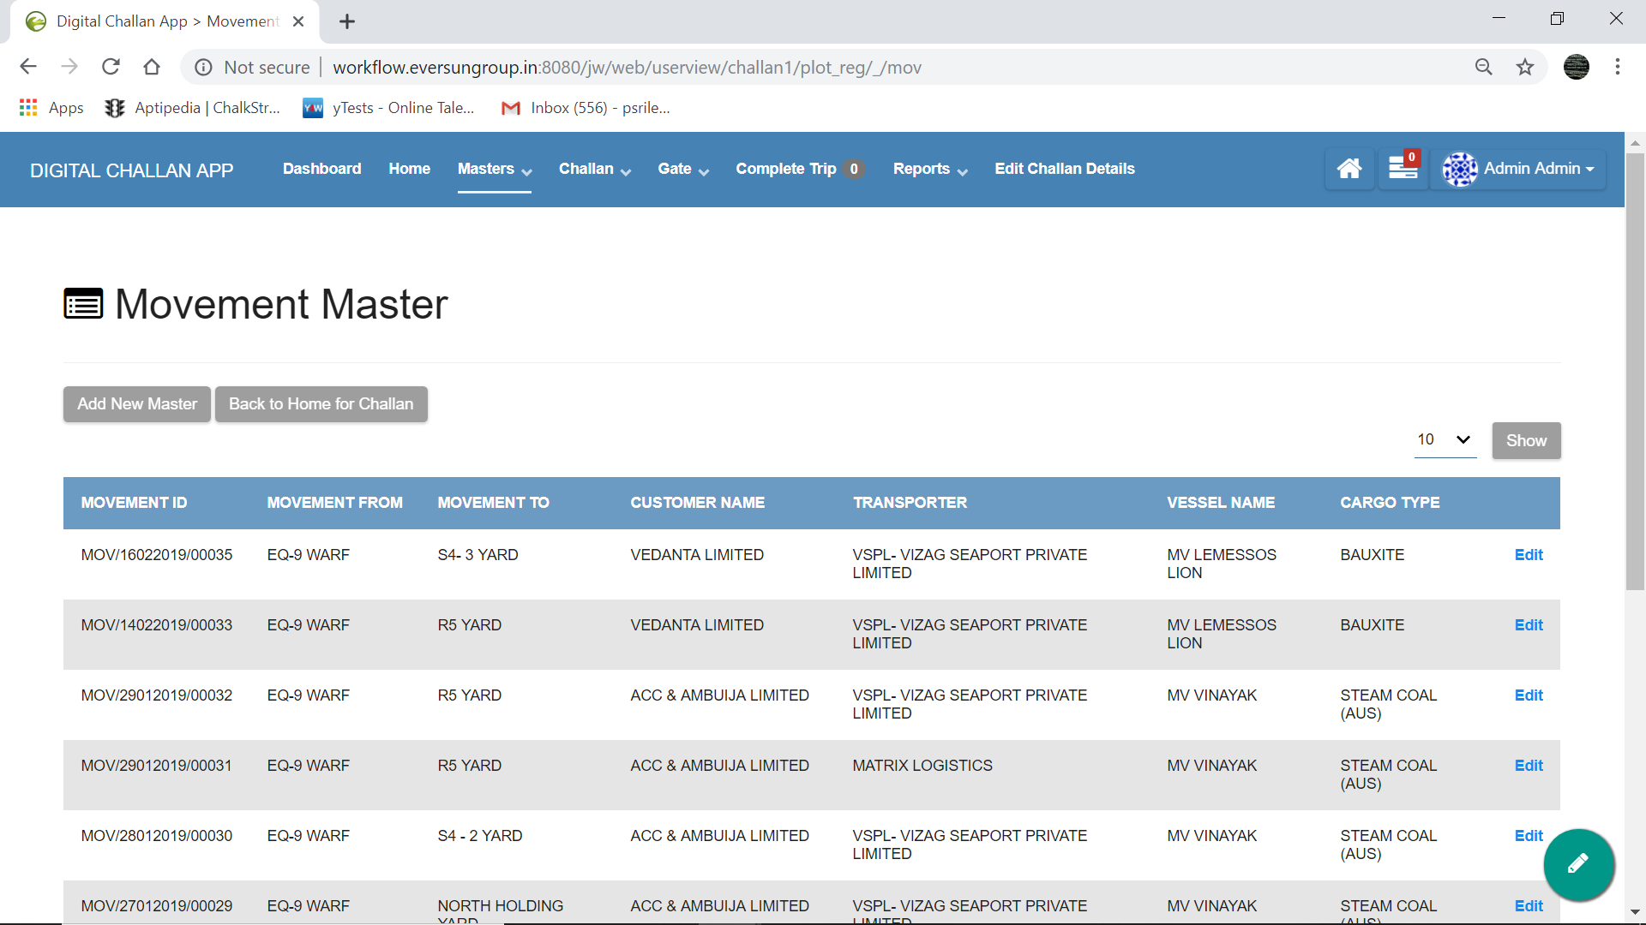

**NAVIGATION: Home >> Movement Master** (or) in header, **Masters >> Movement Master**

* **‘Add New Movement’ button** : It is provided at top left corner(marked by . red arrow ). It can be used to add new Movement details.
* **‘Back to Home for Challan’ button** : It is provided at top left corner(marked by . yellow arrow). It can be used to go back to Home Page.
* On the top right corner, fields (marked by . green colour shape) have been provided which can be used to filter the data provided over there. On filling either one or more of the fields provided there and hitting the ‘**show’** button, filters the data accordingly or the respective data will be displayed.
* **Edit** : A edit option has also been provided with respect to each Movement data(marked by . dark yellow shape). It allows the user to change the entered Movement details if required.

**‘Add New Movement’ , ‘Back to home for Challan’** buttons are also provided at bottom left corner.

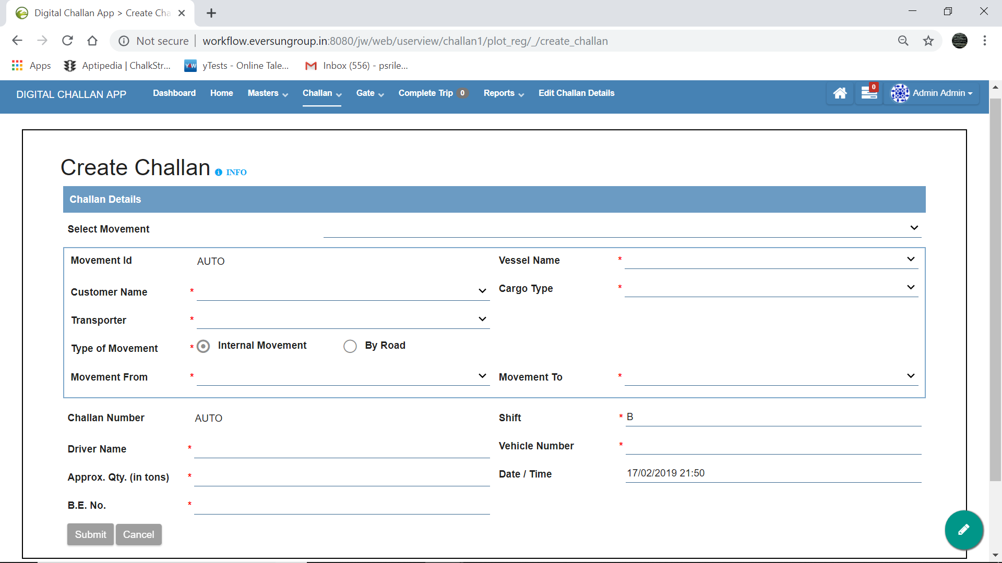

**NAVIGATION: Home >> Create Challan** (or) in header, **Challan >> Create Challan**

* **INFO** : It is provided at top left corner(marked by . blue arrow). It gives a brief idea on how to use and traverse through the respective page.
* Inorder to create a Challan all the required details have to be filled and then submitted.

On selecting the Movement from the dropdown(based on its id), all the details specific to that movement will be filled automatically.

Shift, Date / Time fields will be filled automatically based on the system date and time.

* For each Challan, an automatically generated id will be assigned to uniquely identify each challan.

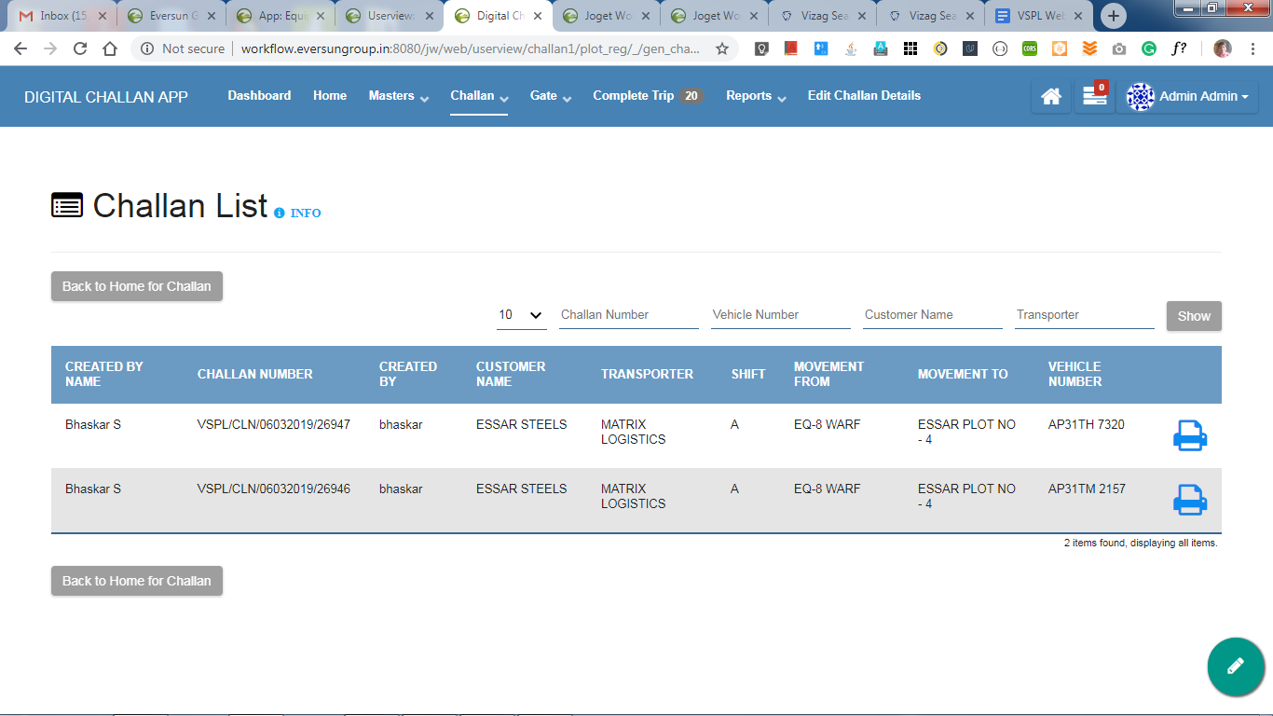

**NAVIGATION: Home >> Print Challan** (or) in header, **Challan >> Print Challan**

* It is the list that shows all the challans that have been generated but not yet moved out of gate.
* **‘Back to Home for Challan’ button** : It is provided at top left corner(marked by . yellow arrow). It can be used to go back to Home Page.
* **INFO** : It is provided at top left corner(marked by . blue arrow). It gives a brief idea on how to use and traverse through the respective page.
* On the top right corner, fields (marked by . green colour shape) have been provided which can be used to filter the data provided over there. On filling either one or more of the fields provided there and hitting the ‘**show’** button, filters the data accordingly or the respective data will be displayed.
* A print button (marked by . dark yellow shape) is provided for each row which redirects the user to the following page from where a user can print challans.

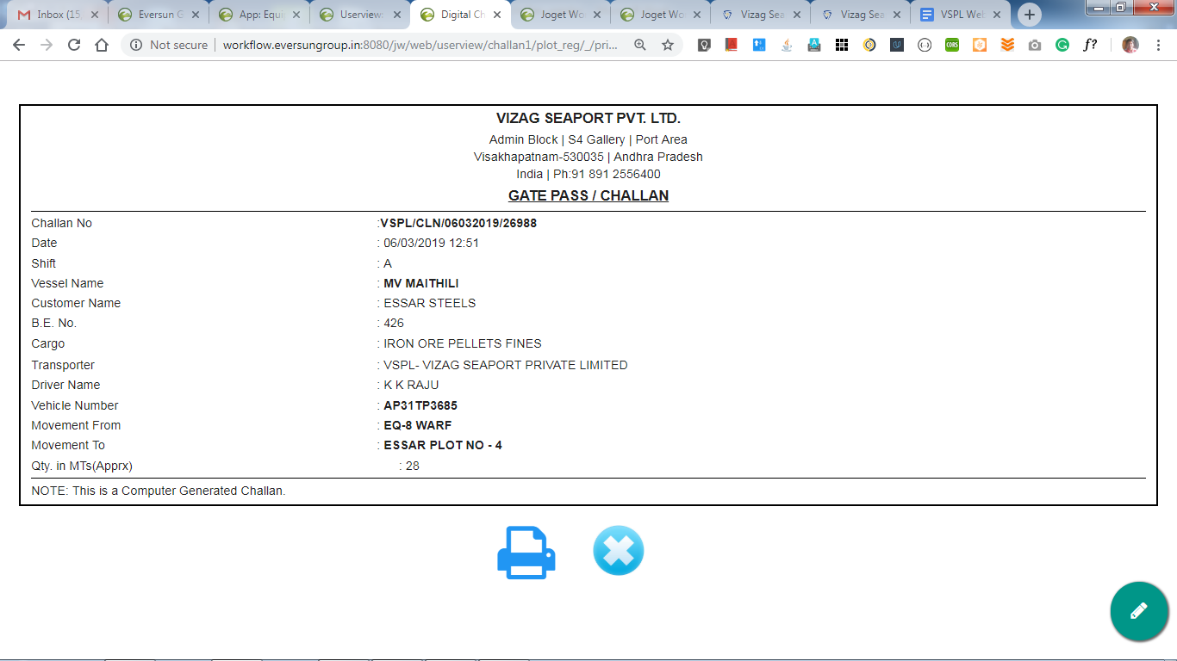

* The user is supposed to check the challan details once and hit the print button(marked by . red arrow ) provided at the bottom. Soon 2 copies of Challan will be printed and the user will be redirected to **Create Challan** page.

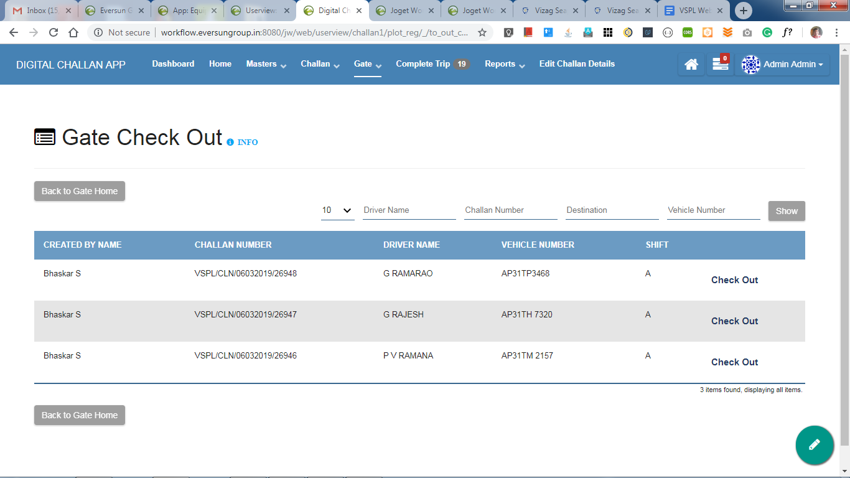

**NAVIGATION: Home >> Check Out**(or) in header, **Gate >> Check Out**

* It is the list that shows all the challans that have been generated but not yet moved out of gate.
* **‘Back to Gate Home’ button** : It is provided at top left corner(marked by . yellow arrow). It can be used to go back to Home Page.
* **INFO** : It is provided at top left corner(marked by . blue arrow). It gives a brief idea on how to use and traverse through the respective page.
* On the top right corner, fields (marked by . green colour shape) have been provided which can be used to filter the data provided over there. On filling either one or more of the fields provided there and hitting the ‘**show’** button, filters the data accordingly or the respective data will be displayed.
* A **‘Check Out’** button (marked by . dark yellow shape) is provided for each row which redirects the user to the following page from where a user can confirm the vehicle corresponding to that particular Challan.

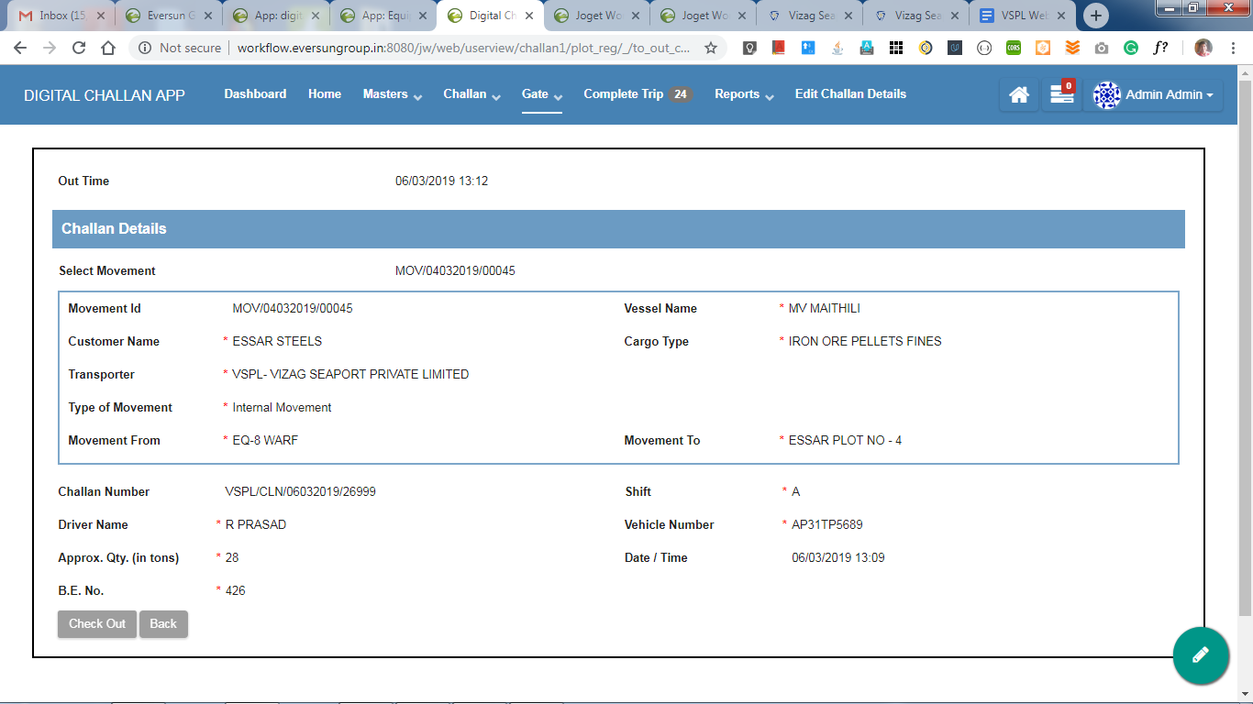

* After checking the details properly, the user is supposed to submit by hitting Check Out Button(marked by . red arrow )at the bottom left.

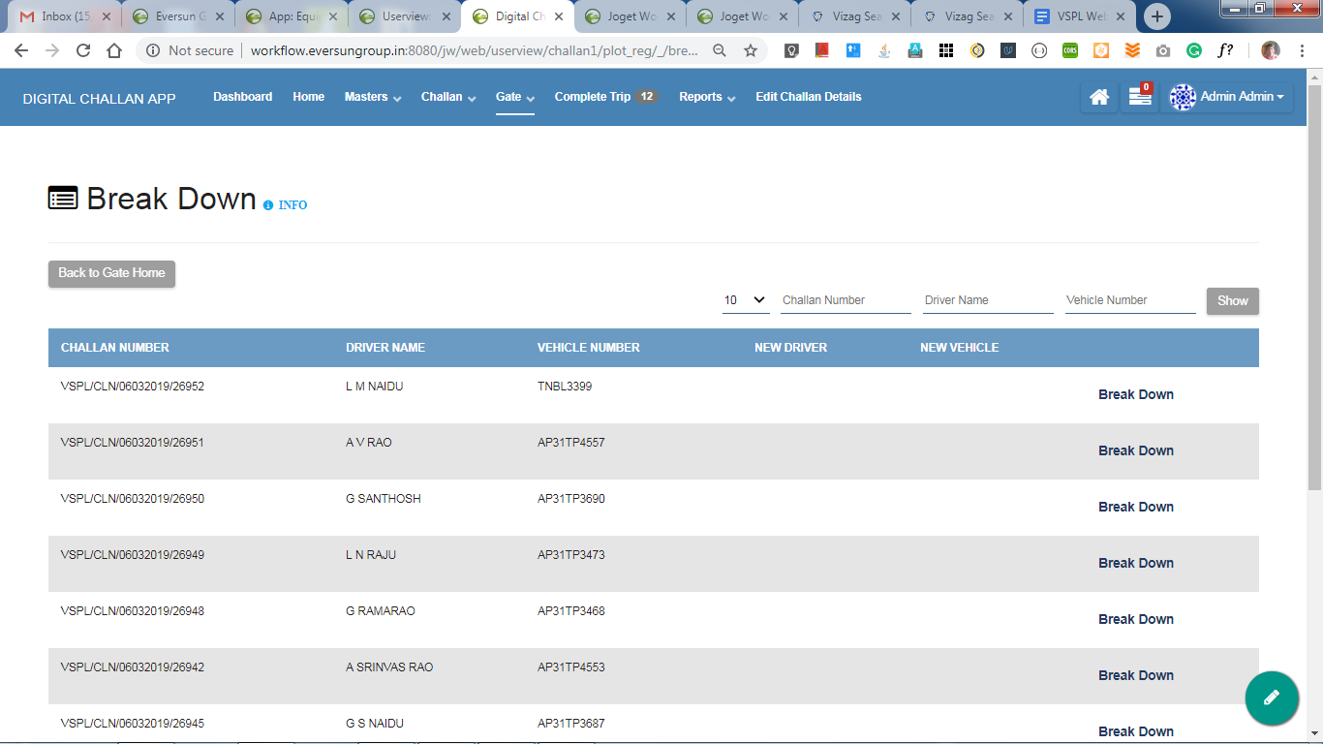

**NAVIGATION: Home >> Breakdown** (or) in header, **Gate >> Breakdown**

* It is the list that shows all the challans that are not yet reached destination. It is useful whenever a vehicle breakdowns.
* **‘Back to Gate Home’ button** : It is provided at top left corner(marked by . yellow arrow). It can be used to go back to Home Page.
* **INFO** : It is provided at top left corner(marked by . blue arrow). It gives a brief idea on how to use and traverse through the respective page.
* On the top right corner, fields (marked by . green colour shape) have been provided which can be used to filter the data provided over there. On filling either one or more of the fields provided there and hitting the ‘**show’** button, filters the data accordingly or the respective data will be displayed.
* A **‘Break Down’** button (marked by . dark yellow shape) is provided for each row which redirects the user to the following page from where a user can make changes regarding new vehicle, in that particular challan.

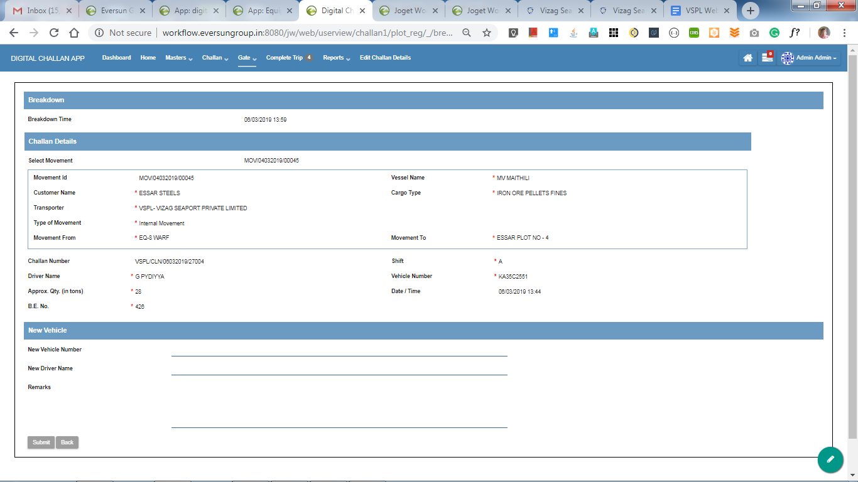

* After entering the details of new vehicle properly, the user is supposed to “Submit” provided at the bottom left (marked by . red arrow ).

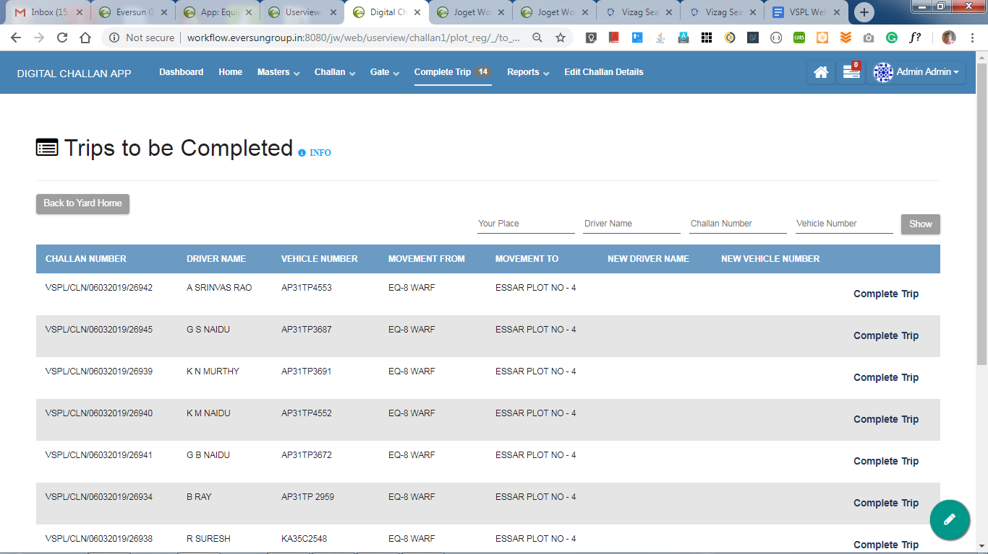

**NAVIGATION: Home >> Complete Trip** (or) in header **Complete trip**

* It is the list that shows all the challans that are to be marked as completed. Marking the challan as completed indicates that the vehicle has reached destination.
* **‘Back to Yard Home’ button** : It is provided at top left corner(marked by . yellow arrow). It can be used to go back to Home Page.
* **INFO** : It is provided at top left corner(marked by . blue arrow). It gives a brief idea on how to use and traverse through the respective page.
* On the top right corner, fields (marked by . green colour shape) have been provided which can be used to filter the data provided over there. On filling either one or more of the fields provided there and hitting the ‘**show’** button, filters the data accordingly or the respective data will be displayed.
* A **‘Complete Trip’** button (marked by . dark yellow shape) is provided for each row which redirects the user to the following page from where a user can check the details and complete trip.

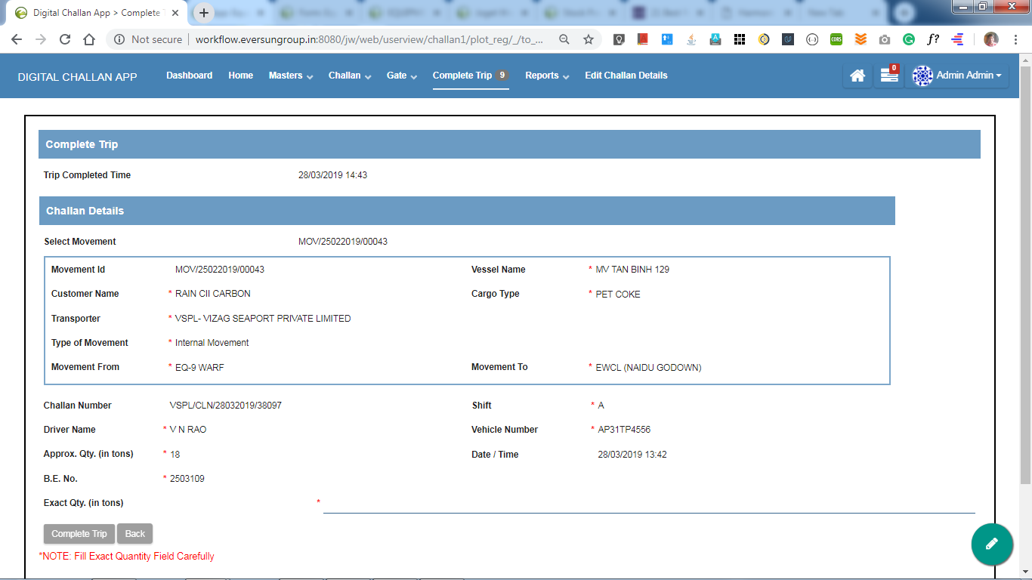

* The user is supposed to enter the Exact Qty brought to yard by that vehicle and then can click **Complete Trip** button provided at bottom left.

**REPORTS:**

**NOTE: Access to reports is given to only particular users.**

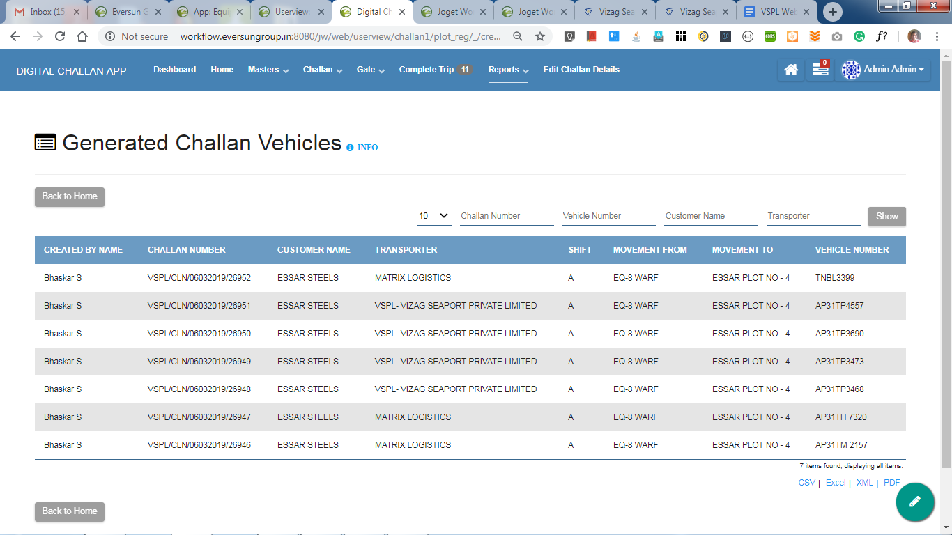  
 **NAVIGATION:** In header **Reports >> Generated Challan Vehicles**

* It is the list that contains details of all the issued challans that are not yet crossed gate.
* **‘Back to Home’ button** : It is provided at top left corner(marked by . yellow arrow). It can be used to go back to Home Page.
* **INFO** : It is provided at top left corner(marked by . blue arrow). It gives a brief idea on how to use and traverse through the respective page.
* On the top right corner, fields (marked by . green colour shape) have been provided which can be used to filter the data provided over there. On filling either one or more of the fields provided there and hitting the ‘**show’** button, filters the data accordingly or the respective data will be displayed.

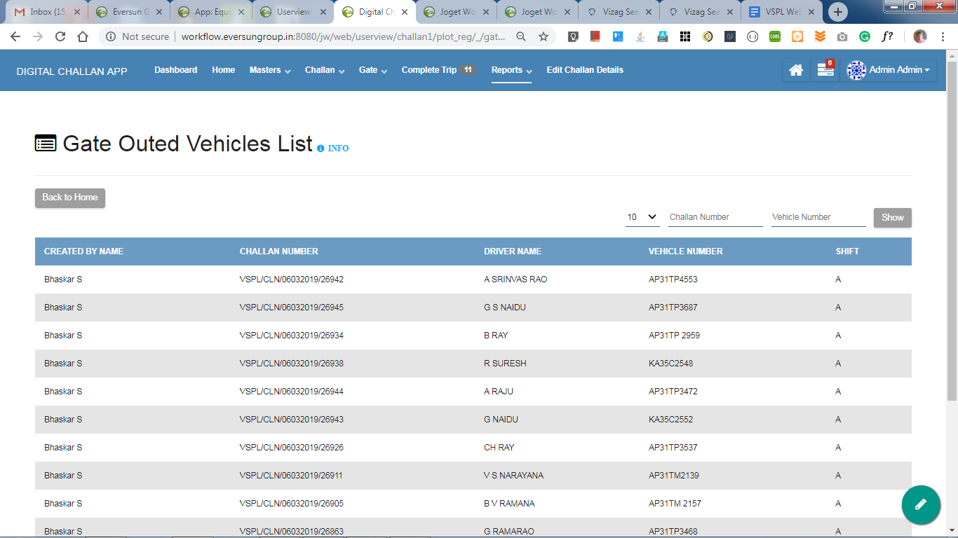

**NAVIGATION:** In header **Reports >> Gate Outed Vehicles List**

* This list contains all challans, which did not cross the gate yet.
* **‘Back to Home’ button** : It is provided at top left corner(marked by . yellow arrow). It can be used to go back to Home Page.
* **INFO**: It is provided at top left corner(marked by . blue arrow). It gives a brief idea on how to use and traverse through the respective page.
* On the top right corner, fields (marked by . green colour shape) have been provided which can be used to filter the data provided over there. On filling either one or more of the fields provided there and hitting the ‘**show’** button, filters the data accordingly or the respective data will be displayed.

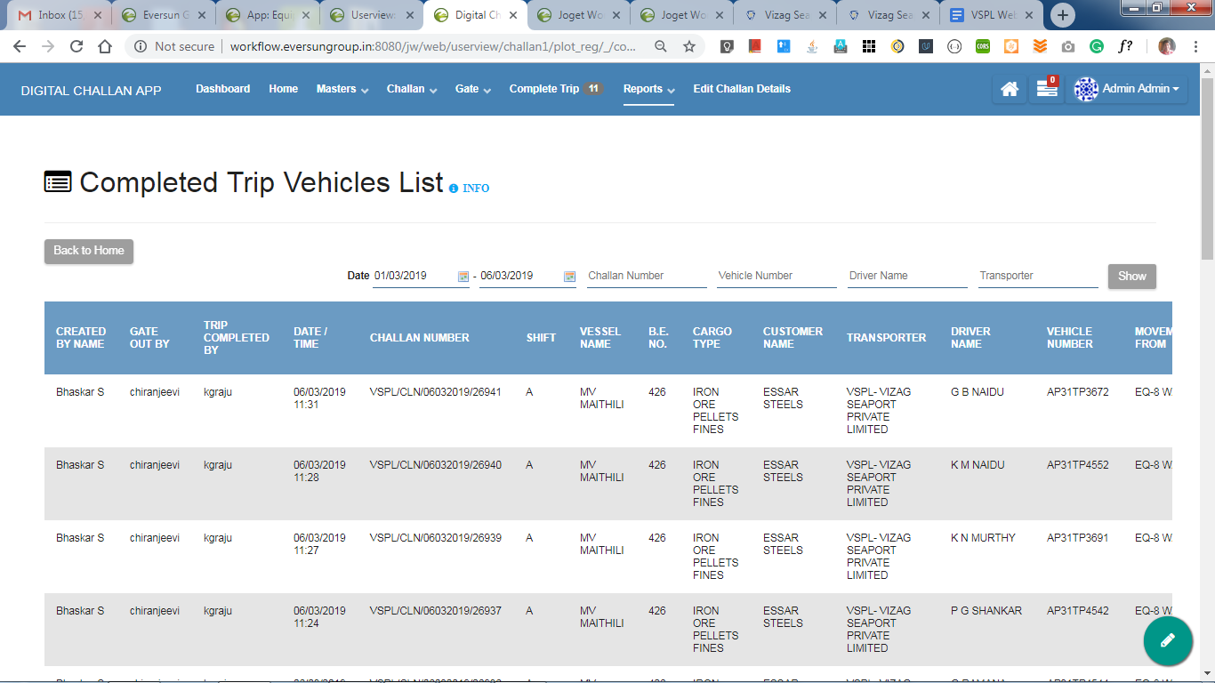

**NAVIGATION:** In header **Reports >> Completed Trip Vehicles List**

* This list contains all challans, whose trip is completed.
* **‘Back to Home’ button** : It is provided at top left corner(marked by . yellow arrow). It can be used to go back to Home Page.
* **INFO**: It is provided at top left corner(marked by . blue arrow). It gives a brief idea on how to use and traverse through the respective page.
* On the top right corner, fields (marked by . green colour shape) have been provided which can be used to filter the data provided over there. On filling either one or more of the fields provided there and hitting the ‘**show’** button, filters the data accordingly or the respective data will be displayed.
* Print option is also provided for each challan.

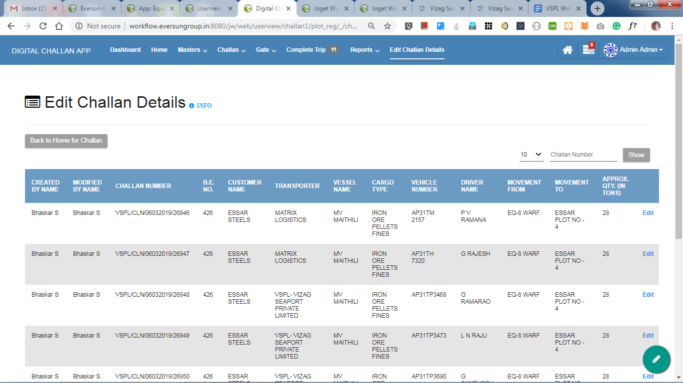

**NAVIGATION: Home >> Edit Challan** (or) in header **Edit Challan Details**

* This list contains all the issued challans which are not yet checked out of gate.
* **‘Back to Yard Home’ button** : It is provided at top left corner(marked by . yellow arrow). It can be used to go back to Home Page.
* **INFO**: It is provided at top left corner(marked by . blue arrow). It gives a brief idea on how to use and traverse through the respective page.
* On the top right corner, fields (marked by . green colour shape) have been provided which can be used to filter the data provided over there. On filling either one or more of the fields provided there and hitting the ‘**show’** button, filters the data accordingly or the respective data will be displayed.
* An **‘Edit’** button (marked by . dark yellow shape) is provided for each row which redirects the user to the following page from where a user can edit the details if the respective challan needs any corrections.

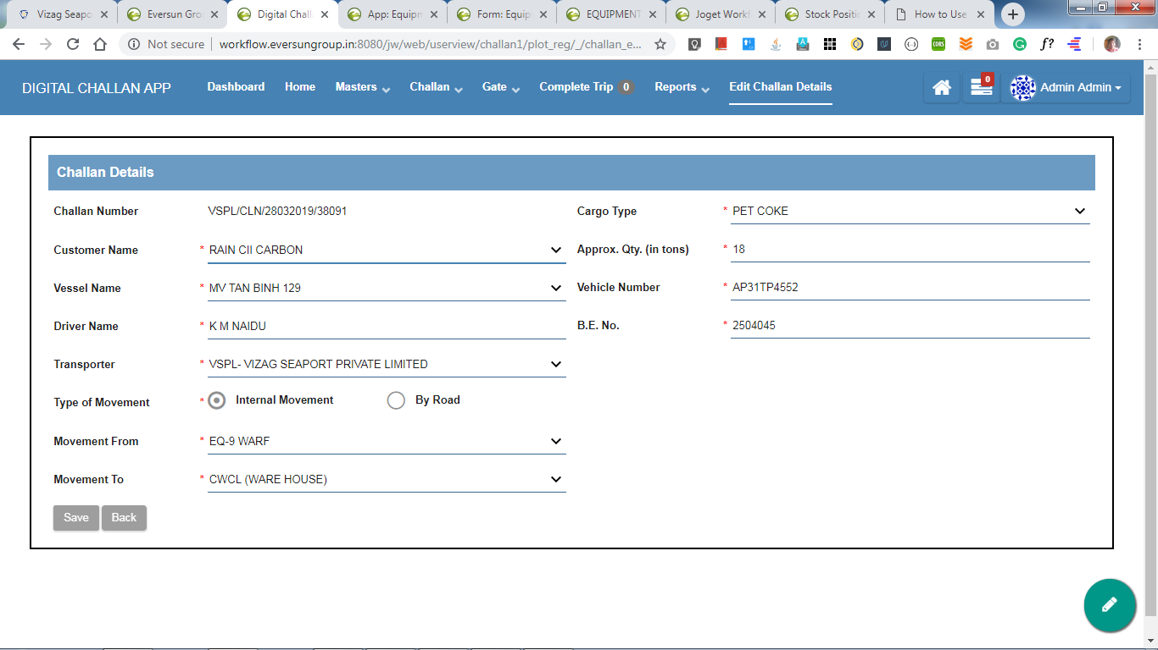

* The user can edit the challan details which are required to be changed and then can click **Save** button provided at bottom left.

**Forms and Datalists:**

Note: Access to this is available to only admin.

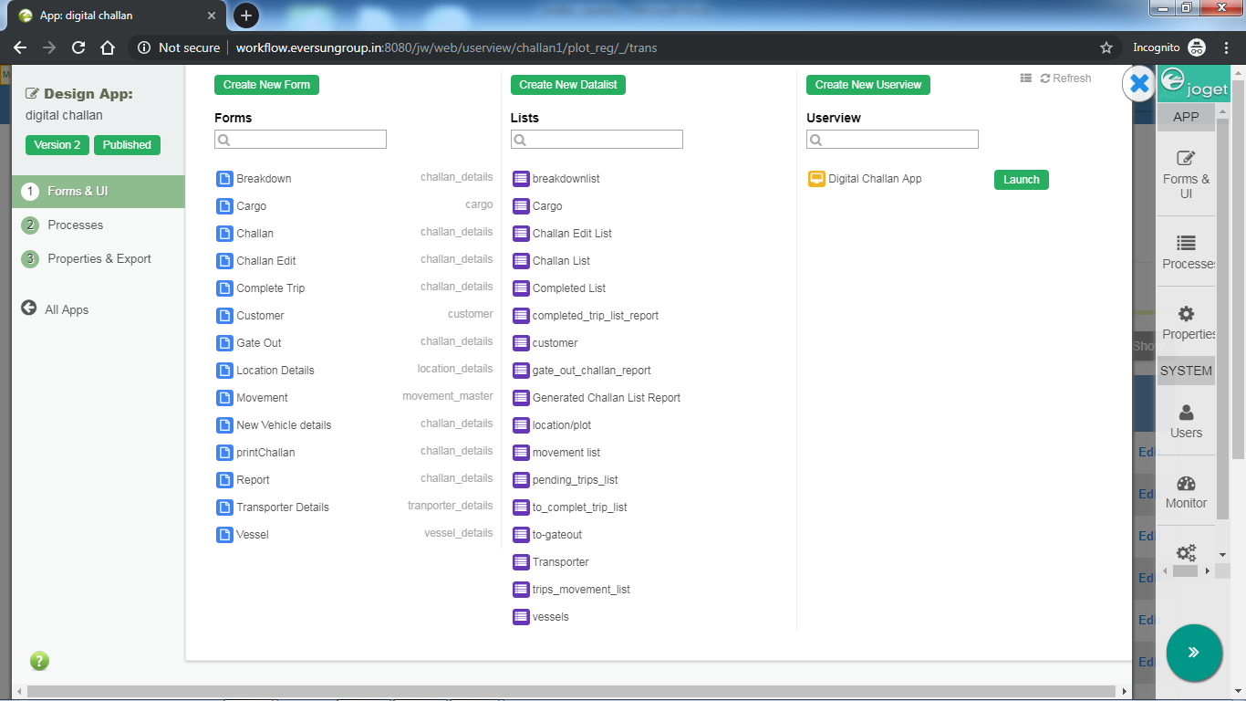

The above screenshot shows the list of all the forms and datalists used in this application.

**“Breakdown” form:**

This form is used to fill new vehicle details when a vehicle breakdowns. This is used at **Break down**. It contains Challan form as subform.

**“Cargo” form:**

This form is used to add new cargo details to the Cargo master.

**“Challan” form:**

This form is used to create new Challan. It contains movement form as AJAX subform.

**“Challan Edit” form:**

This form is used to edit generated Challans.

**“Complete Trip” form:**

This form is used at yard. It contains New Vehicles details form as subform.

**“Customer” form:**

This form is used to add new customer details to the Customer master.

**“Gate Out” form:**

This form is used at gate. It contains challan form as subform.

**“Location Details” form:**

This form is used to add new plot details to the Plot master.

**“New Vehicle details” form:**

It is used in Complete Trip form, as subform.

**“Movement” form:**

This form is used to add new movement to Movement master.

**“printChallan” form:**

Form with Custom HTML. This Form has the print format of a challan.

**“Report” form:**

This is used for dashboard.

**“Transporter Details” form:**

This form is used to add new Transporter details to the Transporter master.

**“Vessel” form:**

This form is used to add new vessel details to the Vessel master.

[**“breakdownlist**](http://workflow.eversungroup.in:8080/jw/web/console/app/challan1/2/datalist/builder/gateout_list)**” Datalist:**

Used to

[**“Cargo**](http://workflow.eversungroup.in:8080/jw/web/console/app/challan1/2/datalist/builder/cargo1)**” Datalist:**

Used to

[**“Challan Edit List**](http://workflow.eversungroup.in:8080/jw/web/console/app/challan1/2/datalist/builder/challan_edit_list)**” Datalist:**

Used to

[**“Challan List**](http://workflow.eversungroup.in:8080/jw/web/console/app/challan1/2/datalist/builder/challan)**” Datalist:**

Used to

[**“Completed List**](http://workflow.eversungroup.in:8080/jw/web/console/app/challan1/2/datalist/builder/endtrip)**” Datalist:**

Used to

[**“completed_trip_list_report**](http://workflow.eversungroup.in:8080/jw/web/console/app/challan1/2/datalist/builder/completed_trip_list_report)**” Datalist:**

Used to

[**“customer**](http://workflow.eversungroup.in:8080/jw/web/console/app/challan1/2/datalist/builder/cust)**” Datalist:**

Used to

[**“gate_out_challan_report**](http://workflow.eversungroup.in:8080/jw/web/console/app/challan1/2/datalist/builder/gate_out_challan_report)**” Datalist:**

Used to

[**“Generated Challan List Report**](http://workflow.eversungroup.in:8080/jw/web/console/app/challan1/2/datalist/builder/challanlist_report)**” Datalist:**

Used to

[**“location/plot**](http://workflow.eversungroup.in:8080/jw/web/console/app/challan1/2/datalist/builder/location)**” Datalist:**

Used to

[**“movement list**](http://workflow.eversungroup.in:8080/jw/web/console/app/challan1/2/datalist/builder/mov_list)**” Datalist:**

Used to

[**“pending_trips_list**](http://workflow.eversungroup.in:8080/jw/web/console/app/challan1/2/datalist/builder/pending_trips_list)**” Datalist:**

Used to

[**“to_complet_trip_list**](http://workflow.eversungroup.in:8080/jw/web/console/app/challan1/2/datalist/builder/to_complet_trip_list)**” Datalist:**

Used to

[**“to-gateout**](http://workflow.eversungroup.in:8080/jw/web/console/app/challan1/2/datalist/builder/gateout)**” Datalist:**

Used to

[**“Transporter**](http://workflow.eversungroup.in:8080/jw/web/console/app/challan1/2/datalist/builder/trans)**” Datalist:**

Used to

[**“trips_movement_list**](http://workflow.eversungroup.in:8080/jw/web/console/app/challan1/2/datalist/builder/trips_movement_list)**” Datalist:**

Used to

[**“vessels**](http://workflow.eversungroup.in:8080/jw/web/console/app/challan1/2/datalist/builder/vessels)**” Datalist:**

Used to