B2C Login Page

1. Checkbox Icon

The default checkbox tick character remains, and the checkbox's custom tick icon has yet to be implemented.

1. Password character

The browser uses the default char code for password characters, which was not implemented according to the Figma design.

2.

1.

1. Email Templates

The development of responsive email templates is not yet complete. The current version, as shown in the screenshot below, only works in a few mobile and web mail clients. (There is a problem with Outlook and some Android mail apps.)

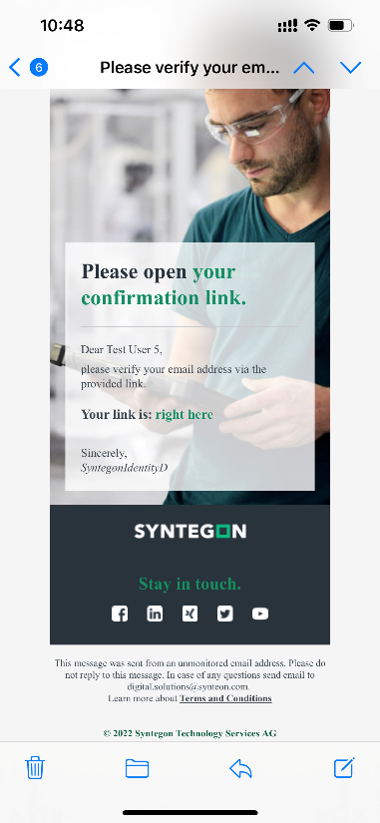

Registration Portal

1. Field validation error

PowerApps portal form generates a validation summary automatically. To insert the validation error under the input boxes, we must customize the client-side validation logic and modify the DOM from JavaScript.

1. The drop-down list arrow needs to be changed as per Figma design.

1.

2.