PROTOCOL: QUANTIFYING LEAF VEIN TRAITS

**Overview**

This protocol explains how to clear and image leaves and to measure key venation traits. Important vein traits include vein densities (length/area), diameters for all vein orders, and the number of free-ending veins per area.

**Background**

This protocol outlines how to obtain the traits used to quantify structure and to relate to the functions of leaf venation architecture. Leaf venation architecture has numerous common functions across plant species—see Sack & Scoffoni, 2013 for review. Briefly, the leaf venation serves for mechanical support (Niklas, 1999), sugar and hormone transport of signal molecules in the phloem (Kehr & Buhtz, 2008), and, via the xylem, the replacement of water lost to transpiration when the stomata open for photosynthesis (Sack & Holbrook, 2006). However, venation architecture is highly diverse across species (Uhl & Mosbrugger, 1999; Roth-Nebelsick *et al.*, 2001; Sack & Frole, 2006; Ellis *et al.*, 2009; Brodribb *et al.*, 2010). In dicotyledons, the leaf venation system typically consists of three orders of major veins and up to five higher orders of minor veins embedded in the mesophyll, with the vein orders arranged in a hierarchy; lower order veins are larger in diameter, with greater xylem conduit numbers and sizes, whereas higher order veins have greater length per leaf area (VLA; Sack & Holbrook, 2006; McKown *et al.*, 2010). The total VLA is positively related to physiological performance (e.g. hydraulic conductance and photosynthetic rate per leaf area; for review, see [Brodribb et al., 2010](javascript:;); [Sack and Scoffoni, 2013](javascript:;)).

**Materials/Equipment**

Equipment: Flatbed scanner, light microscope, ImageJ software (National Institutes of health; free online, http://rsbweb.nih.gov/ij/)

**Units, terms, definitions**

Vein length per unit leaf area (VLA; mm mm-2). Also commonly known as “VLA”. Can be measured for veins of each order, or summed for major or minor veins or the whole system (see below). Total VLA correlates well with the average distance between veins (a.k.a. “interveinal distance”; see Uhl & Mosbrugger, 1999), and with areoles per area.

Major VLA = Sum of vein densities for 1°, 2° and 3° veins (mm mm-2)

Minor VLA = Sum of vein densities for 4° veins and higher (mm mm-2)

**VEIN IMAGING**

The leaf is scanned (flatbed scanner, 1.600 pixels per inch) to allow measurement of the density of 1o, 2o and 3o veins.

**QUANTIFICATION OF MAJOR VEINS AND WHOLE LEAF STRUCTURAL TRAITS USING SCAN LEAVES**

Rules should be made for distinguishing vein orders in your leaves (for excellent advice, see Ellis *et al.*, 2009). There is a level of subjectivity and uncertainty in making these distinctions among vein orders, so attempt to be rigorous and consistent, and keep notes on your rules for distinguishing vein orders (see image below for an example of vein order determination on *Chrysophyllum prieurii*). Minor veins should not be measured on scanned leaves given the lack of resolution. Below is the protocol we recommend:

* **First, a few tips on how to use ImageJ :**

1. *Zooming in and out*: zoom in on the scale by pressing the + button on your computer (you can zoom out using the -) OR in Image J by pressing the magnifying glass icon (10th from the left) where left clicking will permit you to zoom in and right clicking will make you zoom out.
2. Always try to have the image taking up as much of your screen as possible.
3. Going up and down/ left and right within the image: when you have zoomed in and enlarged your image to fit most of your screen, the full image might not appear. You will have to move right and left and up and down depending on what you want to measure. To do so press the space bar key and hold it down. Notice a little hand appeared instead of your normal cursor. While keeping the space button pressed down, click on the mouse and keep it clicked as you move up and down or left and right.
4. **Set your measurement before you start: go to Analyze, Set measurements and click the area (and perimeter) box(es), unclick all the others.**

* **Measuring leaf area (and perimeter)**

1. Zoom out of the scale, and zoom in at leaf lamina insertion, where the lamina starts to come off the petiole (the more you zoom in the more precise your measurement will be).
2. Enlarge your image so that it takes up most of your screen.
3. Adjust the luminosity or contrast as you want to make the veins more visible.
4. Then, apply “Make Binary” (Process 🡪 Binary).
5. Do the operation Analyse 🡪 Analyse particles; change the minimum pixel detection from 0 to 10 000 (for example): this will allow to get only the surface measurements of the black objects (normally, 2). You only want the biggest number (the total surface of the leaf, in pixels2).
6. Copy the results from the results window that popped up. You want to report the area (and perimeter).
7. **Finally, do the conversion needed to get your surface in cm2:**

* **For a 2 lamp scanned picture (resolution of 1600 pixels per inch): pixels2 * (2,542)/(16002)**
* **For a single lamp scanned picture (resolution of 1200 pixels per inch): pixels2 * (2,542)/(12002)**

1. Last step: Open once again the picture you’re working with, do the same luminosity/contrast settings. Select the polygon icon, draw around the petiole and when it ends, double click. Your cursor is free from the line. Press D and M.
2. Your line is now colored. Check that it does follow well the petiole. Report value to your spreadsheet. Do the same conversion as step 7, and substract the petiole surface from the total surface of the leaf. You have the surface needed for the Major VLA measurements.

* **Measuring midrib length**

1. Zoom in on the bottom of the midrib (the point where the petiole connects to the midrib)
2. Select the segmented line by right clicking on the line icon and choosing segmented line.
3. Double click where the midrib begins (this would be at the level where lamina starts coming off the petiole). You have anchored your point.
4. Now, follow the midrib closely by clicking along the midrib. You want to draw over the midrib.
5. When the midrib ends, double click. Your cursor is free from the line. Press D and M.
6. Your line is now colored. Check that it does follow well the midrib. Report value to your spreadsheet.

* **Rules to determine whether a leaf is palmately or pinnately veined.**

A leaf is palmately veined if it has more than one 1o vein; otherwise, it is pinnately veined.

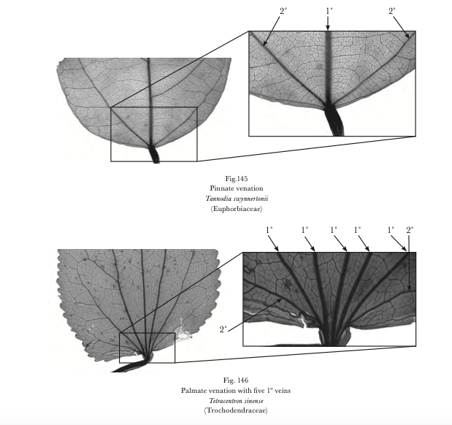

*Differences between a pinnate (a single primary vein) and palmate venation (several primary veins coming from the petiole)*

To be considered a 1° vein, the two following rules need to apply:

1) First order veins are those that depart from the petiole and go towards the margins.

2) Other 1o veins should be at least 75% of the diameter of the midrib. To check this, measure the thickness of the midrib at its middle (to account for vein tapering) by using the segmented line and the one of the vein you want to check and compare measurements. If the vein you measured has a diameter 75% or more of that of the midrib, then you can consider it a first order vein.

* ***Measuring other 1° vein length (in case of pinnately veined leaves)***

1. *Zoom in on the bottom of the midrib, at the lamina insertion.*
2. *Select the segmented line by right clicking on the line icon and choosing segmented line.*
3. *Double click where the 1° vein begins (this would be at the “insertion point”, i.e., where lamina starts coming off the petiole). You have anchored your point.*
4. *Now, follow the 1° vein closely by clicking along it. You want to draw over the vein.*
5. *When the 1° vein ends, double click. Your cursor is free from the line. Press D and M.*
6. *Your line is now colored. Check that it does follow well the vein.*
7. *Continue to the next 1° vein and repeat steps 1-6*
8. *Once all your 1° veins are drawn and measured, select all the measurements in your result section, copy, and paste onto an Excel spreadsheet.*
9. *Report and sum all the lengths together in your spreadsheet.*

* **Determining 2nd vein orders**

Before you start measuring, take a moment to look at your leaf and determine what type of 2° veins your leaf has:

* Leaves can have different types of 2° veins: they can be **craspedodromous** (large 2 veins branch straight from the midrib to the leaf margins), **brochidodromous** (large 2° veins loop one into the other, never touching the leaf margin), or **eucampdodromous** (large 2° veins eventually loop one into the other, but they do so really close to the margin, after having followed the margin for a little bit-- eucampdodromous is sort of an intermediary type between craspedodromous and brochidodromous types leaves).
* Within these categories, we will distinguish three possible types of 2° veins, although these are not necessarily present all leaves: “large 2° veins”, “small 2° veins” and “other 2° veins”.

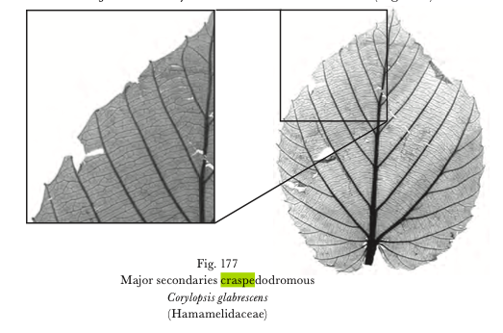

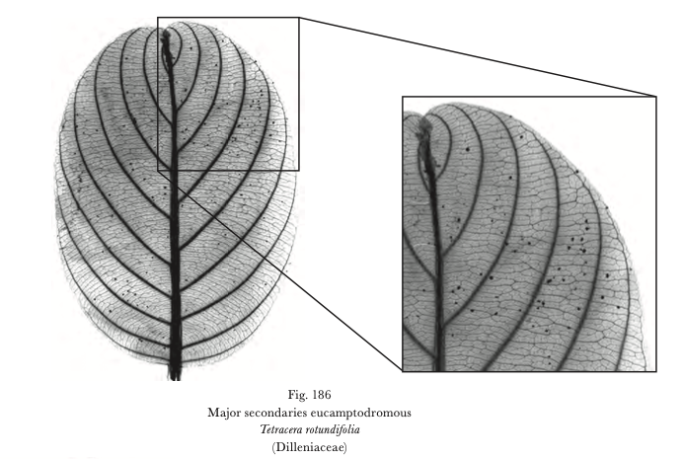

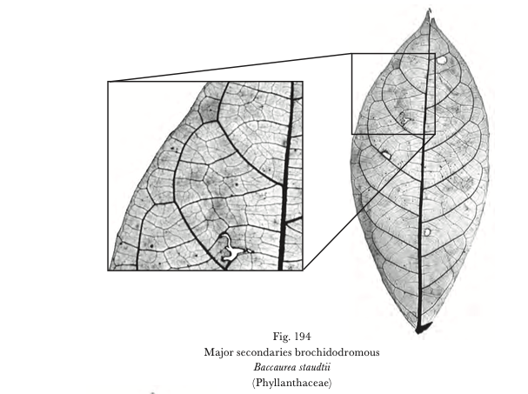

1. The large 2° veins are the most obvious ones. They branch off the midrib and go towards the margin. You can see those in uncleared leaves because they usually are thicker than other veins besides the midrib.
2. The small 2° veins also branch off the midrib. However, they usually are not as long, and may be indistinguishable from 3° veins half way or so toward the leaf margin. CAREFUL! Not all veins branching off the midrib are 2°. You can have 3° veins or even minor veins branching off the midrib. You will recognize small 2° veins because they will follow the same pattern as the large 2° veins, but will be perhaps thinner and will not reach the leaf margins. If you are hesitating as to whether a vein should be a small 2° or a 3°, look at the pattern of 3° and minor veins, which are smaller veins that form a regular mesh in the leaf. Do you think the vein in question is part of the 2° vein pattern that is distinct from the mesh made up of 3° or higher order veins?
3. Other 2° veins are veins that stand out as well, forming an obvious skeleton pattern, but that do not depart from the midrib. They usually are additions to the large 2° veins. See below for illustrations. But again, if in doubt, ask yourself if in that area, the vein in question is more continuous with the 2° vein pattern or with the mesh made up by the 3o and higher order veins.

* **Measuring 2nd vein length**

1. Select the **segmented tool**. Double click on the first 2° vein, **at the intersection of the midrib and 2° vein.** Then click following that vein until the end. Double click once you have drawn over the whole vein. Press D and M.
2. **The result box will show up with the length of that vein. Leave it opened, and go to the next vein. Repeat step 4 until all the 2° veins of the category (ex: large) are measured.**
3. Once all veins are measured, select all the data in the result box (there should be one line per vein measured). Copy, and then paste it to your spreadsheet.
4. Enter and sum all the lengths together using the formula in excel: =SUM(data)

* **Measuring third order vein lengths**

1. **Partition the leaf into three parts: bottom third, middle and top third of the leaf.** Select the Rectangular icon (the very first icon) and draw onto your leaf a rectangle making up half of the third of the whole leaf surface and on one side of the midrib, so as to avoid it (we have had it vary from 10 to 300mm², but depending on your leaf size, this could be smaller or larger than this range; **make sure that the box spans at least two secondary veins).** Draw your rectangle at the bottom of the leaf, **avoiding if possible the midrib** (although for very thin leaves that might be impossible), so that the rectangle fits in between the midrib and the leaf margin.
2. Press D and M, then drag your rectangle to the middle third of the leaf, place it like the first one between the midrib and margin and Press D.
3. Drag your rectangle toward the top third of the leaf; place it between the midrib and margin and Press D.

*Note: some leaves are really narrow toward the top, and the rectangle you drew for the bottom and middle might not fit at the top.* ***In that case, draw a new rectangle of more or less the same size, but that would be longer than wider, so that it fits on your leaf lamina.*** *Be sure to measure the area of that new rectangle.*

1. **Record the area of your rectangle (or rectangles) in your spreadsheet.**
2. **Measure the total length of the secondary veins if present by tracing over them using the segmented line.** Press M and D. Once all are measured, copy the results onto a spreadsheet and sum them all up. Copy the summed up value, paste special “value” and copy the result in your spreadsheet.
3. **Proceed to measure 3° veins by using the segmented line and tracing over all tertiary veins. Then repeat step 5 for the 3°veins results.**
4. **Repeat steps 5 and 6 for all your rectangles. We suggest using a different color for different vein orders.**

*Example of the measurements of Major VLA on a leaf from Chrysophyllum prieurii, following the protocol presented above. The petiole is drawn with a blue polygon. The midrib is drawn in black, the 2nd veins are drawn in red, the three boxes for the 3rd veins (colored in blue) are represented in yellow. The 2nd veins inside the boxes are in pink here.*

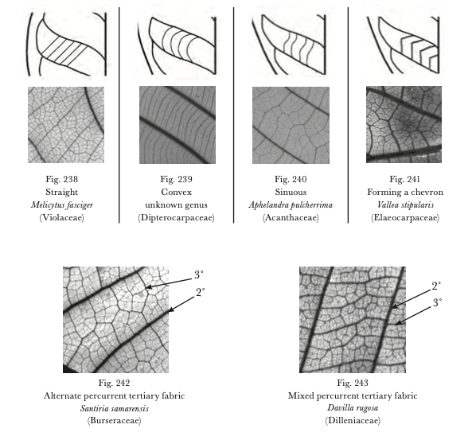

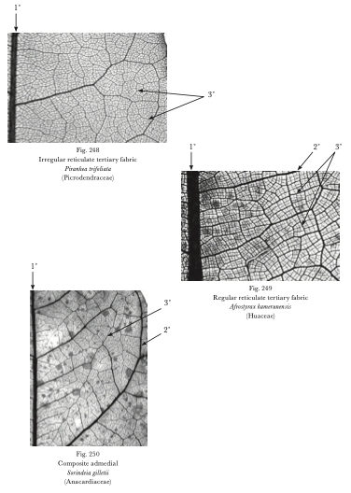

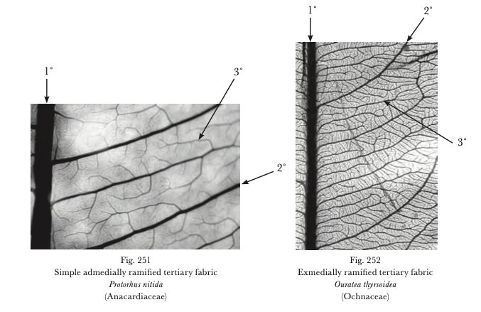

*Third veins categorization (percurrent, reticulate and ramified : three main type of third order veins)*

* **Calculating vein densities for major veins**

1. **Vein densities for each order are calculated as the ratio of vein length/leaf area for 1o and 2o veins, and as 3o length / rectangle area for 3o veins.**

**However, because your 3 vein length per area measurement might be biased by the amount of secondary veins included in the boxed area, we recommend measuring** **3 o VLA as**

**(1)**

**This calculation is for one box. To get the 3rd VLA of your leaf, you calculate the equation (1) for the other boxes and do the average of the three calculations.**

1. **Finally, major VLA is calculated as the sum of the 1°, 2° and 3° vein densities.**

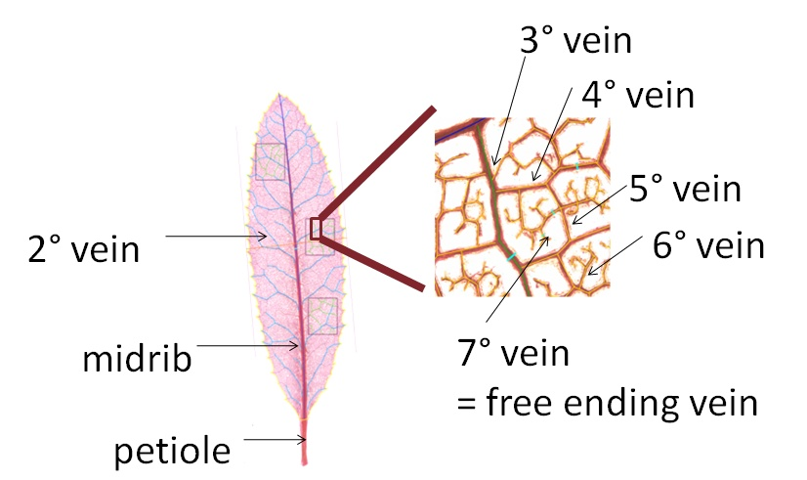

*Picture of the venation patterns from order 1 to 7 (representation of the way to differentiate the vein orders)*

**References**

**Berlyn GP, Miksche JP. 1976.** *Botanical microtechnique and cytochemistry*. Ames, Iowa, USA: Iowa State University Press.

**Brodribb TJ, Feild TS, Jordan GJ. 2007.** Leaf maximum photosynthetic rate and venation are linked by hydraulics. *Plant Physiology* **144**(4): 1890-1898.

**Brodribb TJ, Feild TS, Sack L. 2010.** Viewing leaf structure and evolution from a hydraulic perspective. *Functional Plant Biology* **37**(6): 488-498.

**Ellis B, Daly DC, Hickey LJ, Mitchell JD, Johnson KR, Wilf P, Wing SL. 2009.** *Manual of Leaf Architecture*. Ithaca, NY: Cornell University Press.

**Kehr J, Buhtz A. 2008.** Long distance transport and movement of RNA through the phloem. *Journal of Experimental Botany* **59**(1): 85-92.

**McKown AD, Cochard H, Sack L. 2010.** Decoding leaf hydraulics with a spatially explicit model: principles of venation architecture and implications for its evolution. *American Naturalist* **175**(4): 447-460.

**Niklas KJ. 1999.** A mechanical perspective on foliage leaf form and function. *New Phytologist* **143**(1): 19-31.

**Roth-Nebelsick A, Uhl D, Mosbrugger V, Kerp H. 2001.** Evolution and function of leaf venation architecture: a review. *Annals of Botany* **87**: 553-566.

**Sack L, Caringella M, Scoffoni C, Mason C, Rawls M, Markesteijn L, Poorter L. 2014.** Leaf vein length per area is not intrinsically scale dependent: avoiding measurement artifacts for accuracy and precision. *Plant Physiology* **166**(2): 829-838.

**Sack L, Cowan PD, Jaikumar N, Holbrook NM. 2003.** The 'hydrology' of leaves: co-ordination of structure and function in temperate woody species. *Plant Cell and Environment* **26**(8): 1343-1356.

**Sack L, Dietrich EM, Streeter CM, Sanchez-Gomez D, Holbrook NM. 2008.** Leaf palmate venation and vascular redundancy confer tolerance of hydraulic disruption. *Proceedings of the National Academy of Sciences of the United States of America* **105**(5): 1567-1572.

**Sack L, Frole K. 2006.** Leaf structural diversity is related to hydraulic capacity in tropical rain forest trees. *Ecology* **87**(2): 483-491.

**Sack L, Holbrook NM. 2006.** Leaf hydraulics. *Annual Review of Plant Biology* **57**: 361-381.

**Sack L, Scoffoni C. 2013.** Leaf venation: structure, function, development, evolution, ecology and applications in past, present and future. *New Phytologist* **198**: 938-1000.

**Scoffoni C, Rawls M, McKown AD, Cochard H, Sack L. 2011.** Decline of leaf hydraulic conductance with dehydration: relationship to leaf size and venation architecture. *Plant Physiology*: in press.

**Uhl D, Mosbrugger V. 1999.** Leaf venation density as a climate and environmental proxy: a critical review and new data. *Palaeogeography Palaeoclimatology Palaeoecology* **149**(1-4): 15-26.