We need to send event markers for the following events:

* Start of image stimulus (during anticipation)
* Startle probe (for each condition)

Less important but still useful markers:

* Scream
* Button press
* Fixation
* Attack
* Rating scale

This can be done by assigning each event with a unique 2-digit hex code. Each hex code will activate a different combination of digital input channels in AcqKnowledge. These digital inputs can be converted to “stim events” using the “Digital Input to Stim Events” function in AcqKnowledge. See the AcqKnowledge Software Guide page 472:

*Digital Input to stim events identifies and labels stimulus events corresponding to any combination of digital inputs*.

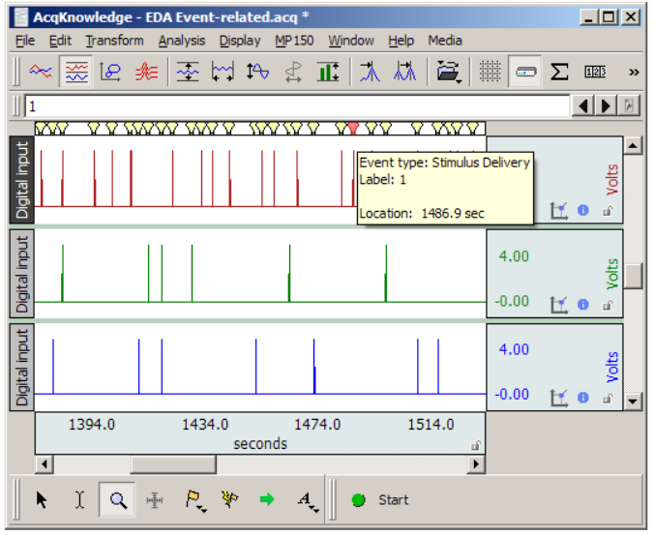

The stim events can then be used in the analysis of skin conductance and EMG. The “Stim-Response Analysis” and “Event-related EDA Analysis” functions are useful for this.

The signals from psychopy can be instantaneous rather than sustained (see the image above). This is how David programmed the signals in E-prime. This way each marker represents the start (or end) of an event. This works well with the analyses in AcqKnowledge.

Channels 2,3,4,5,6,7,8 are available.

|  |  |
| --- | --- |
|  | = not used |

|  |  |  |  |  |
| --- | --- | --- | --- | --- |
| Event | Start/End | hex code | channels | Event marker |
| Threat + none | Start | 04 | 3 | 02 |
| Threat + none | End | 0C | 3,4 |  |
| Threat + none startle | Start | 06 | 3,2 | 03 |
| Threat + far | Start | 14 | 3,5 | 10 |
| Threat + far | End | 24 | 3,6 |  |
| Threat + far startle | Start | 16 | 3,5,2 | 11 |
| Threat + near | Start | 44 | 3,7 | 34 |
| Threat + near | End | 84 | 3,8 |  |
| Threat + near startle | Start | 46 | 3,7,2 | 35 |
| Safe + none | Start | 08 | 4 | 04 |
| Safe + none | End | 18 | 4,5 |  |
| Safe + none startle | Start | 0A | 4,2 | 05 |
| Safe + far | Start | 28 | 4,6 | 20 |
| Safe + far | End | 48 | 4,7 |  |
| Safe + far startle | Start | 2A | 4,6,2 | 21 |
| Safe + near | Start | 88 | 4,8 | 68 |
| Safe + near | End | 10 | 5 |  |
| Safe + near startle | Start | 8A | 4,8,2 | 69 |
| Scream | Start | 30 | 5,6 | 24 |
| Rating scale | Start | 50 | 5,7 | 40 |
| Rating scale | End | 90 | 5,8 |  |
| Button press | Start | 20 | 6 |  |
| Attack | Start | 60 | 6,7 | 48 |
| Fixation | Start | A0 | 6,8 | 80 |
|  |  |  |  |  |

This is the code to send an event signal in Psychopy:

ser.write(str.encode(‘04’))

time.sleep(0.005) # pause for 5 miliseconds

ser.write(str.encode(‘00’))

After data has been collected:

**Digital Input to Stim Events**

1. Analysis>Stim-Response>Digital Input to Stim Events
2. Select only the digital channels with “Specific channels only…”

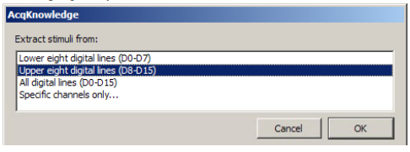

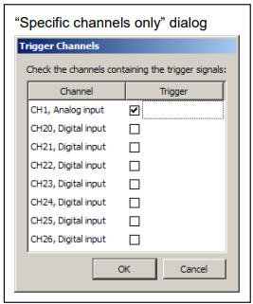

1. Set the transition latency to “0 seconds” or another appropriate number:
   1. *If non zero, any transitions that are separated by less than this latency are treated as a single transition and only one stimulus event is inserted.*
2. Each unique set of digital signals will then be assigned an event number in the global workspace (symbolized by a lightbulb)

Here’s a useful video tutorial: [BIOPAC | Videos | Tutorials & Screencasts](https://www.biopac.com/video/?video_category=automated-analysis-demos&v=digital-input-to-stim-events)

**Stim-Response Analysis**

Here’s a good video tutorial for Stim-Response Analysis: [BIOPAC | Videos | Tutorials & Screencasts](https://www.biopac.com/video/?video_category=automated-analysis-demos&v=stim-response-analysis)