Vaadin Spreadsheet Meets AI Tools in Jmix: a Quality-Control Story
This is a demo example about using Vaadin Spreadsheet, and combining it with Jmix AI Tools in Jmix framework applications. The application itself or its code are not production ready and should not be used in production environments.

Introduction
Vaadin recently released Vaadin UI components for Jmix, a subset of the commercial Vaadin Pro component set consisting of the enterprise-grade dashboard and spreadsheet components, priced more favourably than the full Vaadin Pro subscription.
Excel remains the lingua franca of business data, so an embedded spreadsheet gives users a familiar experience for importing, exporting, previewing, editing and copy-pasting data, and it becomes a genuine power-user instrument once combined with AI tools. It may even save a few MS Excel licences, since the equivalent functionality lives directly inside the application.
In this article we will explore the Vaadin Spreadsheet component and combine it with the AI Tools add-on, available since the Jmix 3.0 release. We will first tour the component itself, and then apply it to a fictional example of AI-assisted quality control in a gas turbine blade machine shop, an application that integrates the spreadsheet and the AI Tools add-on, with custom tools and skills covering the reporting, analysis and failure prediction of the workshop machinery.
Our sample data will intentionally contain planted stories for the analysis to attempt to detect, most notably the DMU-02 diagnostic puzzle, one machining centre whose measurements never go out of tolerance, but drift steadily towards the upper limit over the week. The drift is deliberately shaped to look like the machinist's first suspect, progressive tool wear, while carrying the clues that rule it out and point to a machine-level problem instead. The question the whole example builds up to is whether the AI tools will make the right diagnosis.
The complete source code is available on GitHub.

Exploring the Vaadin Spreadsheet
The official documentation is the best starting point for the Vaadin Spreadsheet, complemented by the API documentation. Vaadin also publishes a live demo, with its source code available on GitHub.
To see how the component behaves inside a Jmix application, we recreated that demo as Jmix views, substituting Vaadin with Jmix add-ons and components wherever an equivalent exists, such as Jmix Charts and the standard Jmix visual components.
The com.company.aispreadsheet.view.vaadinspreadsheetdemo package contains ten demo views covering basic functionality, collaborative features, styling, grouping, report mode, an invoice template, file upload, inline components, data binding to Jmix Charts and embedded Excel charts.

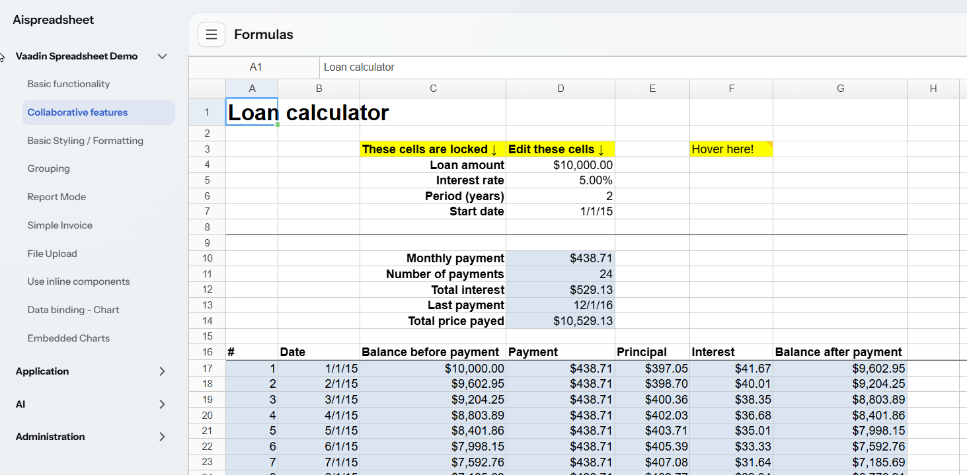
Each demo view has a matching XML descriptor (e.g. spreadsheet-components-view.xml) in src/main/resources/com/company/aispreadsheet/view/vaadinspreadsheetdemo/. The package also holds two supporting non-view classes: DemoComponentFactory and TestSheets (which points at the sample .xlsx files in resources/.../testsheets/). Access is granted via VaadinSpreadsheetDemoRole.
Demo Excel files are here.

Demo Application in Action
Before looking at how the example is built, let's see what it does. We ask our AI Spreadsheet a question:
use the measurement reports to generate a report for the entire fleet including the detected anomalies
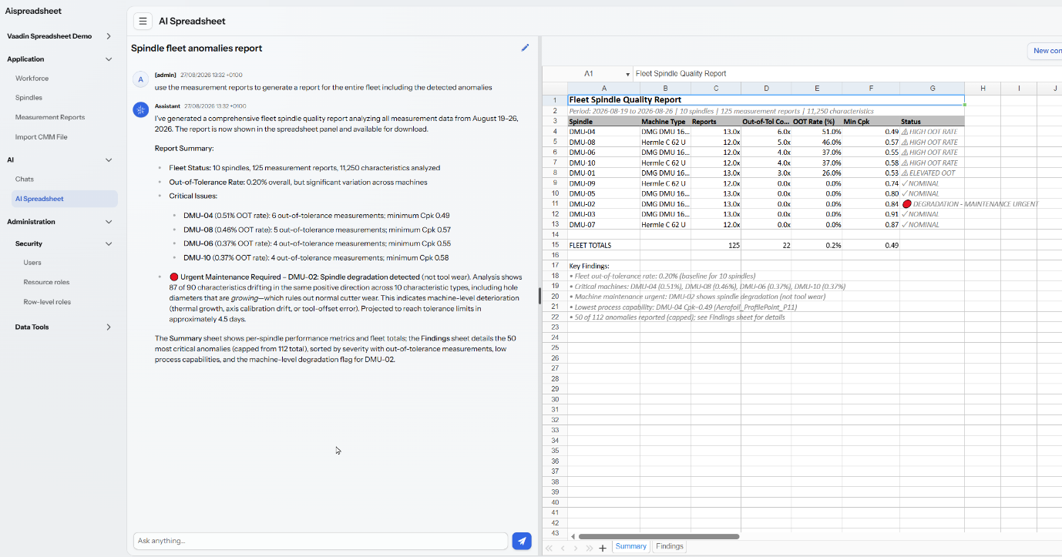
We can ask the AI model various related questions, such as:
Calculate process sigma for all the reports
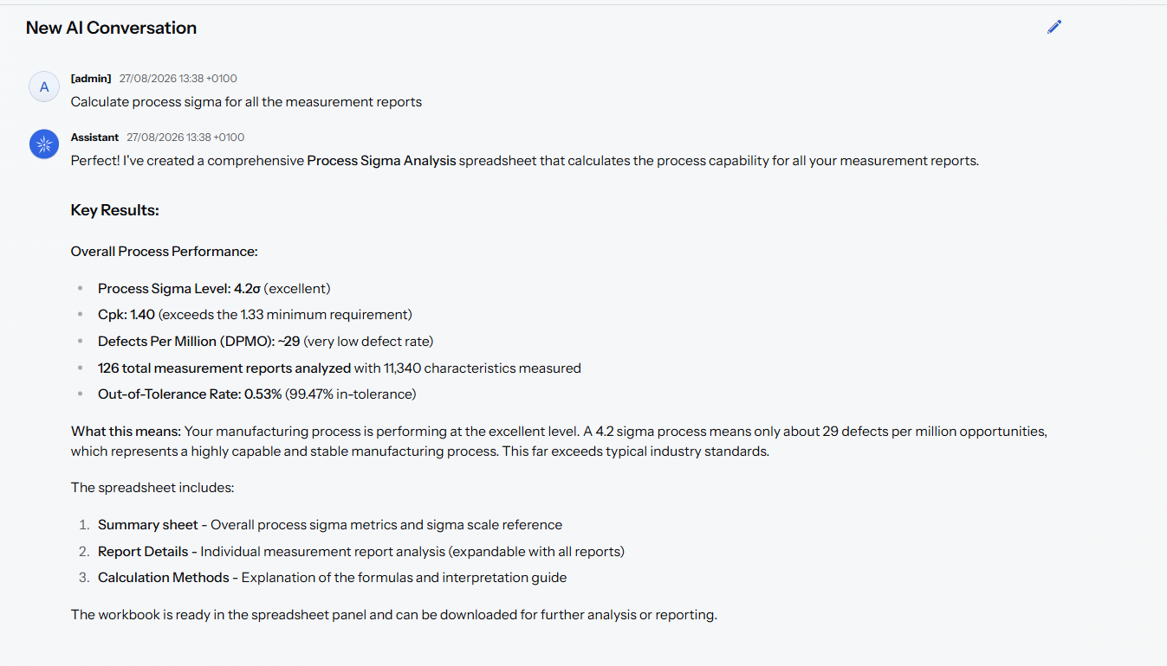
or something as simple as:
how are my spindles doing
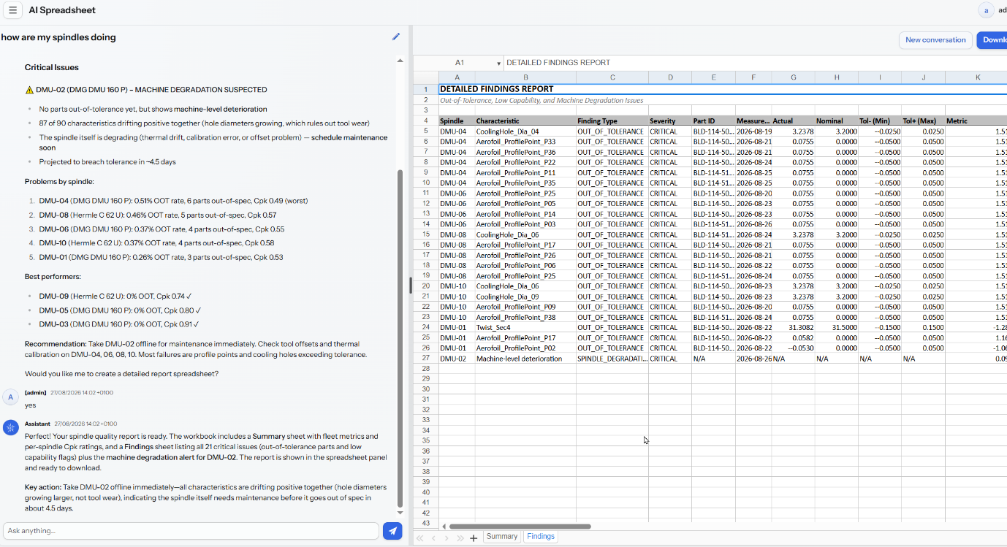
The difference is that for the anomalies report we implemented a deterministic tool, while the questions that do not invoke the tooling are handled by the LLM, and thus the answer's accuracy depends on the model's capabilities.
Prompting for individual spindle or fleet process sigma can therefore result in erroneous LLM answers. To mitigate that, we either need to make a proper tool, or precise prompts. The prompt that produced a correct DMU-05 sigma figure spells out the data extraction, the normalisation and the workbook layout in detail, but the part that actually keeps the model honest is its constraints paragraph:
Constraints: do not derive the sigma level from Cpk, and under no circumstances from the worst single characteristic; with 12–13 parts per characteristic, the lowest Cpk among 75 is sampling noise. The per-characteristic table is for locating causes, not for reporting capability. Do not perform any calculation outside the workbook. Every figure in the response must originate from a workbook formula. Run the audit on the workbook before responding.
The full prompt, and a companion version that applies the same method to the entire fleet with a per-spindle table, are in the project README on GitHub.

The Example: a Gas Turbine Blade Machine Shop
Every demo needs a story and example data, and some heavy metal seemed like a welcome change from the usual CRM, financial, HR and Pet Clinic examples. Our setting is therefore a fictional machine shop producing gas turbine blades.
Naturally, the workshop setup and process are greatly simplified compared to a real shop (no holidays, and several checks that would really be optical or ultrasonic are done on the CMM). The simplifications keep the example readable without changing the story.
Our product is a 420 mm stage-1 gas turbine blade (part BLD-114, drawing DRG-88231-C). The workshop performs the final milling operation OP-060 Final Milling, machining the dovetail root, platform and aerofoil to their finished dimensions.
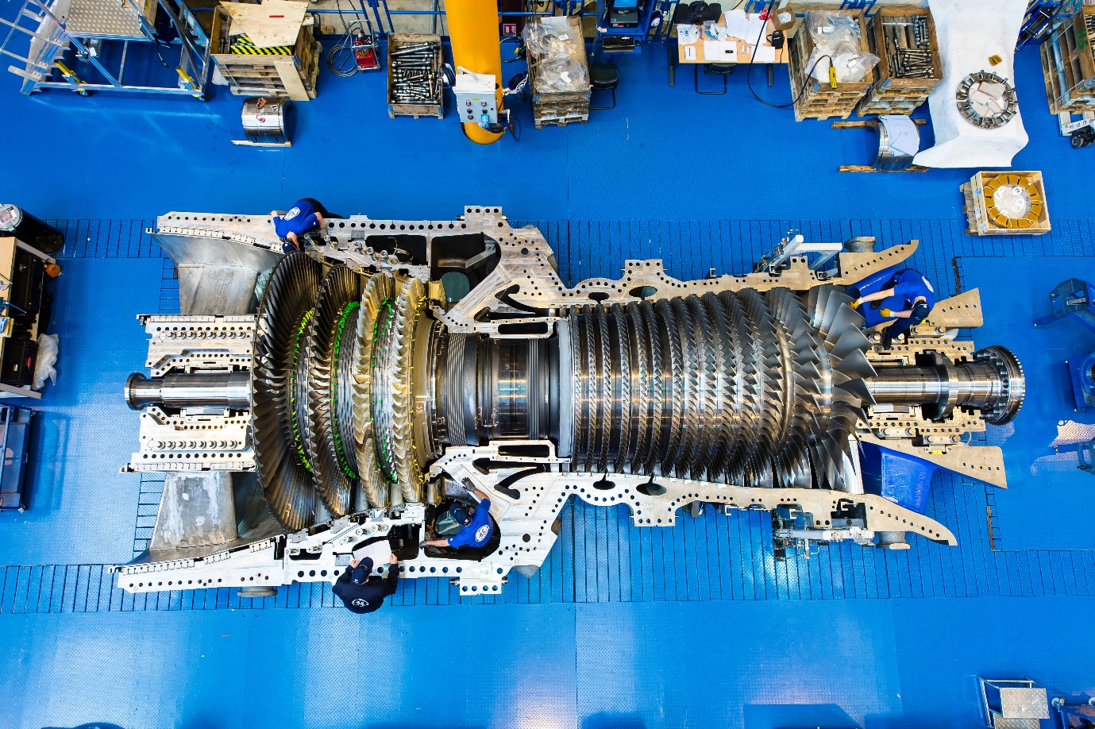
Located downstream of the combustion chamber, gas turbine blades convert the energy of the hot gases into rotation of the turbine shaft, which drives the generator. Operating under extreme heat and mechanical stress, they have to be machined to exceptionally precise tolerances.

Machines and Workforce
- 10 five-axis machining centres ("spindles"), marked DMU-01…DMU-10, six DMG DMU 160 P and four Hermle C 62 U machines.
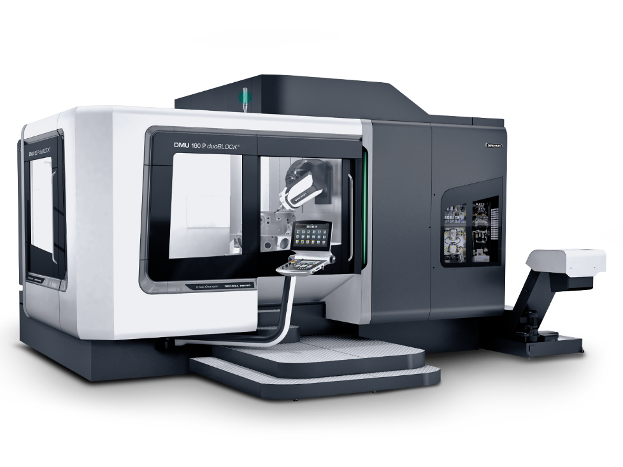
- One coordinate measuring machine (CMM) in the quality room, a Zeiss PRISMO Navigator 9/15/7 with a VAST XT gold scanning head and a 3 mm ruby stylus, driven by Zeiss Calypso 7.6.10.

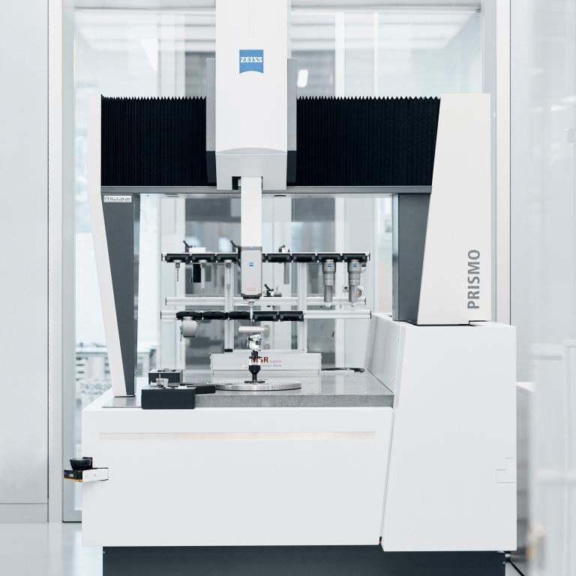
- 15 machine operators (OP-001…OP-015), each deterministically assigned to a spindle + shift combination, so every blade is traceable to the person who machined it.
- 3 CMM inspectors (QA-001…QA-003), one per shift, who run the measurement program and sign the reports.
- The shop runs three 8-hour shifts, Early (06:00–14:00), Late (14:00–22:00) and Night (22:00–06:00).

The Process
- Machining: each blade takes a full 8-hour shift on its spindle, starting at shift start; one blade per spindle per shift, ten blades in progress at any time.
- Thermal soak: after milling, the blade moves to the climate-controlled measuring room (~20 °C) and soaks for about 2 hours (in reality much longer) so it is at reference temperature before probing.
- CMM measurement: roughly 1–2 hours after machining ends, the inspector runs the Calypso measurement plan BLD-114_OP60_FINAL. The plan checks 90 characteristics per blade, namely dovetail root angles, sizes and form; platform geometry; edge radii and total blade length (420 ±0.15 mm); chord, twist and wall thickness at 5 aerofoil sections; 11 film-cooling holes, diameter (⌀3.2 ±0.025 mm) and true position (0.05 mm); and 40 aerofoil surface profile points (±0.05 mm against the CAD aerofoil).
- Report export: at the end of every run Calypso automatically writes a semicolon-delimited table file (Characteristic;Type;Nominal;Actual;Deviation;Tol -;Tol +;Out of Tol) with a traceability header (part ID, batch, works order, machine, operator as F.Lastname, inspector, temperatures) into a network share.
- Import & disposition: the application watches that directory, parses each file into measurement report and characteristic entities, and resolves the raw machine/operator/inspector strings to master data. A blade with every characteristic in tolerance is a PASS; any out-of-tolerance characteristic routes the report to REWORK / CONCESSION REVIEW with an MRB (Material Review Board) disposition.
How realistic is this? Gas turbine blade tolerances are among the tightest in mechanical manufacturing, with aerofoil profile ±0.025–0.13 mm, root fixings at ±5–15 µm, tip/length at ±0.025–0.05 mm, cooling holes at roughly ±0.05 mm on size. Actual drawings are OEM-proprietary, but our BLD-114 numbers sit comfortably in this landscape.
A short primer on Calypso's report columns and its automatic file output, which our import pipeline is built around, is available in the project README on GitHub, together with an example measurement report. Instead of implementing the watcher service and importing many measurement reports, we seed the database with an example dataset, as this is more convenient for development and testing. We still implement a manual file upload view, so individual reports can be imported without the watcher service.

The Dataset
The example dataset covers one week of production, 125 blades × 90 characteristics = 11,250 measured values (part IDs BLD-114-5001…5125), and it deliberately contains stories for the spreadsheet and AI analysis to find:
- most spindles run a healthy 4σ process;
- DMU-01 runs at only 3σ, so it occasionally produces natural out-of-tolerance values;
- DMU-02 never goes out of tolerance, but its deviations drift steadily towards the upper limit over the week, a deterioration trend waiting to be spotted;
- roughly every 8th blade gets the "usual suspect" defect (an out-of-tolerance cooling-hole diameter or aerofoil profile point), giving 110 PASS and 15 REWORK/CONCESSION reports overall.
Sidebar: What Does 4σ Mean? A sigma (σ) is one standard deviation, a measure of how much variation exists in a process. A 4σ process means the specification limits sit about four standard deviations from the process mean; centred and two-sided, it yields roughly 63 defects per million opportunities. In manufacturing terms, 2σ means a large risk of out-of-tolerance parts, 4σ is good industrial process control, and 6σ is the high-capability regime used for aerospace and medical work. For our DMU-02, a steady drift towards the limit reduces the sigma margin even while every part is still within specification, increasing the future risk of defects.
The dataset is produced by a seeder that fills an empty MeasurementReport table at application startup, modelled directly on the Calypso sample export and following the shop schedule, with operators deterministically assigned per spindle + shift and one inspector per shift. Default machines sample at 4σ, DMU-01 at 3σ, and DMU-02 applies a rising drift clamped to 95% of tolerance so it never trips a flag. Verified against the seeded database, DMU-01 collected 3 natural out-of-tolerance values; DMU-02 collected zero, but its per-blade average deviation climbs steadily from 0.0041 to 0.0356 over the week.

The DMU-02 Diagnostic Puzzle
The DMU-02 drift is no accident. We deliberately shaped it so that it points to a machine-level (spindle) problem, not tool wear, to see whether the analysis can diagnose the spindle as the root cause. A gradual drift like this is usually blamed on progressive tool wear, so the generator plants the clues that rule it out:
- the drift is uniform across all characteristic types, so hole diameters drift positive along with everything else, whereas a worn cutter removes less material and makes holes smaller;
- it ramps smoothly, with no resets at tool changes, whereas a wearing tool would show a sawtooth pattern, snapping back after each replacement;
- the same CMM measures blades from all ten spindles but only DMU-02 drifts, ruling out the measurement system itself.
That signature is consistent with axis calibration drift, spindle thermal growth, or a tool-offset/compensation error; in short, something wrong with the DMU-02 machine, which is exactly the diagnosis the dataset was engineered to support.

Implementation
The blade-workshop part of the application is a classic Jmix CRUD-plus-services slice of four JPA entities, standard list and detail views grouped under the Application menu, a pure parser service, an import service and a startup seeder.

Domain Model
Four persistent entities in com.company.aispreadsheet.entity model the shop:
- `Employee`: a person on the shop floor, with a unique employeeId, first and last name, an active flag and a type backed by the EmployeeType enum (machine operator or CMM inspector).
- `Spindle`: a machining centre, with a unique numberMark (DMU-01…DMU-10), a free-text machine type and an active flag.
- `MeasurementReport`: one imported Calypso file. It carries the full header block, the summary counts, the overall ReportResult enum (PASS or REWORK / CONCESSION REVIEW), a FileRef to the stored original file, and the traceability block. Traceability is stored twice on purpose, as the raw claimed strings from the file (machineIdRaw, millOperatorRaw, inspectorRaw) plus the resolved associations to Spindle and Employee, with a traceabilityDiscrepancy flag when resolution fails. A unique constraint on (partId, measurementDateTime) backs the duplicate-import check.
- `MeasurementCharacteristic`: one measured row, owned by the report as a @Composition, holding sequence, name, the CharacteristicType enum, nominal, actual, deviation, the tolerance limits and the out-of-tolerance flag.

Views Under the Application Menu
All four workshop views live in com.company.aispreadsheet.view.bladeworkshop:
- Workforce and Spindles: standard generated Jmix list and detail views for maintaining operators, inspectors and machines.
- Measurement Reports: the main working view. The list loads reports read-only, newest first, and marks every non-PASS row with an attention-row CSS class, so failed blades stand out. The detail view shows the header fields, a characteristics grid where out-of-tolerance rows get an oot-row class, a discrepancy badge shown only on a traceability mismatch, and a download button that streams the originally imported Calypso file via Downloader.
- Import CMM File: a manual upload counterpart to the automated directory watcher. A FileUploadField hands the uploaded bytes to MeasurementImportService; on success the view shows the counts and result, lists any warnings, and offers to open the report. A duplicate file is not an error, since the view catches DuplicateReportException and offers to open the existing report instead.
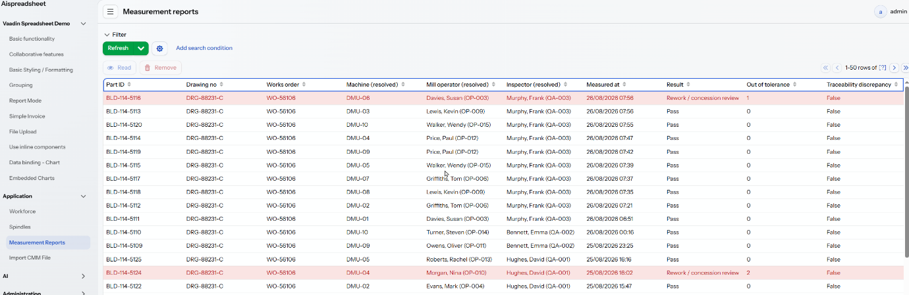

Services and Supporting Classes
The import pipeline in com.company.aispreadsheet.app is split into a pure parser and a persisting service:
- `CalypsoReportParserService`: parses the semicolon-delimited Calypso export with a small zone state machine (header, characteristic table, summary). It produces immutable records (ParsedReport, ParsedCharacteristic) plus a warning list, and throws CalypsoParseException on structural problems. It touches no database, which keeps it trivially unit-testable.
- `MeasurementImportService`: orchestrates one import. It checks for duplicates; resolves the claimed traceability strings against master data (F.Lastname matched by surname plus first-name initial), always storing the raw values verbatim and flagging a discrepancy rather than failing the import; recomputes the in/out-of-tolerance counts from the parsed rows; stores the original file in Jmix FileStorage; and saves the report with all characteristics atomically in a single SaveContext.
- `SeedDataInitializer`: an ApplicationStartedEvent listener that runs under SystemAuthenticator (startup code has no user session) and seeds the spindles, employees and the week of measurement reports. Each set is inserted only when its table is completely empty, so user data is never touched.

Security Roles
Two resource roles in com.company.aispreadsheet.security cover the workshop. `MeasurementViewerRole` grants read-only access to the four entities plus the list and detail views. `MeasurementImporterRole` extends it with CREATE rights on reports and characteristics and access to the import view. There are deliberately no UPDATE or DELETE grants, so imported reports stay immutable, matching how quality records are handled in a real shop. The demo views have their own VaadinSpreadsheetDemoRole, and the AI views their AiSpreadsheetRole.

Letting AI Tools Loose on the Measurements
This is where the two headline components meet. The AI menu holds two views, the AI Tools add-on's standard chat hub, and a custom AI Spreadsheet workspace that merges the chat assistant with a live Vaadin Spreadsheet. The user talks to the assistant on the left; the workbooks the assistant builds appear instantly on the right, rendered by the Vaadin Spreadsheet component and downloadable as regular .xlsx files.
The chat model used is Claude Haiku 4.5, via AWS Bedrock (spring.ai.bedrock.converse.chat.model in application.properties), but nothing below depends on the provider; the tools are plain Spring AI tools and work with any Spring AI chat model.

The AI Spreadsheet Workspace
`AiSpreadsheetView` (route /ai-spreadsheet) is a split layout, with the add-on's AiChatFragment on the left, a Vaadin Spreadsheet on the right, plus New Conversation and Download buttons. The interesting part is how a tool call on a background AI thread ends up on the user's screen:
- The assistant calls a spreadsheet tool; the tool builds the workbook server-side and puts the resulting bytes into `AiWorkbookStore`, keyed by username.
- The tool then publishes a `SpreadsheetReadyEvent` through Jmix UiEventPublisher, targeted at that user only.
- Jmix delivers the event on the UI thread of every open UI of that user; the view's @EventListener reads the bytes into the spreadsheet component. If the build reported formula issues, a warning notification appears as well.
AiWorkbookStore holds the current workbook per user as an immutable xlsx byte array rather than a live POI workbook, because POI is not thread-safe and the AI tool thread, the UI thread and the downloader all touch the same workbook. Every save is also copied to Jmix FileStorage for durability and audit.

Spreadsheet Tools
`AiSpreadsheetTools` implements the add-on's JmixAiTool marker interface, so the chat assistant discovers it automatically. It exposes four Spring AI @Tool methods:
- `app_createSpreadsheet`: builds a new workbook from a complete JSON specification (SpreadsheetSpec with sheets, cells, merges, column widths and named ranges) and replaces the user's current workbook.
- `app_updateSpreadsheetCells`: applies targeted cell changes (set a value, set a formula, or clear) to the current workbook. This is the repair loop; the model uses it to fix reported formula issues instead of rebuilding.
- `app_readSpreadsheet`: dumps the current workbook as text (every non-empty cell with formula, evaluated value and number format) so the model can inspect before editing.
- `app_auditSpreadsheet`: reviews the workbook and returns an AuditReport with CRITICAL / WARNING / INFO findings; it reports and never modifies.
The heavy lifting sits in two pure services operating on byte arrays. `SpreadsheetBuilderService` builds and mutates workbooks with Apache POI, applies a style-token system (TITLE, HEADER, INPUT, FORMULA, CURRENCY and so on), and runs a per-cell formula verification pass; broken formulas (#REF!, #NAME?, unsupported functions) come back as CellIssue entries, which the tool returns to the model with the instruction to fix them. `SpreadsheetAuditService` is a deterministic reviewer that checks for formula error values, hardcoded literals inside formulas, formulas breaking the pattern of their neighbours, failed Checks-sheet validations, and style violations.
Every tool reports progress into the chat via the add-on's AiToolStatusPublisher and returns a structured SpreadsheetToolResult rather than throwing, so a model that sends a malformed spec gets guidance for a correct retry instead of an opaque error.

The Spindle Analysis Tool
The measurement side gets its own tool. `SpindleAnalysisTools` exposes `app_analyzeSpindleAnomalies`, which delegates to `SpindleAnomalyAnalysisService`, which loads the measurement data through DataManager under the calling user's permissions and computes, in memory, six kinds of findings:
- OUT_OF_TOLERANCE: characteristics measured outside their tolerance band;
- ELEVATED_OOT_RATE: spindles whose failure rate is far above the fleet average;
- DRIFT: a single characteristic trending toward a limit over time (the classic tool-wear signal);
- SPINDLE_DEGRADATION: broad, same-direction drift across most characteristics and multiple characteristic types of one spindle, with no resets at tool changes. Per-characteristic drift findings are consolidated into this one machine-level finding;
- STATISTICAL_OUTLIER: single measurements far outside that spindle's history (z-score of 3 or more) while still in tolerance;
- LOW_CAPABILITY: spindle/characteristic combinations with Cpk below 1.0.
The SPINDLE_DEGRADATION check is the payoff of the planted DMU-02 puzzle, because the analysis distinguishes exactly the signature we generated (uniform positive drift, smooth ramp, one spindle) from ordinary tool wear, and the tool description instructs the model to state prominently that such a spindle needs maintenance.

Skills and the System Prompt
Tool definitions alone do not make a model build good spreadsheets. Two more pieces steer it:
- Embedded skills. The construction and audit rules are adapted from the xlsx-author and audit-xls skills of the Apache-2.0 licensed anthropics/financial-services repository, so every calculation cell must be a formula; every hardcoded value lives in a labelled input cell on an Inputs sheet; models get a Checks sheet with TRUE/FALSE validations. Instead of shipping skill files, the rules travel inside the @Tool descriptions, where the model sees them at exactly the moment it needs them.
- `AppAiChatSystemPromptProvider` replaces the add-on's default chat system prompt (registered with @ConditionalOnMissingBean, so a project bean simply wins). The extended prompt wires the workflow together, load business data with the add-on's built-in entity discovery and data querying tools first, then build workbooks rather than printing Markdown tables; audit after creating and fix CRITICAL findings; and for any spindle quality question, call app_analyzeSpindleAnomalies first and build the report only from its numbers, never from invented ones.
The end-to-end flow is therefore that the user asks "how are my spindles doing?", the assistant calls the analysis tool, gets back the DMU-02 degradation finding with the fleet summaries, builds and audits a report workbook, and the result appears in the spreadsheet panel, ready to attach to a maintenance work order.

Security
The guiding principle is that the AI operates strictly under the calling user's permissions, so the data querying and the spindle analysis both load business data under the user who asks. What the user cannot see, the AI cannot see either.
`AiSpreadsheetRole` grants view and menu access to the AI Spreadsheet workspace. It deliberately contains no entity policies, because the workbook lives in memory and file storage, not in the database. Assign it together with the add-on's AiToolsChatUserRole, which covers the chat conversation entities and views, and with a data role such as MeasurementViewerRole so the querying and analysis tools have data to work with.

Running this example
Licensed components. The Vaadin Spreadsheet is a commercial component. You need either a Vaadin UI components for Jmix subscription or a Vaadin Spreadsheet trial; a trial key is enough to run this demo. The dependency comes from the Jmix premium repository, so your Jmix premium credentials must be available to Gradle (premiumRepoUser / premiumRepoPass, typically in ~/.gradle/gradle.properties). Without those credentials the build fails at dependency resolution, and without a valid Vaadin licence the spreadsheet views will not render; in development mode Vaadin opens a browser prompt asking you to validate the licence with your vaadin.com account.
Jmix add-ons. Besides the spreadsheet starter (io.jmix.vcc:vaadin-spreadsheet-starter), the project uses Charts, Grid Export Actions, AI Tools and Data Tools, all declared in build.gradle.
An LLM of your own. This project uses Anthropic Claude via AWS Bedrock, with credentials in the AWS_ACCESS_KEY_ID and AWS_SECRET_ACCESS_KEY environment variables. To use another provider, swap the Spring AI starter dependency and the spring.ai.* properties; nothing in the application code changes.
With that in place, ./gradlew bootRun starts the application on port 8080 with a local HSQLDB database; log in as admin. On first start, the seeder fills the database with the example dataset, showing its progress on screen. Wait for the seeding to finish before exploring the data.
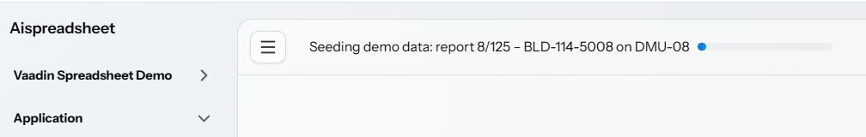

Conclusion
The first lesson is that the spreadsheet and the AI assistant are a genuine power-user combo, and each covers the other's weak side. The Vaadin Spreadsheet brings the interface every business user already knows, so they can inspect any number, follow the formulas that produced it, and download a regular .xlsx to attach to a work order. The AI brings the part Excel never had, where you ask a question in plain language and get back a finished, formula-driven workbook built from live application data. And since the component lives inside the Jmix application, behind its security model, users who only ever needed Excel to view exported data may not need an MS Excel licence at all.
The second lesson is about where to put the intelligence. A capable model with the generic data-querying tools could answer most of our questions on its own; given enough measurements it would probably even notice that DMU-02 looks odd. We still wrote a dedicated analysis tool, for two reasons:
- Determinism. The drift regressions, z-scores and Cpk values are computed in plain, unit-tested Java, so the same data produces the same findings every time, findings a quality engineer can sign off on. An LLM eyeballing 11,250 values would give a plausible answer today and a slightly different one tomorrow; fine for brainstorming, unacceptable for a maintenance decision.
- Token economy. The raw dataset never enters the context window. The tool processes the measurements in the JVM and hands the model a compact structured summary, a few kilobytes instead of megabytes of rows. That makes every question dramatically cheaper and faster, and is exactly why the demo runs comfortably on a small, inexpensive model rather than requiring a frontier one.
The pattern generalises, so let the model do language, orchestration and judgement; let tools do arithmetic, data access and anything that must be reproducible. The skills embedded in the tool descriptions then bridge the two, teaching the model to use the deterministic machinery well.
The third lesson is about security, and it is where the Jmix AI Tools add-on shows its value. Because the assistant runs inside the application rather than beside it, every tool call, whether the add-on's built-in data querying or our custom analysis, executes under the calling user's Jmix roles and row-level constraints. There is no separate AI account with broad database access and no service credentials to protect, and no prompt trick can make the model read data the user could not open in a view. Access to the AI workspace itself is just another resource role, granted and revoked like any other. Each conversation is stored as a Jmix entity and every generated workbook is copied to file storage, so the whole exchange is auditable after the fact. Since only compact tool results reach the model, the raw measurements never leave the JVM, and the LLM sees a summary, not the shop's quality records.
To answer the question from the start, the AI Tools did spot the DMU-02 problem, because we gave them a tool that cannot miss it.

