Mike Buchanan

IT213-01

Unit 2

Exercise 2-1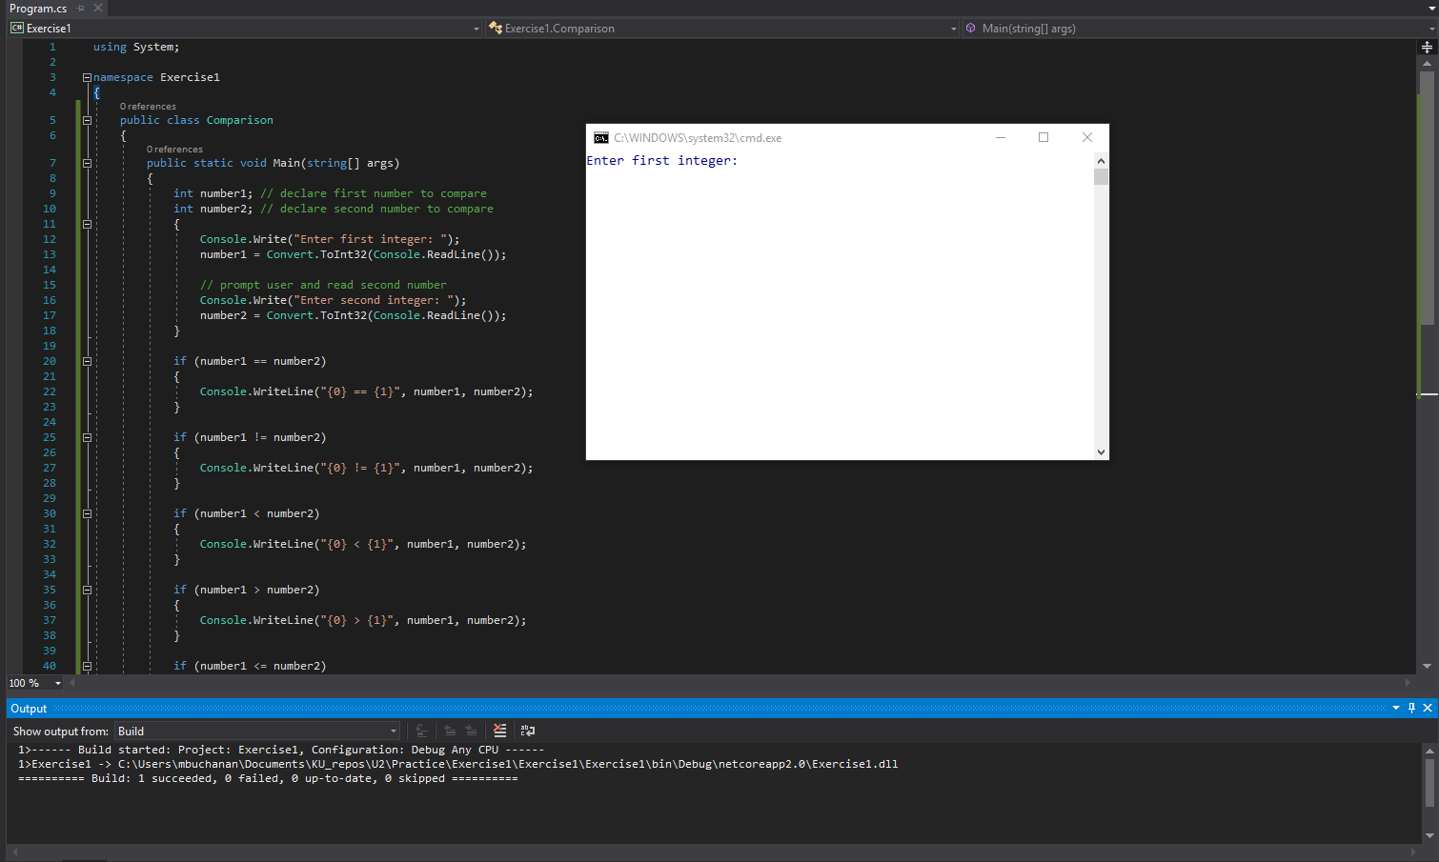

Exercise 2-2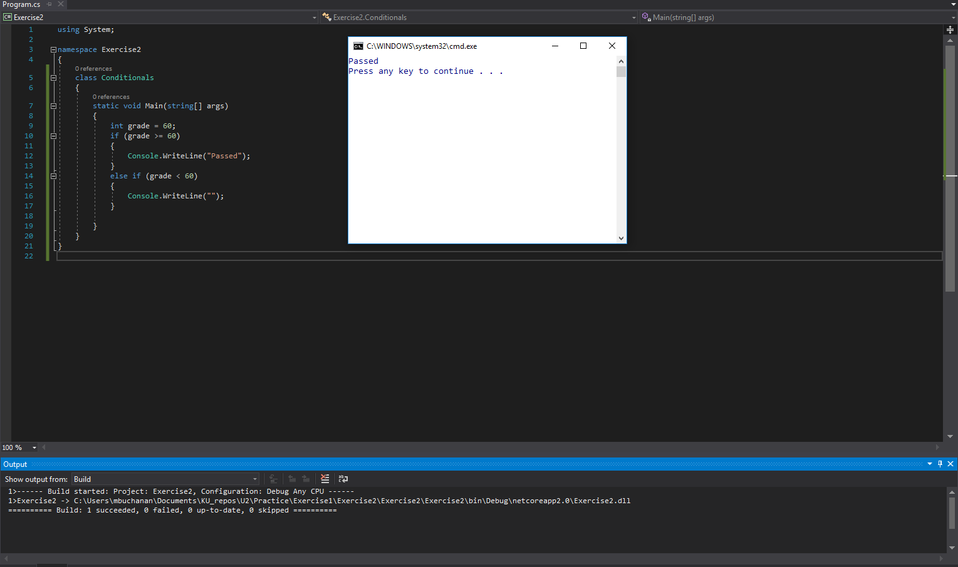

Exercise 2-3

