Ng’ang’a Job Mbugua
project proposal
News aggregator app

ABSTRACT

The development of a news aggregator application with advanced NLP-driven classification and recommendation represents a significant leap forward in digital content curation, specifically designed to cater to the diverse needs of news consumers,publishers and information enthusiasts. The platform will be designed to offers a highly personalized news experience by leveraging cutting-edge technologies and real-time data analysis,Provide a platform to publish and work /track progress of contents to be published.

At the core of my solution is a robust system using NLP algorithms, the platform classifies content into multiple categories, allowing users to effortlessly discover news tailored to their specific interests in politics, technology, sports, and other domains.

From a technical perspective, the application will be built on a robust stack of modern technologies. The frontend will be developed using React, ensuring a responsive and intuitive user interface. Backend operations are powered by Express.js, efficiently managing API requests and server-side logic. Data storage utilizes MongoDB for flexible management of unstructured data and SQL for structured data, ensuring robust and scalable data handling. For natural language processing tasks, I will leverage powerful libraries such as spaCy and transformers, enabling effective content classification and analysis.

How the system works
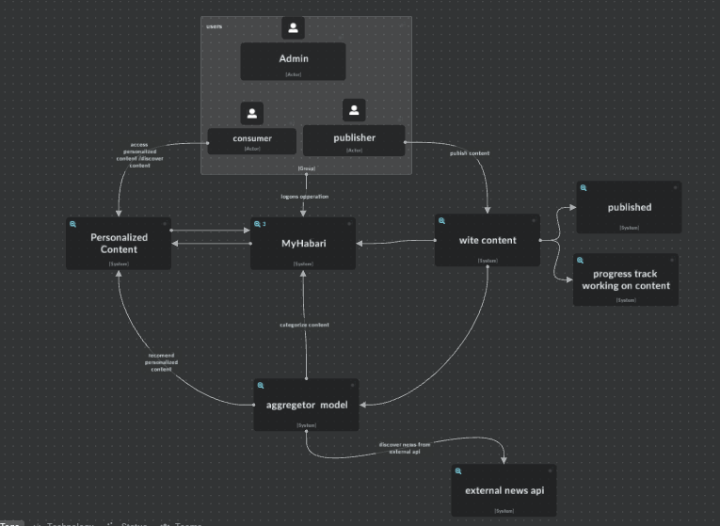
Image 1:illustration of Users,Roles and Functionalities in the News Aggregator App

The super user(admin)will be responsible for managing the users,The Content consumer will get personalized content based on their preferences,and The Publisher will be able to seamlessly work on multiple contents and track the progress for a review and later publish the content .The aggregator model will be able to Categorize the Content from the publisher and recommend it to the content consumer as well will discover news from external api’s categorize and recommend them

User Roles and Functionalities in the News Aggregator App
Super User (Admin):
- User Management: Oversee and manage user accounts, including content consumers and publishers. This includes roles such as account creation, deletion, and permissions assignment.
- Content Oversight: Ensure the integrity of published content by overseeing the review and approval processes.
- System Monitoring: Monitor system performance and user activity to maintain optimal functionality and security.
Content Consumer:
- Personalized Content: Receive tailored content recommendations based on their specified preferences and reading history.
- Content Interaction: Engage with content through options such as saving, liking, sharing, and commenting.
- Subscription Management: Manage subscriptions to specific topics, publishers, or types of content to customize their news feed.
Publisher:

- Content Creation and Management: Create and manage multiple content pieces simultaneously, with tools for drafting, editing, and tracking the progress of each piece.
- Workflow Management: Utilize a streamlined workflow to track content through various stages of review and editing, ensuring it meets quality standards before publication.
- Performance Tracking: Analyze the reach and engagement of published content to inform future content strategies and optimize audience reach.

