Architecture:
My web application will comprise of a nodejs api serving data from mysql database to a reactjs client. This system will be hosted on both web-01 and web-02 and traffic from the clients will be distributed between those two servers
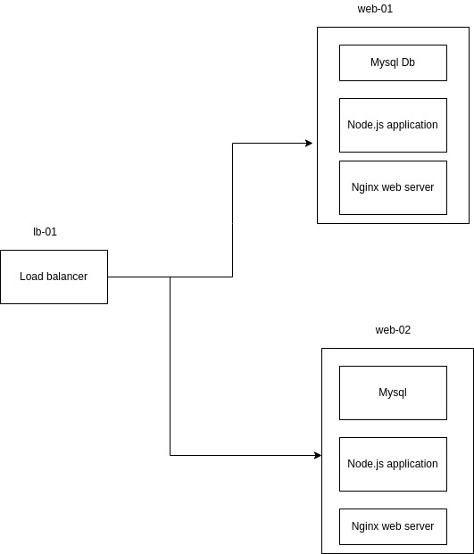

APIs and Methods:

These are major api endpoints that my nodejs application will be serving data through

1. api/v1/resources

GET: returns all resources in json format
2. api/v1/resources
POST: creates new resource
3. api/v1/resources/:r_id
GET: returns a resources with id of r_id
4. api/v1/resources/:r_id
PATCH: updates a resource with id of r_id

Data Model:

1. User (email: String, username: String, id: int)
2. Resource (title: String, content: String, userId(foreign key): int

User Stories:

As a alx student I can share my knowledge via alx_resources, so that I can help my fellow students

When stuck with some concept, I can visit alx_resources to see some articles and resources posted by fellow students.

Mockups:

