SME Development in Zambia

Medha Bulumulla

**Brief History of SMEs and Political Climate in Zambia**

After USSR and communist governments fell in addition to dissatisfaction of the one-party system in Zambia, the Movement for Multiparty Democracy (MMD) began to gain traction. MMD had the goal of re-introducing multiparty politics and made numerous promises to the working class. Once they were in power, they were unable to live up to their expectations. Trade unions became disadvantaged through many legislative measures and there was a sharp decline in real wages in the private sector. Specifically in 1991-92, some wages in the manufacturing sector fell to 75%. The government did not intervene as expected for the working class and living conditions worsened for the general public. (Momba & Madimutsa, n.d.).

A country focused on mining now found themselves in the need to develop a diverse economy and focus less on mining copper. Zambia as a nation needed to increase support for Micro, Small and Medium Enterprises (MSME) to increase quality of life for the working class, provide capital and jobs, as well as develop equity for women and youth. Zambia’s ease of Doing Business Score is an 86, where 1 categorizes a country with the most business-friendly regulations. (Ease of Doing Business Rank - Zambia | Data, 2021).

**Challenges to Growth and Development**

***Accessibility of Credit and Finance***

SMEs have a hard time accessing credit from financial institutions in Zambia. Interest rates from loans are high and collateral requirements prevent SMEs from accessing startup and expansion loans. Some SMEs also struggle with finding resources to securing loans. The procedures can be long and they might lack credible financial accounts. (Muyasani, n.d.)

Entrepreneurs Financial Centre focuses on providing loans for micro enterprises. Loans given to SME are 60% of Entrepreneurs Financial Centre (EFC)’s portfolio. These loans are still considered risky and difficult to get. If the SME’s have poor credit, they may charge 28% more and loan collateral. (Nuwagaba, 2015).

Obtaining loans are especially difficult for women who want to get involved in the business center. Loans require some sort of collateral which many women do not own. Only 10% of the total loan portfolio features female lending.

***Registration of Businesses***

Over 90% of Zambian SMEs participate in the informal sector. It is difficult for governmental and non-governmental bodies to estimate how to properly assist them. Registered SMEs must pay taxes to the government. They have the power to increase governmental revenue and provide funding for social programs to benefit the nation. Many SMEs are operating informally because the process is cumbersome and they want to avoid state taxes. (Nuwagaba, 2015). There is little incentive for SMEs to participate in the formal sector, therefore most do not.

***Access to Markets***

MSMEs struggle to access both domestic and international markets. As a nation originally primarily focused on copper exports, reaching and competing in the market is often a struggle for many enterprises with less resources and information. (*Sixth National Development Plan 2011-2015 Executive Summary*, 2011).

Domestically, infrastructure including road and railway quality limit the ease of transport. Weather equipment and electricity can also facilitate transport of goods.

***Education***

As of January 2022, free primary and secondary education is provided for all Zambians. (*Times of Zambia | Free Education Effective January 10, 2022*, n.d.) 91.8% of Zambians complete year 7, but students begin to drop out in upper primary and secondary school. Girls disproportionally drop out during this time due to factors including menstruation hygiene, teenage pregnancy, and child marriage. (*Education*, n.d.). Only 67.5% of students transition from primary to secondary school.

The current entrepreneurial education is inadequate. Teachers do not have their own work experience knowledge to provide their students. Entrepreneurial programs are underfunded and require adequate training materials. There is also a poor entrepreneurship culture as it is seen as a need-based practice. Educated individuals often work for government or already established organizations/businesses because they are reliable and more respected. Many young people are unemployed because they lack work experience, but they lack work experience because they cannot get work with prior employment. (Mwamba et al., 2021)

**Governmental Initiatives**

***Technical Education, Vocational and entrepreneurship Training (TEVET)***

The Technical Education, Vocational and entrepreneurship Training (TEVET) program focuses on putting entrepreneurship in the Zambian education system. It provides resources for youth to empower them. They have vocational training and education programs. They also provide certifications that can help with employment and education. (*TEVETA | Home*, n.d.)

TEVET programs often lack consistency. The educators of the programs do not always have the appropriate experience to teach students. (Insurance, 2008)

***Zambia Development Agency Act (ZDA)***

The Zambia Development Agency (ZDA) Act was introduced in 2006 to increase capital and create jobs. It promotes international investment and monitors registered MSMEs (*About ZDA - Overview*, n.d.). It provides incentives for foreign and local investors who invest more than 500,000 USD in priority sectors (*The Zambia Development Agency (Amendment) Investment Policy Monitor | UNCTAD Investment Policy Hub*, n.d.).

ZDA has a variety of interventions aimed at SMEs, these include entrepreneurship training, technical skills support, business advisory services, business formalization, business incubation, product development, business linkage, and business intelligence and market information (BMI). In 2020, the agency supported 3203 MSMEs that created 6082 jobs; while in 2019, 4505 MSMEs created 5987 jobs. 139 MSMEs were formalized compared to the 63 in 2019. 53 of these were from the manufacturing sector, 41 in the agricultural sector and 24 in the service industry. 1215 women and youth use Business Development Services (BDS) compared to the 1712 in 2019. This program focused on women and youth, in which 74% of women and 26% of youth used it compared to the 16% and 22% of women and youth respectively in 2019. (*ZDA 2020 Annual Report*, 2020).

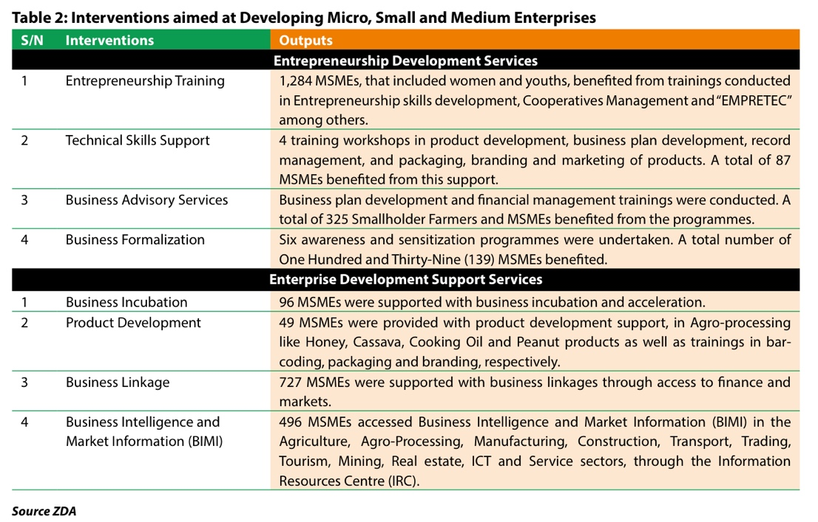

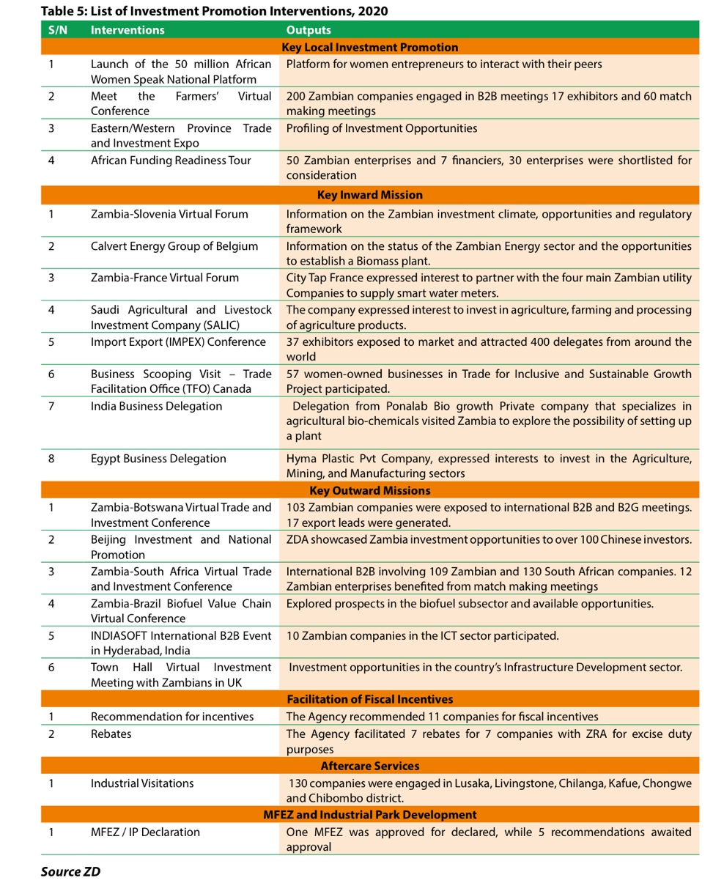

***Citizens Economic Empowerment Act (CEE)***

The Citizens Economic Empowerment Commission (CEEC) aims to increase participation of targeted citizens which include “a citizen who is or has been marginalized or disadvantaged and whose access to economic resources and development capacity has been constrained due to various factors including race, sex, educational background, status and disability”. It applies to all state institutions and businesses employing more than twenty-five people. Their objective includes helping individuals to own more assets, promote employment in formal sector, increase literacy and skills. They provide a Preferential Procurement (PP) Certificate to educate citizens. (*Preferential Procurement – Citizens Economic Empowerment Commission*, n.d.).

**Non-governmental Initiatives**

Entrepreneurs Financial Center (EFC) has women market loans where they provide micro loans that require small amounts of capital for women selling vegetables and other petty trading. Their intention is to give them micro loans in the beginning and as their business grows, give them the rate other SMEs have, (Nuwagaba, 2015). Women market traders loans do not require collateral in the terms of vehicles, property and machinery, instead it asks for household good properties (Women Market Traders Loans – EFC Zambia, n.d.)

***Mentorship Programs***

VC4 Mentor Driven Capital Program connects investors and provides capital for startups. They create courses and connect startups with mentors.

WomenConnect gives mentorship to women and youth entrepreneurs since 2017. To be part of this group, one must pay a membership fee.

Dreamers Mentorship Program connects people with experts in their industry, colleagues and potentially sponsors.

Woman Entrepreneurship Access Centre (WEAC) It helps women in business regionally and in the local market. They work with startups or established business to help them grow. They provide Certified Business Mentor Programs (CBMP) which is their flagship mentorship program where they work with Angel’s Nest. They partner with Academy for Women Entrepreneurs (AWE), The Zambia Entrepreneurship Summit (ZES), Farmers Business Simulation(FBS), FemBioBiz, Africa Food360 Accelerator(SAIS 2), Seed Catalyzer, Citi Microentrepreneurship Program (CMA), and WEINVEST.

Academy for Women Entrepreneurs (AWE) was launched through the US’s department of State’s Bureau of Educational and Cultural Affairs in 26 countries, including Zambia. They give tools, knowledge, and networks to keep their business running. The program is in partnership with Arizona State University’s Thunderbird School of Management and the global copper mining company Freeport-McMoRan. To be involved in AWE, one must be in in Lusaka, Kitwe, Ndola or Livingstone and have basic computer knowledge as well as being able to learn in English.

The Zambia Entrepreneurship Summit (ZES) which is co-hosted with the US Embassy and WEAC brings startups, start-ups, scale-ups, lenders, investors, policy makers, development partners, financial institutions, ecosystem enablers, enterprise support organizations (ESOs), academia, business development service providers (BDSPs), and empowerment organizations. The summit increases market access and helps connect partners. (*ZES – Weac*, n.d.)

Africa Food360 Accelerator (SAIS 2) empowers women-owned agro-based businesses. It is a regional trade and learning exchange program between Zambia, Namibia, and South Africa spearheaded by WECREATE and funded through Southern African Innovation Support Program (SAIS) and Finland’s Ministry of Foreign Affairs. They have 87 stakeholders and 24 companies participating. There are 24 female-led agricultural enterprises in agro-forestry, aqua-culture, livestock, seed replication, legumes, clean energy, and others. (*ZES – Weac*, n.d.)

Seed Catalyzer helps refine business models to make them more environmentally, socially and economically friendly. They strive to improve the business’ investment readiness. There are 244 catalyzer participants, where 214 received SEED grants and 283 business plans were improved. (gGmbH, n.d.)

***Commercial Bank Programs***

Zanaco provides specialized accounts for registered SMEs. They have the ultra-business and premium account. Business with 20–50-million-kwacha turnover in any sector can qualify for ultra and 2-20 million for premium accounts. It provides debt cards, doorstep banking, fine margin pricing, exclusive contact, private banking, private lounge, relationship to manager, and tax solutions.

Standard Charted Bank Zambia provides short (up to 1 year) and medium (1-5 years) term loans for SMEs. They have flexible repayments and fixed (monthly, quarterly, or annual) repayments. They help protect businesses and give trade and working capital solutions. (*Term Loans | Standard Chartered Bank Zambia*, n.d.)

Citations

*About ZDA - Overview*. (n.d.). Retrieved June 28, 2022, from https://www.zda.org.zm/index.php/about-v-4/

*Ease of doing business rank- Zambia | Data*. (2021, September 16). https://data.worldbank.org/indicator/IC.BUS.EASE.XQ?locations=ZM

*Education*. (n.d.). Retrieved June 28, 2022, from https://www.unicef.org/zambia/education

gGmbH, adelphi research. (n.d.). *SEED Catalyser*. SEED - Promoting Entrepreneurship for Sustainable Development. Retrieved July 8, 2022, from https://seed.uno/programmes/enterprise-support/catalyser

Insurance, K. (2008). *The Micro, Small and Medium Enterprise Development Policy*. 41.

Momba, J. C., & Madimutsa, C. (n.d.). *The Evolution and Development of the Movement for Multiparty Democracy in Zambia*. *17*, 23.

Muyasani, K. (n.d.). *THE CHALLENGES FACED BY SMALL & MEDIUM ENTERPRISES (SMEs) IN OBTAINING CREDIT IN ZAMBIA*. 47.

Mwamba, L., Musonda, A., & Daka, H. (2021). *Bridging the Gap in Teacher Education Curriculum in Promoting Entrepreneurship: A Case Study of Undergraduate Students of Kwame Nkrumah University, Kabwe-Zambia*. *08*, 160–168. https://doi.org/10.51244/IJRSI.2021.8808

Nuwagaba, A. (2015). *Enterprises (SMEs) in Zambia*. *4*(4), 8.

*Preferential Procurement – Citizens Economic Empowerment Commission*. (n.d.). Retrieved June 28, 2022, from http://www.ceec.org.zm/preferential-procurement/

*SAIS - Southern Africa Innovation Support*. (n.d.). Retrieved July 8, 2022, from https://www.saisprogramme.org/news/sais-africa-food360-launched-zambia

*Sixth National Development Plan 2011-2015 Executive Summary*. (2011). Ministry of Finance and National Planning.

*Term Loans | Standard Chartered Bank Zambia*. (n.d.). Standard Chartered Zambia. Retrieved July 7, 2022, from https://www.sc.com/zm/business/working-capital/term-loans/

*TEVETA | Home*. (n.d.). Retrieved June 28, 2022, from https://www.teveta.org.zm/

*The Zambia Development Agency (Amendment) Investment Policy Monitor | UNCTAD Investment Policy Hub*. (n.d.). Retrieved June 28, 2022, from https://investmentpolicy.unctad.org/investment-policy-monitor/measures/3802/zambia-the-zambia-development-agency-amendment-act-2021-provides-new-incentives-for-large-investments

*Times of Zambia | Free education effective January 10, 2022*. (n.d.). Retrieved June 28, 2022, from https://www.times.co.zm/?p=113471

*Women market traders loans – EFC Zambia*. (n.d.). Retrieved June 27, 2022, from https://efczambia.com.zm/women-market-traders-loans/

*Zambia: Academy for Women Entrepreneurs (AWE) Programme – Phase 3—FundsforCompanies*. (n.d.). Retrieved July 12, 2022, from https://fundsforcompanies.com/women-entrepreneurs/zambia-academy-for-women-entrepreneurs-awe-programme-phase-3/

*ZDA 2020 Annual Report*. (2020).

*ZES – Weac*. (n.d.). Retrieved July 12, 2022, from https://weaczambia.org/zes/