Data 624: Week 2 Homework

Angrand, Burke, Deboch, Groysman, Karr

October 12, 2019

### Week 2 Assignment

**Chapter 6 HA 6.2**

##### 6.2 The plastics data set consists of the monthly sales (in thousands) of product A for a plastics manufacturer for five years.

#preliminary EDA  
plastics

## Jan Feb Mar Apr May Jun Jul Aug Sep Oct Nov Dec  
## 1 742 697 776 898 1030 1107 1165 1216 1208 1131 971 783  
## 2 741 700 774 932 1099 1223 1290 1349 1341 1296 1066 901  
## 3 896 793 885 1055 1204 1326 1303 1436 1473 1453 1170 1023  
## 4 951 861 938 1109 1274 1422 1486 1555 1604 1600 1403 1209  
## 5 1030 1032 1126 1285 1468 1637 1611 1608 1528 1420 1119 1013

**a.** Plot the time series of sales of product A. Can you identify seasonal fluctuations and/or a trend-cycle? - Trend: Increasing over 1 year. Appears to be some seasonality(lag graph), length 1 year.Data is heavily seasonal.Dropping in winter and peaking in summer. Overall trend is positive.

general.plot <- autoplot(plastics) +ggtitle("Monthly Sales of Product A") +xlab("Year") +ylab("Thousands")  
seasonal.plot <-ggseasonplot(plastics, year.labels=TRUE, year.labels.left=TRUE) +  
 ggtitle("Monthly Sales of Product A") +  
 xlab("Year") +  
 ylab("Thousands")  
  
acf.plot <-ggAcf(plastics)+ ggtitle("Seasonality of Product A")  
decomp.plot <- autoplot(stl(plastics,"periodic"))  
grid.arrange(general.plot,  
 seasonal.plot,  
 acf.plot,  
 decomp.plot,  
 nrow = 2,  
 top = "Sales of product A")

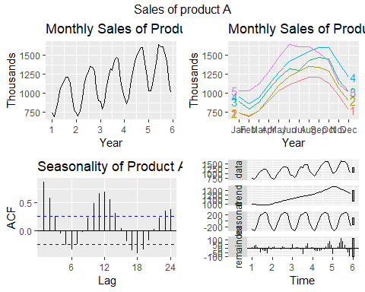

**b.** Use a classical multiplicative decomposition to calculate the trend-cycle and seasonal indices.

* The multiplicative decomposition shows a general upward trend from year 2 through year 5. After year 5, the trend appears to be decreasing. The decomposition graph also displays a seasonal shift (up/down) in one year increments.

plastics_decomp<-decompose(plastics,type="multiplicative")  
head(plastics_decomp)

## $x  
## Jan Feb Mar Apr May Jun Jul Aug Sep Oct Nov Dec  
## 1 742 697 776 898 1030 1107 1165 1216 1208 1131 971 783  
## 2 741 700 774 932 1099 1223 1290 1349 1341 1296 1066 901  
## 3 896 793 885 1055 1204 1326 1303 1436 1473 1453 1170 1023  
## 4 951 861 938 1109 1274 1422 1486 1555 1604 1600 1403 1209  
## 5 1030 1032 1126 1285 1468 1637 1611 1608 1528 1420 1119 1013  
##   
## $seasonal  
## Jan Feb Mar Apr May Jun Jul  
## 1 0.7670466 0.7103357 0.7765294 0.9103112 1.0447386 1.1570026 1.1636317  
## 2 0.7670466 0.7103357 0.7765294 0.9103112 1.0447386 1.1570026 1.1636317  
## 3 0.7670466 0.7103357 0.7765294 0.9103112 1.0447386 1.1570026 1.1636317  
## 4 0.7670466 0.7103357 0.7765294 0.9103112 1.0447386 1.1570026 1.1636317  
## 5 0.7670466 0.7103357 0.7765294 0.9103112 1.0447386 1.1570026 1.1636317  
## Aug Sep Oct Nov Dec  
## 1 1.2252952 1.2313635 1.1887444 0.9919176 0.8330834  
## 2 1.2252952 1.2313635 1.1887444 0.9919176 0.8330834  
## 3 1.2252952 1.2313635 1.1887444 0.9919176 0.8330834  
## 4 1.2252952 1.2313635 1.1887444 0.9919176 0.8330834  
## 5 1.2252952 1.2313635 1.1887444 0.9919176 0.8330834  
##   
## $trend  
## Jan Feb Mar Apr May Jun Jul  
## 1 NA NA NA NA NA NA 976.9583  
## 2 1000.4583 1011.2083 1022.2917 1034.7083 1045.5417 1054.4167 1065.7917  
## 3 1117.3750 1121.5417 1130.6667 1142.7083 1153.5833 1163.0000 1170.3750  
## 4 1208.7083 1221.2917 1231.7083 1243.2917 1259.1250 1276.5833 1287.6250  
## 5 1374.7917 1382.2083 1381.2500 1370.5833 1351.2500 1331.2500 NA  
## Aug Sep Oct Nov Dec  
## 1 977.0417 977.0833 978.4167 982.7083 990.4167  
## 2 1076.1250 1084.6250 1094.3750 1103.8750 1112.5417  
## 3 1175.5000 1180.5417 1185.0000 1190.1667 1197.0833  
## 4 1298.0417 1313.0000 1328.1667 1343.5833 1360.6250  
## 5 NA NA NA NA NA  
##   
## $random  
## Jan Feb Mar Apr May Jun Jul  
## 1 NA NA NA NA NA NA 1.0247887  
## 2 0.9656005 0.9745267 0.9750081 0.9894824 1.0061175 1.0024895 1.0401641  
## 3 1.0454117 0.9953920 1.0079773 1.0142083 0.9990100 0.9854384 0.9567618  
## 4 1.0257400 0.9924762 0.9807020 0.9798704 0.9684851 0.9627557 0.9917766  
## 5 0.9767392 1.0510964 1.0498039 1.0299302 1.0398787 1.0628077 NA  
## Aug Sep Oct Nov Dec  
## 1 1.0157335 1.0040354 0.9724119 0.9961368 0.9489762  
## 2 1.0230774 1.0040674 0.9962088 0.9735577 0.9721203  
## 3 0.9969907 1.0132932 1.0314752 0.9910657 1.0258002  
## 4 0.9776897 0.9920952 1.0133954 1.0527311 1.0665946  
## 5 NA NA NA NA NA  
##   
## $figure  
## [1] 0.7670466 0.7103357 0.7765294 0.9103112 1.0447386 1.1570026 1.1636317  
## [8] 1.2252952 1.2313635 1.1887444 0.9919176 0.8330834  
##   
## $type  
## [1] "multiplicative"

summary(plastics_decomp)

## Length Class Mode   
## x 60 ts numeric   
## seasonal 60 ts numeric   
## trend 60 ts numeric   
## random 60 ts numeric   
## figure 12 -none- numeric   
## type 1 -none- character

plastics %>% decompose(type="multiplicative") %>%  
 autoplot() + xlab("Year") +  
 ggtitle("Classical multiplicative decomposition  
 of Monthly Plastics Sales")

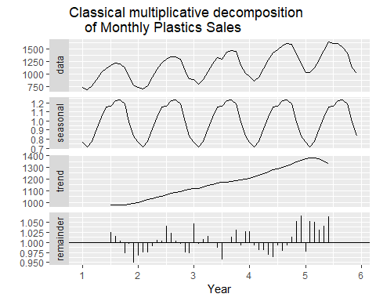

**c.** Do the results support the graphical interpretation from part a?

* Both part a and part b display a seasonal component of 1 year and a trend that is increasing over time.The decomposition shows strong seasonality in middle of year(summer). The decomposition does show a decline after year 5 because it relies on moving averages.

**d.** Compute and plot the seasonally adjusted data.

* The “Adjusted Seasonal” plot shows the sales with the seasonality removed, making the upward trend is more visable. Seasonal Adjustment plot also shows that the first year sales were flat and then they grew for the next 3 years. The 5th year saw a drop in sales.

mult.decomposition <- plastics %>%  
 decompose(type="multiplicative") %>%  
 seasonal  
  
  
autoplot(plastics /mult.decomposition, series = "Adjusted Seasonal")+   
 autolayer(plastics, series = "Plastics - Normal") +  
 ggtitle("Sales of Product A & Seasonally Adjusted Sales Product A")

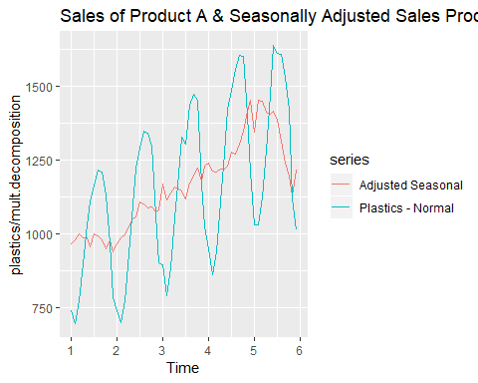

**e.** Change one observation to be an outlier (e.g., add 500 to one observation), and recompute the seasonally adjusted data. What is the effect of the outlier?

* After 500 was added to the 35th datapoint in “plastics.adj” dataset, a large spike occurred in the middle of the data series and the seasonally adjusted data series. This can be observed in the chart below.

plastics.adj <- plastics  
plastics.adj[35] <- plastics.adj[35]+500  
  
  
mult.decomposition.adj <- plastics.adj %>%  
 decompose(type="multiplicative") %>%  
 seasonal  
  
  
autoplot(plastics.adj /mult.decomposition, series = "Adjusted Seasonal")+   
 autolayer(plastics.adj, series = "Plastics - Normal") +  
 ggtitle("Sales of Product A & Seasonally Adjusted Sales Product A (Adjusted Series [MIDDLE])")

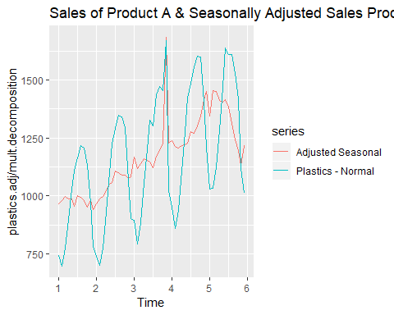

**f.** Does it make any difference if the outlier is near the end rather than in the middle of the time series?

* After 500 was added to the 60th datapoint in “plastics.adj.end” dataset, a large spike occurred at the end of the dataset. However, the seasonality seems to more closely mirror that of the original chart.

end.series<- length(plastics)  
plastics.adj.end <- plastics  
plastics.adj.end[end.series] <- plastics.adj.end[end.series]+500  
  
  
mult.decomposition.adj <- plastics.adj.end %>%  
 decompose(type="multiplicative") %>%  
 seasonal  
  
  
autoplot(plastics.adj.end /mult.decomposition, series = "Adjusted Seasonal [END]")+   
 autolayer(plastics.adj.end, series = "Plastics - Normal") +  
 ggtitle("Sales of Product A & Seasonally Adjusted Sales Product A (Adjusted Series [END])")

