Data 624: Week 4 Homework

Angrand, Burke, Deboch, Groysman, Karr

October 12, 2019

### Week 4 Assignment

**Chapter 7 HA 7.1, 7.3**

##### 7.1 Consider the **pigs** series - the number of pigs slaughtered in Victoria each month.

The pigs ts contains monthly total number of pigs slaughtered in Victoria, Australia (Jan 1980 to Aug 1995).

#sampling and shape of dataset, preliminary EDA  
head(pigs)

## Jan Feb Mar Apr May Jun  
## 1980 76378 71947 33873 96428 105084 95741

#autoplot the series  
pigsdata<-window(pigs)  
autoplot(pigsdata) +  
 ylab("Number of pigs slaughtered") +xlab("Year")

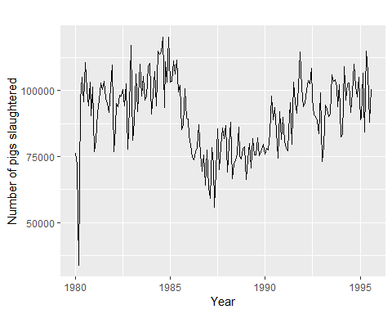

**a.** Use the **ses()** function in R to find the optimal values of $α$ and $l_{0}$, and generate forecasts for the next four months.

#Estimate parameters  
fc_pigs_ses<-ses(pigsdata, h=4)  
  
  
  
#Get forecasted estimate parameters from model -(alpha and l)  
round(fc_pigs_ses$model$par[1:2],4)

## alpha l   
## 0.2971 77260.0561

#generate 4 months of forecasts   
data.frame(fc_pigs_ses)

## Point.Forecast Lo.80 Hi.80 Lo.95 Hi.95  
## Sep 1995 98816.41 85605.43 112027.4 78611.97 119020.8  
## Oct 1995 98816.41 85034.52 112598.3 77738.83 119894.0  
## Nov 1995 98816.41 84486.34 113146.5 76900.46 120732.4  
## Dec 1995 98816.41 83958.37 113674.4 76092.99 121539.8

#Accuracy of one-step-ahead training errors  
round(accuracy(fc_pigs_ses),2)

## ME RMSE MAE MPE MAPE MASE ACF1  
## Training set 385.87 10253.6 7961.38 -0.92 9.27 0.8 0.01

# see how SES model was fitted  
fc_pigs_ses$model

## Simple exponential smoothing   
##   
## Call:  
## ses(y = pigsdata, h = 4)   
##   
## Smoothing parameters:  
## alpha = 0.2971   
##   
## Initial states:  
## l = 77260.0561   
##   
## sigma: 10308.58  
##   
## AIC AICc BIC   
## 4462.955 4463.086 4472.665

# get 1st 4 months of forecasts  
tsCV(pigs,ses,h=4)[1:4,]

## h=1 h=2 h=3 h=4  
## [1,] -4431.00 -42505.00 20050.00 28706.00  
## [2,] -42431.44 20123.56 28779.56 19436.56  
## [3,] 62555.00 71211.00 61868.00 76774.00  
## [4,] 28706.00 19363.00 34269.00 23953.00

#Plot (Note that forecast using ses doesn't have a trend component.)  
fc_pigs_ses<-ses(pigs, h=100)  
autoplot(fc_pigs_ses) +   
 autolayer(fitted(fc_pigs_ses), series="fitted") +  
 ylab("Total number of Pigs slaughtered in Victoria, Austrailia") + xlab("Jan 1980 to Aug 1995")

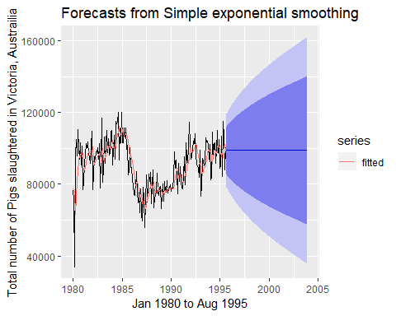

**b.** Compute a 95% prediction interval for the first forecast using $\overset{^}{y}±1.96s$ is the standard deviation of the residuals. Compare your interval with the interval produced by R.

# 95% prediction interval for the first forecast  
  
lower.upper <- data.frame( fc_pigs_ses$lower[1, "95%"], fc_pigs_ses$upper[1, "95%"])  
names(lower.upper)<- c("lower.limit", "upper.limit")  
lower.upper

## lower.limit upper.limit  
## 95% 78611.97 119020.8

# calculate standard deviation of residuals with and without model, s = 10273.69 vs s (estimated) 10308.58  
s <- sd(fc_pigs_ses$residuals)  
print(paste("Standard Deviation: ",round(s,2)))

## [1] "Standard Deviation: 10273.69"

# calculate 95% prediction interval with model  
pred.interval.model<- data.frame(fc_pigs_ses$mean[1] - 1.96*s,fc_pigs_ses$mean[1] + 1.96*s)  
names(pred.interval.model)<- c("Lower.Model", "Upper.Model")  
pred.interval.model

## Lower.Model Upper.Model  
## 1 78679.97 118952.8

# calculate 95% prediction interval without model  
pred.interval.womodel<- data.frame(mean(pigs) - 1.96*s, mean(pigs) + 1.96*s)  
names(pred.interval.womodel)<- c("Lower.NOModel", "Upper.NOModel")  
pred.interval.womodel

## Lower.NOModel Upper.NOModel  
## 1 70504 110776.9

* R gives an interval of [78611.97, 119020.8] and by computing the standard deviation of the residuals we got [78679.97, 118952.8]. Both are really close.

##### 7.3 Modify your function from the previous exercise to return the sum of squared errors rather than the forecast of the next observation. Then use the **optim()** function to find the optimal values of $α$ and $l_{0}$. Do you get the same values as the **ses()** function?

* my_ses_func returns an l value that is ~.01% different then the ses function.

## alpha l   
## 0.2971 77269.3253

## alpha l   
## 0.2971 77260.0561