Data 624

Project 1 fall 2019

**Group 1: Angrand, Burke, Deboch, Groysman, Karr**

Table of Contents

Part A - ATM Forecast, ATM624Data.xlsx 2

Part B - Forecasting Power, ResidentialCustomerForecastLoad-624.xlsx 25

Part C – Waterflow_Pipe1.xlsx and Waterflow_Pipe2.xlsx 40

Step 1. Load Libraries 40

Step 2. Read in 2 Excel files 40

Step 3. Exploratory Analysis. 40

Step 4. Data Cleaning. 44

Step 5. Converting data into time series. 46

Step 6. Looking at seasonality and trend. 48

Step 8. Applying decomposition. 51

Step 9. Exponential Forecasting. 55

Step 9. Selecting Forecasting Method. 57

Step 10. Preparing the final file to be ouputed in the Excel 60

Data 624. Project 1: Part A

Angrand, Burke, Deboch, Groysman, Karr

October 22, 2019

### Part A - ATM Forecast, ATM624Data.xlsx

**Data: ATM624Data.xlsx**

In part A, I want you to forecast how much cash is taken out of 4 different ATM machines for May 2010. The data is given in a single file. The variable ‘Cash’ is provided in hundreds of dollars, other than that it is straight forward. I am being somewhat ambiguous on purpose. I am giving you data, please provide your written report on your findings, visuals, discussion and your R code all within a Word readable document, except the forecast which you will put in an Excel readable file. I must be able to cut and paste your R code and run it in R studio. Your report must be professional - most of all - readable, EASY to follow. Let me know what you are thinking, assumptions you are making! Your forecast is a simple CSV or Excel file that MATCHES the format of the data I provide.

#Upload library  
library(tidyverse)  
library(readxl)  
library(fpp2)  
library(forecast)

Read in File/EDA/Data Adjustments

* drop nulls
* restructure dataset
* convert to time series object
* plot time series object for each ATM

temp = tempfile(fileext = ".xlsx")  
dataURL <- "https://raw.githubusercontent.com/mburke65/CUNY_Data624/master/ProjectFolder/Provided_Files/ATM624Data.xlsx"  
download.file(dataURL, destfile=temp, mode='wb')  
  
atm <- readxl::read_excel(temp, sheet =1)  
  
head(atm,5)

## # A tibble: 5 x 3  
## DATE ATM Cash  
## <dttm> <chr> <dbl>  
## 1 2009-05-01 00:00:00 ATM1 96  
## 2 2009-05-01 00:00:00 ATM2 107  
## 3 2009-05-02 00:00:00 ATM1 82  
## 4 2009-05-02 00:00:00 ATM2 89  
## 5 2009-05-03 00:00:00 ATM1 85

#Drop null values  
atm<-atm %>%  
 drop_na()

#Convert each ATM to Column  
atm<- atm %>%  
 spread(ATM,Cash)  
head(atm,5)

## # A tibble: 5 x 5  
## DATE ATM1 ATM2 ATM3 ATM4  
## <dttm> <dbl> <dbl> <dbl> <dbl>  
## 1 2009-05-01 00:00:00 96 107 0 96  
## 2 2009-05-02 00:00:00 82 89 0 82  
## 3 2009-05-03 00:00:00 85 90 0 85  
## 4 2009-05-04 00:00:00 90 55 0 90  
## 5 2009-05-05 00:00:00 99 79 0 99

#Fix the date column  
atm <- atm %>%  
 mutate(DATE =as.Date(DATE))  
head(atm)

## # A tibble: 6 x 5  
## DATE ATM1 ATM2 ATM3 ATM4  
## <date> <dbl> <dbl> <dbl> <dbl>  
## 1 2009-05-01 96 107 0 96  
## 2 2009-05-02 82 89 0 82  
## 3 2009-05-03 85 90 0 85  
## 4 2009-05-04 90 55 0 90  
## 5 2009-05-05 99 79 0 99  
## 6 2009-05-06 88 19 0 88

#Convert to a time series  
ts_atm <- ts(atm %>% select(-DATE))  
  
head(ts_atm)

## Time Series:  
## Start = 1   
## End = 6   
## Frequency = 1   
## ATM1 ATM2 ATM3 ATM4  
## 1 96 107 0 96  
## 2 82 89 0 82  
## 3 85 90 0 85  
## 4 90 55 0 90  
## 5 99 79 0 99  
## 6 88 19 0 88

* ATM1, ATM2, and ATM4 are a big deal of variation. buT ATM3 shows no cash withdrawn for most of the year. One assumption we can do about ATM3 is that it has just opened. we will use the entire time series of ATM1 and ATM2. ATM3 will be used to forecast future prediction.

#Separate each ATM from the dataset and graph each dataset  
atm1<-ts_atm[,"ATM1"]  
autoplot(atm1) +  
 labs(title ="Cash Withdrawn from ATM1", x="Day") +  
 scale_y_continuous("Cash withdrawns in hundreds") +  
 scale_color_discrete(NULL)

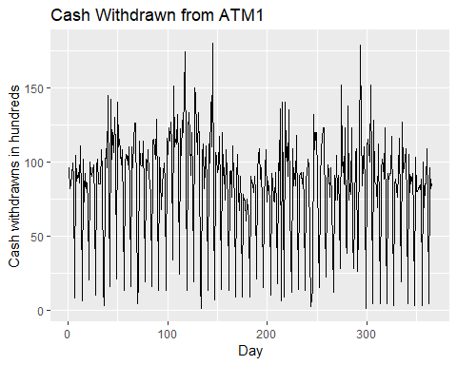

#Separate each ATM from the dataset and graph each dataset  
atm2<-ts_atm[,"ATM2"]  
autoplot(atm2) +  
 labs(title ="Cash Withdrawn from ATM2", x="Day") +  
 scale_y_continuous("Cash withdrawns in hundreds") +  
 scale_color_discrete(NULL)

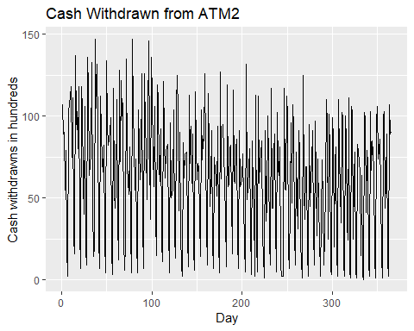

#Separate each ATM from the dataset and graph each dataset  
atm3<-ts_atm[,"ATM3"]  
autoplot(atm3) +  
 labs(title ="Cash Withdrawn from ATM3", x="Day") +  
 scale_y_continuous("Cash withdrawns in hundreds") +  
 scale_color_discrete(NULL)

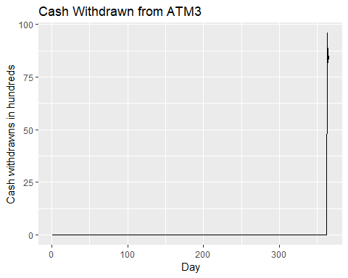

#Separate each ATM from the dataset and graph each dataset  
atm4<-ts_atm[,"ATM4"]  
autoplot(atm4) +  
 labs(title ="Cash Withdrawn from ATM4", x="Day") +  
 scale_y_continuous("Cash withdrawns in hundreds") +  
 scale_color_discrete(NULL)

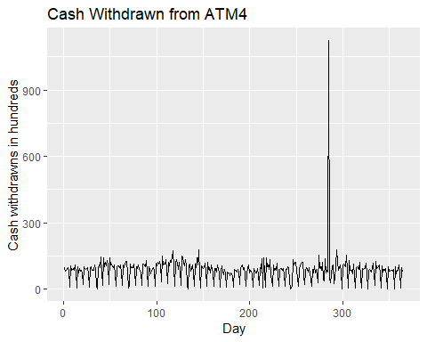

* ATM1, ATM2 and ATM4 show a lot of deal of seasonality in the withdrawn from those ATM.We can further analyze it by selecting the first 2 months of the data.

autoplot(ts(ts_atm[1:61, ])) +  
  
 labs(title = "Cash withdrawn from 4 ATMs",  
  
 subtitle = "May 2009 - June 2010",  
  
 x = "Day") +  
  
 scale_y_continuous("Cash withdrawn (hundreds)") +  
  
 scale_color_discrete(NULL)

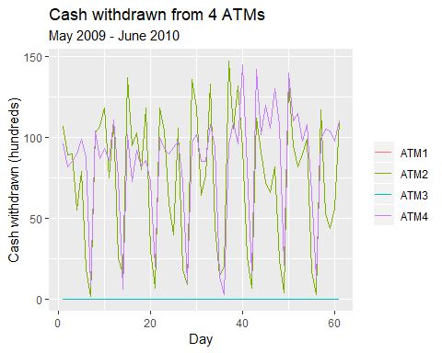

* The data presents a sort of weekly seasonnality. To capture the seasonnality of this data we will set the frequency to 7.

atm1_freq<-ts(atm1, frequency =7)  
atm2_freq<-ts(atm2, frequency=7)  
atm4_freq<-ts(atm4, frequency=7)

#### ATM1

#ACF and spectrum plot  
ggtsdisplay(atm1_freq, points = FALSE, plot.type = "spectrum",  
  
 main = "Withdrawals from ATM1", xlab = "Week", ylab = "Cash (hundreds)")

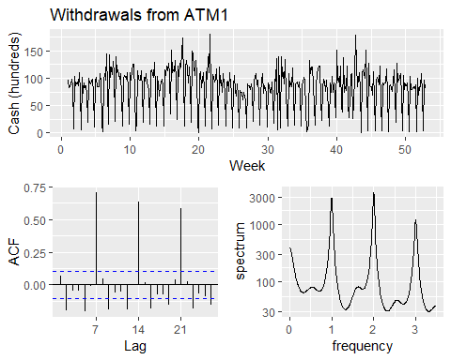

* In 7, 14 and 21 there are large spikes. the frequency 1,2,3 show the spike as well. Both suggest a seasonnal ARIMA model.

ggtsdisplay(diff(atm1_freq, 7), points = FALSE,  
  
 main = "Differenced (lag-7) withdrawals from ATM1",  
  
 xlab = "Week", ylab = "Cash (hundreds)")

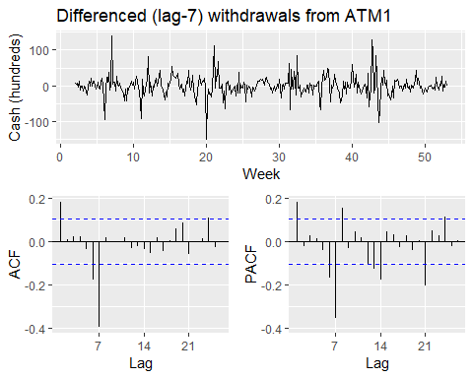 - BoxCox transformation to estimate lambda

# get optimal lambda for Box-cox transformation  
  
lambda_atm1<- BoxCox.lambda(atm1_freq)  
  
# define function to create models & return AIC values for timeseries  
  
aic_atm<- function(p, d, q, P, D, Q) {  
  
 # create model with Box-Cox and specified ARIMA parameters; extract AIC  
  
 AIC(Arima(atm1_freq, order = c(p, d, q), seasonal = c(P, D, Q), lambda = lambda_atm1))  
  
}  
  
# create possible combinations of p, q, P, Q except all zero  
  
expand.grid(p = 0:1, q = 0:1, P = 0:1, Q = 0:1) %>%  
  
 filter(p > 0 | q > 0 | P > 0 | Q > 0) %>%   
  
 # calc AIC for models  
  
 mutate(aic = pmap_dbl(list(p, 0, q, P, 1, Q), aic_atm)) %>%   
  
 # return best AIC  
  
 slice(which.min(aic))

## p q P Q aic  
## 1 1 1 0 1 1221.26

* The minimum aic value is for non-seasonality AR(1) and MA(1). AR(0) and AM(1) is for seasonality. Let’s fit the model using arima model arima(1,0,1)(0,1,1)

fit_atm1 <- Arima(atm1_freq, order = c(1, 0, 1), seasonal = c(0, 1, 1), lambda = lambda_atm1)  
summary(fit_atm1)

## Series: atm1_freq   
## ARIMA(1,0,1)(0,1,1)[7]   
## Box Cox transformation: lambda= 0.2584338   
##   
## Coefficients:  
## ar1 ma1 sma1  
## -0.4894 0.6125 -0.6385  
## s.e. 0.2309 0.2081 0.0432  
##   
## sigma^2 estimated as 1.732: log likelihood=-606.63  
## AIC=1221.26 AICc=1221.37 BIC=1236.78  
##   
## Training set error measures:  
## ME RMSE MAE MPE MAPE MASE  
## Training set 2.293003 24.81988 15.66437 -89.57546 108.1682 0.892827  
## ACF1  
## Training set -0.008839946

Let’s diagnostic the residuals with Ljung-Box.

Box.test(resid(fit_atm1), type = "L", fitdf = 3, lag = 7)

##   
## Box-Ljung test  
##   
## data: resid(fit_atm1)  
## X-squared = 8.0497, df = 4, p-value = 0.08977

ggtsdisplay(resid(fit_atm1), points = FALSE, plot.type = "histogram",  
  
 main = "Residuals for ARIMA(1,0,1)(0,1,1) fit of ATM1 withdrawals",  
  
 xlab = "Week", ylab = "Residual")

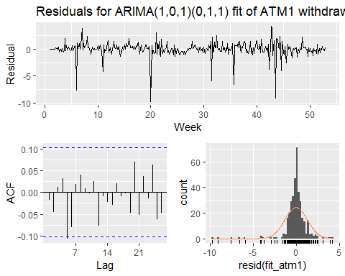

* The p_value is greater than 0.05 meaning that the residual is white noise. The residuals are not correlated and there is a normal distribution around the mean 0. We can use that model for forecasting.

forecast_atm1 <- forecast(fit_atm1, 31, level = 95)  
autoplot(forecast_atm1) +   
  
 labs(title = "ATM1: ARIMA(1,0,1)(0,1,1)", x = "Week", y = NULL) +  
  
 theme(legend.position = "none")

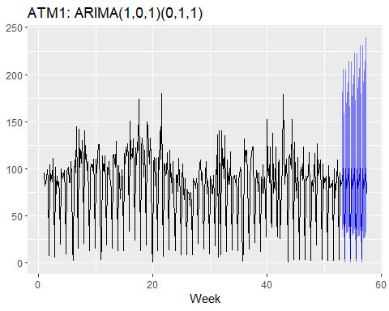

#### ATM2

* We can repeat the same stepp for ATM2.

ggtsdisplay(atm2_freq, points = FALSE,  
  
 main = "Withdrawals from ATM2", xlab = "Week", ylab = "Cash (hundreds)")

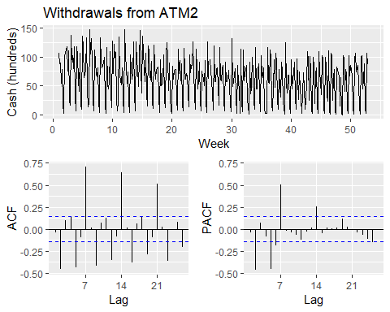

* The lag difference is 7.

ggtsdisplay(diff(atm2_freq, 7), points = FALSE,  
  
 main = "Differenced (lag-7) withdrawals from ATM2",  
  
 xlab = "Week", ylab = "Cash (hundreds)")

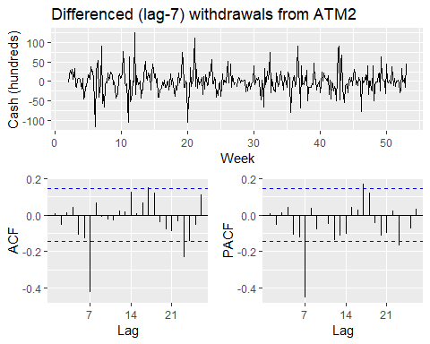

* The spikes in ACF & PACF in the non-differenced series at $k=2$& $k=5$ suggest $p,q∈[0,2,5]$. using the same aic function we can evaluate the minimum aic

# get optimal lambda for Box-cox transformation  
  
lambda_atm2 <- BoxCox.lambda(atm2_freq)  
  
# Evaluate aic  
  
aic_atm <- function(p, d, q, P, D, Q) {  
  
 # create model with Box-Cox and specified ARIMA parameters; extract AIC  
  
 AIC(Arima(atm2_freq, order = c(p, d, q), seasonal = c(P, D, Q), lambda = lambda_atm2))  
  
}  
  
# create possible combinations of p, q, P, Q except all zero  
  
expand.grid(p = c(0, 2, 5), q = c(0, 2, 5), P = 0:1, Q = 0:1) %>%  
  
 filter(p > 0 | q > 0 | P > 0 | Q > 0) %>%   
  
 # calculate AIC for models  
  
 mutate(aic = pmap_dbl(list(p, 0, q, P, 1, Q), aic_atm)) %>%   
  
 # return minimum AIC  
  
 slice(which.min(aic))

## p q P Q aic  
## 1 2 2 0 1 2323.517

* the model arima used is arima(5,0,5)(0,1,1). Let’s fit that model

fit_atm2<-Arima(atm2_freq, order = c(5, 0, 5), seasonal = c(0, 1, 1), lambda = lambda_atm2)  
summary(fit_atm2)

## Series: atm2_freq   
## ARIMA(5,0,5)(0,1,1)[7]   
## Box Cox transformation: lambda= 0.6584081   
##   
## Coefficients:  
## ar1 ar2 ar3 ar4 ar5 ma1 ma2 ma3  
## 0.2055 -0.1209 0.2260 0.3032 -0.4312 -0.1448 0.0114 -0.2213  
## s.e. 0.4529 0.4033 0.2176 0.2419 0.4136 0.4787 0.4200 0.2100  
## ma4 ma5 sma1  
## -0.2466 0.2470 -0.6905  
## s.e. 0.2463 0.4176 0.0595  
##   
## sigma^2 estimated as 37.91: log likelihood=-1152.1  
## AIC=2328.19 AICc=2329.1 BIC=2374.76  
##   
## Training set error measures:  
## ME RMSE MAE MPE MAPE MASE ACF1  
## Training set 0.2238867 23.87153 16.65107 -Inf Inf 0.8279025 -0.03050682

* Let’s evaluate the residual to check the validity of the model

Box.test(resid(fit_atm2), type = "L", fitdf = 11, lag = 14)

##   
## Box-Ljung test  
##   
## data: resid(fit_atm2)  
## X-squared = 2.1119, df = 3, p-value = 0.5495

ggtsdisplay(resid(fit_atm2), points = FALSE, plot.type = "histogram",  
  
 main = "Residuals for ARIMA(5,0,5)(0,1,1) of ATM2 withdrawals",  
  
 xlab = "Week", ylab = "Residual")

## Warning: Removed 1 rows containing non-finite values (stat_bin).

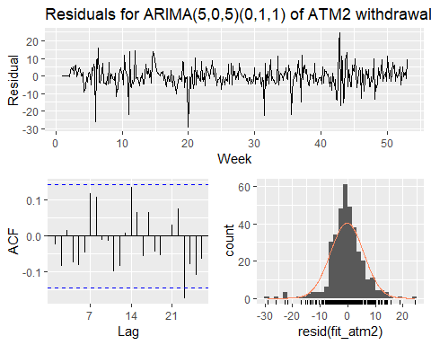

* P-value is greater than 0.05 and the residual appear to be normally distributed with a mean of 0. It can be used for forecast ATM2.

forecast_atm2<- forecast(fit_atm2, 31, level = 95)  
autoplot(forecast_atm2) +   
  
 labs(title = "ATM2: ARIMA(5,0,5)(0,1,1)", x = "Week", y = NULL) +  
  
 theme(legend.position = "none")

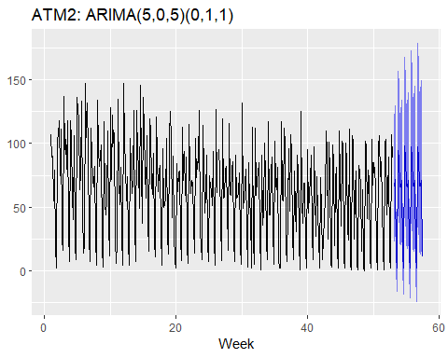

#### ATM4

* ATM4 has the same seasonality as ATM1 and ATM2. We will use the previous step to evaluate ATM4 model.

#Minimze the effect of the big withdraw in the day by using the median of the ATM4 dataset  
  
atm4_freq[which.max(atm4_freq)] <- median(atm4_freq, na.rm = TRUE)  
  
ggtsdisplay(atm4_freq, points = FALSE,  
  
 main = "Withdrawals from ATM4", xlab = "Week", ylab = "Cash (hundreds)")

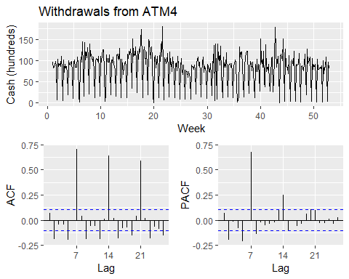

* We notice a difference lag of 7.

ggtsdisplay(diff(atm4_freq, 7), points = FALSE,  
  
 main = "Differenced (lag-7) withdrawals from ATM4",  
  
 xlab = "Week", ylab = "Cash (hundreds)")

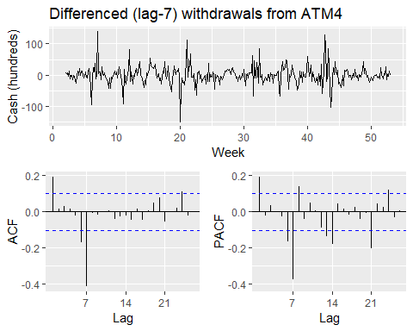

* ARIMA model for ATM4 will be evaluated.

# get optimal lambda for Box-cox transformation  
  
lambda_atm4 <- BoxCox.lambda(atm4_freq)  
  
aic_atm(0,2,5,0,2,5)

## [1] 2365.837

# create possible combinations of p, q, P, Q except all zero  
  
expand.grid(p = c(0, 2, 5), q = c(0, 2, 5), P = 0:1, Q = 0:1) %>%  
  
 filter(p > 0 | q > 0 | P > 0 | Q > 0) %>%   
  
 # calculate AIC for models  
  
 mutate(aic = pmap_dbl(list(p, 0, q, P, 1, Q), aic_atm)) %>%   
  
 # return minimum AIC  
  
 slice(which.min(aic))

## p q P Q aic  
## 1 2 2 0 1 2323.517

* Let’s fit the ARIMA model with the values (0,0,2)(0,1,1)

fit_atm4<-Arima(atm4_freq, order = c(0, 0, 2), seasonal = c(0, 1, 1), lambda = lambda_atm4)  
summary(fit_atm4)

## Series: atm4_freq   
## ARIMA(0,0,2)(0,1,1)[7]   
## Box Cox transformation: lambda= 0.2355973   
##   
## Coefficients:  
## ma1 ma2 sma1  
## 0.1094 -0.1089 -0.6468  
## s.e. 0.0524 0.0523 0.0422  
##   
## sigma^2 estimated as 1.467: log likelihood=-576.96  
## AIC=1161.92 AICc=1162.03 BIC=1177.44  
##   
## Training set error measures:  
## ME RMSE MAE MPE MAPE MASE  
## Training set 2.356651 24.88094 15.90136 -85.71176 104.5953 0.9023123  
## ACF1  
## Training set 0.02127326

* Let’s investigate the residuals using Ljung-box test

Box.test(resid(fit_atm4), type = "L", fitdf = 3, lag = 7)

##   
## Box-Ljung test  
##   
## data: resid(fit_atm4)  
## X-squared = 5.7899, df = 4, p-value = 0.2154

ggtsdisplay(resid(fit_atm4), points = FALSE, plot.type = "histogram",  
  
 main = "Residuals for ARIMA(0,0,2)(0,1,1) of ATM4 withdrawals",  
  
 xlab = "Week", ylab = "Residual")

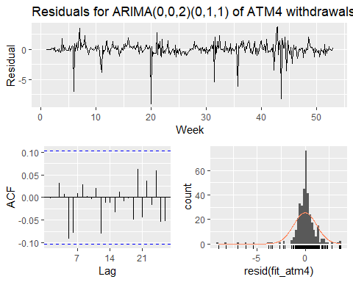

* It is normally distributed around a mean of 0.p-value is also greater than 0.05. We can use the model to forecast.

forecast_atm4<- forecast(fit_atm4, 31, level = 95)  
autoplot(forecast_atm4) +   
  
 labs(title = "ATM4: ARIMA(0,0,2)(0,1,1)", x = "Week", y = NULL) +  
  
 theme(legend.position = "none")

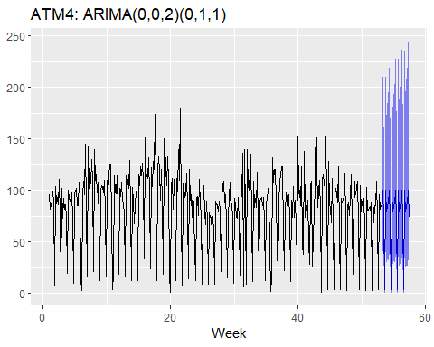

#### ATM3

* Since ATM3 contains limited data we will use the mean forecast method.

forecast_atm3 <- meanf(atm3, 31, level = 95)  
autoplot(forecast_atm3) +   
  
 labs(title = "ATM3: mean", x = "Day", y = NULL) +  
  
 theme(legend.position = "none")

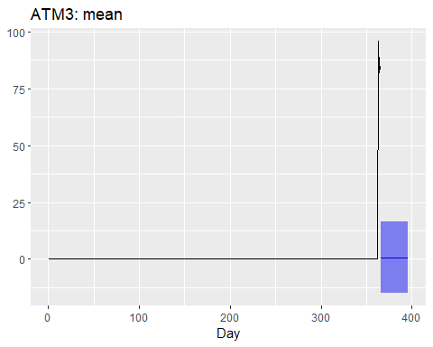

#### Writing the forecast to a CSV file

data_frame(DATE = rep(max(atm$DATE) + 1:31, 4),  
  
 atm = rep(names(atm)[-1], each = 31),  
  
 Cash = c(forecast_atm1$mean, forecast_atm2$mean,  
  
 forecast_atm3$mean, forecast_atm4$mean)) %>%   
  
 write_csv("project1_forecast_atm_1.csv")

## Warning: `data_frame()` is deprecated, use `tibble()`.  
## This warning is displayed once per session.

Data 624. Project 1: Part B

Angrand, Burke, Deboch, Groysman, Karr

October 22, 2019

### Part B - Forecasting Power, ResidentialCustomerForecastLoad-624.xlsx

**Data: ResidentialCustomerForecastLoad-624.xlsx**

Part B consists of a simple dataset of residential power usage for January 1998 until December 2013. Your assignment is to model these data and a monthly forecast for 2014. The data is given in a single file. The variable ‘KWH’ is power consumption in Kilowatt hours, the rest is straight forward. Add these to your existing files above - clearly labeled.

library(httr)  
library(xlsx)  
library(ggplot2)  
library(gridExtra)  
library(forecast)

**a.** Read in File

temp = tempfile(fileext = ".xlsx")  
dataURL <- "https://raw.githubusercontent.com/mburke65/CUNY_Data624/master/ProjectFolder/Provided_Files/ResidentialCustomerForecastLoad-624.xlsx"  
download.file(dataURL, destfile=temp, mode='wb')  
  
power.data <- readxl::read_excel(temp, sheet =1)

**b.** EDA Analysis

- Check/Fill in null values   
- Convert to time series  
- Graph the monthly data   
 - General plot & seasonal plot: seasonality can be observed in the below plot. There are spikes each year from May to August (air conditioning?) and again in December (holiday season?). There is a slight dip in Jul 2010 maybe due to an unseasonably cold month.  
 - Seasonal Box Plot: provides a similar visual to the seasonal plot with usage spikes in the summer months and December. IT also highlights the flucuations in consumption within each month.   
 - Decomposition components graph: this plot again shows that there is a general upwards trend in the data with an observed outlier in July 2010.

head(power.data)

## # A tibble: 6 x 3  
## CaseSequence `YYYY-MMM` KWH  
## <dbl> <chr> <dbl>  
## 1 733 1998-Jan 6862583  
## 2 734 1998-Feb 5838198  
## 3 735 1998-Mar 5420658  
## 4 736 1998-Apr 5010364  
## 5 737 1998-May 4665377  
## 6 738 1998-Jun 6467147

summary(power.data)

## CaseSequence YYYY-MMM KWH   
## Min. :733.0 Length:192 Min. : 770523   
## 1st Qu.:780.8 Class :character 1st Qu.: 5429912   
## Median :828.5 Mode :character Median : 6283324   
## Mean :828.5 Mean : 6502475   
## 3rd Qu.:876.2 3rd Qu.: 7620524   
## Max. :924.0 Max. :10655730   
## NA's :1

print(paste("Check for nulls: ",sum(is.na(power.data)), " Row of Nulls"))

## [1] "Check for nulls: 1 Row of Nulls"

power.data[is.na(power.data)] <- median(power.data$KWH,na.rm = TRUE)  
power.data.ts <-ts(power.data[,"KWH"],start = c(1998,1),frequency = 12)  
ggtsdisplay(power.data.ts, points = FALSE, plot.type = "histogram")

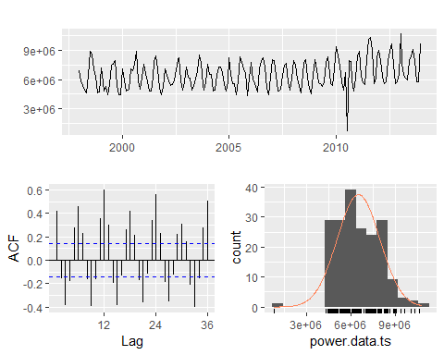

ggseasonplot(power.data.ts)

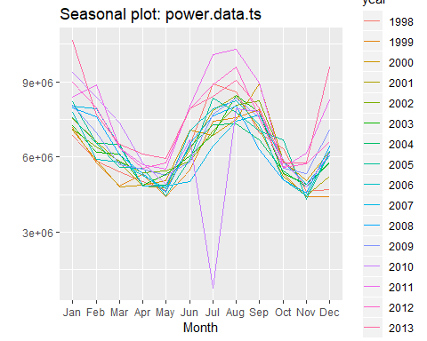

boxplot(power.data.ts~cycle(power.data.ts),xlab="Month", ylab = "Power Usage")

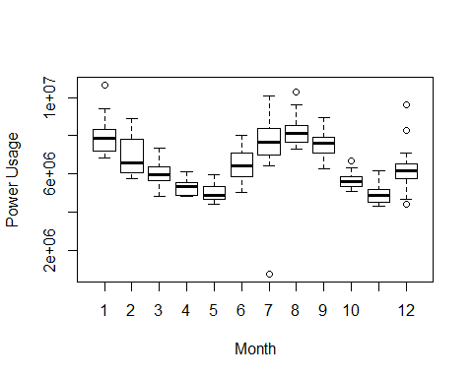

plot(decompose(power.data.ts))

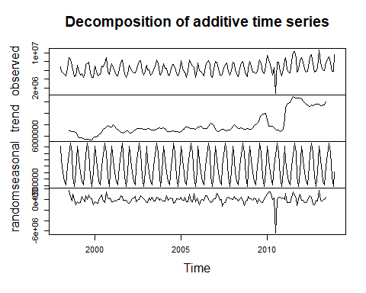

**C.** Model 1: Arima W/ Box-Cox Transformation

- Replace outlier with tsoutlier suggestion (utilizes a box-cox transformation)  
- Use an auto arima model on the box-cox adjusted data  
 - Suggested model: ARIMA(0,0,3)(2,1,0)[12] with drift. RSME(595389) & AICc (5332.67)  
- Check the residuals to make sure the model is satisfactory:   
 - ACF /PACF Plots: the residual appears normal residuals mostly around 0, suggesting stationarity of the residuals   
 - The Box Ljung tests presents a p-value of 0.6951 which indicates white noise  
- Forecast 2014 power values & plot forecasted values

#outlier detection/suggestion/replacement  
find.outlier<- tsoutliers(power.data.ts, iterate = 2, lambda = "auto")  
power.data.ts.bc<- power.data.ts  
power.data.ts.bc[find.outlier$`index`[1]] <- find.outlier$replacements[1]  
print(paste("Suggested/Implemented Change for Outlier: ",power.data.ts.bc[151], " Original Value",power.data.ts[151]))

## [1] "Suggested/Implemented Change for Outlier: 7757388.48810024 Original Value 770523"

#auto arima model  
power.model <- auto.arima(power.data.ts.bc, seasonal = TRUE, stepwise = FALSE)  
summary.arima<- summary(power.model)

## Series: power.data.ts.bc   
## ARIMA(0,0,3)(2,1,0)[12] with drift   
##   
## Coefficients:  
## ma1 ma2 ma3 sar1 sar2 drift  
## 0.3492 0.0587 0.2303 -0.7222 -0.4251 9027.233  
## s.e. 0.0788 0.0892 0.0741 0.0765 0.0784 3057.838  
##   
## sigma^2 estimated as 3.912e+11: log likelihood=-2659.01  
## AIC=5332.02 AICc=5332.67 BIC=5354.37  
##   
## Training set error measures:  
## ME RMSE MAE MPE MAPE MASE  
## Training set -8181.906 595389 434520.9 -0.8060555 6.610412 0.6977491  
## ACF1  
## Training set -0.01026567

summary.arima

## ME RMSE MAE MPE MAPE MASE  
## Training set -8181.906 595389 434520.9 -0.8060555 6.610412 0.6977491  
## ACF1  
## Training set -0.01026567

#check residuals  
checkresiduals(power.model)

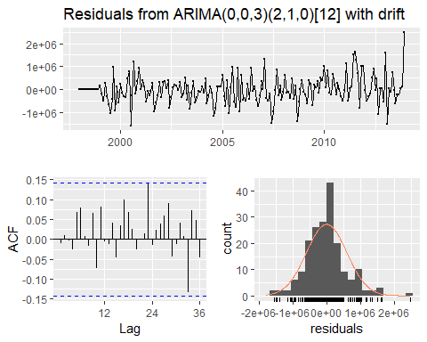

##   
## Ljung-Box test  
##   
## data: Residuals from ARIMA(0,0,3)(2,1,0)[12] with drift  
## Q* = 14.513, df = 18, p-value = 0.6951  
##   
## Model df: 6. Total lags used: 24

#forecast model @ 95%  
forecast.power <- forecast(power.model, level = c(95), h =12)  
forecast.power

## Point Forecast Lo 95 Hi 95  
## Jan 2014 10312755 9086940 11538570  
## Feb 2014 8685531 7387130 9983933  
## Mar 2014 7203085 5902687 8503482  
## Apr 2014 6000251 4669575 7330927  
## May 2014 5941905 4611229 7272581  
## Jun 2014 8204931 6874255 9535607  
## Jul 2014 9501418 8170742 10832094  
## Aug 2014 9992966 8662290 11323642  
## Sep 2014 8493959 7163283 9824635  
## Oct 2014 5871672 4540996 7202348  
## Nov 2014 6154352 4823676 7485028  
## Dec 2014 8381806 7051130 9712482

autoplot(forecast.power)

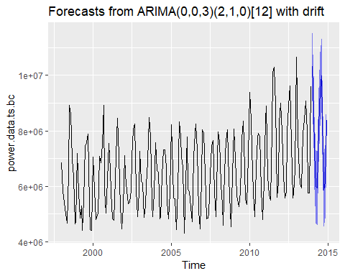

**D.** Model 2: ETS W/ Box-Cox Transformation

- The ets function automatically selects the best method for forecasting data. the ets function selected ETS(M,N,M) exponential smoothing:  
 - The first letter denotes the error type: multiplicative errors  
 - The second letter denotes the trend type: no trend  
 - The third letter denotes the season type: multiplicative seasonality  
- Utilize the transformed data & ETS model  
- Model Results: RMSE (630869.7) & AICc (6148.032)  
- Check the residuals to make sure the model is satisfactory:   
 - ACF /PACF Plots: the residual appears normal residuals mostly around 0, suggesting stationarity of the residuals   
 - The Box Ljung tests presents a p-value of 0.0002921 which may indicate that there's dependency issues with the lags

#model w/ previously transformed data  
power.model.ets <- ets(power.data.ts.bc)  
summary.ets<- summary(power.model.ets)

## ETS(M,N,M)   
##   
## Call:  
## ets(y = power.data.ts.bc)   
##   
## Smoothing parameters:  
## alpha = 0.1206   
## gamma = 0.203   
##   
## Initial states:  
## l = 6188160.6435   
## s = 0.9017 0.755 0.9295 1.223 1.2676 1.2298  
## 1.0165 0.7614 0.8029 0.8903 1.029 1.1935  
##   
## sigma: 0.0971  
##   
## AIC AICc BIC   
## 6145.305 6148.032 6194.167   
##   
## Training set error measures:  
## ME RMSE MAE MPE MAPE MASE  
## Training set 51458.11 630869.7 482886.1 0.04287257 7.292037 0.7754135  
## ACF1  
## Training set 0.2096574

summary.ets

## ME RMSE MAE MPE MAPE MASE  
## Training set 51458.11 630869.7 482886.1 0.04287257 7.292037 0.7754135  
## ACF1  
## Training set 0.2096574

#check residuals  
checkresiduals(power.model.ets)

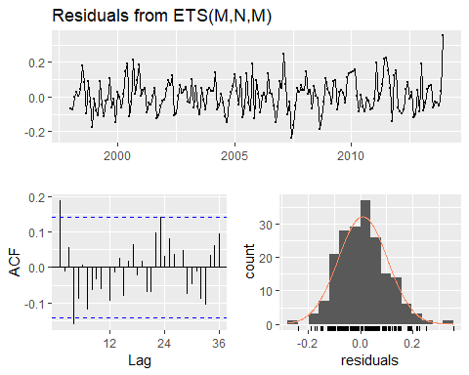

##   
## Ljung-Box test  
##   
## data: Residuals from ETS(M,N,M)  
## Q* = 32.819, df = 10, p-value = 0.0002921  
##   
## Model df: 14. Total lags used: 24

#forecast model @ 95%  
forecast.power.ets <- forecast(power.model.ets, level = c(95), h =12)  
forecast.power.ets

## Point Forecast Lo 95 Hi 95  
## Jan 2014 9825114 7955694 11694534  
## Feb 2014 8460361 6838842 10081879  
## Mar 2014 6974291 5627960 8320623  
## Apr 2014 6167737 4968643 7366830  
## May 2014 5886368 4733958 7038779  
## Jun 2014 7783200 6248904 9317496  
## Jul 2014 9070884 7270556 10871212  
## Aug 2014 9599368 7681334 11517403  
## Sep 2014 8501578 6791613 10211542  
## Oct 2014 6241977 4978271 7505684  
## Nov 2014 5885873 4686553 7085194  
## Dec 2014 7933193 6306380 9560005

autoplot(forecast.power.ets)

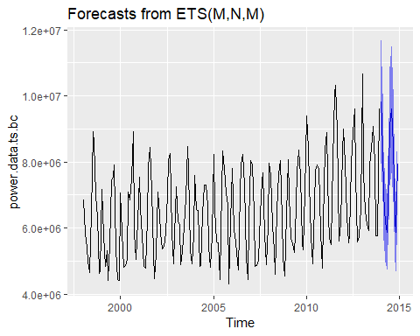

**E.** Model 3: STLF

- STLF model will be the third model as it provides the user more control and can be robust when dealing with outliers. the STLF utilizes a local weighted regression to fit the points (Loess smoothing) and forecast future values.  
- Model summary: RMSE (843670.1) & AICc (6255.445)  
- Check residuals:   
 - ACF/PACF: most lags are within the error bounds, suggesting stationarity of the residuals   
 - Box Ljung:p-value = 0.1457 which indicates white noise  
- Forecast 2014 power values & plot forecasted values

power.model.stl <- stlf(power.data.ts, s.window='periodic', robust=TRUE)   
summary.stl<- summary(power.model.stl)

##   
## Forecast method: STL + ETS(A,N,N)  
##   
## Model Information:  
## ETS(A,N,N)   
##   
## Call:  
## ets(y = x, model = etsmodel, allow.multiplicative.trend = allow.multiplicative.trend)   
##   
## Smoothing parameters:  
## alpha = 0.0892   
##   
## Initial states:  
## l = 6317161.2015   
##   
## sigma: 848098.8  
##   
## AIC AICc BIC   
## 6255.318 6255.445 6265.090   
##   
## Error measures:  
## ME RMSE MAE MPE MAPE MASE  
## Training set 69834.05 843670.1 512067.7 -4.243142 12.03155 0.7316422  
## ACF1  
## Training set 0.209786  
##   
## Forecasts:  
## Point Forecast Lo 80 Hi 80 Lo 95 Hi 95  
## Jan 2014 8919230 7832347 10006112 7256987 10581473  
## Feb 2014 7833393 6742199 8924586 6164556 9502230  
## Mar 2014 7005154 5909665 8100642 5329749 8680558  
## Apr 2014 6358706 5258940 7458473 4676759 8040654  
## May 2014 6086344 4982317 7190371 4397880 7774808  
## Jun 2014 7653295 6545023 8761567 5958339 9348251  
## Jul 2014 8801193 7688692 9913693 7099770 10502616  
## Aug 2014 9301580 8184867 10418293 7593714 11009445  
## Sep 2014 8524478 7403568 9645387 6810194 10238761  
## Oct 2014 6593256 5468165 7718347 4872577 8313934  
## Nov 2014 5961092 4831835 7090349 4234043 7688141  
## Dec 2014 7113767 5980360 8247174 5380371 8847164  
## Jan 2015 8919230 7781688 10056772 7179509 10658950  
## Feb 2015 7833393 6691730 8975055 6087371 9579415  
## Mar 2015 7005154 5859386 8150921 5252853 8757454  
## Apr 2015 6358706 5208848 7508565 4600150 8117263  
## May 2015 6086344 4932409 7240279 4321553 7851135  
## Jun 2015 7653295 6495299 8811292 5882292 9424298  
## Jul 2015 8801193 7639149 9963237 7023999 10578386  
## Aug 2015 9301580 8135502 10467658 7518218 11084942  
## Sep 2015 8524478 7354380 9694575 6734968 10313987  
## Oct 2015 6593256 5419152 7767359 4797619 8388892  
## Nov 2015 5961092 4782996 7139188 4159350 7762834  
## Dec 2015 7113767 5931693 8295842 5305940 8921594

summary.stl

## Point Forecast Lo 80 Hi 80 Lo 95 Hi 95  
## Jan 2014 8919230 7832347 10006112 7256987 10581473  
## Feb 2014 7833393 6742199 8924586 6164556 9502230  
## Mar 2014 7005154 5909665 8100642 5329749 8680558  
## Apr 2014 6358706 5258940 7458473 4676759 8040654  
## May 2014 6086344 4982317 7190371 4397880 7774808  
## Jun 2014 7653295 6545023 8761567 5958339 9348251  
## Jul 2014 8801193 7688692 9913693 7099770 10502616  
## Aug 2014 9301580 8184867 10418293 7593714 11009445  
## Sep 2014 8524478 7403568 9645387 6810194 10238761  
## Oct 2014 6593256 5468165 7718347 4872577 8313934  
## Nov 2014 5961092 4831835 7090349 4234043 7688141  
## Dec 2014 7113767 5980360 8247174 5380371 8847164  
## Jan 2015 8919230 7781688 10056772 7179509 10658950  
## Feb 2015 7833393 6691730 8975055 6087371 9579415  
## Mar 2015 7005154 5859386 8150921 5252853 8757454  
## Apr 2015 6358706 5208848 7508565 4600150 8117263  
## May 2015 6086344 4932409 7240279 4321553 7851135  
## Jun 2015 7653295 6495299 8811292 5882292 9424298  
## Jul 2015 8801193 7639149 9963237 7023999 10578386  
## Aug 2015 9301580 8135502 10467658 7518218 11084942  
## Sep 2015 8524478 7354380 9694575 6734968 10313987  
## Oct 2015 6593256 5419152 7767359 4797619 8388892  
## Nov 2015 5961092 4782996 7139188 4159350 7762834  
## Dec 2015 7113767 5931693 8295842 5305940 8921594

power.model.stl<- forecast(power.model.stl)  
autoplot(power.model.stl, 12)

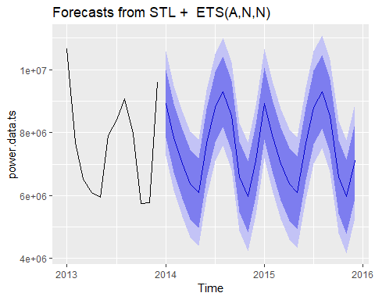

checkresiduals(power.model.stl)

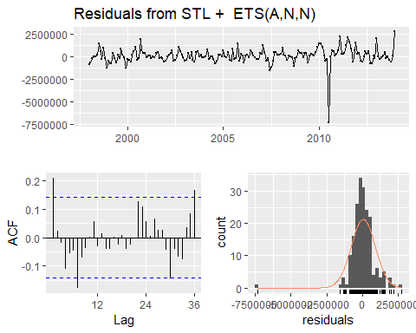

##   
## Ljung-Box test  
##   
## data: Residuals from STL + ETS(A,N,N)  
## Q* = 28.969, df = 22, p-value = 0.1457  
##   
## Model df: 2. Total lags used: 24

**F.** Compare Model Results/Export Data

- After comparing the RMSE of in the accuracy test, the ARIMA model will be used as the final model due to the lower RSME and better prediction capabilities. The ARIMA model also has the lowest AICc score and best score from the Box Ljung tests.

rmse.list <- data.frame(list(accuracy(power.model)[2], accuracy(power.model.ets)[2], accuracy(power.model.stl)[2]))  
names(rmse.list)<- list('Arima', 'ETS','STL')  
rmse.list

## Arima ETS STL  
## 1 595389 630869.7 843670.1

**G.** Send Results to excel

- Send to a .csv file, will manually merge into the project's consolidated file for project submission

write.csv(forecast.power,"Power_Forecasts_ARIMA.csv")

Data 624. Project 1: Part C

Team 1. Angrand, Burke, Deboch, Groysman, Karr

10/22/2019

## Part C – Waterflow_Pipe1.xlsx and Waterflow_Pipe2.xlsx

Part C consists of two data sets. These are simple 2 columns sets, however they have different time stamps. Your optional assignment is to time-base sequence the data and aggregate based on hour (example of what this looks like, follows). Note for multiple recordings within an hour, take the mean. Then to test appropriate assumptions and forecast a week forward with confidence bands (80 and 95%). Add these to your existing files above – clearly labeled.

### Step 1. Load Libraries

library(forecast)  
  
library(ggplot2)  
  
library(Hmisc)  
  
library(lubridate)  
  
library(fma)  
  
library(readxl)  
  
library(knitr)  
  
library(seasonal)  
  
library(openxlsx)

### Step 2. Read in 2 Excel files

mdata1 <- read_excel("Waterflow_Pipe1.xlsx")  
  
mdata2 <- read_excel("Waterflow_Pipe2.xlsx")

### Step 3. Exploratory Analysis.

Let’s see domensions, top/bottom records, data types

dim(mdata1)

## [1] 1000 2

str(mdata1)

## Classes 'tbl_df', 'tbl' and 'data.frame': 1000 obs. of 2 variables:  
## $ DateTime : POSIXct, format: "2015-10-23 00:24:06" "2015-10-23 00:40:02" ...  
## $ WaterFlow: num 23.4 28 23.1 30 6 ...

kable(summary(mdata1))

|  |  |  |
| --- | --- | --- |
|  | DateTime | WaterFlow |
|  | Min. :2015-10-23 00:24:06 | Min. : 1.067 |
|  | 1st Qu.:2015-10-25 11:21:35 | 1st Qu.:13.683 |
|  | Median :2015-10-27 20:07:30 | Median :19.880 |
|  | Mean :2015-10-27 20:49:15 | Mean :19.897 |
|  | 3rd Qu.:2015-10-30 08:24:51 | 3rd Qu.:26.159 |
|  | Max. :2015-11-01 23:35:43 | Max. :38.913 |

head(mdata1)

## # A tibble: 6 x 2  
## DateTime WaterFlow  
## <dttm> <dbl>  
## 1 2015-10-23 00:24:06 23.4   
## 2 2015-10-23 00:40:02 28.0   
## 3 2015-10-23 00:53:51 23.1   
## 4 2015-10-23 00:55:40 30.0   
## 5 2015-10-23 01:19:17 6.00  
## 6 2015-10-23 01:23:58 15.9

tail(mdata1)

## # A tibble: 6 x 2  
## DateTime WaterFlow  
## <dttm> <dbl>  
## 1 2015-11-01 22:09:14 15.3  
## 2 2015-11-01 22:09:18 26.3  
## 3 2015-11-01 22:25:31 29.1  
## 4 2015-11-01 23:08:20 22.8  
## 5 2015-11-01 23:34:10 16.2  
## 6 2015-11-01 23:35:43 21.2

dim(mdata2)

## [1] 1000 2

str(mdata2)

## Classes 'tbl_df', 'tbl' and 'data.frame': 1000 obs. of 2 variables:  
## $ DateTime : POSIXct, format: "2015-10-23 01:00:00" "2015-10-23 02:00:00" ...  
## $ WaterFlow: num 18.8 43.1 38 36.1 31.9 ...

summary(mdata2)

## DateTime WaterFlow   
## Min. :2015-10-23 01:00:00 Min. : 1.885   
## 1st Qu.:2015-11-02 10:45:00 1st Qu.:28.140   
## Median :2015-11-12 20:30:00 Median :39.682   
## Mean :2015-11-12 20:30:00 Mean :39.556   
## 3rd Qu.:2015-11-23 06:15:00 3rd Qu.:50.782   
## Max. :2015-12-03 16:00:00 Max. :78.303

head(mdata2)

## # A tibble: 6 x 2  
## DateTime WaterFlow  
## <dttm> <dbl>  
## 1 2015-10-23 01:00:00 18.8  
## 2 2015-10-23 02:00:00 43.1  
## 3 2015-10-23 03:00:00 38.0  
## 4 2015-10-23 04:00:00 36.1  
## 5 2015-10-23 05:00:00 31.9  
## 6 2015-10-23 06:00:00 28.2

tail(mdata2)

## # A tibble: 6 x 2  
## DateTime WaterFlow  
## <dttm> <dbl>  
## 1 2015-12-03 11:00:00 73.0  
## 2 2015-12-03 12:00:00 31.5  
## 3 2015-12-03 13:00:00 66.8  
## 4 2015-12-03 14:00:00 42.9  
## 5 2015-12-03 15:00:00 33.4  
## 6 2015-12-03 16:00:00 66.7

Some basis scatter plots of our data.

plot(mdata1$DateTime, mdata1$WaterFlow, main="Water Flow - Pipe 1",  
 xlab= "DateTime", ylab="WaterFlow ", pch=19)

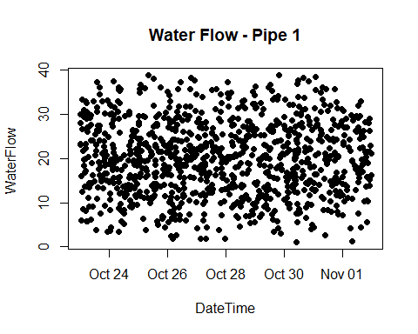

plot(mdata2$DateTime, mdata2$WaterFlow, main="Water Flow - Pipe 2",  
 xlab="DateTime", ylab="WaterFlow ", pch=19)

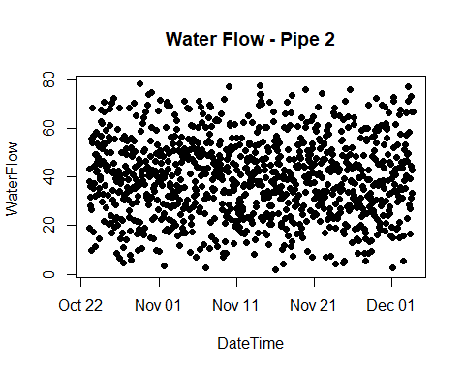

### Step 4. Data Cleaning.

Let’s get the first dataset in the right format. One record per an hour.

mdata1$WFp<-Lag(mdata1$WaterFlow,shift=1)  
  
mdata1$DateTimep<-Lag(mdata1$DateTime)  
  
#mydata1$myhour<-hour(mdata1$DateTime)  
  
  
  
mdata1$mhour<-hour(mdata1$DateTime)  
  
mdata1$mhourp<-hour(mdata1$DateTimep)  
  
mdata1$WaterFlowN<-ifelse(mdata1$mhour!=mdata1$mhourp,(mdata1$WaterFlow+mdata1$WFp)/2,NA)  
  
  
mdata1N<-mdata1[complete.cases(mdata1), ]  
  
  
  
mdata1N$DateTimeN<-floor_date(mdata1N$DateTime,"hour")  
  
mdata1N<-mdata1N[,c(8,7)]

Let’s see domensions, top and bottom records, and a plot of transformed data.

dim(mdata1N)

## [1] 235 2

head(mdata1N)

## # A tibble: 6 x 2  
## DateTimeN WaterFlowN  
## <dttm> <dbl>  
## 1 2015-10-23 01:00:00 18.0  
## 2 2015-10-23 02:00:00 17.1  
## 3 2015-10-23 03:00:00 18.9  
## 4 2015-10-23 04:00:00 15.3  
## 5 2015-10-23 05:00:00 20.3  
## 6 2015-10-23 06:00:00 29.6

tail(mdata1N)

## # A tibble: 6 x 2  
## DateTimeN WaterFlowN  
## <dttm> <dbl>  
## 1 2015-11-01 18:00:00 18.3  
## 2 2015-11-01 19:00:00 17.7  
## 3 2015-11-01 20:00:00 19.7  
## 4 2015-11-01 21:00:00 14.6  
## 5 2015-11-01 22:00:00 21.0  
## 6 2015-11-01 23:00:00 26.0

plot(mdata1N$DateTimeN, mdata1N$WaterFlowN, main="Water Flow - Pipe 1",  
 xlab= "DateTime", ylab="WaterFlow ", pch=19)

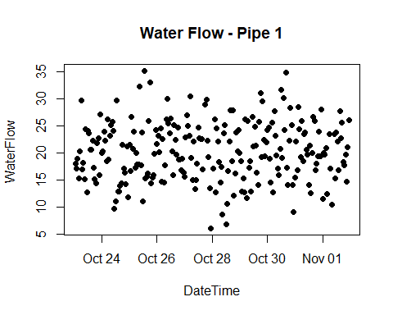

Fixing missing data (4 records were missing), taking into account time zone and daylight saving time.

#4 hour difference  
  
nr1<-data.frame(as.POSIXct("2015-10-27 17:00:00 -0400"),28.944308)  
names(nr1)<-c("DateTimeN","WaterFlowN")  
nr1

## DateTimeN WaterFlowN  
## 1 2015-10-27 17:00:00 28.94431

mdata1N <- rbind(mdata1N, nr1)  
  
#4 hour difference  
nr2<-data.frame(as.POSIXct("2015-11-01 01:00:00 -0400"),19.998079)  
names(nr2)<-c("DateTimeN","WaterFlowN")  
  
#4 hour difference  
nr2<-data.frame(as.POSIXct("2015-10-28 00:00:00 -0400"),17.089225)  
names(nr2)<-c("DateTimeN","WaterFlowN")  
  
mdata1N <- rbind(mdata1N, nr2)  
#5 hour difference - time change  
nr3<-data.frame(as.POSIXct("2015-11-01 08:00:00 -0500"),23.474922)  
names(nr3)<-c("DateTimeN","WaterFlowN")  
  
  
mdata1N <- rbind(mdata1N, nr3)  
  
  
mdata1N1 <- mdata1N[order(mdata1N$DateTimeN),]

### Step 5. Converting data into time series.

Our first dataset only covers time period from 10/23/2019, 1AM to 11/1/2019 11PM, while the second dataset covers from 10/23/2019, 1AM to 12/3/2019, 4PM. We are required to forecast one week of data flow for both pipes. So, the correct way would be to predict one week from the earliest data set, or from 11/1/2019, 11PM. For that time period, we only need to forecast first dataset and for the second we have actual data.

ts1<-ts(mdata1N1$WaterFlowN,start=c(2015,10,23,1),freq=24)

autoplot(ts1) +  
 ggtitle("Water Flow - Pipe 1") +  
 xlab("Hour") +  
 ylab("Water Flow")

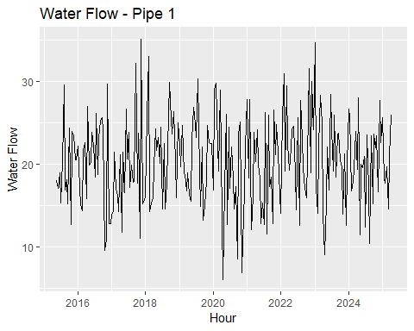

#ts2<-ts(mdata2$WaterFlow,start=c(2015,10,23,1),freq=24*365)  
  
#ts2  
  
#autoplot(ts2) +  
# ggtitle("Water Flow - Pipe 2") +  
# xlab("Hour") +  
# ylab("Water Flow")  
  
#mdataM=merge(x = mdata1N1, y = mdata2, by.x = "DateTimeN", by.y="DateTime")  
  
#dim(mdataM)  
  
#dim(mdataM)  
  
#mdataM$WaterFlowC<-mdataM$WaterFlowN+mdataM$WaterFlow  
  
#mdataM<-mdataM[,c(1,4)]  
  
#mdataM  
  
#strftime(mdataM$DateTimeN,"%Y-%m-%d %H:%M:%S %z")  
  
#ts3<-ts(mdataM$WaterFlowC,start=c(2015,10,23,2),freq=24)  
  
#autoplot(ts3) +  
# ggtitle("Water Flow - Pipe 1 and 2") +  
# xlab("Hour") +  
# ylab("Water Flow")

### Step 6. Looking at seasonality and trend.

Maximum value

which.max(ts1)/24

## [1] 2.541667

The spike in water flow was on 3 day, we can see on the graph.

ggseasonplot(ts1)

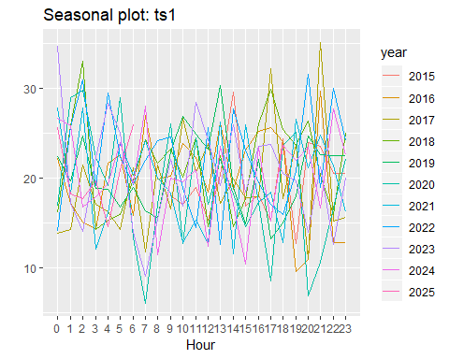

No clear patern in water use by time of day. Even though, more water seems to be used in late hours.

ggsubseriesplot(ts1)

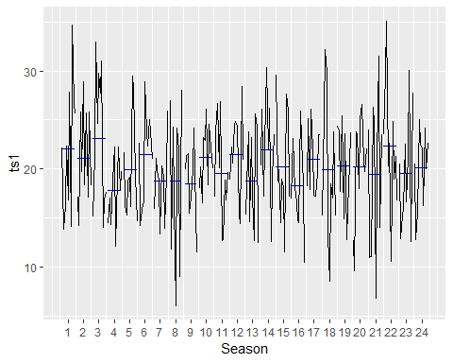

No clear picture. But the top hours were evening and night. The lowest water use was in mornings.

gglagplot(ts1)

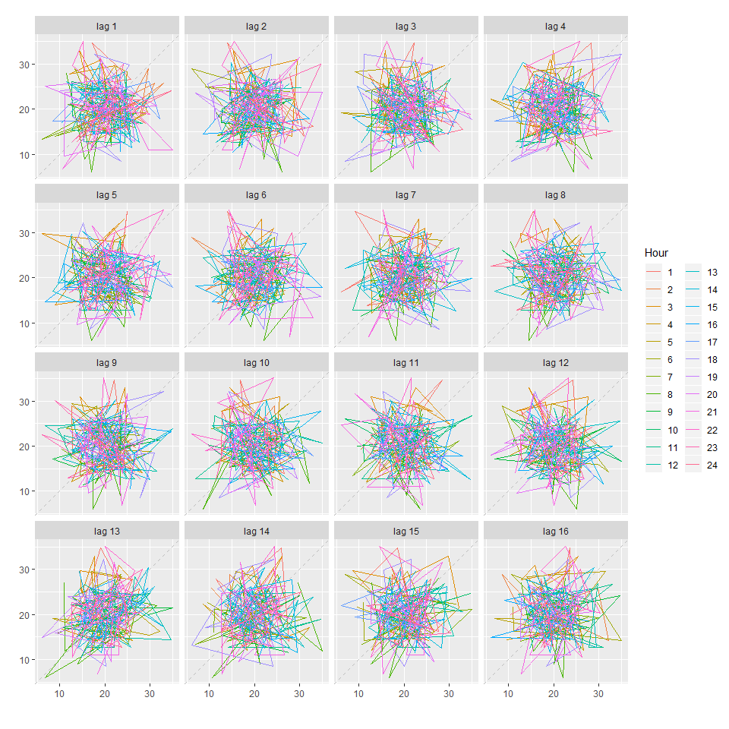

ggAcf(ts1, lag=24)

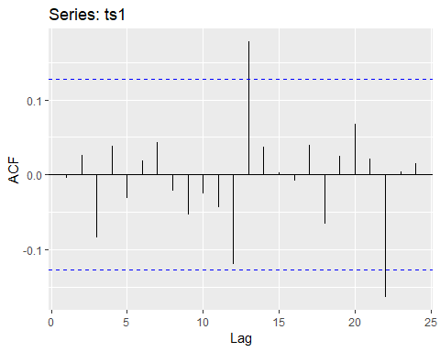

Again no clear pattern

### Step 8. Applying decomposition.

ts_decomp<-decompose(ts1,type="multiplicative")

autoplot(ts_decomp) +  
 ggtitle("Hourly water flow - 10 days time period - Multiplicative Decomposition") +  
 xlab("Hourly")

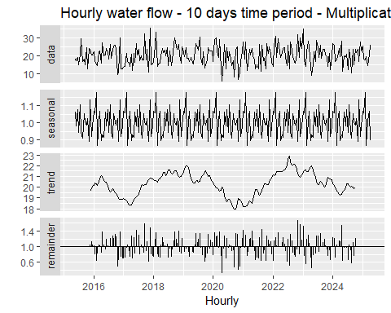

There is some type of sesonality - pattern repeats daily. But no clear trend.

Seasonaly adjusted data

adjust_ts<-ts1/ts_decomp$seasonal  
  
autoplot(adjust_ts) +  
 ggtitle("Hourly water flow - 10 days - Seasonally Adjusted") +  
 xlab("Hourly")

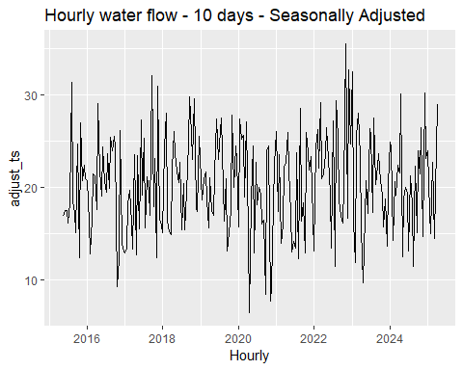

fit <- stl(ts1, t.window=13, s.window="periodic",  
 robust=TRUE)  
  
fit1<-fit %>% seasadj() %>% naive()  
   
fit1%>%autoplot() + ylab("New orders index") +  
 ggtitle("Naive forecasts of seasonally adjusted data")

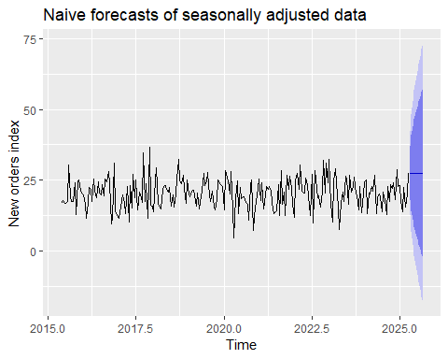

fit2<-fit %>% forecast(method="naive")   
  
fit2%>%autoplot() + ylab("New orders index")

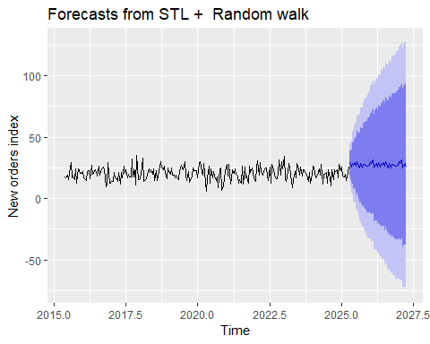

fcast <- stlf(ts1, method='naive')

### Step 9. Exponential Forecasting.

Simple exponential forecast.

fc <- ses(ts1, h=24*7)  
# Accuracy of one-step-ahead training errors  
round(accuracy(fc),2)

## ME RMSE MAE MPE MAPE MASE ACF1  
## Training set 0 5.37 4.4 -8.68 25.25 0.71 0

autoplot(fc) +  
 autolayer(fitted(fc), series="Fitted") +  
 ylab("Water Flow - Pipes 1") + xlab("Hours")

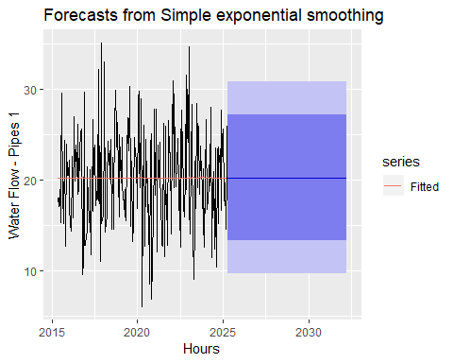

fc <- holt(ts1, h=24*7)  
  
fc2 <- holt(ts1, damped=TRUE, phi = 0.9, h=24*7)  
autoplot(ts1) +  
 autolayer(fc, series="Holt's method", PI=FALSE) +  
 autolayer(fc2, series="Damped Holt's method", PI=FALSE) +  
 ggtitle("Forecasts from Holt's method") + xlab("Hours") +  
 ylab("Water Flow)") +  
 guides(colour=guide_legend(title="Forecast"))

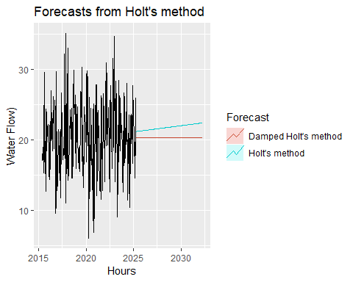

e1 <- tsCV(ts1, ses, h=1)  
e2 <- tsCV(ts1, holt, h=1)  
e3 <- tsCV(ts1, holt, damped=TRUE, h=1)  
mean(e1^2, na.rm=TRUE)

## [1] 29.51763

mean(e2^2, na.rm=TRUE)

## [1] 33.01115

mean(e3^2, na.rm=TRUE)

## [1] 31.76159

mean(abs(e1), na.rm=TRUE)

## [1] 4.435647

mean(abs(e2), na.rm=TRUE)

## [1] 4.668705

mean(abs(e3), na.rm=TRUE)

## [1] 4.561972

The simple exponential forecast appears to be the best.

fit1 <- hw(ts1,seasonal="additive")  
fit2 <- hw(ts1,seasonal="multiplicative")  
autoplot(ts1) +  
 autolayer(fit1, series="HW additive forecasts", PI=FALSE) +  
 autolayer(fit2, series="HW multiplicative forecasts",  
 PI=FALSE) +  
 xlab("Hours") +  
 ggtitle("Water flow - Pipe 1") +  
 guides(colour=guide_legend(title="Forecast"))

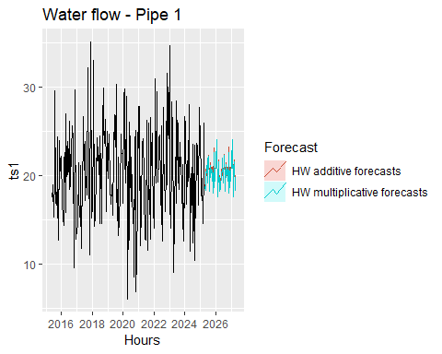

### Step 9. Selecting Forecasting Method.

fit<-ets(ts1)  
  
summary(fit)

## ETS(A,N,N)   
##   
## Call:  
## ets(y = ts1)   
##   
## Smoothing parameters:  
## alpha = 1e-04   
##   
## Initial states:  
## l = 20.2605   
##   
## sigma: 5.3919  
##   
## AIC AICc BIC   
## 2108.400 2108.502 2118.817   
##   
## Training set error measures:  
## ME RMSE MAE MPE MAPE MASE  
## Training set 0.001743637 5.369158 4.397655 -8.679627 25.24513 0.7132159  
## ACF1  
## Training set -0.004125927

Model selected is A and N and N

autoplot(fit)

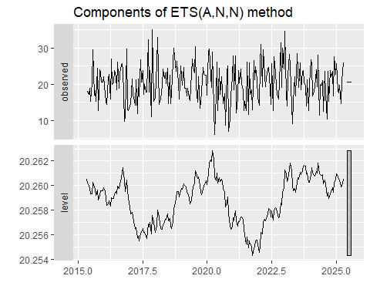

cbind('Residuals' = residuals(fit),  
 'Forecast errors' = residuals(fit,type='response')) %>%  
 autoplot(facet=TRUE) + xlab("Hours") + ylab("")

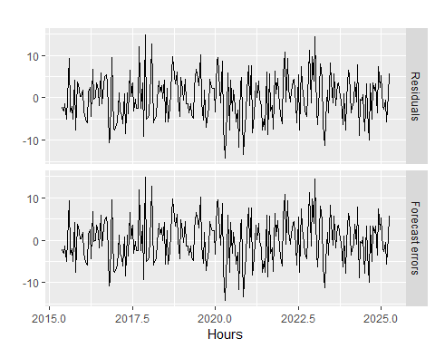

fit1 <- fit%>%forecast(h=24*7,level=c(80,95))   
  
fit1%>%  
 autoplot() +  
 ylab("Water flow - pipe 1 - 7 days forecast")

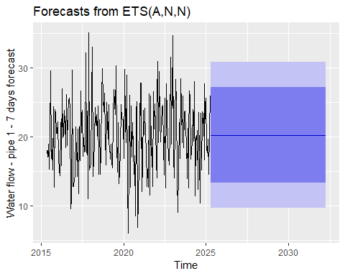

### Step 10. Preparing the final file to be ouputed in the Excel

mdata1A<-mdata2[240:(239+24*7),]  
  
fdata<-cbind(fit1,mdata1A)  
  
#write.xlsx(fdata, "fdata.xlsx")