Data 624: Project 1: Part A

Angrand, Burke, Deboch, Groysman, Karr

October 22, 2019

### Part A - ATM Forecast, ATM624Data.xlsx

**Data: ATM624Data.xlsx**

In part A, I want you to forecast how much cash is taken out of 4 different ATM machines for May 2010. The data is given in a single file. The variable ‘Cash’ is provided in hundreds of dollars, other than that it is straight forward. I am being somewhat ambiguous on purpose. I am giving you data, please provide your written report on your findings, visuals, discussion and your R code all within a Word readable document, except the forecast which you will put in an Excel readable file. I must be able to cut and paste your R code and run it in R studio. Your report must be professional - most of all - readable, EASY to follow. Let me know what you are thinking, assumptions you are making! Your forecast is a simple CSV or Excel file that MATCHES the format of the data I provide.

#Upload library  
library(tidyverse)  
library(readxl)  
library(fpp2)  
library(forecast)

Read in File/EDA/Data Adjustments

* drop nulls
* restructure dataset
* convert to time series object
* plot time series object for each ATM

temp = tempfile(fileext = ".xlsx")  
dataURL <- "https://raw.githubusercontent.com/mburke65/CUNY_Data624/master/ProjectFolder/Provided_Files/ATM624Data.xlsx"  
download.file(dataURL, destfile=temp, mode='wb')  
  
atm <- readxl::read_excel(temp, sheet =1)  
  
head(atm,5)

## # A tibble: 5 x 3  
## DATE ATM Cash  
## <dttm> <chr> <dbl>  
## 1 2009-05-01 00:00:00 ATM1 96  
## 2 2009-05-01 00:00:00 ATM2 107  
## 3 2009-05-02 00:00:00 ATM1 82  
## 4 2009-05-02 00:00:00 ATM2 89  
## 5 2009-05-03 00:00:00 ATM1 85

#Drop null values  
atm<-atm %>%  
 drop_na()

#Convert each ATM to Column  
atm<- atm %>%  
 spread(ATM,Cash)  
head(atm,5)

## # A tibble: 5 x 5  
## DATE ATM1 ATM2 ATM3 ATM4  
## <dttm> <dbl> <dbl> <dbl> <dbl>  
## 1 2009-05-01 00:00:00 96 107 0 96  
## 2 2009-05-02 00:00:00 82 89 0 82  
## 3 2009-05-03 00:00:00 85 90 0 85  
## 4 2009-05-04 00:00:00 90 55 0 90  
## 5 2009-05-05 00:00:00 99 79 0 99

#Fix the date column  
atm <- atm %>%  
 mutate(DATE =as.Date(DATE))  
head(atm)

## # A tibble: 6 x 5  
## DATE ATM1 ATM2 ATM3 ATM4  
## <date> <dbl> <dbl> <dbl> <dbl>  
## 1 2009-05-01 96 107 0 96  
## 2 2009-05-02 82 89 0 82  
## 3 2009-05-03 85 90 0 85  
## 4 2009-05-04 90 55 0 90  
## 5 2009-05-05 99 79 0 99  
## 6 2009-05-06 88 19 0 88

#Convert to a time series  
ts_atm <- ts(atm %>% select(-DATE))  
  
head(ts_atm)

## Time Series:  
## Start = 1   
## End = 6   
## Frequency = 1   
## ATM1 ATM2 ATM3 ATM4  
## 1 96 107 0 96  
## 2 82 89 0 82  
## 3 85 90 0 85  
## 4 90 55 0 90  
## 5 99 79 0 99  
## 6 88 19 0 88

* ATM1, ATM2, and ATM4 are a big deal of variation. buT ATM3 shows no cash withdrawn for most of the year. One assumption we can do about ATM3 is that it has just opened. we will use the entire time series of ATM1 and ATM2. ATM3 will be used to forecast future prediction.

#Separate each ATM from the dataset and graph each dataset  
atm1<-ts_atm[,"ATM1"]  
autoplot(atm1) +  
 labs(title ="Cash Withdrawn from ATM1", x="Day") +  
 scale_y_continuous("Cash withdrawns in hundreds") +  
 scale_color_discrete(NULL)

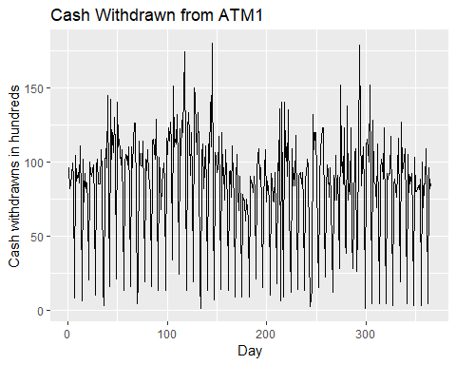

#Separate each ATM from the dataset and graph each dataset  
atm2<-ts_atm[,"ATM2"]  
autoplot(atm2) +  
 labs(title ="Cash Withdrawn from ATM2", x="Day") +  
 scale_y_continuous("Cash withdrawns in hundreds") +  
 scale_color_discrete(NULL)

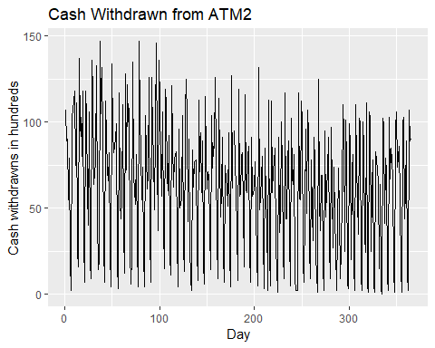

#Separate each ATM from the dataset and graph each dataset  
atm3<-ts_atm[,"ATM3"]  
autoplot(atm3) +  
 labs(title ="Cash Withdrawn from ATM3", x="Day") +  
 scale_y_continuous("Cash withdrawns in hundreds") +  
 scale_color_discrete(NULL)

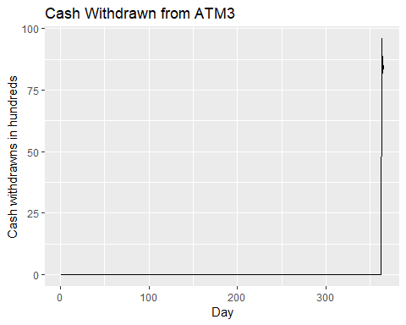

#Separate each ATM from the dataset and graph each dataset  
atm4<-ts_atm[,"ATM4"]  
autoplot(atm4) +  
 labs(title ="Cash Withdrawn from ATM4", x="Day") +  
 scale_y_continuous("Cash withdrawns in hundreds") +  
 scale_color_discrete(NULL)

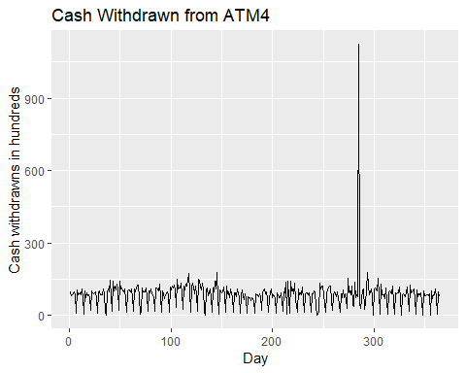

* ATM1, ATM2 and ATM4 show a lot of deal of seasonality in the withdrawn from those ATM.We can further analyze it by selecting the first 2 months of the data.

autoplot(ts(ts_atm[1:61, ])) +  
  
 labs(title = "Cash withdrawn from 4 ATMs",  
  
 subtitle = "May 2009 - June 2010",  
  
 x = "Day") +  
  
 scale_y_continuous("Cash withdrawn (hundreds)") +  
  
 scale_color_discrete(NULL)

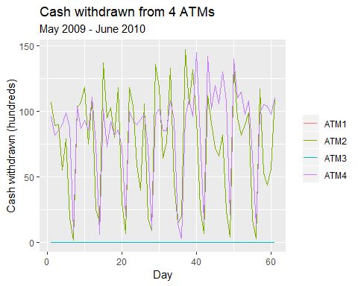

* The data presents a sort of weekly seasonnality. To capture the seasonnality of this data we will set the frequency to 7.

atm1_freq<-ts(atm1, frequency =7)  
atm2_freq<-ts(atm2, frequency=7)  
atm4_freq<-ts(atm4, frequency=7)

#### ATM1

#ACF and spectrum plot  
ggtsdisplay(atm1_freq, points = FALSE, plot.type = "spectrum",  
  
 main = "Withdrawals from ATM1", xlab = "Week", ylab = "Cash (hundreds)")

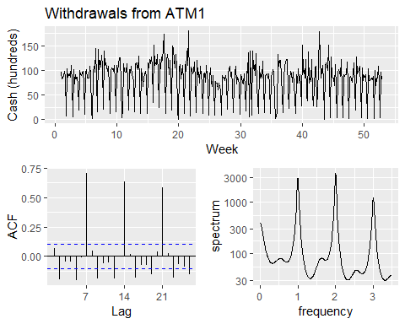

* In 7, 14 and 21 there are large spikes. the frequency 1,2,3 show the spike as well. Both suggest a seasonnal ARIMA model.

ggtsdisplay(diff(atm1_freq, 7), points = FALSE,  
  
 main = "Differenced (lag-7) withdrawals from ATM1",  
  
 xlab = "Week", ylab = "Cash (hundreds)")

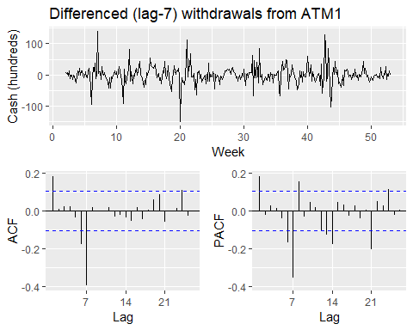 - BoxCox transformation to estimate lambda

# get optimal lambda for Box-cox transformation  
  
lambda_atm1<- BoxCox.lambda(atm1_freq)  
  
# define function to create models & return AIC values for timeseries  
  
aic_atm<- function(p, d, q, P, D, Q) {  
  
 # create model with Box-Cox and specified ARIMA parameters; extract AIC  
  
 AIC(Arima(atm1_freq, order = c(p, d, q), seasonal = c(P, D, Q), lambda = lambda_atm1))  
  
}  
  
# create possible combinations of p, q, P, Q except all zero  
  
expand.grid(p = 0:1, q = 0:1, P = 0:1, Q = 0:1) %>%  
  
 filter(p > 0 | q > 0 | P > 0 | Q > 0) %>%   
  
 # calc AIC for models  
  
 mutate(aic = pmap_dbl(list(p, 0, q, P, 1, Q), aic_atm)) %>%   
  
 # return best AIC  
  
 slice(which.min(aic))

## p q P Q aic  
## 1 1 1 0 1 1221.26

* The minimum aic value is for non-seasonality AR(1) and MA(1). AR(0) and AM(1) is for seasonality. Let’s fit the model using arima model arima(1,0,1)(0,1,1)

fit_atm1 <- Arima(atm1_freq, order = c(1, 0, 1), seasonal = c(0, 1, 1), lambda = lambda_atm1)  
summary(fit_atm1)

## Series: atm1_freq   
## ARIMA(1,0,1)(0,1,1)[7]   
## Box Cox transformation: lambda= 0.2584338   
##   
## Coefficients:  
## ar1 ma1 sma1  
## -0.4894 0.6125 -0.6385  
## s.e. 0.2309 0.2081 0.0432  
##   
## sigma^2 estimated as 1.732: log likelihood=-606.63  
## AIC=1221.26 AICc=1221.37 BIC=1236.78  
##   
## Training set error measures:  
## ME RMSE MAE MPE MAPE MASE  
## Training set 2.293003 24.81988 15.66437 -89.57546 108.1682 0.892827  
## ACF1  
## Training set -0.008839946

Let’s diagnostic the residuals with Ljung-Box.

Box.test(resid(fit_atm1), type = "L", fitdf = 3, lag = 7)

##   
## Box-Ljung test  
##   
## data: resid(fit_atm1)  
## X-squared = 8.0497, df = 4, p-value = 0.08977

ggtsdisplay(resid(fit_atm1), points = FALSE, plot.type = "histogram",  
  
 main = "Residuals for ARIMA(1,0,1)(0,1,1) fit of ATM1 withdrawals",  
  
 xlab = "Week", ylab = "Residual")

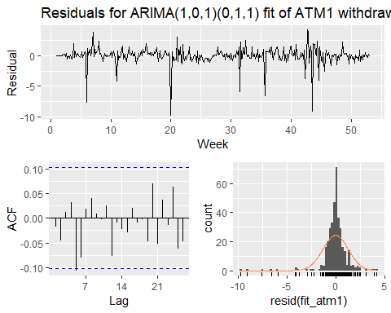

* The p_value is greater than 0.05 meaning that the residual is white noise. The residuals are not correlated and there is a normal distribution around the mean 0. We can use that model for forecasting.

forecast_atm1 <- forecast(fit_atm1, 31, level = 95)  
autoplot(forecast_atm1) +   
  
 labs(title = "ATM1: ARIMA(1,0,1)(0,1,1)", x = "Week", y = NULL) +  
  
 theme(legend.position = "none")

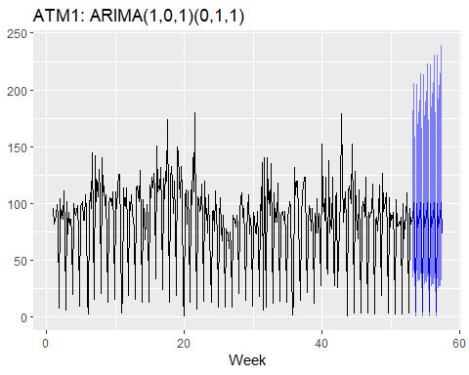

#### ATM2

* We can repeat the same stepp for ATM2.

ggtsdisplay(atm2_freq, points = FALSE,  
  
 main = "Withdrawals from ATM2", xlab = "Week", ylab = "Cash (hundreds)")

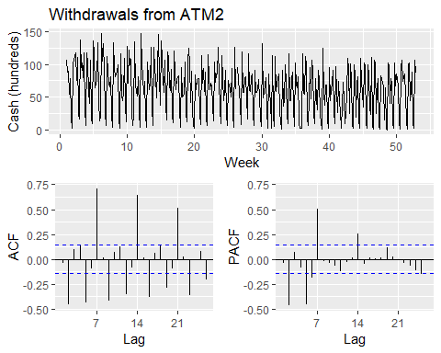

* The lag difference is 7.

ggtsdisplay(diff(atm2_freq, 7), points = FALSE,  
  
 main = "Differenced (lag-7) withdrawals from ATM2",  
  
 xlab = "Week", ylab = "Cash (hundreds)")

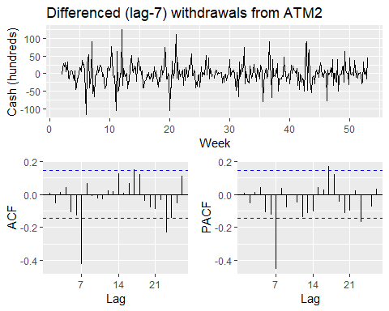

* The spikes in ACF & PACF in the non-differenced series at $k=2$& $k=5$ suggest $p,q∈[0,2,5]$. using the same aic function we can evaluate the minimum aic

# get optimal lambda for Box-cox transformation  
  
lambda_atm2 <- BoxCox.lambda(atm2_freq)  
  
# Evaluate aic  
  
aic_atm <- function(p, d, q, P, D, Q) {  
  
 # create model with Box-Cox and specified ARIMA parameters; extract AIC  
  
 AIC(Arima(atm2_freq, order = c(p, d, q), seasonal = c(P, D, Q), lambda = lambda_atm2))  
  
}  
  
# create possible combinations of p, q, P, Q except all zero  
  
expand.grid(p = c(0, 2, 5), q = c(0, 2, 5), P = 0:1, Q = 0:1) %>%  
  
 filter(p > 0 | q > 0 | P > 0 | Q > 0) %>%   
  
 # calculate AIC for models  
  
 mutate(aic = pmap_dbl(list(p, 0, q, P, 1, Q), aic_atm)) %>%   
  
 # return minimum AIC  
  
 slice(which.min(aic))

## p q P Q aic  
## 1 2 2 0 1 2323.517

* the model arima used is arima(5,0,5)(0,1,1). Let’s fit that model

fit_atm2<-Arima(atm2_freq, order = c(5, 0, 5), seasonal = c(0, 1, 1), lambda = lambda_atm2)  
summary(fit_atm2)

## Series: atm2_freq   
## ARIMA(5,0,5)(0,1,1)[7]   
## Box Cox transformation: lambda= 0.6584081   
##   
## Coefficients:  
## ar1 ar2 ar3 ar4 ar5 ma1 ma2 ma3  
## 0.2055 -0.1209 0.2260 0.3032 -0.4312 -0.1448 0.0114 -0.2213  
## s.e. 0.4529 0.4033 0.2176 0.2419 0.4136 0.4787 0.4200 0.2100  
## ma4 ma5 sma1  
## -0.2466 0.2470 -0.6905  
## s.e. 0.2463 0.4176 0.0595  
##   
## sigma^2 estimated as 37.91: log likelihood=-1152.1  
## AIC=2328.19 AICc=2329.1 BIC=2374.76  
##   
## Training set error measures:  
## ME RMSE MAE MPE MAPE MASE ACF1  
## Training set 0.2238867 23.87153 16.65107 -Inf Inf 0.8279025 -0.03050682

* Let’s evaluate the residual to check the validity of the model

Box.test(resid(fit_atm2), type = "L", fitdf = 11, lag = 14)

##   
## Box-Ljung test  
##   
## data: resid(fit_atm2)  
## X-squared = 2.1119, df = 3, p-value = 0.5495

ggtsdisplay(resid(fit_atm2), points = FALSE, plot.type = "histogram",  
  
 main = "Residuals for ARIMA(5,0,5)(0,1,1) of ATM2 withdrawals",  
  
 xlab = "Week", ylab = "Residual")

## Warning: Removed 1 rows containing non-finite values (stat_bin).

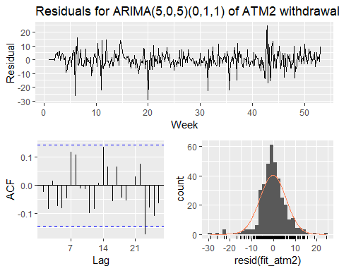

* P-value is greater than 0.05 and the residual appear to be normally distributed with a mean of 0. It can be used for forecast ATM2.

forecast_atm2<- forecast(fit_atm2, 31, level = 95)  
autoplot(forecast_atm2) +   
  
 labs(title = "ATM2: ARIMA(5,0,5)(0,1,1)", x = "Week", y = NULL) +  
  
 theme(legend.position = "none")

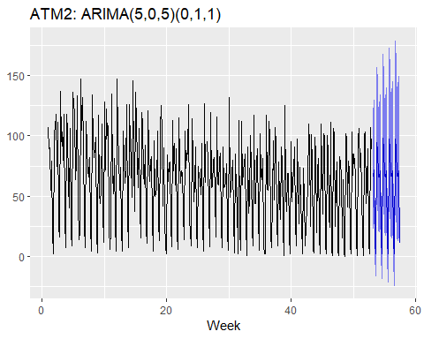

#### ATM4

* ATM4 has the same seasonality as ATM1 and ATM2. We will use the previous step to evaluate ATM4 model.

#Minimze the effect of the big withdraw in the day by using the median of the ATM4 dataset  
  
atm4_freq[which.max(atm4_freq)] <- median(atm4_freq, na.rm = TRUE)  
  
ggtsdisplay(atm4_freq, points = FALSE,  
  
 main = "Withdrawals from ATM4", xlab = "Week", ylab = "Cash (hundreds)")

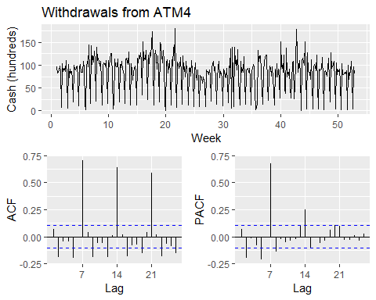

* We notice a difference lag of 7.

ggtsdisplay(diff(atm4_freq, 7), points = FALSE,  
  
 main = "Differenced (lag-7) withdrawals from ATM4",  
  
 xlab = "Week", ylab = "Cash (hundreds)")

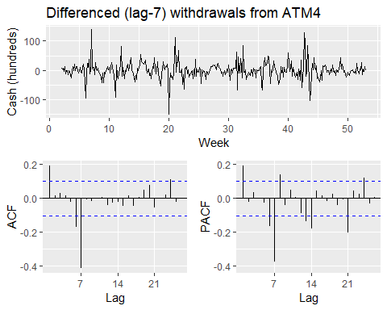

* ARIMA model for ATM4 will be evaluated.

# get optimal lambda for Box-cox transformation  
  
lambda_atm4 <- BoxCox.lambda(atm4_freq)  
  
aic_atm(0,2,5,0,2,5)

## [1] 2365.837

# create possible combinations of p, q, P, Q except all zero  
  
expand.grid(p = c(0, 2, 5), q = c(0, 2, 5), P = 0:1, Q = 0:1) %>%  
  
 filter(p > 0 | q > 0 | P > 0 | Q > 0) %>%   
  
 # calculate AIC for models  
  
 mutate(aic = pmap_dbl(list(p, 0, q, P, 1, Q), aic_atm)) %>%   
  
 # return minimum AIC  
  
 slice(which.min(aic))

## p q P Q aic  
## 1 2 2 0 1 2323.517

* Let’s fit the ARIMA model with the values (0,0,2)(0,1,1)

fit_atm4<-Arima(atm4_freq, order = c(0, 0, 2), seasonal = c(0, 1, 1), lambda = lambda_atm4)  
summary(fit_atm4)

## Series: atm4_freq   
## ARIMA(0,0,2)(0,1,1)[7]   
## Box Cox transformation: lambda= 0.2355973   
##   
## Coefficients:  
## ma1 ma2 sma1  
## 0.1094 -0.1089 -0.6468  
## s.e. 0.0524 0.0523 0.0422  
##   
## sigma^2 estimated as 1.467: log likelihood=-576.96  
## AIC=1161.92 AICc=1162.03 BIC=1177.44  
##   
## Training set error measures:  
## ME RMSE MAE MPE MAPE MASE  
## Training set 2.356651 24.88094 15.90136 -85.71176 104.5953 0.9023123  
## ACF1  
## Training set 0.02127326

* Let’s investigate the residuals using Ljung-box test

Box.test(resid(fit_atm4), type = "L", fitdf = 3, lag = 7)

##   
## Box-Ljung test  
##   
## data: resid(fit_atm4)  
## X-squared = 5.7899, df = 4, p-value = 0.2154

ggtsdisplay(resid(fit_atm4), points = FALSE, plot.type = "histogram",  
  
 main = "Residuals for ARIMA(0,0,2)(0,1,1) of ATM4 withdrawals",  
  
 xlab = "Week", ylab = "Residual")

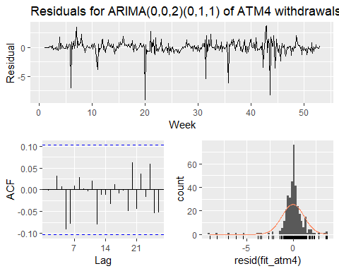

* It is normally distributed around a mean of 0.p-value is also greater than 0.05. We can use the model to forecast.

forecast_atm4<- forecast(fit_atm4, 31, level = 95)  
autoplot(forecast_atm4) +   
  
 labs(title = "ATM4: ARIMA(0,0,2)(0,1,1)", x = "Week", y = NULL) +  
  
 theme(legend.position = "none")

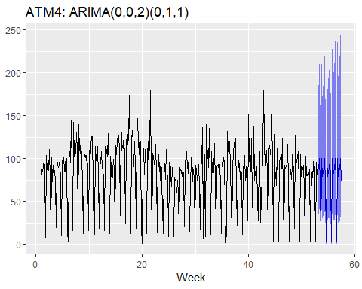

#### ATM3

* Since ATM3 contains limited data we will use the mean forecast method.

forecast_atm3 <- meanf(atm3, 31, level = 95)  
autoplot(forecast_atm3) +   
  
 labs(title = "ATM3: mean", x = "Day", y = NULL) +  
  
 theme(legend.position = "none")

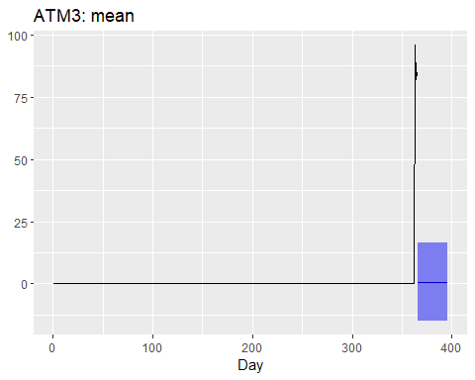

#### Writing the forecast to a CSV file

data_frame(DATE = rep(max(atm$DATE) + 1:31, 4),  
  
 atm = rep(names(atm)[-1], each = 31),  
  
 Cash = c(forecast_atm1$mean, forecast_atm2$mean,  
  
 forecast_atm3$mean, forecast_atm4$mean)) %>%   
  
 write_csv("project1_forecast_atm_1.csv")

## Warning: `data_frame()` is deprecated, use `tibble()`.  
## This warning is displayed once per session.