Output of R script

Question 2 - When it was grown = 2327, Where = Paris, Weight_lbs = 2700.833

Question 5
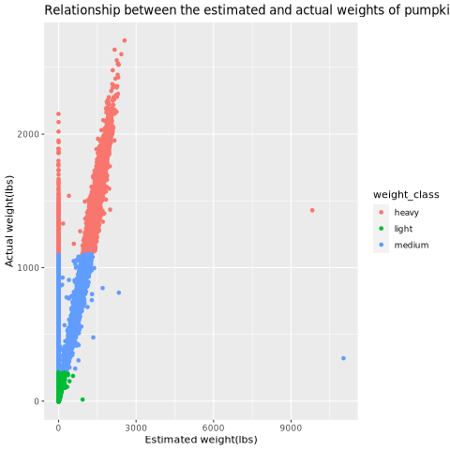
Figure 1: Relationship between the actual weights of the pumpkin’s vs what the pumpkins were estimated to have weighed, with the data being divided into weight classes “heavy”, “medium” and “light”.

To begin with the graph shows that a large number of the pumpkins fit into the heavy category. It also shows that the estimations of what the pumpkins should weight are not very accurate with the heavier the pumpkins are the more it strays from the estimation.

Question 7a- France = 777, UK = 748 and USA = 757 meaning France had the heavies mean pumpkin weights.

Question 7b – The country with the lowest min was UK with a corresponding variety of pumpkin being Porcelain Doll. The smallest value was 713.7625

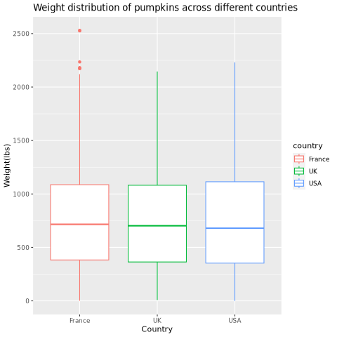
Figure 2: Distribution of weight in lbs in the Countries of France, USA and UK.

Based on the graph the mean values for each of the countries are basically indistinguishable from one another though you can barely tell that France has the highest median followed by the Uk and then the US. Interestingly France is the only country with clear outliers, despite the US having the highest maximum value according to the line. Because of this it could be argued that the outliers in France should be filtered out since it shews the mean weight from France.

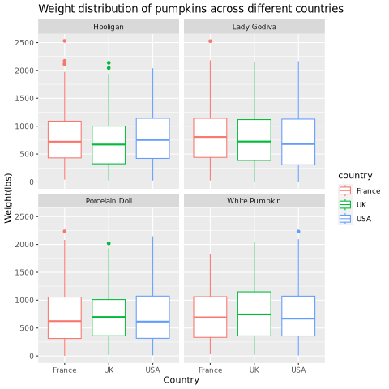
Figure 3: Weight distribution of pumpkins across the Countries of France, Uk and USA across four varieties of pumpkins, Hooligan, Lady Godiva, Porcelain Doll and White Pumpkin.

Separating the previous graph by the varieties of pumpkin shows that the hooligan pumpkins where responsible for the outliers in the France data set. For the previously identified Porcelain Doll variety in the Uk that was found to have the lowest mean, this does not appear to be super apparent in the box plots with UK porcelain dolls having the highest median values compared to the other countries though it appears there is less variation in pumpkin weight in the Uk for the porcelain doll.

