* Login as Technical user:

URL: <http://localhost:8080/bonita/login.jsp?redirectUrl=%2Fbonita%2Fportal%2Fhomepage>

Credentials: tech_user / secret

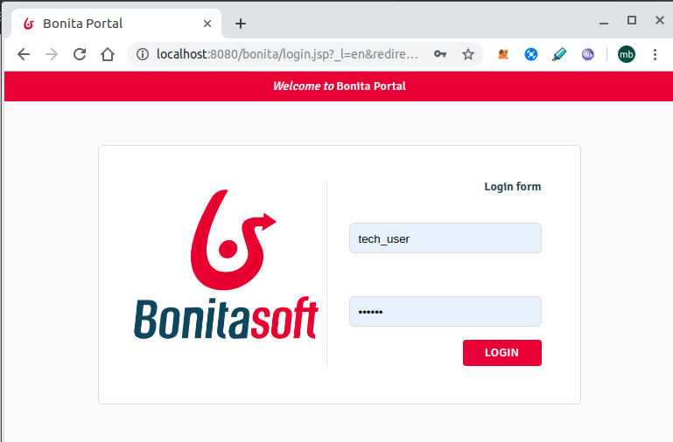

* Install organisation and add walter.bates user to Administrator/User profiles

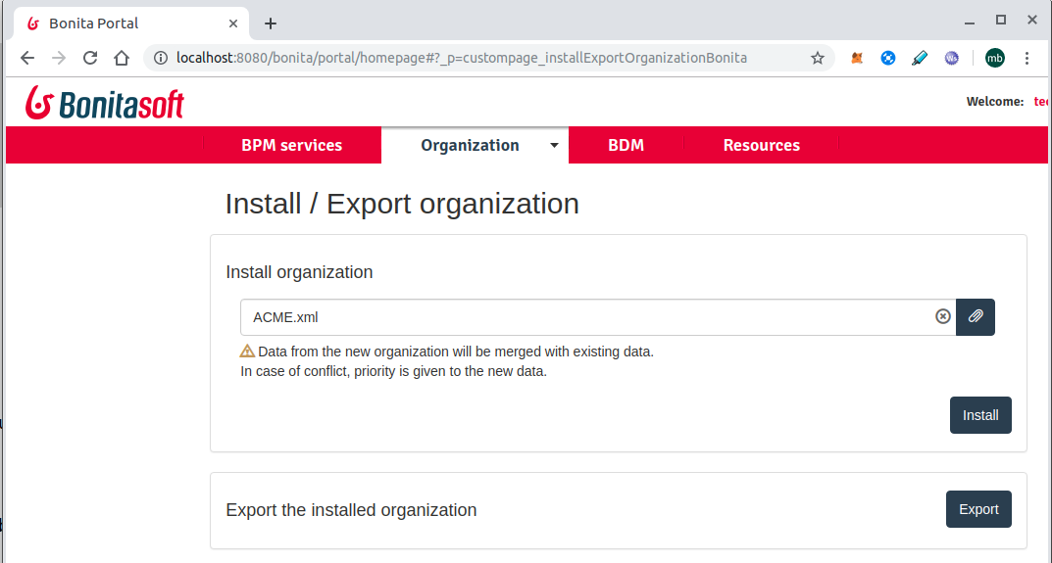

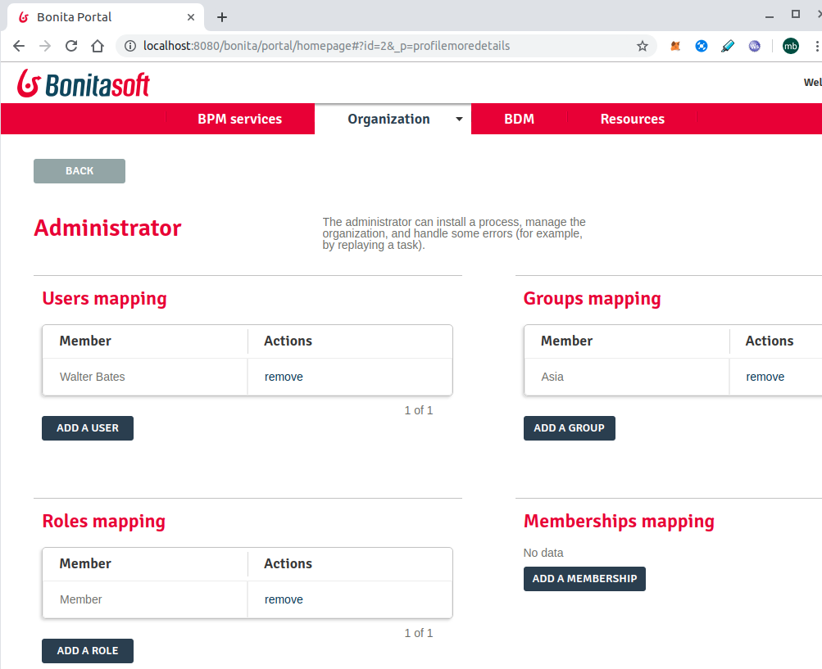

* Install BDM:

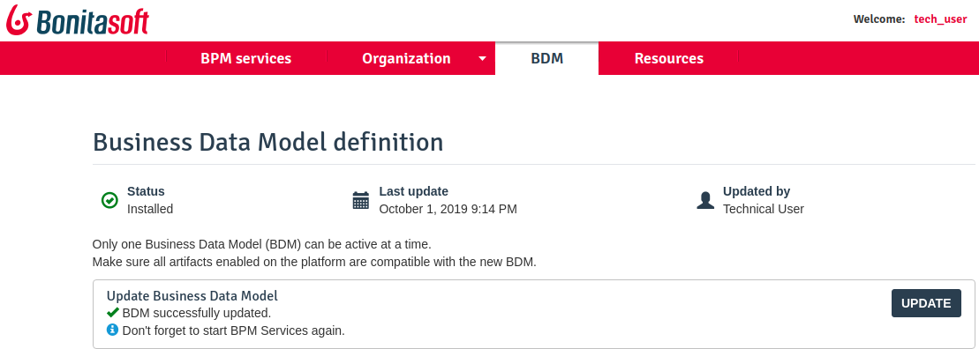

* Logout as Technical User and Login as :

walter.bates / bpm

* Install BAR file:

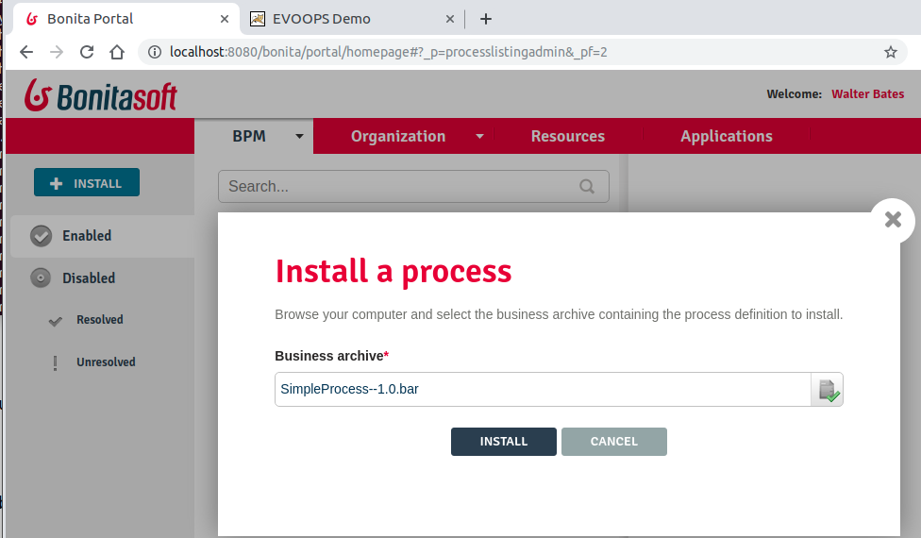

* Activate the process by mapping the user:

