Katie McCorkell

Kmccork 0822555

Machine Learning 446

Winter 2014

Homework 3

**Problem 2: Textbook problems re: Neural Networks**

**MITCHELL, 4.5**

The gradient descent algorithm should be implemented as in the course lecture slides on Nueral Networks, slide 15, however a different formula for ∆wi should be used.

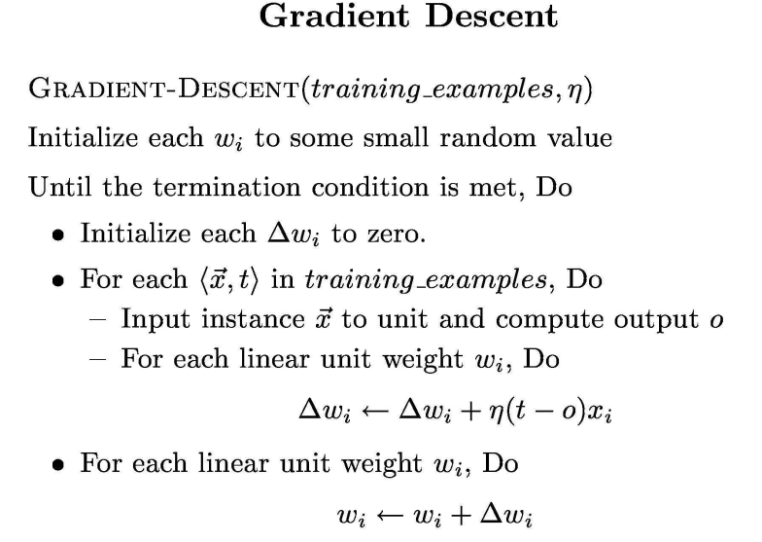

∆wi should be equal to –ŋ () as before, but a different value should be used for.

 should be derived as follows

 = 

 =  where  is the o given in problem 4.5, see next page

= 

 = 

 = 

 refers to the equation given in the problem:

This can be rewritten as 

Thus, the derivative of this with respect to weight i, for any  is 

Since only the i terms remain after taking the derivative with repsect to weight i.

This is used in my work on the previous page.

**MITCHELL, 4.10**

This can be implemented by multiplying each weight by the constant (1-2γŋ) upon each iteration.