No. | FORMUL NAME | FORMULA
1 | Quadratic Equation | 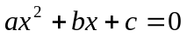
2 | Cosine Theorem | 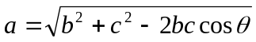
3 | Heron’s Formula | 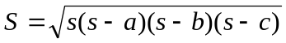
4 | Normal Probability Function P(x) | 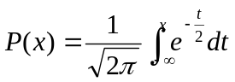
5 | Normal Probability Function Q(x) | 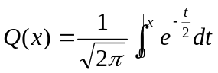
6 | Coulomb’s Law | 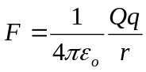
7 | Resistance of a Conductor | 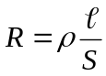
8 | Magnetic Force | 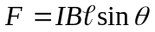
9 | Change in Terminal Voltage of R in RC Series Circuit | 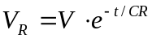
10 | Voltage Gain | 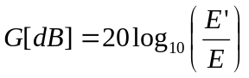
11 | Impedance in LRC Series Circuit | 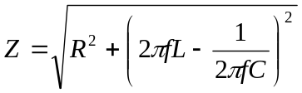
12 | Impedance in LRC Parallel Circuit | 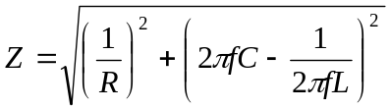
13 | Frequency of Electric Osciliation | 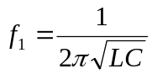
14 | Distance of Drop | 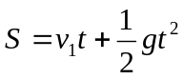
15 | Cycle of Simple Pendulum | 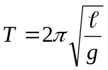
16 | Cycle of Spring Pendulum | 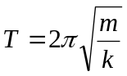
17 | Doppler Effect | 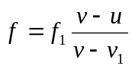
18 | Equation of State of Ideal Gas | 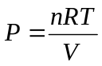
19 | Centrifugal Force | 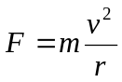
20 | Elastic Energy | 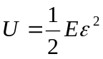
21 | Bernoulli’s Theorem | 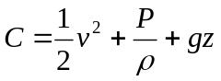
22 | Calculations Using a Stadia (1) | 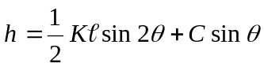
23 | Calculations Using Stadia (2) | 