Week-1 Assesment

Here are the things which i did for the week one project :

1) Loading the csv file in to Power BI by using the load option  
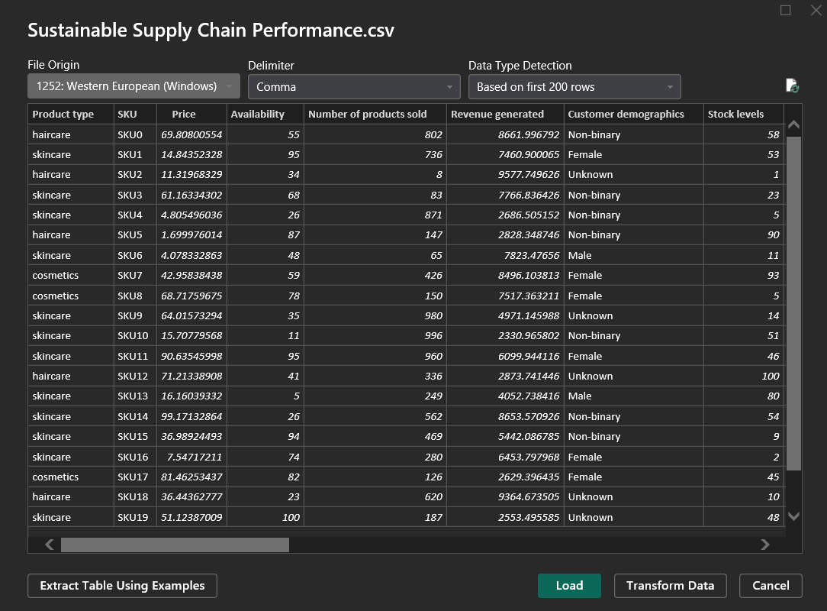

2) Then after importing we transformed the given csv file into various tables

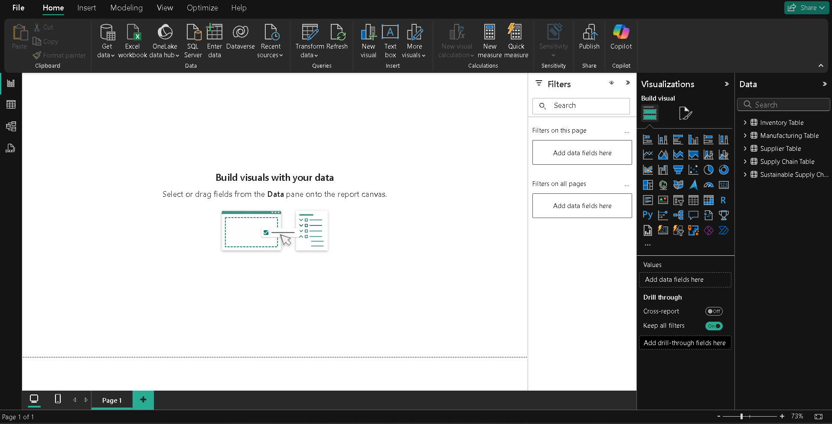

3) By using the transform data option under queries tab  
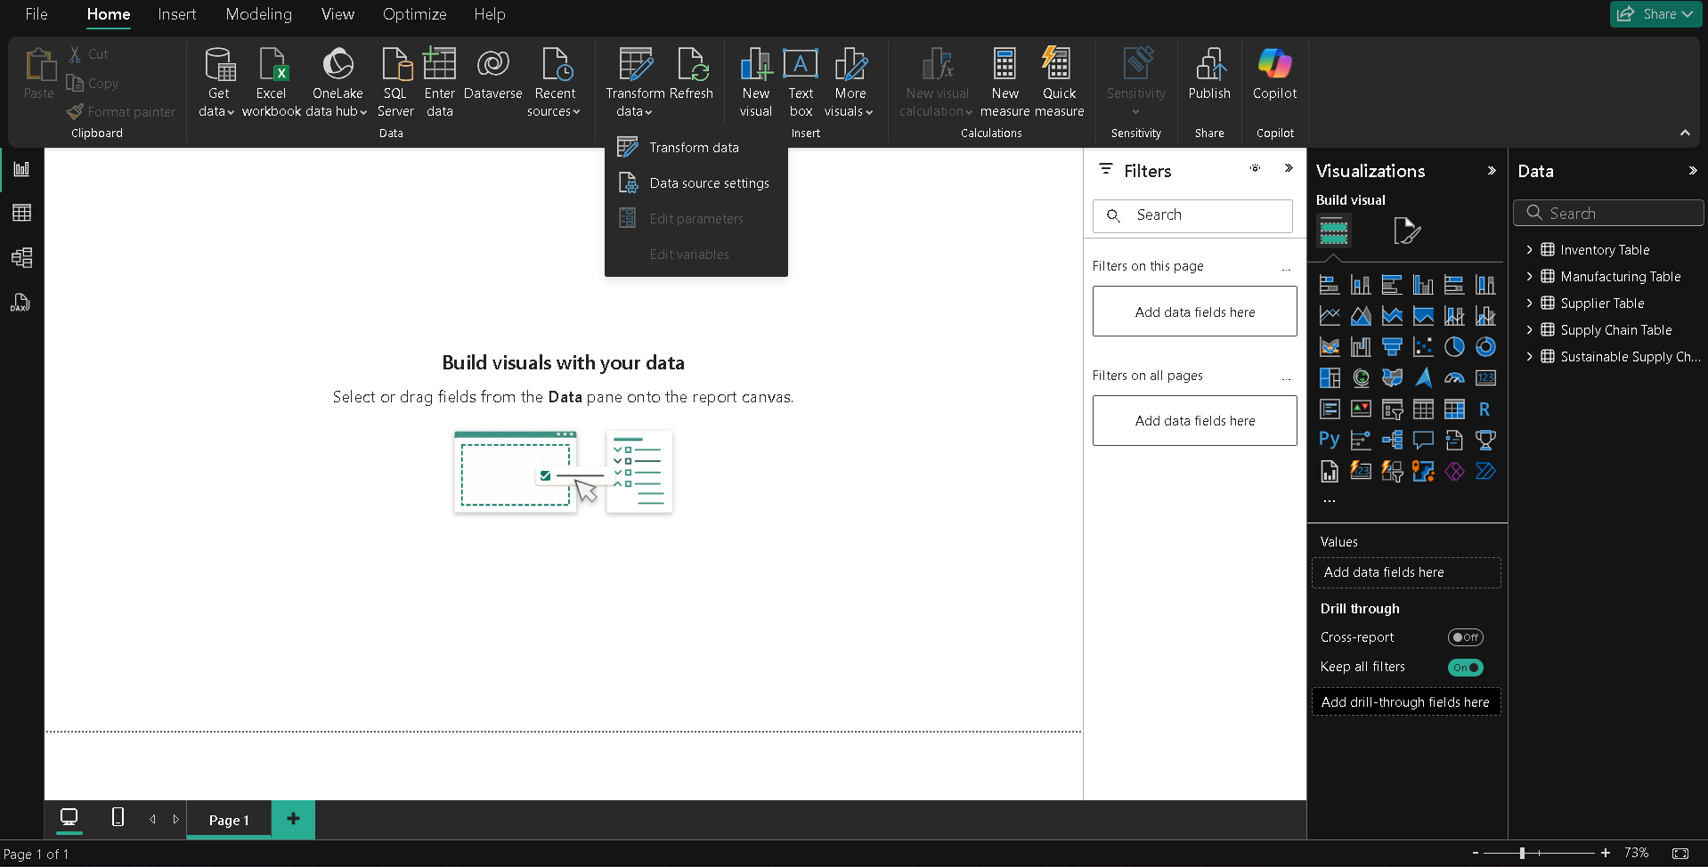

4) Then a new window of power query opens.

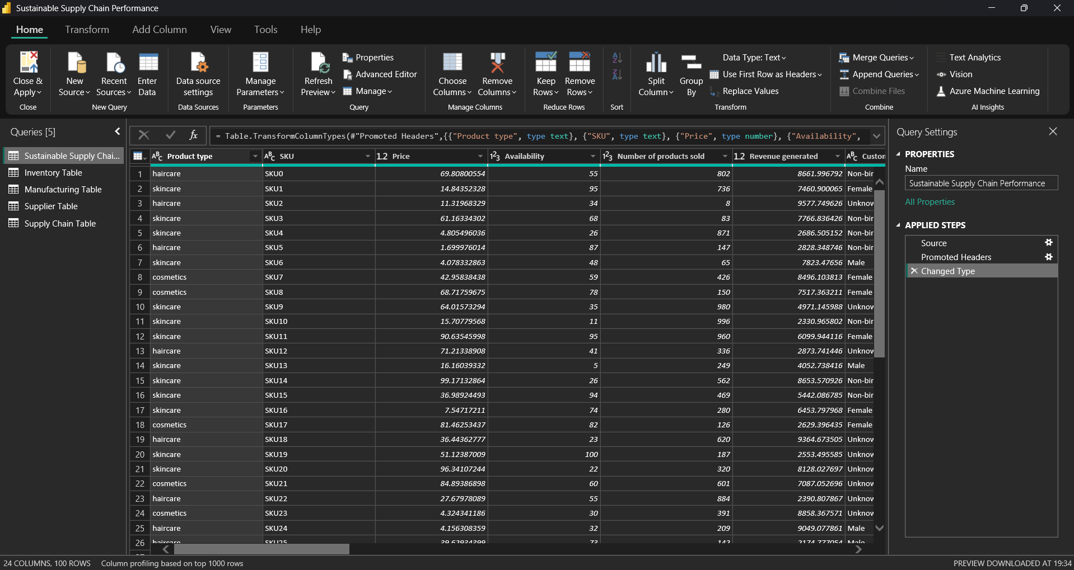

5) According to given details we created duplicate tables



6) Then we removed the unnecessary columns by right clicking on the column name and selecting the remove option

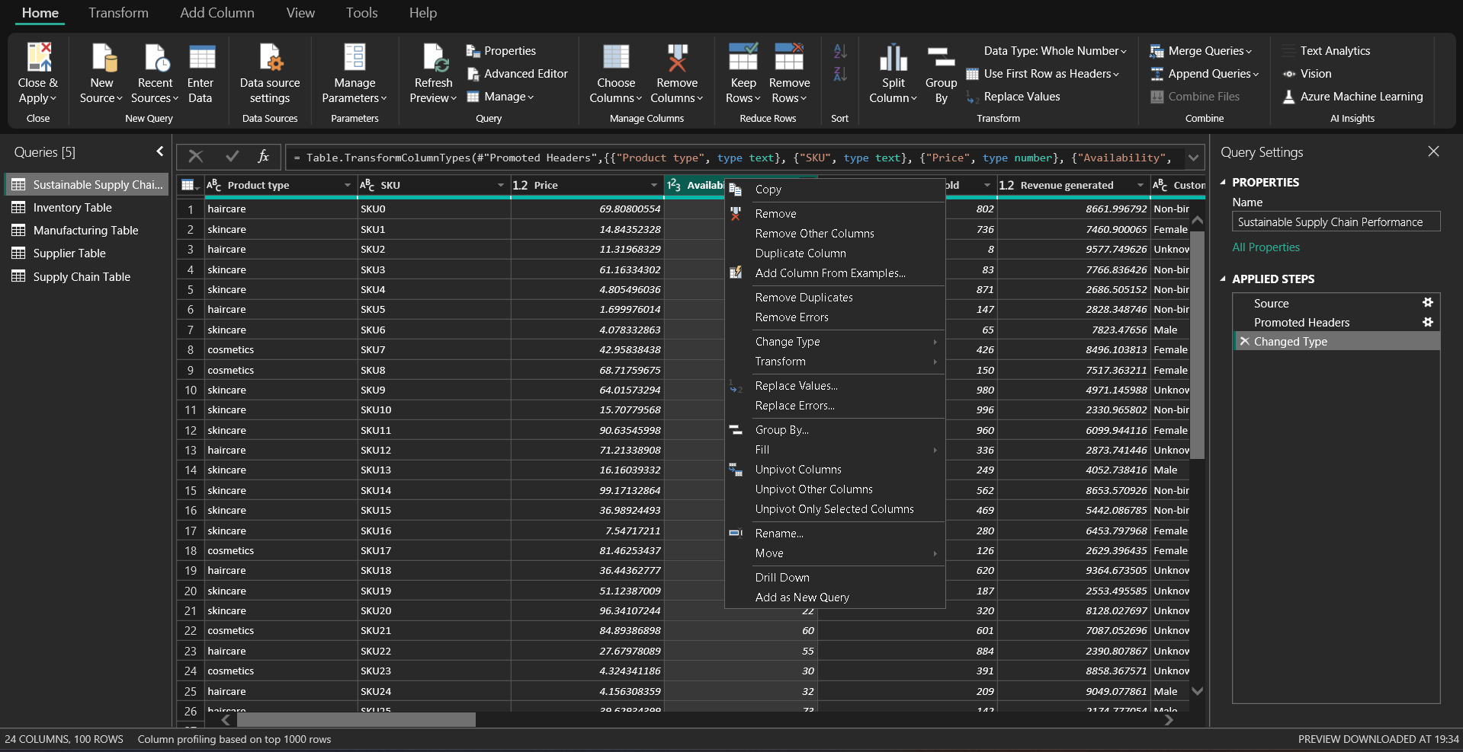

7) In this way we created all the required tables

