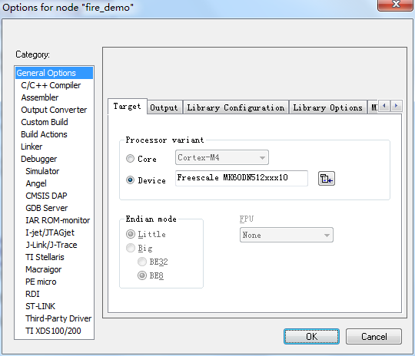

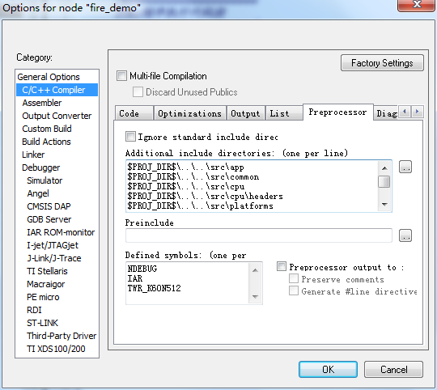

$PROJ_DIR$\..\..\src\app

$PROJ_DIR$\..\..\src\common

$PROJ_DIR$\..\..\src\cpu

$PROJ_DIR$\..\..\src\cpu\headers

$PROJ_DIR$\..\..\src\platforms

$PROJ_DIR$\..\..\src\drivers

$PROJ_DIR$\..\..\src\drivers\adc

$PROJ_DIR$\..\..\src\drivers\AT24C02

$PROJ_DIR$\..\..\src\drivers\exti

$PROJ_DIR$\..\..\src\drivers\delay

$PROJ_DIR$\..\..\src\drivers\FTM

$PROJ_DIR$\..\..\src\drivers\gpio

$PROJ_DIR$\..\..\src\drivers\i2c

$PROJ_DIR$\..\..\src\drivers\lptmr

$PROJ_DIR$\..\..\src\drivers\mcg

$PROJ_DIR$\..\..\src\drivers\PIT

$PROJ_DIR$\..\..\src\drivers\pmc

$PROJ_DIR$\..\..\src\drivers\rtc

$PROJ_DIR$\..\..\src\drivers\uart

$PROJ_DIR$\..\..\src\drivers\wdog

$PROJ_DIR$\..\..\src\drivers\dma

$PROJ_DIR$\..\..\src\LIB\CMSIS

$PROJ_DIR$\..\..\src\LIB\FatFs

$PROJ_DIR$\..\..\build

$PROJ_DIR$\..\..\src\uCOS-II\Ports

$PROJ_DIR$\..\..\src\uCOS-II\Source

$PROJ_DIR$\..\..\src\uCOS-II\App

$PROJ_DIR$\..\..\src\uCOS-II\App\CFG

$TOOLKIT_DIR$\inc

NDEBUG

IAR

TWR_K60N512

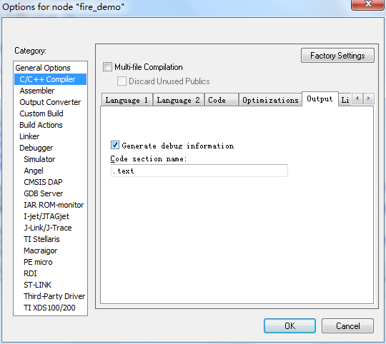

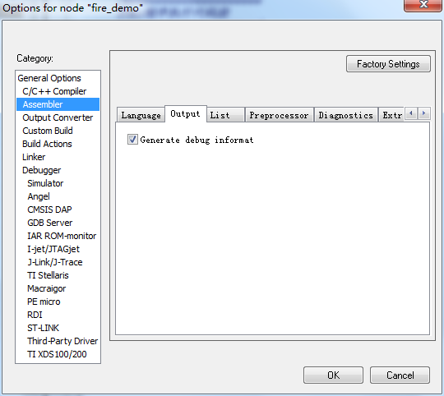

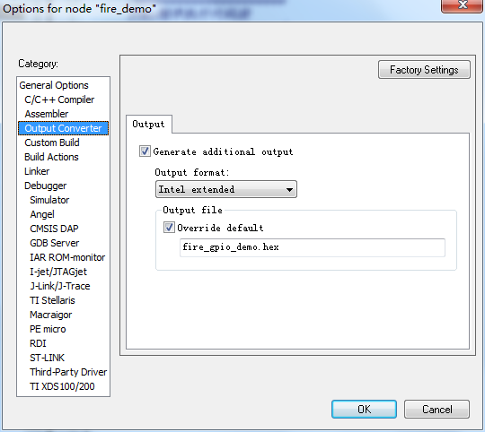

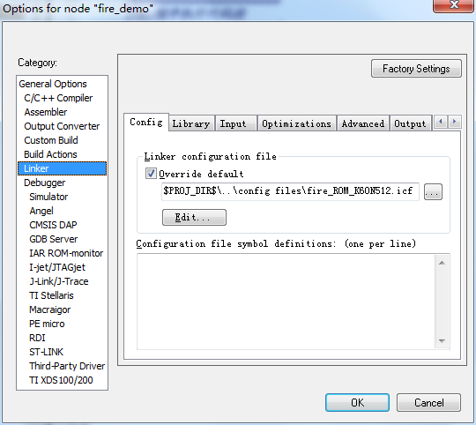

$PROJ_DIR$\..\config files\fire_ROM_K60N512.icf

