TSYP14 Technical Challenge: NEXUS, Next-Generation Emergency eXchange for Universal Sustainability
WadiWatch
A community-owned flash-flood early-warning system for the wadis of Nabeul / Cap Bon
Phase 1 Project Report
October 2026
Application area | Environmental & Climate Sensing (flash floods)
Region | Nabeul governorate, Cap Bon peninsula, Tunisia
Smart components | Sensing, edge processing, low-power LoRa communication
Recipients | Households, farmers, municipality, Civil Protection
UN SDGs | 11 and 13 (primary); 1 and 9 (secondary)

Contents
1. Executive summary
2. Problem and community context
3. Mission, vision and values
4. Solution overview
5. System architecture
6. Technical feasibility, methodologies and tools
7. Risk management and lifecycle resilience
8. Humanitarian impact
9. Ethics and values
10. Market analysis and potential partners
11. Financial analysis
12. Implementation timeline and team roles
13. Conclusion
References

1. Executive summary
On 22 September 2018 about 200 mm of rain fell on Nabeul in a few hours. Water in some streets rose by 1.7 m, at least five people died, and recovery needs were later estimated at about US$100 million [1][2][4]. The national meteorological institute had issued a warning the day before [2]. The information existed. It did not reach the people standing next to the wadis in a form they could act on, at the moment they needed it.
WadiWatch closes that last gap. Solar-powered wadi nodes measure water level and rainfall, decide the alert level on the node itself, and trigger neighbourhood siren nodes directly over LoRa radio. This life-safety path needs no internet, no mobile network and no grid power. In parallel a gateway sends SMS alerts to registered residents and farmers and feeds a dashboard used by the municipality and Civil Protection to coordinate the response.
The system is built from parts the team already holds (ESP32 microcontrollers, LoRa radios, ultrasonic sensors). A wadi node costs an estimated 380 TND, and a complete pilot on one wadi (four wadi nodes, three siren nodes, one gateway, installation and training) an estimated 6,500 TND. It is designed to be assembled, maintained and governed locally: thresholds, siren locations and recipient lists belong to a wadi committee of residents, municipal staff and Civil Protection.
WadiWatch complements the national investment in hydrometeorological services and early warning [5][7] by covering the last few hundred metres between a forecast and a household. It advances SDG 11 (target 11.5) and SDG 13 (target 13.1), and contributes to SDG 1 and SDG 9. A working prototype of the full chain, from sensor to siren, SMS and dashboard, will be demonstrated on 10 December 2026.

2. Problem and community context

2.1 Floods are Tunisia's costliest hazard
Between 1957 and 2018 floods caused about 60% of Tunisia's recorded disaster losses, the highest number of casualties and the highest number of people affected, around 560,000 [5]. The World Bank's risk profile estimates the average annual loss from floods at US$40 million, or 0.1% of 2018 GDP [6]. The trend is not improving: in January 2026 several regions saw their heaviest rainfall in more than 70 years [8].

2.2 Nabeul, 22 September 2018
Cap Bon is a peninsula crossed by short, steep wadis: riverbeds that are dry most of the year and run through towns, farms and industrial zones on their way to the sea. On 22 September 2018 the storm delivered about 200 mm of rain to Nabeul and up to 225 mm at Beni Khalled, close to six months of average precipitation and the heaviest rainfall since the meteorological institute's records began in 1995 [2]. Water rose by as much as 1.7 m. Roads and bridges were cut, homes and cars were carried away, and at least five people died, among them two sisters swept away while leaving work [1][2]. The government committed to restoring about 2,500 homes [3]. A Rapid Needs Assessment by the Government of Tunisia with the World Bank, the United Nations and the European Union put recovery needs at about US$100 million, concentrated in transport, agriculture and housing [4].

2.3 The real gap: the last few hundred metres
A weather warning was issued the day before the 2018 flood [2]. The losses were not caused by a lack of data. The World Bank describes Tunisia's early-warning chain as held back by insufficient monitoring equipment, institutional fragmentation and inefficient procedures for alert communication and dissemination [4]. A regional bulletin cannot tell a family in a specific street that the wadi behind their house will overflow in fifteen minutes. In a flash flood the useful warning time is counted in minutes, and during a storm the electricity and the mobile network can fail just when they are needed.
Nabeul governorate has 863,172 residents (2024 census) [9]. Many live, work or farm beside a wadi. The need is a warning that is local to one wadi, automatic, audible without a phone, and still working when the infrastructure is not.

2.4 Who needs what
Table 1. Recipients and the information each needs
Recipient | What they need to know | Form they can use
Household near a wadi | Is the water coming, and do I leave now? | Siren and strobe; short SMS
Farmer | Do I move livestock, pumps and vehicles? | SMS with wadi name and level
School, factory, market | Do we keep people inside or send them home another way? | SMS to a named contact; siren
Municipality | Which wadi, which streets, what is the trend? | Dashboard map and alert log
Civil Protection | Where to send teams and close roads first? | Dashboard; SMS to the duty officer

3. Mission, vision and values
Mission. Give every household living beside a wadi in Cap Bon enough warning to get out of the water's way, using technology the community can afford, understand and repair.
Vision. A Tunisia where nobody dies in a flash flood for lack of a warning.
Values.
- Lives first. The path that sounds the siren is the simplest and most protected part of the system.
- Inclusion. A warning must reach people with no smartphone, no credit, no literacy and no electricity.
- Transparency. Open hardware, open firmware, published thresholds and a public alert log.
- Frugality. Low cost and low power are design requirements, not afterthoughts.
- Community ownership. The people at risk decide how the system behaves and keep it running.

4. Solution overview
WadiWatch implements the full chain the challenge asks for: Detect, Communicate, Coordinate, Enable Response (Figure 1).
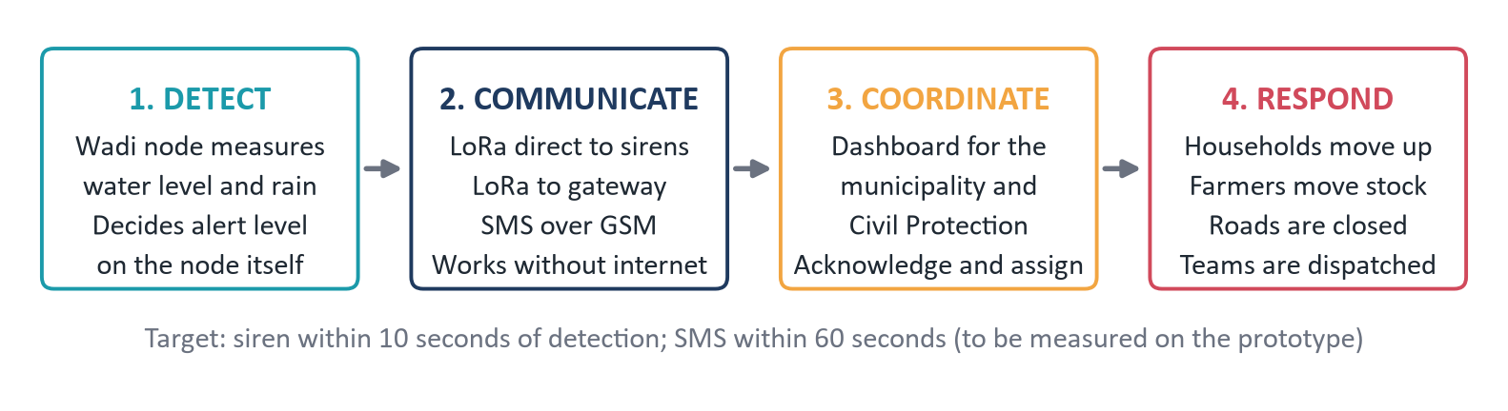
Figure 1. From a rising wadi to people moving, in four stages
- Detect. Wadi nodes on bridges and culverts measure water level by ultrasound and rainfall with a tipping-bucket gauge. Each node computes the rate of rise and decides one of three alert levels itself.
- Communicate. The node sends an authenticated LoRa packet. Siren nodes in the neighbourhood hear it directly and sound. The gateway hears it too and sends SMS through its own GSM modem.
- Coordinate. The dashboard shows the municipality and Civil Protection which wadi is rising, how fast, which sirens have sounded and who has acknowledged.
- Respond. Households move to higher ground, farmers move stock and equipment, the municipality closes crossings and Civil Protection sends teams where the level is highest.

4.1 Innovation and efficiency
- A life-safety path with no infrastructure dependency. Most connected sensors report to a cloud that then decides. Here the decision is made on the node and delivered radio-to-radio, so the siren still works when the gateway, the internet, the mobile network and the grid are all down.
- Graceful degradation. Each lost service removes a convenience, never the warning: without internet the dashboard is stale but SMS still goes out; without GSM the SMS stops but the sirens still sound.
- Upstream confirmation. A node in the upper reach sees the flood wave before the town does. Combining its state with the town node turns travel time along the wadi into warning time and reduces false alarms.
- Energy on demand. A node sleeps for almost all of a dry day and is woken by the first tips of the rain gauge, so it spends energy only when a flood is possible.
- Frugal by construction. Off-the-shelf modules, an estimated 380 TND per wadi node, no subscription for the radio link.

4.2 Key requirements
Table 2. System requirements and design targets (targets to be verified on the prototype)
ID | Requirement | Design target
RQ1 | Sound the siren quickly after a threshold is crossed | 10 seconds or less
RQ2 | Deliver SMS to registered recipients | 60 seconds or less when GSM is available
RQ3 | Life-safety path independent of internet, GSM and grid | Demonstrated with all three switched off
RQ4 | Wadi node autonomy without sun | At least 14 days in storm mode
RQ5 | Radio range between wadi node and siren node | At least 1 km in a built-up area
RQ6 | Affordability | Wadi node at or under 400 TND in parts
RQ7 | Local maintainability | Any module replaceable with hand tools in 15 minutes
RQ8 | Alert authenticity | Unsigned or replayed packets are ignored

5. System architecture
The architecture (Figure 2) separates two paths with different duties. The life-safety path (wadi node to siren node) must always work and is kept as simple as possible. The information path (wadi node to gateway, then SMS and dashboard) is richer and is allowed to degrade.
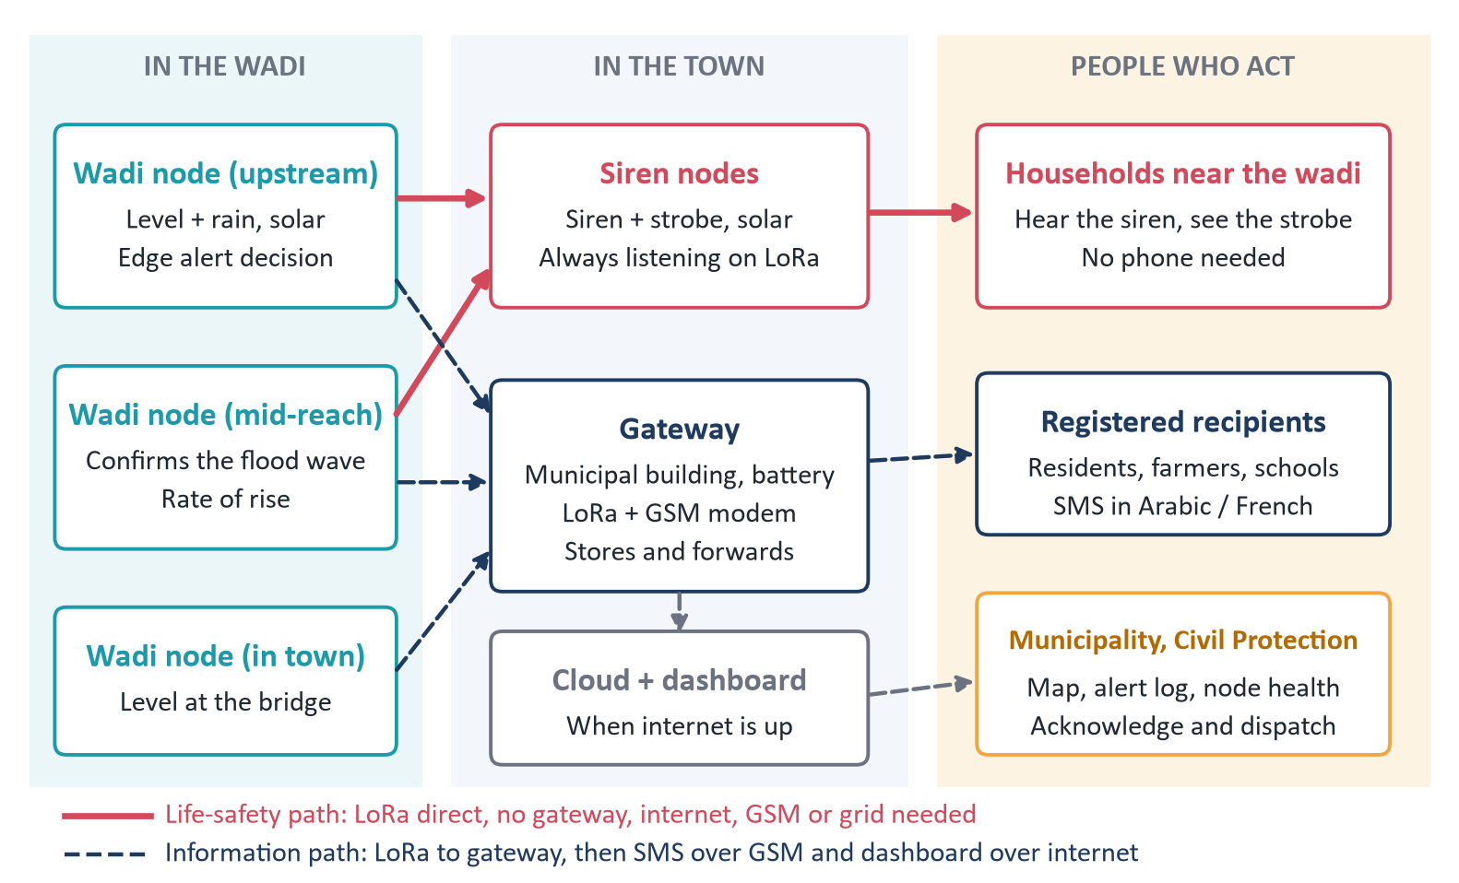
Figure 2. Sensor and communication architecture: two paths, three recipient groups

5.1 Wadi node (sensing and edge processing)
The wadi node (Figure 3) is built around an ESP32 that stays in deep sleep between measurements. A waterproof ultrasonic sensor mounted under a bridge deck or on a culvert headwall measures the distance to the water surface; the level is the mounting height minus that distance. A tipping-bucket rain gauge closes a reed switch at each tip, which both counts rainfall and wakes the processor. A 5 W solar panel charges a 3000 mAh lithium-ion cell through a protection and charge-control stage.
The edge logic runs entirely on the node:
- Adaptive sampling. Dry mode takes one measurement every 15 minutes. The first rain tips, or a level above the Watch threshold, switch the node to storm mode at one measurement per minute.
- Filtering. Each measurement is the median of five ultrasonic pings, which rejects echoes from debris, spray and insects. Readings outside the physically possible range are discarded and counted in the heartbeat.
- Rate of rise. The node keeps a short history and computes the change in level over a sliding five-minute window. A fast rise is the earliest reliable sign of a flash flood, before the absolute level is alarming.
- Alert level. Level, rate of rise, rainfall intensity and the last state heard from the upstream node are combined into one of three levels (Table 3).
- Signing. Every alert packet carries the node identifier, a message counter and a message authentication code computed with a key shared with the siren nodes.
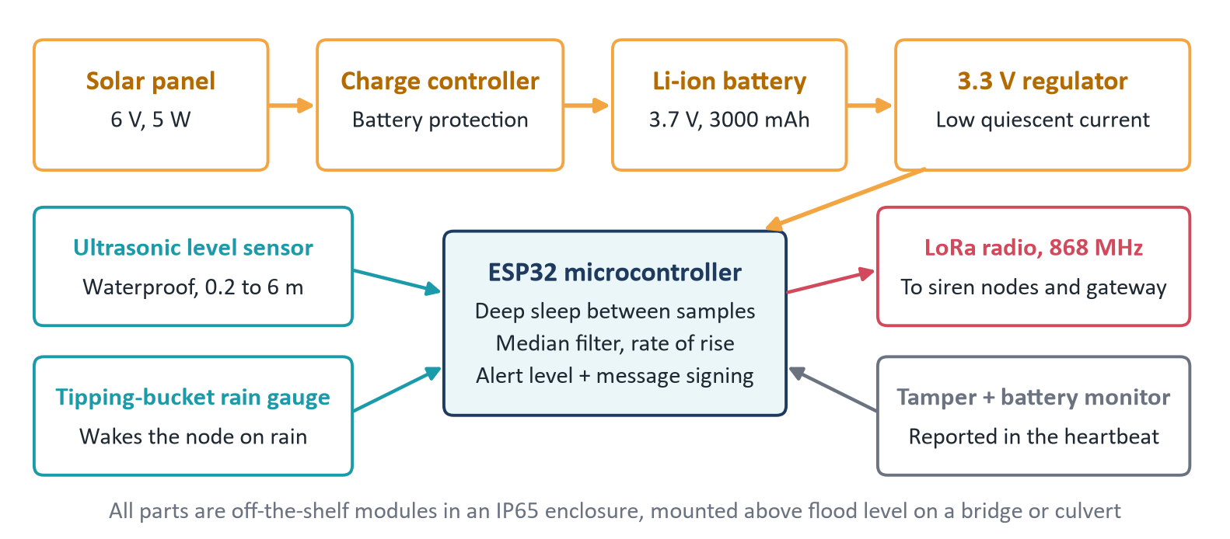
Figure 3. Block diagram of the wadi node
Table 3. Alert levels. Thresholds are starting values for the prototype and will be calibrated for each site with the wadi committee
Level | Trigger on the node (starting values) | What happens
Watch | Rain of 10 mm in 30 minutes, or level above 30% of bank-full depth | Dashboard turns yellow; SMS to the municipal and Civil Protection duty contacts; node enters storm mode
Warning | Level above 50% of bank-full depth, or rise of 5 cm per minute sustained for 3 minutes | Siren pattern 1 (intermittent) with strobe; SMS to registered recipients near that wadi
Evacuate | Level above 75% of bank-full depth, or Warning at this node together with Warning at the upstream node | Continuous siren with strobe; SMS to all registered recipients; dashboard requests acknowledgement
All clear | Level below the Watch threshold for 30 minutes, confirmed by an authorised officer | Sirens stop; closing SMS; event stored in the public alert log

5.2 Low-power communication
The radio is LoRa in the 868 MHz short-range band, used peer-to-peer. LoRaWAN was considered and rejected for the life-safety path: every LoRaWAN packet passes through a gateway and a network server, so a single failed gateway would silence every siren. With peer-to-peer LoRa a wadi node addresses the siren nodes directly and the gateway is only one more listener.
- Packets are short (about 24 bytes). An alert is repeated three times with random spacing and each siren node acknowledges it.
- In storm mode a node transmits about once per minute for a few hundred milliseconds, which stays under the 1% duty-cycle limit that applies to most of the European 863-870 MHz plan [16]. Use of this band in Tunisia will be confirmed with the national frequency agency before any field deployment; 433 MHz modules are the fallback.
- Spreading factor and power will be tuned in range tests to meet RQ5 with margin.
- Each node sends a heartbeat every hour (battery voltage, signal strength, last reading, tamper flag), so silence is itself a visible fault.

5.3 Siren node
A siren node is an ESP32 with a LoRa radio that listens continuously, a 12 V siren, a strobe light for people who are deaf or hard of hearing, and a manual test and silence button under a locked cover. Because it never sleeps it has a larger panel and battery than a wadi node, sized for at least five days without sun. It acts only on packets whose authentication code and counter are valid, latches the alert until an all-clear or a timeout, and reports its own health in a heartbeat.

5.4 Gateway, SMS and dashboard
The gateway sits in a municipal building on a small battery-backed supply. It receives all LoRa traffic, keeps the recipient list locally and sends SMS itself through a GSM modem, so SMS does not depend on the internet. When a connection is available it forwards readings and alerts over MQTT to a small server; when it is not, it stores them and forwards later.
The dashboard is a web page showing a map of nodes coloured by alert level, the level and rate-of-rise curves, node health, and an alert log with acknowledgement by the officer on duty. It is the coordination tool: it tells the municipality which crossings to close and tells Civil Protection where the water is highest. Example SMS text (English version; the Arabic and French wording will be validated with residents): "WADI SOUHIL: WARNING. Water rising fast. Move away from the wadi to higher ground. Do not cross."

5.5 Power budget
Table 4. Wadi node energy estimate. Currents are design assumptions to be measured on the prototype
Item | Dry mode | Storm mode
Measurements per day | 96 | 1,440
Energy per measurement (80 mA for 3 s, then 120 mA for 0.3 s) | 0.077 mAh | 0.077 mAh
Measurement and transmission per day | 7.4 mAh | 110 mAh
Sleep current (0.15 mA at board level) | 3.6 mAh | 3.6 mAh
Total per day | about 11 mAh | about 114 mAh
Autonomy on 2,400 mAh usable (80% of 3,000 mAh), no sun | about 7 months | about 3 weeks

Even in continuous storm mode with no sunlight the node meets RQ4. In normal operation the panel returns far more energy per day than the node uses, so the battery is cycled gently, which extends its life.

6. Technical feasibility, methodologies and tools

6.1 Technical feasibility
- The hardware is in hand. The team already has ESP32 boards, LoRa modules and sensors. Nothing in the design needs a custom chip, an import licence or a paid network.
- The principle is proven elsewhere. A community flash-flood station built from a solar panel, ultrasonic sensor, processing unit, battery and automatic siren has been demonstrated in the Nepalese mountains as a low-cost alternative to satellite-based systems [12]. The United States Geological Survey has deployed low-cost LoRa sensor networks for urban flash-flood detection [13]. WadiWatch combines the two ideas and adds the offline siren path and community governance.
- The scope fits the calendar. The prototype for 10 December is two wadi nodes, one siren node, one gateway and the dashboard: enough to demonstrate every link in Figure 2, including the upstream confirmation.
- Known limits are stated. Ultrasonic ranging is affected by temperature, foam and debris. The design answers with median filtering, a temperature correction, rain-gauge cross-checking and a second node, and the prototype will measure the residual error.

6.2 Use of the right methodologies
- Systems engineering (V-model). Stakeholder needs (Table 1) become requirements (Table 2), which drive the architecture (Section 5); each requirement has a verification test (Table 6).
- Systems thinking. The system boundary includes people and institutions: who owns the thresholds, who answers the dashboard at night, who replaces a battery. Section 9 treats these as design elements.
- Risk management. A risk register with likelihood, impact and mitigation (Section 7), supported by a failure mode and effects analysis of the life-safety path.
- Agile delivery. Four two-week sprints, each ending with a working, demonstrable increment (Section 12).
- Human-centred design. Alert wording, siren patterns and siren locations are tested with residents before they are fixed.

6.3 Tools
Table 5. Tools by activity
Activity | Tools
Electronic design | KiCad for schematic and PCB; SPICE simulation of the solar charging and regulator stage
Firmware | ESP32 with the Arduino framework under PlatformIO; Wokwi simulation before hardware tests
Radio | LoRa (SX127x) peer-to-peer; range and packet-loss logging in the field
Gateway and backend | MQTT (Mosquitto), Python (FastAPI), SQLite; GSM modem driven by AT commands
Dashboard | Web page with a Leaflet map; no installation on the user's side
Project | Git and GitHub with issues and a sprint board; this report's diagrams are generated from code

6.4 Verification plan
Table 6. How each requirement will be verified before 10 December
Req. | Test
RQ1, RQ2 | Raise the water level in a test channel past each threshold; log timestamps at the node, siren node and a test phone over 30 trials.
RQ3 | Repeat the test with the gateway unplugged, the router off and the SIM removed; the siren must still sound.
RQ4 | Measure sleep and active current with a meter; run storm mode on battery with the panel covered and extrapolate.
RQ5 | Walk test in a built-up area, logging signal strength and packet loss against distance.
RQ6, RQ7 | Priced bill of materials from local suppliers; timed module swap by someone outside the team.
RQ8 | Transmit forged and replayed packets from a third radio; the siren must stay silent.

7. Risk management and lifecycle resilience

7.1 Risk mitigation
Risks are scored for likelihood and impact from 1 to 5 (Figure 4). The two that matter most are a missed flood (R2) and a false alarm that teaches people to ignore the siren (R1); the design spends most of its redundancy on these.
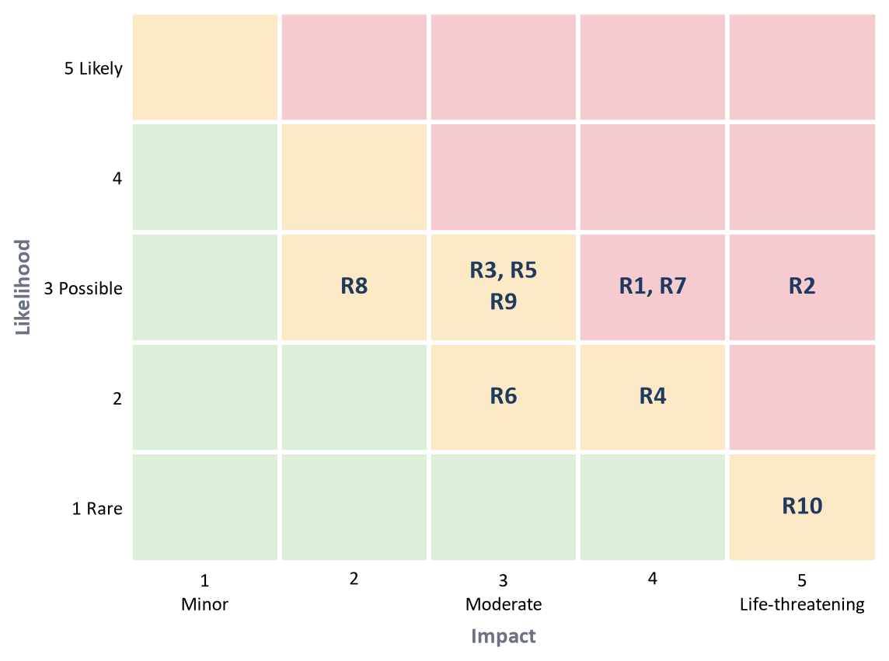
Figure 4. Risk matrix before mitigation
Table 7. Risk register
ID | Risk | L x I | Mitigation
R1 | False alarm erodes trust | 3 x 4 | Median filtering; graded levels; upstream confirmation before Evacuate; monthly announced siren test; every alert reviewed in the public log
R2 | Missed detection (fouled or blocked sensor) | 3 x 5 | Two or more nodes per wadi; rain gauge as an independent signal; heartbeat exposes a dead node; inspection before each rain season
R3 | Vandalism or theft | 3 x 3 | Mounting out of reach; low-value parts; tamper flag; community ownership through the wadi committee
R4 | Long overcast period drains batteries | 2 x 4 | Three weeks of storm-mode autonomy; low-battery alert in the heartbeat
R5 | Mobile network fails in the storm | 3 x 3 | Sirens do not use it; SMS queued and sent when service returns
R6 | Radio band not authorised or congested | 2 x 3 | Confirm with the frequency agency before deployment; 433 MHz fallback; duty cycle under 1%
R7 | Maintenance lapses after the pilot | 3 x 4 | Train local technicians; spare modules held by the municipality; annual service agreement; open documentation
R8 | Component supply delays | 3 x 2 | Parts available from several local suppliers; spares bought with the first order
R9 | Prototype schedule slips | 3 x 3 | Minimum demonstrable chain first (one node, one siren), then additions; weekly review
R10 | Spoofed or replayed alert | 1 x 5 | Message authentication code and counter on every packet; keys set per site

7.2 Lifecycle resilience
- Design for repair. Sensor, radio, processor and battery are separate plug-in modules; a failed part is swapped, not the node.
- Design for failure. Every node reports its own health, and a missing heartbeat raises a maintenance ticket on the dashboard. The system never fails silently.
- Design for seasons. Inspection and a full siren test are scheduled before the autumn rains, when Cap Bon's flash floods are most likely.
- Design for end of life. Batteries are the only consumable (planned replacement after about three years) and are returned through a take-back arrangement with the supplier; enclosures and panels are reused.

8. Humanitarian impact

8.1 Addresses real community needs
The need is documented by the 2018 disaster and by residents' own account of it: people described water taking a fence, a boiler room and part of a house within minutes, and blamed wadis left unmaintained for decades [2]. What they lacked was not a forecast but a few minutes of certain, local warning. WadiWatch provides exactly that, per wadi.

8.2 Demonstrates real impact
Impact will be measured, not assumed. Table 8 lists the indicators the prototype and the pilot will report. They are targets today; the December demonstration will replace the first four with measured values.
Table 8. Indicators of community benefit
Indicator | Prototype target (Dec 2026) | Pilot target (2027)
Time from threshold crossing to siren | 10 s or less | 10 s or less
Time from threshold crossing to SMS | 60 s or less | 60 s or less
Siren path works with internet, GSM and grid off | Demonstrated | Tested monthly
Wadi node availability in the rain season | Not applicable | 99% or more
Households in the mapped flood zone within siren range | Not applicable | 90% or more
Households in the flood zone with a registered phone | Not applicable | 60% or more
False Evacuate alerts per season | Not applicable | 1 or fewer
Residents who can state what each siren pattern means | Not applicable | 80% or more in a survey

8.3 Promotes inclusion
- No phone needed. The siren and strobe reach people without a handset, without credit and without literacy.
- Hearing and sight. A strobe accompanies the siren for people who are deaf or hard of hearing; the siren serves people who are blind or asleep.
- Language. SMS in Arabic and French, in short sentences tested with residents. A voice-call option for people who cannot read is on the roadmap.
- No cost to households. Registration is free and done in person at the municipality, schools and local associations, so people without internet access are not left out.
- Women and older residents have reserved seats on the wadi committee, because they are often at home when a daytime flood arrives and know which neighbours need help to move.

8.4 Empowers local actors
- Municipal technicians are trained to install, test and repair nodes, and hold the spares.
- Vocational and engineering students in the region assemble nodes from the open design, which keeps skills and spending local.
- Civil Protection gains a live picture of each wadi and helps set the thresholds.
- Farmers' groups and neighbourhood associations run registration and the yearly siren drill.

8.5 SDG alignment
Table 9. Contribution to the UN Sustainable Development Goals [14]
Goal and target | What the target asks | WadiWatch contribution
SDG 11, target 11.5 | Fewer deaths, fewer people affected and lower economic losses from disasters, including water-related ones | Minutes of local warning for households beside wadis; indicators in Table 8
SDG 13, target 13.1 | Stronger resilience and adaptive capacity to climate-related hazards | A locally run early-warning capacity for more intense rainfall events
SDG 1, target 1.5 | Resilience of poor and vulnerable people to climate-related extreme events | Free to households; works without a smartphone; protects livelihoods such as livestock and stock
SDG 9, target 9.1 | Reliable, sustainable and resilient infrastructure | Low-cost monitoring of crossings and culverts; open data for planning drainage works

The project also answers the United Nations call for Early Warnings for All, which aims to protect everyone on Earth with an early-warning system by the end of 2027 [15].

9. Ethics and values

9.1 Equity
Sirens are placed by flood exposure, never by ability to pay or by property value. Households pay nothing. The pilot site is chosen with the municipality from the areas flooded in 2018, giving priority to dense housing close to the wadi banks.

9.2 Transparency
Hardware designs, firmware and thresholds are published under open licences. Every alert, test and false alarm appears in a public log. The system is presented honestly: it complements official warnings from the national authorities and does not replace them, and its limits (it warns about one wadi; it cannot predict rainfall) are explained at registration.

9.3 Sustainability
Nodes run on solar energy with small batteries, use a few milliamp-hours a day, and are built to be repaired module by module. Batteries are taken back for recycling. The financial model (Section 11) covers maintenance from a modest annual fee, so the system does not depend on a one-off grant.

9.4 Wellbeing
Graded levels and upstream confirmation limit false alarms and the anxiety and fatigue they cause. Drills are announced in advance. Personal data is kept to the minimum: a phone number, a preferred language and the nearest wadi, collected with written consent, stored on the municipality's gateway, never sold or shared, and deleted on request, in line with Tunisian law on personal data protection [17]. The nodes carry no cameras or microphones.

9.5 Community ownership
A wadi committee of residents, municipal staff and Civil Protection owns the thresholds, the siren locations, the recipient list and the drill calendar. The municipality owns the equipment and the data. The team's role is to design, train and support, and to hand over.

9.6 Ethics and technology
- Explainable by design. Alerts come from thresholds the committee can read and change, not from an opaque model. Any future machine-learning forecast will advise the officer on duty and will never trigger a siren on its own.
- Safe against misuse. Signed packets prevent a malicious or accidental siren. Manual activation is limited to authorised officers and is logged.
- Human in the loop where it matters. The siren is automatic because seconds count; the all-clear is always a human decision.

10. Market analysis and potential partners

10.1 Market analysis
Customers. The buyer is a public body responsible for people's safety near a wadi: first municipalities and regional councils, then Civil Protection and the water directorate of the Ministry of Agriculture. Secondary buyers are operators with assets beside wadis: industrial zones, farms and cooperatives, insurers interested in loss prevention.
Size. Tunisia has 350 municipalities [11]. Flood protection is being financed by the World Bank in Bizerte, Monastir and Nabeul, and since March 2026 in Western Tunis, Gabes and Djerba [8], which identifies where demand is most immediate. The national disaster resilience programme (US$125 million, launched in December 2021) counts "people reached by early-warning systems" among its results [4][7], so a last-mile product fits an objective that is already funded.
Timing. The benefit is recognised at the highest level: the World Bank estimates that every US$1 invested in hydrometeorological services and early warning returns at least US$5.5 in socio-economic benefits [6]. Mobile subscriptions stand at about 122 per 100 inhabitants [10], which makes SMS a realistic second channel.
Table 10. Alternatives and positioning
Alternative | Strength | Gap that WadiWatch fills
National vigilance maps and bulletins | Authoritative; cover the whole country | Regional scale; no street-level trigger; depend on media and phones
Imported hydrometric telemetry stations | High accuracy; proven | Costly; specialist maintenance; measure but do not warn residents
Mobile apps and social media | Fast and free where connected | Need smartphone, data and power; unverified information
Informal warning (phone calls, shouting) | Trusted and local | Depends on someone seeing the water in time; fails at night

Go-to-market. One grant-funded pilot on a wadi flooded in 2018, operated through a full rain season and evaluated openly. The measured results then support offers to neighbouring municipalities in Cap Bon, followed by the governorates already engaged in flood-protection programmes.

10.2 Potential partners
Table 11. Potential partners and their role (to be approached; no agreement is claimed)
Partner | Role
A municipality in Nabeul governorate | Pilot site, mounting permissions, host of the gateway, owner of equipment and data
Regional Civil Protection | Threshold setting, dashboard user, drills
National meteorological institute and water directorate | Rainfall and hydrological expertise; link to national warnings
National frequency agency | Confirmation of radio band and power limits
Red Crescent and neighbourhood associations | Registration, awareness sessions, support for vulnerable residents
Farmers' groups | Recipients; hosts for upstream nodes on farm land
Vocational training centres and engineering schools | Assembly, maintenance training, student projects
IEEE humanitarian programmes and development donors | Pilot funding and technical review

11. Financial analysis
All prices in this section are the team's indicative estimates in Tunisian dinars (October 2026). They will be replaced by supplier quotations during the prototype phase.

11.1 Bill of materials
Table 12. Estimated cost of each unit
Item | Wadi node | Siren node | Gateway
ESP32 board and LoRa radio with antenna | 80 | 80 | 80
Ultrasonic level sensor | 35 | - | -
Tipping-bucket rain gauge | 90 | - | -
Siren and strobe, 12 V | - | 90 | -
GSM modem and SIM | - | - | 90
Solar panel | 45 | 110 | -
Battery and charge control | 40 | 110 | 100
Enclosure, mounting, wiring, PCB | 90 | 80 | 80
Total (TND) | 380 | 470 | 350

11.2 Budget estimates
Table 13. Prototype and pilot budgets
Line | Prototype (Dec 2026) | Pilot, one wadi (2027)
Wadi nodes | 2 x 380 = 760 | 4 x 380 = 1,520
Siren nodes | 1 x 470 = 470 | 3 x 470 = 1,410
Gateway | 350 | 350
Installation and mounting works | - | 1,200
Training and community workshops | - | 800
First-year operation (SIM, hosting, spares) | 60 | 600
Contingency (15% prototype, 10% pilot) | 246 | 588
Total (TND) | about 1,890 | about 6,470

11.3 Revenue model, cost and profit
WadiWatch is offered to public bodies as an installed system with a yearly service. The assumed price is 8,500 TND per wadi installed (hardware, installation and training, against a cost of about 5,280 TND) and 1,200 TND per wadi per year for service (SIM, hosting, spares, pre-season inspection, against a cost of about 600 TND). Table 14 projects five years under a deliberately modest roll-out. It is an illustrative scenario built on those assumptions, not a forecast.
Table 14. Five-year scenario (TND)
 | Year 1 | Year 2 | Year 3 | Year 4 | Year 5
New wadis installed | 1 (pilot) | 3 | 8 | 15 | 25
Wadis in service at year start | 0 | 1 | 4 | 12 | 27
Installation revenue | 0 | 25,500 | 68,000 | 127,500 | 212,500
Service revenue | 0 | 1,200 | 4,800 | 14,400 | 32,400
Grant funding | 6,470 | 0 | 0 | 0 | 0
Installation cost | 5,870 | 15,840 | 42,240 | 79,200 | 132,000
Service cost | 600 | 600 | 2,400 | 7,200 | 16,200
Fixed costs (staff time, travel, tools) | 0 | 5,000 | 12,000 | 25,000 | 45,000
Net result | 0 | 5,260 | 16,160 | 30,500 | 51,700

11.4 Return on investment
- For the venture. The pilot is grant-funded, so the activity is cash-positive from the first paid installation. Each installation contributes about 3,200 TND and each wadi in service about 600 TND a year, which covers the assumed fixed costs in every year of the scenario.
- For a municipality. About 8,500 TND once and 1,200 TND a year protects the residents of a wadi corridor. Set against recovery needs of about US$100 million for the single 2018 event [4], the cost of equipping every critical wadi in a town is small. A system does not stop the water, but it lets people move themselves, vehicles, livestock and stock in time.
- For society. At the World Bank's ratio of at least 5.5 to 1 for early-warning investment [6], a 6,470 TND pilot would return on the order of 35,000 TND in avoided losses over its life if the same ratio held at this scale. That is an assumption; the pilot's own indicators (Table 8) are there to test it.

12. Implementation timeline and team roles

12.1 Realistic implementation timeline
The plan (Figure 5) has two parts. Until 10 December 2026 the team builds and tests the prototype in four two-week sprints, each ending with something that can be demonstrated. After the challenge, the pilot is prepared with a municipality, installed before the autumn rains of 2027 and evaluated through that season.
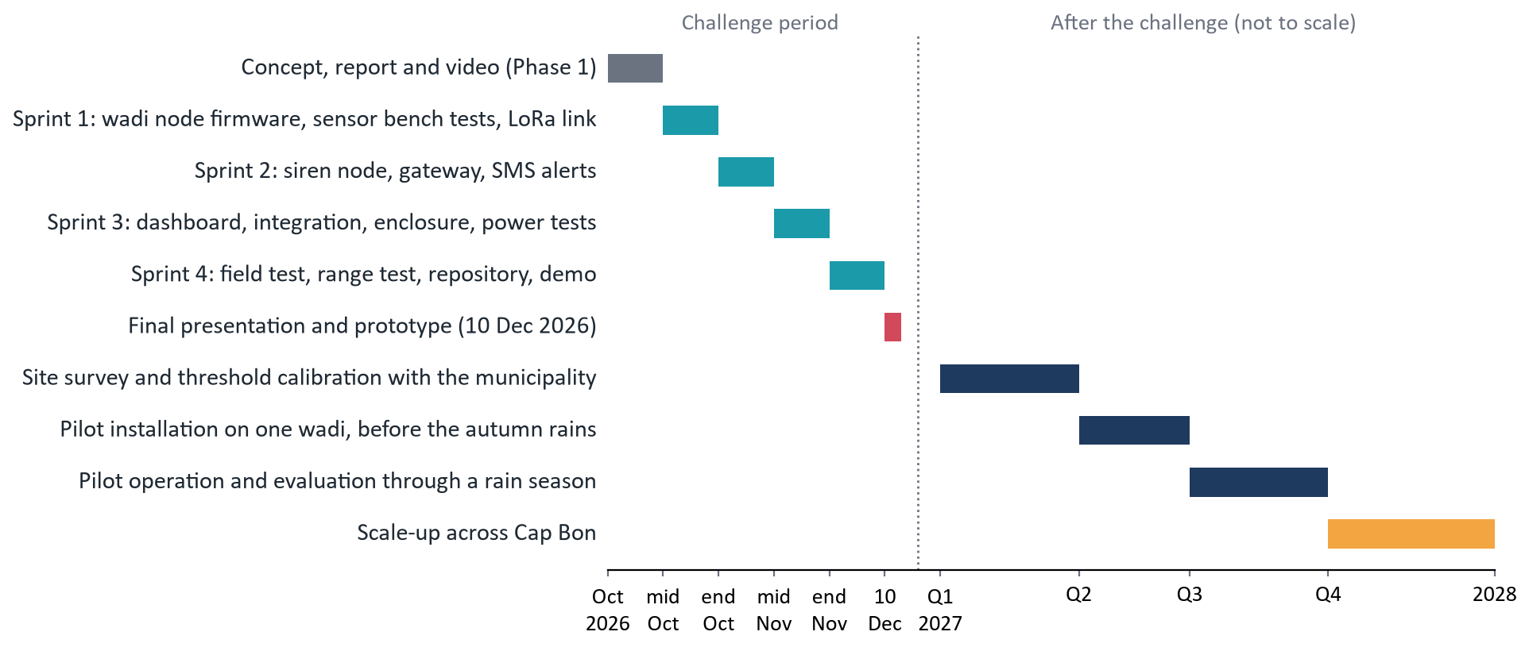
Figure 5. Implementation timeline
Table 15. Sprint outcomes before the final phase
Sprint | Demonstrable outcome
1 (13 to 26 Oct) | A wadi node on the bench reads level and rain, sleeps, wakes on rain and sends LoRa packets; current consumption measured
2 (27 Oct to 9 Nov) | A threshold crossing sounds the siren node with the gateway off; the gateway sends an SMS
3 (10 to 23 Nov) | Dashboard shows live levels and alerts; two nodes give upstream confirmation; nodes in enclosures on solar power
4 (24 Nov to 6 Dec) | Outdoor test on a water channel; range and latency measured; repository, diagrams and demo recording complete

12.2 Defined team roles
The team has five members and includes members of IEEE SIGHT, the IEEE Systems Council and IEEE CEDA. Roles are stated without names to keep this report anonymous.
Table 16. Team roles
Role | Responsibilities
Project lead and systems engineer | Requirements, architecture, integration, verification plan, risk register, schedule
Embedded hardware engineer | Schematic and PCB, power stage, sensor interfacing, enclosure, bill of materials
Communications and firmware engineer | LoRa protocol, edge alert logic, message authentication, siren node, range tests
Software and data engineer | Gateway, SMS, backend, dashboard, data logging and analysis
Community and business lead | Partner contact, resident feedback, market and financial analysis, video and pitch

13. Conclusion
The 2018 Nabeul flood showed that a warning which stops at a bulletin does not save the people beside the wadi. WadiWatch carries the warning the rest of the way: it senses the water where it rises, decides on the spot, and tells people through a siren that needs nothing but sunlight and a radio link, while giving the municipality and Civil Protection the picture they need to coordinate. It is affordable, repairable and owned by the community it protects. The next step is to prove each link of the chain on real hardware by 10 December 2026, and then to prove it on a real wadi.

References
[1] ReliefWeb, "Tunisia: Flash Floods - Sep 2018" (ECHO daily flash, 25 September 2018). https://reliefweb.int/disaster/ff-2018-000158-tun
[2] Agence France-Presse, "Four killed in torrential Tunisia rains", Arab News, 23 September 2018, and later updates. https://www.arabnews.com/node/1376526
[3] Kapitalis, "Cap Bon : Mesures d'urgence en faveur des sinistrés des inondations", September 2018. https://kapitalis.com/tunisie/?p=175831
[4] World Bank, "Tunisia Integrated Disaster Resilience Program (P173568): Program Information Document, Concept Stage", Report No. PIDC225236, 22 June 2020.
[5] World Bank, "World Bank and AFD Join Efforts to Strengthen Tunisia's Disaster Resilience Capacities", press release, 11 March 2021.
[6] World Bank, "New Report Recommends Ways to Strengthen Tunisia Disaster Preparedness", press release, 19 May 2022 (on the roadmap "Strengthening Hydromet and Early Warning Systems and Services in Tunisia").
[7] World Bank, "Strengthening Tunisia's Resilience to Climate Risks", brief, 17 March 2025.
[8] World Bank, "Tunisia Scales Up Urban Flood Protection Efforts with World Bank Support", press release, 4 March 2026.
[9] Institut National de la Statistique, Recensement Général de la Population et de l'Habitat 2024, results by governorate (Nabeul: 863,172).
[10] Instance Nationale des Télécommunications, telecommunications market indicators, first half of 2025 (mobile subscriptions: 122.1 per 100 inhabitants).
[11] OECD/UCLG World Observatory on Subnational Government Finance and Investment, Tunisia country profile (350 municipalities). https://www.sng-wofi.org/country_profiles/tunisia.html
[12] "Community Based Flash Flood Early Warning System: a Low-cost Technology for Nepalese Mountains", Bulletin of the Department of Geology, Tribhuvan University, 2018. https://nepjol.info/index.php/BDG/article/view/20728
[13] U.S. Geological Survey, "Low-Cost Sensor Networks for Pluvial Flash Flood Detection and Early Warning in Urban Areas".
[14] United Nations, Sustainable Development Goals, targets 1.5, 9.1, 11.5 and 13.1. https://sdgs.un.org/goals
[15] United Nations, "Early Warnings for All" initiative. https://www.un.org/en/climatechange/early-warnings-for-all
[16] LoRa Alliance, LoRaWAN Regional Parameters, EU863-870 channel plan and duty-cycle limits.
[17] Republic of Tunisia, Organic Law No. 2004-63 of 27 July 2004 on the protection of personal data.

