# Identifying Coding Weaknesses Using UML Tools

## Introduction

UML is a standardised approach for visualising and structuring software systems, particularly in designing secure applications. Visual Paradigm, an open-source UML tool, facilitates the creation of various UML diagrams, including use case diagrams, class diagrams, and sequence diagrams. These diagrams assist developers in identifying security vulnerabilities and ensuring robust software design.  
  
One of the critical security weaknesses identified by OWASP (2023) is Cross-Site Scripting (XSS). This vulnerability occurs when an application fails to validate user input, allowing an attacker to inject malicious scripts that execute in the user’s browser. UML diagrams can help model how this weakness occurs and inform the implementation of preventative security measures (Buelta, 2022).

## Leading to XSS Vulnerability

Cross-Site Scripting (XSS) exploits occur due to insufficient input validation and inadequate output encoding. The Visual Paradigm UML Activity Diagram below represents the steps leading to an XSS attack:

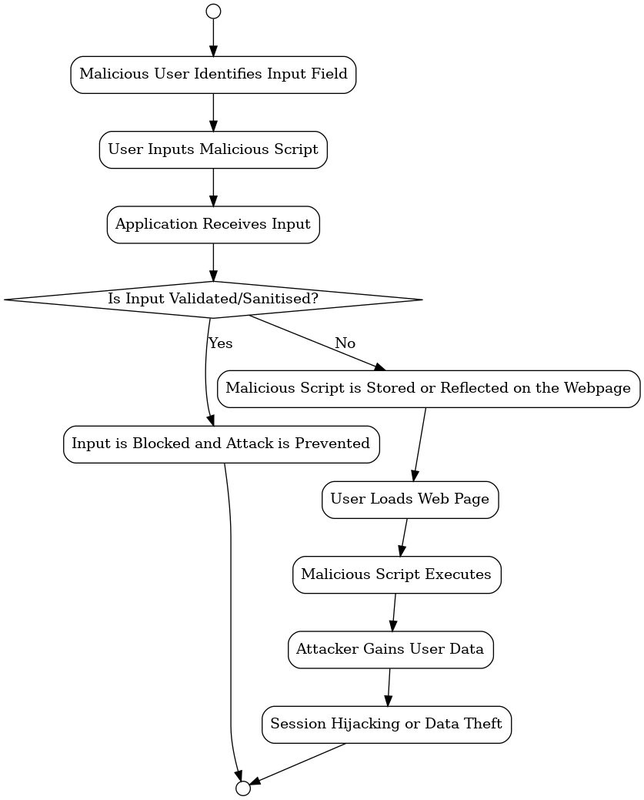

## Appropriate UML Models for Secure Software Design

To address Cross-Site Scripting (XSS) vulnerabilities, the following UML models are most effective:  
  
Use Case Diagram  
 Defines system actors (e.g., users, administrators) and their interactions.  
Helps identify input validation points and potential attack surfaces.  
  
Sequence Diagram  
 -Illustrates the flow of interactions between the user and system, highlighting where input validation should occur.  
 - Helps identify vulnerable sequences, such as form submission and script execution.

Activity Diagram  
 - Depicts the decision-making process in handling user input and preventing malicious script execution.  
 - Highlights security checks and proper handling of user-submitted data.  
  
By integrating UML modelling into secure software development, teams can enhance application security, ensuring structured validation mechanisms and better security monitoring (Velepucha and Flores, 2023).

## Conclusion

Using Visual Paradigm to model Cross-Site Scripting (XSS) vulnerabilities allows developers to proactively identify and mitigate security flaws. UML diagrams such as Use Case, Sequence, and Activity Diagrams support the design of secure input validation mechanisms.  
  
Following best practices from ISO/IEC 27000 and OWASP ensures that software systems are resilient against attacks, safeguarding user data and application integrity.

## References

* Buelta, J. (2022) Python Architecture Patterns: Master API Design, Event-Driven Structures, and Package Management in Python. Birmingham: Packt Publishing Ltd.
* **Visual Paradigm** (2024) UML Class Diagram Tutorial. Available at: https://www.visual-paradigm.com/guide/uml-unified-modeling-language/uml-class-diagram-tutorial (Accessed: 2 February 2025).
* **OWASP** (2023) Secure Coding Practices - Quick Reference Guide. Available at: https://owasp.org/www-project-secure-coding-practices-quick-reference-guide (Accessed: 2 February 2025).
* **International Organization for Standardization (ISO)** (2018) ISO/IEC 27000: Information Security Management Systems Overview and Vocabulary. Geneva: ISO. Available at: https://www.iso.org/standard/iso-iec-27000-family (Accessed: 2 February 2025).
* Open Web Application Security Project (OWASP) (2023) OWASP Top Ten: Cross-Site Scripting (XSS). Available at: https://owasp.org/www-project-top-ten/