UNIVERSITY OF MACAU
CISC7204 Data Science and Data Visualization
Who Will Churn Next?
Customer Churn Prediction and User Behaviour Visualization
for a California Telecom Operator

Course code | CISC7204
Course title | Data Science and Data Visualization
Coursework item | Assignment 02 – Pair Project Proposal (Revised)
Pair number | Pair 04
Region | California, United States
Domain category | Telecommunications and subscription services
Date | 25 October 2026

Team members
Name | Student ID | Project role
XIE AN | MC652723 | Project scribe and progress tracker
XI YUHANG | MC652645 | Project coordinator and liaison

1. Project Title and Research Question
Project title: Who Will Churn Next? Customer Churn Prediction and User Behaviour Visualization for a California Telecom Operator.
Region and domain. The project studies telecommunications and subscription services in California, United States. The public sample has no customer-level location field, so California defines the operator scenario and the regulatory and market context rather than a predictive variable. The analytical domain is customer relationship management: identifying avoidable churn before cancellation and explaining the behaviour that precedes it.
Research question. Which contract, service, billing and demographic attributes are most strongly associated with customer churn in the California telecom scenario, and how accurately can a classification model rank customers by churn risk so that a retention team can act on the ranking?
Visualization question. Which combination of charts, small multiples and model diagnostics communicates the segment evidence and the precision–recall trade-off most clearly to a non-technical retention team?
What this revision changes. The preliminary proposal treated prediction as the main deliverable and visualization as supporting evidence. This revision reverses that emphasis, in line with Assignment 02: the deliverable is a visualization-led investigation in which the model supplies evidence for the visual story. The question is unchanged, but it is now answered with an annotated executive figure, an interactive dashboard and a threshold-capacity view rather than with a model metric table alone.

2. Project Purpose

2.1 Outcomes
The project applies the course learning outcomes to a complete inquiry: selecting public data, documenting its provenance, cleaning and auditing it, exploring relationships, building and evaluating a classifier, and communicating the result visually. The finished work should let a retention team rank at-risk customers and recognise which contract, tenure, service and billing patterns define each risk segment. It also supports the pair's postgraduate study and career preparation in data science, customer analytics and applied machine learning.

2.2 Skills
The pair will practise Pandas and NumPy preparation; Matplotlib, Seaborn, Plotly and Dash visualization; Folium mapping for the regional context; SciPy chi-square testing; scikit-learn pipelines with logistic regression and random forests; stratified cross-validation; imbalanced-data handling; threshold tuning; colour-accessible chart design; dashboard layout; reproducible notebooks; and pair coordination with explicit handoffs.

2.3 Knowledge
The work strengthens understanding of classification, confusion matrices, the precision–recall trade-off, ROC and PR curves, class imbalance, encoding and scaling, multicollinearity, cross-validation, overfitting and the limits of causal claims from observational data. On the visualization side it develops knowledge of chart selection, small-multiple comparison, annotation, pre-attentive encoding and the difference between an exploratory chart and an executive visual.

3. Data Sources and Preliminary Evidence
The primary source is the IBM and Kaggle Telco Customer Churn sample. It contains 7,043 customer records and 21 columns: one identifier, 19 candidate predictors and the binary target Churn. The target contains 1,869 churned and 5,174 retained customers, a churn rate of 26.54%. The identifier is excluded from modelling. Table 1 lists the two required public sources plus the documentation used to interpret the fields.
Dataset link | Format and scope | Use in the project
Kaggle: Telco Customer Churn (blastchar) | CSV, 7,043 records × 21 columns | Primary download and dataset description
IBM GitHub sample repository | Raw CSV and repository files | Reproducible access to the same public sample
IBM sample documentation | Web documentation | Variable definitions and background
Table 1. Public data sources and their role in the project.
The preliminary analysis in Assignment 01 already answers part of the question. Churn rates by contract are 42.7% for month-to-month, 11.3% for one-year and 2.8% for two-year customers; the chi-square test is significant and Cramér's V is approximately 0.41, a moderate association. Churned customers pay more per month (US$74.4 against US$61.3) and have shorter median tenure (10 months against 38). Tenure correlates with churn at r = −0.35, while tenure and TotalCharges correlate at r = 0.83, which is why the model must handle multicollinearity. The overlapping density plots show that neither charges nor tenure separates the two groups on its own, so a multivariable model is justified.
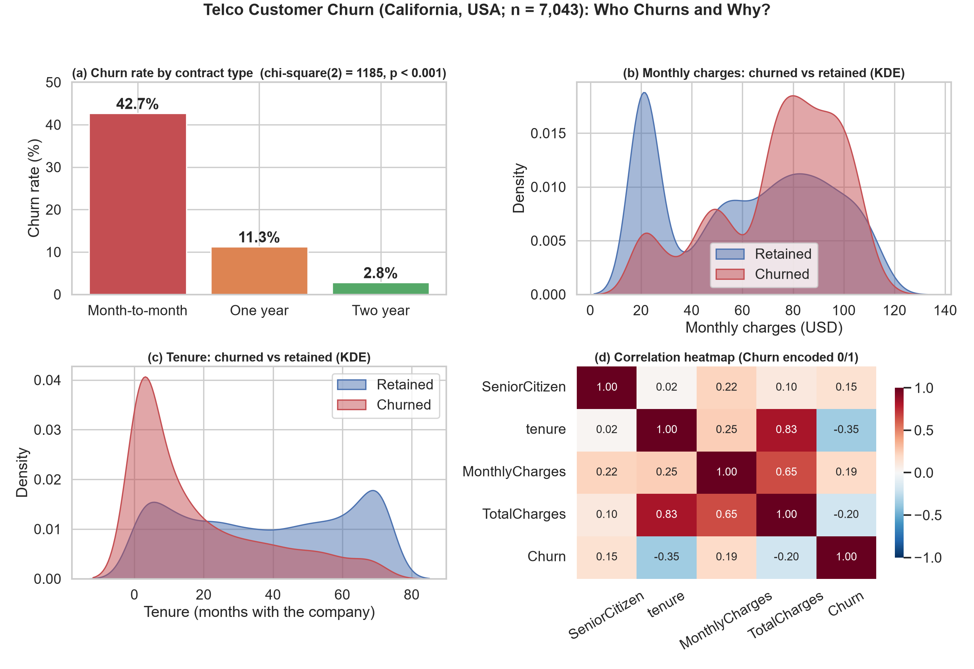
Figure 1. Preliminary analysis of contract type, monthly charges, tenure and numeric correlations (n = 7,043).

3.1 How the visualization answers the question
Figure 1 addresses the question directly: it compares churn across contract types with sample sizes printed on each bar, shows the overlap in monthly charges and tenure that rules out a single-variable explanation, and displays the correlation structure that determines which predictors enter the model. A reader can see, without reading the code, that contract and tenure separate churners far more sharply than charges alone. The revision keeps that logic but rebuilds the figure for an executive audience: a single annotated panel for contract risk, a small-multiple strip for service add-ons, and a side panel that translates the chosen decision threshold into customers contacted and churners identified.
The model results are presented visually rather than as a table of scores. ROC and precision–recall curves show the operating range, the confusion matrix at the selected threshold shows the operational consequence, and a permutation-importance chart shows which variables drive the ranking. This keeps the promise of the proposal: every quantitative claim is paired with a visual that a retention manager can read, and no chart implies causation that the observational data cannot support.

4. Project Tasks
Table 2 sets out the work remaining after Assignment 01. Each step has a deliverable and an owner so that progress can be traced from the proposal to the final notebook and presentation.
Step | Period | Work to complete | Deliverable | Owner
1 | Week 8 | Confirm the revised question, visual specification and success criteria | Approved proposal and task register | Joint
2 | Weeks 8–9 | Finalise the field dictionary, cleaning log and quality summary | Validated data dictionary and audit log | XI YUHANG
3 | Weeks 9–10 | Complete EDA: contract, service, billing and demographic comparisons with tests | Six or more annotated charts | XIE AN
4 | Week 10 | Build the executive figure and the accessibility palette | Publication-quality main visual | XIE AN
5 | Weeks 11–12 | Fit the logistic baseline and random forest, calibrate and tune the threshold | Metric tables, ROC/PR curves, error review | XIE AN
6 | Weeks 12–13 | Build the Plotly/Dash dashboard with filters, risk ranking and threshold slider | Working dashboard project | XI YUHANG
7 | Week 14 | Integrate the narrative, rerun the notebook end to end and peer-check | Final notebook and report | Joint
8 | Week 15 | Prepare the presentation and submit | Slides and submission package | Joint
Table 2. Remaining work, deliverables and owners.
Guides and requirements. The pair will adapt the workflows from CISC7204 Modules 01–05 of Assignment 02 (pandas exploration, Matplotlib and Seaborn chart types, Waffle and word-cloud techniques, Folium maps, Plotly and Dash). All work stays in one integrated Python 3 notebook for the analysis, with the dashboard kept as a separate project directory. Every variable is documented; every reused snippet and dataset is cited; file names follow the course convention; and the notebook must run from top to bottom with recorded versions and seeds.

5. Project Criteria for Success
A successful deliverable is reproducible, visually legible and honest about uncertainty. Table 3 converts those expectations into a checklist that the pair will use as a rubric before submission.
Criterion | Successful characteristic | Evidence
Data quality | 7,043 unique records; identifier excluded; 11 blank TotalCharges cases resolved; no unexpected missing values | Cleaning log and quality summary
Visualization | At least six readable charts with sample sizes and test results; colour-blind-safe palette; direct labels | Figure set and written interpretation
Executive visual | One main figure answers the research question without the code; threshold panel shows operational cost | Annotated main figure
Prediction | Logistic baseline and random forest comparison; held-out ROC-AUC ≥ 0.80; churn recall ≥ 0.50 at the selected threshold | Metric table, ROC and PR curves
Evaluation rigour | Preprocessing fitted inside folds; cross-validation mean and spread reported; threshold justified by retention capacity | Pipeline output and error analysis
Dashboard | Filters by contract and service; risk ranking table; threshold slider; loads without error | Dashboard project and screenshots
Reproducibility | Notebook runs end to end with versions, seeds and sources recorded | Reviewed notebook and checklist
Communication | Question answered; segment patterns explained without causal overclaiming | Final narrative and presentation
Table 3. Success checklist and evidence.
The numerical targets are planning criteria, not guaranteed results. If a target is missed, the report will say so and direct refinement to feature engineering, regularisation, threshold choice and error analysis rather than repeatedly testing alternative splits against the hold-out set.

6. Project Collaboration

6.1 Division of work
Task A is led by XI YUHANG (MC652645) and covers the business background, dataset description, Pandas cleaning plan, quality controls, project schedule and the Plotly/Dash dashboard. Task B is led by XIE AN (MC652723) and covers EDA visualization, model construction, evaluation and optimization, including the executive figure. Both members will integrate the sections, review the notebook and approve the final submission.

6.2 Ground rules
The team will meet weekly, store dated deliverables in a shared workspace, cite every data source and reused code fragment, exchange drafts within 48 hours and review each stage before moving forward. A task is complete only when its notebook cells execute without error and the other member has checked the output. Disagreements will be recorded and resolved against the research question and course requirements.

6.3 Group structure
XI YUHANG will act as project coordinator and liaison, maintaining the schedule and handling instructor communication. XIE AN will act as project scribe and progress tracker, recording decisions, maintaining the milestone log and coordinating technical integration. Both members remain responsible for final quality control and individual submission obligations.

7. References
[1] BlastChar. "Telco Customer Churn." Kaggle Datasets. https://www.kaggle.com/datasets/blastchar/telco-customer-churn
[2] IBM. "Telco Customer Churn" sample repository and CSV mirror. https://github.com/IBM/telco-customer-churn-on-icp4d
[3] IBM Samples Team. "Telco customer churn 11.1.3+." IBM Community, 11 July 2019.
[4] CISC7204. Assignment 02 Modules 01–05 lab notebooks, Project Proposal Guideline and Project Proposal Ideation. UMMoodle, 2026.

