Telecom and SaaS Customer Churn Prediction and User Behavior Visualization
Preliminary Project Proposal
MC652723 XIE AN
Course | CISC7204 Data Science and Data Visualization | Coursework | Assignment 01
Team member | XIE AN | Student ID | MC652723
Team member | XI YUHANG | Student ID | MC652645
Region | California, United States | Domain | Telecommunications and subscription services

1 Project Topic Name

Project title: Who Will Churn Next Customer Churn Prediction and User Behavior Visualization for a California Telecom Operator?
The project studies telecommunications and subscription services in California, United States. The public CSV contains no customer-level location field, so California is the operator scenario and not a predictive variable. The analysis focuses on customer relationship management and the commercial problem of identifying avoidable churn before cancellation.
Telecom and SaaS businesses rely on recurring revenue. A customer who leaves reduces expected subscription income and creates replacement-acquisition cost. Because contract terms, tenure, service bundles, support access, payment method and monthly charges may interact, the proposed analysis will combine prediction with visual explanation instead of relying on an overall churn rate or manual account review.
Research question Which contract, service use, billing and demographic attributes are most strongly associated with customer churn in the California telecom scenario, and how accurately can a classification model use those attributes to identify the customers most likely to churn?

2 Project Purpose

Outcomes
This project applies the course outcomes to a complete statistical inquiry: selecting public data, cleaning and documenting it, exploring relationships, building classification models, evaluating them honestly and communicating findings through visualization. The completed work should help a retention team rank at-risk customers and identify segments suitable for targeted outreach. It also supports postgraduate study and career preparation in data science, customer analytics and artificial intelligence applications.

Business Value
Churn prediction can convert a broad retention problem into a prioritized work queue. The proposed score will help a retention team focus limited outreach on customers with high estimated risk, while the charts will show which contract, tenure, service and billing patterns define each segment. The final business output will combine model scores with segment evidence that can guide tests of contract renewal offers, service follow-up or targeted support. Any estimate of retained revenue will be presented as a scenario with explicit assumptions rather than as guaranteed savings.

Skills
The work will develop practical skills in Pandas and NumPy data preparation; Matplotlib and Seaborn charts; SciPy chi-square tests; scikit-learn pipelines, Logistic Regression and Random Forest models; stratified validation; imbalanced-data handling; metric interpretation; reproducible notebooks; and pair-work coordination.

Knowledge
The team will strengthen its understanding of classification, confusion matrices, the precision and recall trade-off, ROC and precision-recall curves, class imbalance, one-hot encoding, scaling, multicollinearity, cross-validation, overfitting and the limits of drawing causal conclusions from observational sample data.

3 Data Sources and Preliminary Visualization

The primary source is the IBM and Kaggle Telco Customer Churn sample. It contains 7,043 customer records and 21 columns: customerID, 19 candidate predictors and the binary target Churn. The target includes 1,869 churned and 5,174 retained customers, giving a churn rate of 26.54 percent. The following public links provide the data and its documentation [1-3].
Dataset link | Format and scope | Use in the project
Kaggle dataset page | CSV 7043 records and 21 columns | Primary data download and dataset description
IBM GitHub mirror | Raw CSV and repository files | Direct reproducible access to the same public sample
IBM sample data documentation | Web documentation | Background and variable interpretation

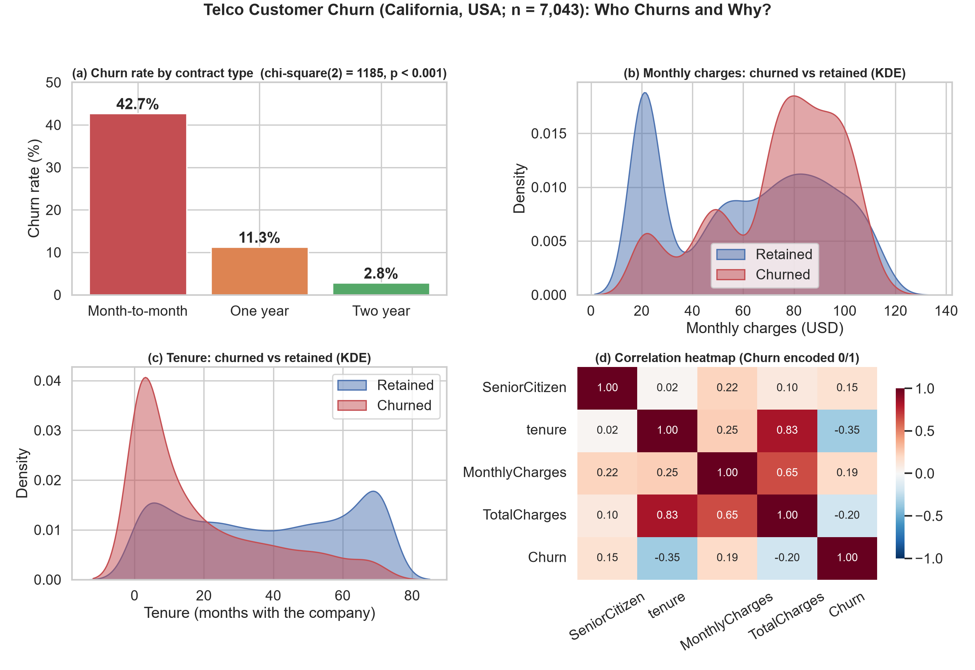
Figure 1 Preliminary analysis of contract type monthly charges tenure and numeric correlations

Figure 1 addresses the research question by comparing contract, billing and tenure patterns between churned and retained customers. The contract panel covers 3,875 month-to-month customers, 1,473 one-year customers and 1,695 two-year customers. Their churn rates are 42.7 percent, 11.3 percent and 2.8 percent respectively. The chi-square result is statistically significant, and Cramer's V is approximately 0.41, which indicates a meaningful association between contract type and churn in this sample. Churned customers also have higher average monthly charges, US$74.4 compared with US$61.3, and shorter median tenure, 10 months compared with 38 months. Together, the panels identify newer customers on month-to-month contracts with relatively high monthly charges as a priority segment for further analysis.
The overlapping density plots show that neither monthly charges nor tenure separates all churned and retained customers, supporting multivariable modelling. The heatmap links churn most strongly with tenure, r = -0.35, while tenure and TotalCharges correlate at r = 0.83. We will therefore check multicollinearity and coefficient stability. Further EDA will compare InternetService, PaymentMethod, TechSupport and OnlineSecurity; ROC and precision-recall curves will then link these segments to model performance without implying causation.

4 Project Tasks

The project will follow the seven steps below. Each step has a visible deliverable and an owner, allowing the team to trace progress from the proposal to the final notebook and presentation.
Step and period | Work to complete | Deliverable | Owner
1 Week 4 | Confirm the business question region domain sources roles and success criteria | Approved proposal and task register | Joint
2 Week 5 | Acquire the public CSV inspect 7043 by 21 fields and document target balance | Data dictionary and audit log | XI YUHANG
3 Week 5 | Trim text convert blank TotalCharges values validate tenure zero cases and run quality checks | Executed cleaning notebook and clean table | XI YUHANG
4 Weeks 6 to 7 | Create churn bars KDE and boxplots chi-square tests and a correlation heatmap | Six or more annotated charts and findings | XIE AN
5 Weeks 8 to 9 | Build a preprocessing pipeline and Logistic Regression baseline with a stratified split | Baseline metrics coefficients and error review | XIE AN
6 Weeks 10 to 11 | Compare Random Forest class weighting and a training-fold-only SMOTE variant using cross-validation | Model comparison ROC and precision-recall curves | XIE AN
7 Weeks 12 to 13 | Integrate the narrative rerun the notebook check figures and files and prepare delivery | Final report notebook visual and presentation | Joint

Guides Worksheets and Requirements
The team will adapt the workflows in CISC7204 Modules 01 to 06, including data import, describe, value_counts, visual exploration, Pipeline and train_test_split. Work will use public sources, document every variable, retain one integrated Python 3 notebook, cite reused code and data, follow the course file-naming convention, and keep evidence that the notebook runs from top to bottom.
Pandas checks will trim whitespace, convert blank strings to missing values and apply pd.to_numeric with errors set to coerce for TotalCharges. Initial inspection found 11 whitespace-only TotalCharges entries, all with tenure equal to zero; the plan is to preserve these new customers and assign zero only after validating that relationship. customerID uniqueness, category levels, numeric ranges, row count and target distribution will also be checked.
The model pipeline will one-hot encode categorical variables and scale numeric variables when the algorithm requires it. Logistic Regression will provide an interpretable baseline, followed by Random Forest. Evaluation will report Precision, Recall, F1, ROC-AUC, PR-AUC, confusion matrices and five-fold stratified cross-validation. Class weights and SMOTE will be compared only inside training folds, and the held-out test set will be used once for final evaluation.

Deliverable Handoffs and Quality Controls
By the end of Week 5, XI YUHANG will provide a validated field dictionary, cleaning decisions and a quality summary; XIE AN will return annotated EDA charts, model outputs and metric tables. The team will integrate the evidence in one notebook and submission narrative. A stage is complete only when cells run from top to bottom, the output is peer-checked and evidence is stored under an agreed filename, reducing incomplete handoffs and inconsistent results.

5 Project Criteria for Success

To satisfy the benchmark of a successful capstone inquiry, the final deliverable must establish an end-to-end synergy between statistical rigor, machine learning integrity, and stakeholder-centric data storytelling. First, data quality and reproducibility serve as the non-negotiable bedrock: all preprocessing routines must be strictly fitted within cross-validation folds to prevent data leakage, yielding an execution-ready artifact that reproduces identically across environments. Second, predictive modeling is evaluated not merely on high baseline metrics, but on fair and robust discriminative capacity. Given the operational cost of false negatives in customer churn, the classification system will be benchmarked through stratified cross-validation, with particular emphasis on PR-AUC, confusion matrix trade-offs, and cost-sensitive threshold tuning. Finally, quantitative outcomes will be anchored in visual storytelling. Serving as the governance framework, Table 2 details the project checklist and quality criteria across each developmental stage. While Figure 1 establishes the preliminary exploratory baseline, the final visual product will integrate these findings into an executive-level storytelling layout. This deliverable will feature model performance comparisons, discriminative ROC and PR curves, tree-based feature importance profiles, and targeted retention policy matrices to ensure that empirical findings directly empower strategic decision-making.

Criterion | Successful characteristic | Evidence
Data quality | 7043 unique records loaded customerID excluded from predictors 11 blank TotalCharges cases resolved and no unexpected missing values | Cleaning log and quality summary
Visualization | At least six readable annotated charts with sample sizes and chi-square results for selected categorical drivers | Figure set and written interpretation
Prediction | Logistic Regression baseline and Random Forest comparison with target held-out ROC-AUC at least 0.80 and churn Recall at least 0.50 | Metric table ROC and precision-recall curves
Evaluation rigor | Threshold justified cross-validation mean and spread reported and all preprocessing fitted inside training data | Pipeline output and error analysis
Reproducibility | Integrated notebook runs from top to bottom with versions seeds transformations sources and filenames recorded | Reviewed notebook and submission checklist
Communication | The research question is answered and the final visual explains the main segment patterns without causal overclaiming | Final narrative visual and presentation

The numerical targets are planning criteria rather than guaranteed results. If a target is not reached, the report will state that outcome and focus refinement on feature engineering, regularization, threshold choice and error analysis rather than repeatedly testing alternative splits against the hold-out set.
Model selection will also be judged at a decision threshold that matches a stated retention capacity. The final report will show, for each 100 customers contacted, the expected number of churners identified and the number of retained customers contacted unnecessarily. This operational view connects Precision and Recall to a practical outreach workload and makes the success criteria testable.

6 Project Collaboration

Division of Work
Task A is led by XI YUHANG MC652645 and covers the business background, dataset description, Pandas cleaning plan, quality controls and project schedule. Task B is led by XIE AN MC652723 and covers EDA visualization, model construction, evaluation and optimization. Both members will integrate the sections, review the notebook and approve the final submission.

Ground Rules
The team will meet weekly, store dated deliverables in a shared workspace, cite every data source and reused code fragment, exchange drafts within 48 hours and review each stage before moving forward. A task is complete only when its notebook cells execute without error and the other member has checked the output. Disagreements will be recorded and resolved against the research question and course requirements.

Group Structure
XI YUHANG will act as project coordinator and liaison, maintaining the schedule and handling instructor communication. XIE AN will act as project scribe and progress tracker, recording decisions, maintaining the milestone log and coordinating technical integration. Both members remain responsible for final quality control and individual submission obligations.

References
[1] BlastChar, “Telco Customer Churn,” Kaggle Datasets. Dataset page
[2] IBM, “Telco Customer Churn,” public repository and CSV mirror. IBM repository
[3] IBM Samples Team, "Telco customer churn 11.1.3+," IBM Community, 11 July 2019. IBM documentation
[4] CISC7204, Assignment 01 Modules 01-06 lab notebooks and project guidance, UMMoodle, 2026.

