Data Brief: 2020 Increases in Deaths in California

(Draft Under Review - Not for Distribution)

California Department of Public Health - Fusion Center - Last updated: 5.18.2021

This Data Brief presents an analysis of excess mortality (increase in deaths) for California in 2020, using California vital statistics death data, and includes assessment of differential increases by race/ethnic group, age, and increases in deaths due to conditions other than COVID-19. This analysis is a follow-up to findings in the 2020 State of Public Health Report, part of the State Health Assessment.

# Summary

* After many years of decreasing death rates in California, the death rate increased substantially in 2020. This increase is due largely to the emergence of COVID-19.
* The increase in death rate differed by race/ethnicity, with striking increases among Latinos. Compared to prior years, **deaths in 2020 increased 34.1% among Latinos, including a 62.5% increase in the 4th quarter.**
* Increases in deaths from conditions other than COVID-19 were observed, including deaths from drug overdoses (38.7%), homicide (31.3%), Alzheimer’s disease and other dementias (10.0%), and ischemic heart disease (4.2%). These 2020 **increases in homicide and ischemic heart disease death rates are in contrast to many prior years of decreasing or level rates**.
* The increase in death rate differed by age differentially among race/ethnic groups. Of particular note, **the overall death rate increased sharply among young blacks (aged 5-14 and 15-24) and American Indian/Alaska Natives aged 34-44**, with almost all of the increase due to conditions other than COVID-19.

# Findings

## Deaths increased in 2020 compared to prior years

* There were 316,544 deaths in California in 2020 (corresponding to an age-adjusted all-cause death rate of 649.1 per 100,000 population), compared to 267,034 deaths in 2019 (rate of 560.0). This is a 15.9% increase in the death rate in California, and is the highest statewide death rate in the past 12 years.

### Table 1 - Number, Age-Adjusted Rate, and Increase in Rate from Prior Year, Deaths from All Causes in California, 2017-2020

| **year** | **Ndeaths** | **aRate** | **pIncrease** |
| --- | --- | --- | --- |
| 2020 | 316,544 | 649.1 | 15.9% |
| 2019 | 267,034 | 560.0 | -2.3% |
| 2018 | 266,161 | 572.9 | -4.3% |
| 2017 | 265,439 | 598.6 | - |

* As the pandemic intensified throughout 2020, the increases in the rates accelerated. Comparing the 1st quarter of 2020 to the 1st quarter of 2019, death rates were similar, with just a 0.6% increase; then, comparing 2nd quarters, there was a 10.3% increase; comparing 3rd quarters, a 23.3% increase; and when comparing 4th quarters, a 30.6% increase.

### Figure 1 - All-Cause Death Rate by Quarter and Year, California 2017-2020

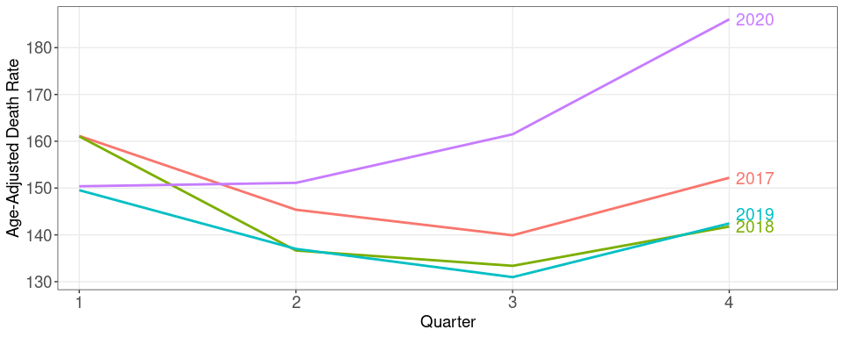

## Deaths increased more among some race/ethnicity groups than others

* From 2019 to 2020, the death rate increased 34.1% among Latinos, 7.8% among Whites, and about 20% among other groups.

### Figure 2 - Percentage Increase in Race-Specific Age-Adjusted Death Rates 2019 to 2020

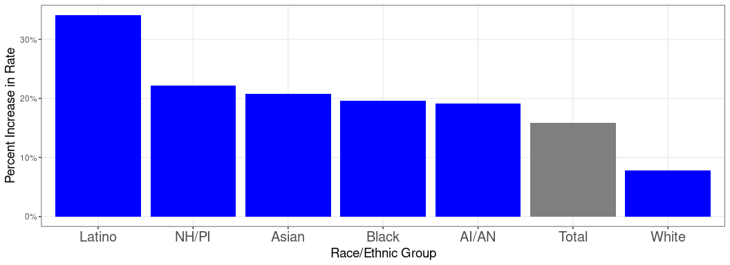

* Deaths among all race/ethnic groups were higher in quarters 2, 3, and 4 of 2020 compared to the average rate of the corresponding 2017-2019 quarters. As the year progressed, these differences **within** each race/ethnic group increased for all race/ethnic groups, and the disparities in these differences **between** most groups increased.
* These disparities are seen in Figure 3a by observing the increasing gap within any specific race/ethnicity group (dotted line compared to solid line), and by observing the increasingly larger gaps in some groups than others.
* These increases are all statistically significant for all groups. (See Appendix Figure Set 1)

### Figure 3a - Trends in All Cause Age-Adjusted Mortality Rate by Race/Ethnicity by Quarter, 2020 and 2017-2019 Average

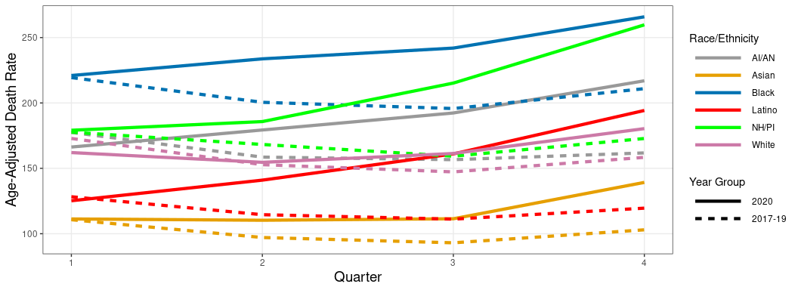

* Figure 3b below shows the same data as in 3a above, with a different perspective. Each bar is the **percent increase** in the death rate for each race/ethnicity group comparing quarters of 2017-19 to the corresponding quarters of 2020. The height of the bar reflects the size of the increase, or decrease if the value is less than zero.
* Comparing 1st quarters, there were very small increases for some groups, and small decreases for others.
* In the 2nd quarter of 2020, death rates increased in all race/ethnic groups, with the largest increase among Latinos and the smallest increase among Whites.
* In the 3rd quarter, the death rate increased 44.9% among Latinos, 13.9% among Whites, and at an intermediate level among other groups.
* In the 4th quarter, the death rate increased 62.5% among Latinos, 50.3% among NH/PI, 35.2% among Asians, 34.1% among AI/AN, 26.0% among Blacks, and 13.9% among Whites.

### Figure 3b - Percentage Increase in Age-Adjusted Death Rate by Quarter, 2020 and 2017-2019 Average, by Race/Ethnicity

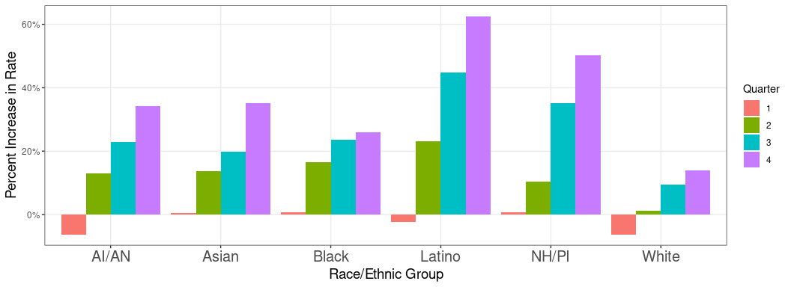

## Causes of death other than COVID-19 also increased

* Aside from COVID-19, three conditions with large percent increases in deaths from 2019 to 2020 were drug overdose (38.7%), homicide (31.3%), and diabetes (17.0%), Table 2.
* The conditions with the largest absolute increases in number of deaths from 2019 to 2020 were Alzheimer’s disease and other dementias (3,617), ischemic heart disease (2,580), and drug overdoses (2,228).
* For drug overdose and Alzheimer’s disease and other dementias, the increases are consistent with recent trends, albeit accelerated. But **for ischemic heart disease, the leading cause of death in California, the apparent increase is a concerning reversal of a steady downward trend of many prior years**. The **increase in homicide is also striking and alarming, in contrast to the encouraging decreases the last few years, and the long-term downward trend.** (For long-term trends in cause-specific deaths in California see Appendix Figure Set 2 or the California Community Burden of Disease Engine (CCB).)
* Regarding **decreases** from 2019 to 2020, **suicide/self-harm and lung cancers** both had large percentage and absolute decreases in number of deaths, and leukemia had a noteworthy percent decrease.

### Table 2 - 2017 to 2020, Selected Causes of Death, ordered by percent increase 2019 to 2020 [note: table is sortable]

|  | N deaths | | | | Age-Adjusted Rate | | | |  | |
| --- | --- | --- | --- | --- | --- | --- | --- | --- | --- | --- |
| **Cause** | **2017** | **2018** | **2019** | **2020** | **2017** | **2018** | **2019** | **2020** | **2019 -> 2020 Increase in N** | **2019 -> 2020 % Increase in Rate** |
| Drug overdose | 4,589 | 5,204 | 6,039 | 8,267 | 11.1 | 12.6 | 14.8 | 20.5 | 2,228 | 38.7% |
| Homicide | 2,020 | 1,967 | 1,849 | 2,392 | 5.2 | 5.0 | 4.7 | 6.2 | 543 | 31.3% |
| Diabetes mellitus | 5,993 | 5,936 | 6,151 | 7,407 | 13.5 | 12.8 | 13.0 | 15.2 | 1,256 | 17.0% |
| Endocrine, blood, immune disorders | 3,637 | 3,761 | 3,791 | 4,392 | 8.3 | 8.2 | 8.1 | 9.2 | 601 | 13.4% |
| Alzheimer’s disease | 24,878 | 25,070 | 25,637 | 29,254 | 54.3 | 50.8 | 50.3 | 55.3 | 3,617 | 10.0% |
| Hypertensive heart disease | 11,532 | 11,817 | 12,156 | 13,636 | 25.4 | 24.7 | 24.6 | 26.8 | 1,480 | 9.0% |
| Ischemic heart disease | 37,799 | 37,099 | 36,197 | 38,777 | 83.7 | 77.8 | 73.7 | 76.9 | 2,580 | 4.2% |
| COPD | 13,265 | 13,043 | 12,542 | 12,264 | 29.9 | 27.8 | 25.7 | 24.4 | -278 | -5.3% |
| Lung Cancer | 11,530 | 11,073 | 10,710 | 10,360 | 26.1 | 23.9 | 22.4 | 21.0 | -350 | -6.3% |
| Other respiratory diseases | 4,720 | 4,630 | 4,715 | 4,502 | 10.6 | 9.9 | 9.8 | 9.1 | -213 | -7.3% |
| Suicide/Self-harm | 4,230 | 4,423 | 4,343 | 3,992 | 10.3 | 10.7 | 10.5 | 9.6 | -351 | -8.4% |
| Neonatal conditions | 1,133 | 1,096 | 1,052 | 941 | 3.1 | 3.0 | 2.9 | 2.7 | -111 | -8.7% |
| COVID-19 |  |  |  | 30,857 |  |  |  | 63.2 |  | -- |

* Figure 4 below (and Appendix Table 1) shows 2017-2020 quarterly trends in conditions that had large percentage or large absolute increases from 2019 to 2020.
* As noted above, homicide deaths increased substantially in 2020, and strikingly by quarter. Homicide rates increased 24% in the 2nd quarter, 43% in the 3rd quarter and 54% in the 4th quarter 2020 compared to respective quarters in 2019.
* COVID-19 emerged in early 2020 and deaths increased rapidly not only in California, but almost everywhere, as a massive global pandemic. In the 4th quarter of 2020, COVID-19 was, by far, the leading cause of death in California.

### Figure 4 - Quarterly Trend in Selected Causes of Death 2017-2020

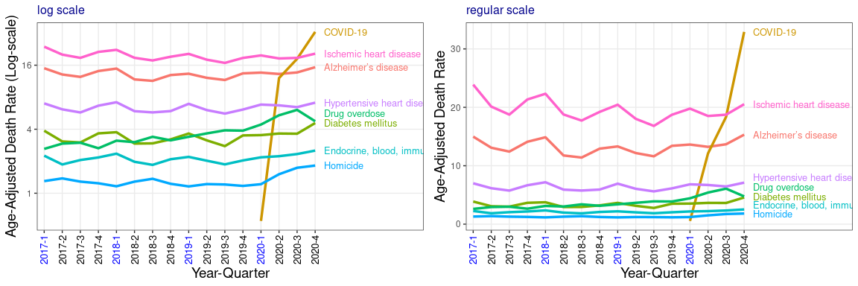

## The amount of increase in deaths and conditions associated with the increase differed substantially by age and race/ethnicity

* In general, a large proportion1 of the increase in deaths among older persons was due to COVID-19 while a large proportion of the increase in deaths among younger persons was due to other conditions.
* As seen in Figure 5 (and detailed in Appendix Figure Set 3 and Appendix Table 2), the greatest percentage increases in the number of deaths were among older Latinos, younger Blacks, and 35-44 year-old AI/AN.
* While the striking increases among Blacks ages 5-14 and 15-24 are particularly concerning for a range of reasons, it is important to note that large percentage increases among young persons represent a smaller number of deaths than among older persons.
* Of the 465 deaths (an increase of 156 deaths) among 15-24 year old Blacks in 2020, the greatest contributing causes were homicide, road injury, and drug overdose. Specifically, 137 (increase of 22 deaths) were due to homicides, 82 (increase of 28) to road injury, 75 (increase of 41) to drug overdoses, and 27 (increase of 17) to “ill-defined” conditions, some of which will be clarified in the coming months. These concerns are of course not restricted to just one race/ethnic group. For example, these same causes were leading contributors to the 1,965 deaths among Latinos aged 15-24 in 2020. Specifically, 436 (increase of 211 deaths) were due to drug overdoses, 334 (increase of 85) to homicide, 411 (increase of 64) to road injury, as well as 106 (increase of 78) to “ill-defined” conditions and 51 to COVID-19. These cause-specific data by race/ethnicity and age are available in Appendix Table 3.
* Of the 106 deaths (an increase of 46 deaths) among 35-44 year old AI/AN in 2020, the greatest contributing causes were drug overdose, 22 (increase of 14 deaths) and road injury, 11 (increase of 6).

### Figure 5 - Percent Increase in Number of Deaths 2019 to 2020 by Age Group and Race/Ethnicity and Proportion1 of Increase due to COVID-19

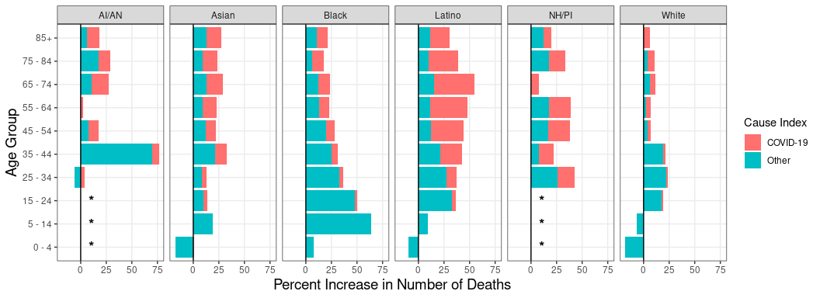

##### 1 - The “cause index” is, rather than a direct proportion, the ratio of the number of COVID-19 deaths in 2020 to the total increase in deaths from 2019 to 2020, and is truncated at 1.0. See the Methods section for details.

##### * - For younger NH/PI and AI/AN age groups, the underlying number of deaths for 2019 and/or 2020 is <25 so data are not shown

# Data, Methods, and Technical Notes

* This Data Brief is a follow up to findings in the 2020 State of Public Health Report, part of the State Health Assessment.
* Death data are from the California Integrated Vital Records (CalIVRS) system, based on death certificates/reports transmitted to the California Department of Public Health, Center for Health Statistics and Informatics (CHSI):
  + 2020 deaths are based on data received from CHSI on April 12, 2021. Additional 2020 deaths will continue to be reported subsequent to that date, and cause of death information will change for some deaths already reported. However, based on examination of the data and historic precedence, it is highly unlikely that the statewide patterns and trends described in the report will change in any meaningful way once final 2020 data are available (in the Fall of 2021).
* All death numbers and rates in this analysis are based only on the primary underlying cause of death, not on any secondary contributing factors (i.e. no “multiple cause of death” codes are included).
* Deaths in this Data Brief are based on this vital statistic data, and death numbers may differ from numbers reported based on other systems. In particular, numbers of deaths from COVID-19 may differ from COVID-19 death numbers posted on CDPH, National, or other web sites. Those sites can include reports of deaths from sources other than death certificates and/or on deaths where COVID-19 is not listed as the “primary” cause of death.
* The grouping of ICD-10 cause of death codes into condition categories is based on the California Burden of Disease System, a California-modified version of the Global Burden of Disease system. Details of this system are available on the California Community Burden of Disease Engine (CCB), in the **About -> Technical Documentation** tab. Of specific note for this Data Brief:
  + “COVID-19” is based on ICD-10 codes U07.1.
    - [ICD code introduced for COVID-19 deaths](https://www.cdc.gov/nchs/data/nvss/coronavirus/Alert-2-New-ICD-code-introduced-for-COVID-19-deaths.pdf)
    - [CDC report supporting the accuracy of COVID-19 mortality surveillance](https://www.cdc.gov/mmwr/volumes/70/wr/mm7014e2.htm?s_cid=mm7014e2_w)
  + The “Drug overdose” condition includes “accidental poisonings by drugs” codes (X40-X44) and “substance use disorder codes” (F11-F16, F18, F19), but not “alcohol use disorder” (F10). The drug overdose condition also includes “newborn (suspected to be) affected by maternal use of drugs of addiction” (P044).
* Population denominator data for rate calculations are from the California Department of Finance (DOF) Population Projections (Baseline 2019) Table P-3: Complete State and County Projections Dataset.
* Unless otherwise specified, the term “rate” throughout this Data Brief means age-adjusted death rate per 100,000 population.
* Age-adjusted rates are calculated using the “direct” method, with the CDC standard 2000 projected U.S. population published by CDC/NCHS in January 2001–specifically, Table 2, Distribution #1 was used, but with age groups <1 and 1-4 combined.
* Race/ethnicity is grouped and coded using standard CDPH methods and is detailed in the CCB technical documentation. Persons coded as “multi-race” are excluded from race-specific data, because numerator-denominator mis-alignment makes such rates uninterpretable.
* The data in **Table 2** were first restricted to causes of death for which there were > 500 deaths in any year, 2017-2020. Then, among those causes, the data were restricted to causes that had among the top five relative (percent change in age-adjusted death rate) or absolute (change in number of deaths) increases from 2019 to 2020 or among the bottom three relative or absolute decreases.
* The data in **Figure 4 and Appendix Table 2** are restricted to causes of death for which there were > 500 deaths in any quarter of any year, 2017-2020, and among those the causes that were among the top three relative or absolute increases from Quarter 2, 3 or 4 in 2019 to the same quarter in 2020.
  + Figure 4 also includes COVID-19 for reference, even though there is no prior year comparison.
  + Appendix Table 2 also includes causes of death among the bottom two respective relative or absolute decreases.
* For **Figure 5**, the overall length of each bar is the percent increase in the **number** of deaths from all cases from 2019 to 2020 in the specific age and race/ethnic group. The “Cause Index” was constructed by first calculating the ratio of the number of COVID-19 deaths (in 2020) in each group to the total increase in the the number of deaths in that group. If that ratio was greater than 1.0 (i.e. the number of COVID-19 deaths in 2020 was greater than the increase in number of deaths from 2019 to 2020), the ratio was set to one. The COVID-19 proportion of each bar is the product of that ratio and that overall percent increase; the “Other cause” proportion is the remainder of each bar.
* All analysis and data display were conducted using R and this document was generated using R markdown. All data and numbers in this document were generated/extracted directly from the data; no numbers were “hand transcribed”. This approach provides internal documentation and facilitates updating, reproducibility, and reuse.
* All data and visualizations in the Data Brief are available at the county level, at the request of the respective county health department.

# Discussion

* Deaths increased 15.9% in 2020 compared to 2019, with most of this increase due to COVID-19. The death rate increased as the year progressed–COVID-19 was the leading cause of death in the 4th quarter of 2020, with a 30.6% increase in the death rate that quarter compared to the 4th quarter of 2019. Deaths among Latinos increased 34.1% in 2020, including a staggering 62.5% increase in the 4th quarter compared to the 4th quarter of 2019.
* Deaths from a number of other conditions also increased, including drug overdoses, Alzheimer’s disease and other dementias, homicide, ischemic heart disease, and others. The increase in ischemic heart disease, the leading cause of death in California, is a reversal of a 20 year downward trend. The sharp increase in homicides reverses three prior years of decreases, and results in rates not seen since 2007. Charts showing these trends are available in the Appendix [HERE](https://skylab.dev.cdph.ca.gov/content/ca9bd32f-66c4-4108-91b8-4afdd24dd277) and are available for all California counties [HERE](https://skylab.cdph.ca.gov/communityBurden/).
* Overall suicide rates decreased from 2019 to 2020. This observation is being investigated and it is clear that this trend differs by multiple factors including age, race/ethnicity, and place. Sadly, there appears to be a noteworthy increase in suicides among the 5-14 year-old age group (See Appendix Table 3), mostly among Latinos and Blacks.
* As has been well described, older persons are at elevated risk for severe outcomes of COVID-19 infection including death. Among all groups, COVID-19 cases-fatality rates increase sharply with increasing age. However, because of a combination of 1) the differences in age-specific incidence of COVID-19 across race/ethnic groups, 2) the differences in the population age distribution of different race/ethnic groups in California, and 3) differences in case fatality rates, there are substantial differences in the age distributions of COVID-19 deaths by race/ethnicity, as seen in Appendix Figure 4. Of note, the largest proportion of COVID-19 deaths among Whites and Asians is among the 85+ year old age group, whereas the largest proportion of COVID-19 deaths among Latinos, Blacks, NH/PI, and AI/AN is among the 65-74 year-old age group. And, the latter four groups have substantial numbers of COVID-19 deaths among persons less than 55 years of age, whereas Whites and Asians do not.
* These data do not provide insight into what role COVID-19 has had in these observed increases, or on decreases in other conditions. It is logical to think that COVID-19 caused changes and delays in access to care, changes in social support, and changes in eating, drinking, exercising and other behaviors, all of which could have had important impacts on health.
* The increase in deaths among young persons, particularly the 63.9% increase among 5-14 year-old Blacks and the 50.5% increase among 15-24 year-old Blacks is highly concerning. While the underlying absolute numbers are small, the increases are nevertheless concerning on their own, and for their implications of differential health status, social pressures and access to care during the pandemic crisis. Additional investigation of these data will continue, and updates will be provided as they become available.
* There are important limitations to this analysis:
  + The 2020 death data are not fully complete, and some small changes are likely to occur, but they are unlikely to alter any of these observations of state level trends. For example, the proportion of 2020 deaths in the “Ill-defined” category, while very small (0.9%), is larger than in prior years. Some of these deaths will likely be recoded to defined categories eventually (perhaps accentuating slightly observations noted in this report).
  + The data in this report focus exclusively on the “underlying” or “primary” cause of death, and do not reflect the “contributory” or “multiple cause of death” causes. For example, the 30,857 COVID-19 deaths shown in Table 2 all have COVID-19 listed as the underlying cause of death, but there are an additional 2,106 deaths in 2020 with some other condition listed as the primary cause of death and COVID-19 as a contributing cause. Another important example is that there were 1,519 deaths in 2020 with “alcohol disorders” listed as the underlying cause of death, but many more (4,479) with another condition listed as the underlying cause and alcohol disorders listed as a contributory cause. Additional investigation of both contributory and underlying cause of death data is underway.
  + This analysis does not include data for 2021, when very large increases in death due to COVID-19 are known to have occurred. Those data are currently being investigated with similar lenses to this report.
* Reporting on changes in deaths is the “tip of the iceberg” and changes seen in deaths may not fully reflect changes in morbidity. Investigations into changes in rates of hospitalizations, emergency department visits, reportable diseases, and other measures of morbidity are underway. The relationship of these changes in mortality, and morbidity, to the underlying social determinants of health, such as poverty, education, racism, language, and a host of others, are also underway. This ongoing comprehensive assessment and analysis across multiple programs is critical to long-term prevention and equitable improvements in population health.
* While this rapid analysis of these readily available vital statistics death data provides clear evidence of important trends, deeper insights and understanding are urgently required.  It may be possible to gain insights from additional rapid analysis of other available data including surveillance data, administrative data sets, and other sources. Other critical insights will require longer-term complex research and study designs.

# Conclusion

* Deaths increased substantially in California in 2020 in large part because of COVID-19 and, importantly, other causes of death also increased. These increases differed by race/ethnicity and age. Further investigation of these changes is crucial to address the immediate situation and to prepare for the future.

# Related information and resources

* [COVID-19 is the Number One Cause of Death in the U.S. in Early 2021 - Kaiser Family Foundation - 2/22/2021](%3Chttps://www.healthsystemtracker.org/brief/covid-19-is-the-number-one-cause-of-death-in-the-u-s-in-early-2021/)
* [The Leading Causes of Death in the US for 2020 - JAMA 3/31/2021](https://jamanetwork.com/journals/jama/fullarticle/2778234)
* [Learning From Excess Pandemic Deaths - Editorial - JAMA 4/2/2021](https://jamanetwork.com/journals/jama/fullarticle/2778362)
* [COVID-19 and Excess Deaths - Michel Baudin Linkedin blog - 8/20/2020](https://www.linkedin.com/pulse/covid-19-excess-deaths-michel-baudin?trk=public_profile_article_view%3E)