**Interested in a “Data Science Team”?**

* [**Samfam921@gmail.com**](mailto:Samfam921@gmail.com)
* [**Michael.Samuel@cdph.ca.gov**](mailto:Michael.Samuel@cdph.ca.gov)
* **925-285-2926**
* [**https://mcsamueldatasci.github.io/Data_Science_Team/**](https://mcsamueldatasci.github.io/Data_Science_Team/)
* [**https://github.com/mcSamuelDataSci/Data_Science_Team**](https://github.com/mcSamuelDataSci/Data_Science_Team)

Map Example

The library() function loads “packages” that perfrom special functions into the workspace.

* the dplyr packages is a workhorse for data manipulation
* the tigris package connect to the US census and reads in geographic “shape” files. It requires a free “census key” to run
* tmap is the R package I use for mapping. There are many others.

library(dplyr)   
library(tigris)   
library(tmap)  
options(tigris_class = "sf")

This step reads in a dataset from the cloud on votting patterns in Califonira. The dataset is from a California Open Data Set. The main portal home pages is here <https://data.chhs.ca.gov/>

voterData.t <- read.csv("https://data.chhs.ca.gov/dataset/40fd0792-2bfd-4303-a848-fc5cb4338295/resource/c384c86a-49d2-4128-8389-b2701ff0bc35/download/voter-registration-2002-2010.csv",as.is=TRUE)

This little step reads in a census-tract level geographic “shape file” for California from the US census. (A free “key” from the US Census in needed if you want to run it yourself; available here <https://api.census.gov/data/key_signup.html>. )

tracts_CA <- tracts(state = "CA", cb = TRUE)

voterData <- filter(voterData.t, geotype=="CT",   
 reportyear==2010,   
 race_eth_name=="Total",   
 type == "voted/registered") %>%  
 transform(GEOID=paste0("0",geotypevalue))

This step merges the data using “join”

map.1 <- left_join(tracts_CA, voterData, by="GEOID")

This step makes a very simple map, with coloring based on the percent in the census tract who voted

tm_shape(map.1) + tm_polygons(col="percent")

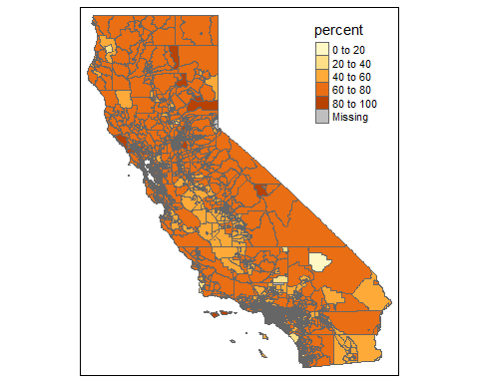

This step filters the data to just Conta Costa County, and re-maps

map.2 <- filter(map.1,county_name == "Contra Costa")  
tm_shape(map.2) + tm_polygons(col="percent")

